The ANTECEDENTS AND CONSEQUENCES OF SOCIAL MEDIA ENGAGEMENT with a sustainability adVERTISEMENT

Nuzhat Nuery
Student ID- 140158113
Newcastle University Business School

A thesis submitted to the faculty of Humanities and Social Science at Newcastle University as a requirement for the degree of Doctor of Philosophy

October 2022

Declaration
This is to state that the accompanying publication have not been previously submitted by any candidate for a degree in this or any other university.

Nuzhat Nuery
17/06/2021
Newcastle upon Tyne

abstract:
Social–media–users are increasingly placing their opinions about organisations and their actions on social–media. This is especially true when companies take sustainability related initiative or circulate a sustainability ad, because consumers are concerned over sustainability and have lack of trust on organisations. Social–media–users’ positive/ negative opinion significantly influences brand’s reputation and sales. This thesis investigates the antecedents (positive or negative captions accompanying a sustainability–ad) and consequences (users’ purchase intentions and further sustainable–behavioural intentions) of social–media–engagement with a sustainability–ad through the lens of ‘self–consumption–vision’ (SCV), ’pleasure–arousal–dominance’ (PAD) theory of emotion, and social influence theory. These theories have been chosen because, choice of products with sustainability association is mostly emotional in nature, but consumers do not see themselves adopting those because of social influence.
It is posited that, positive captions should generate greater SCV in other users/audience than negative captions, because positive sustainability–related messages are more readily accepted than a negative one and initiate greater information processing which facilitate SCV. In turn, higher SCV should generate higher levels of PAD. This should motivate the users to engage more on social–media. Furthermore, social–media–engagement should lead to greater purchase intentions and other sustainable–behaviour through normative and informational influence.
2 (positive vs negative caption) x 2 (high vs low source expertise) between–subject experiment with 279 respondents reveals that, positive captions induce greater level of SCV and PAD than negative captions, which lead to higher social–media–engagement with the sustainability–ad, purchase intentions and further sustainable–behavioural intentions. Significant interaction–effect was observed between the types of captions and level of source–expertise on social–media–engagement– if the source–expertise is low, the users will engage more for positive caption than the negative caption, but if the souse–expertise is high, people will engage more for negative caption than positive caption. This thesis contributes to both social–media–engagement and sustainability–advertising streams of literature by examining the role of consumers opinions on social–media–engagement and the role of social–media–engagement on sustainable–behaviour intention. This will help managers to understand focus of their attention while promoting products with sustainability association. Future studies may examine users’–reciprocity in social–media–platforms and social–acceptance of sustainable–behaviours.

Dedication
To my uncle AFM Manirul Islam, whose unthinkable and unconditional support was my driving force from the day I flew to UK

Acknowledgement
This has not been an easy journey, especially for someone like me, who is self-funded and without any support system. Yet, by the grace of Almighty, I have gained the most wonderful support system anyone can ever dream of. In my 4 years of PhD programme, I have the opportunity to work with 4 supervisors. Each of them brought different blessings. Dr. Natalia Yannopoulou, who has been with me throughout the journey has backed me not only academically but also personally. Though I had a very limited time with Dr. Raffaele Filieri, yet he planted the confidence in me that, this is a good enough topic to work on. Dr. Danae Manika supported me when I was in the desperate need of guidance of a quantitative researcher. She helped me beyond my imagination by arranging an experimental lab. Otherwise, it would have been really hard on my budget. Most importantly, she has continued helping me even after she left Newcastle University. Dr. Eleftherios Alamanos agreed to join my supervisory team at my 4th year, knowing that how inconvenient it will be for him to supervise, since he has to cover three years’ worth of journey of developing a conceptual framework in one year. I will be ever grateful to each and every one of them. Apart from them, if I have to mention another person in Newcastle University Business School, I want to thank Carolyn Watkin, who catered all of my needs with a smile on her face. And God knows how much I have irritated her.
Come to think of it, I am blessed with the best of both worlds. My mentors in Dhaka University, Dr. Md. Masudur Rahman and Dr. Mubina Khondkar, were the ones who pushed me to pursue this degree. Truth to be told, I was not in my optimum position to take a massive decision like this. But standing at this point of time, I realised that if I were to delay even for 6 months, I may not have been able to do it. They believed in me when I did not have confidence in myself. Another soul I should take a bow to, is Dr. Md. Kamal Uddin, who stood for me when no one else did.
My family has always been the wind under my wings. Their inspiration, prayers, and support led me through these 4 years of hardship. Especially my little sister, who acted as a one stop solution for my depression, stress, and anxiety. I was able to concentrate in my study because I knew she is with my parents. My uncle, AFM Manirul Islam, deserves a special thank for being the monumental support for me despite losing his son in June 2020.
Though I did not have my family with me, I have gained a family here. First of all, my landlady- Rifat Rashid, who not only provided me with food and shelter, but also gave me the warmth and safety of a family. It is said, that, friends are the family people choose themselves. My friends- Dr. Meryam Alttaf, Dr. Nosheen Khan, Dr. Hugo Du and Hassan Safdar (Doctoral candidate) held me at my darkest hours. They were the ears I can talk to, shoulders I can lean on, hands I can count on, and souls I can resonate with.
Greek philosopher Epicurus once said, “The greater the difficulty, the more glory in surmounting it”. But there is no way I could have ascended the mountain named ‘PhD’, without these people lending me their strength, wisdom, guidance, and support. Thanks for being there for me.

List of Contents
Chapter 1. Introduction 16
1.1 Background and research problem identification 17
1.2. The context- social media 20
1.3 Research and manegerial probelm 20
1.3.1. Managerial problem 20
1.3.2. Research problem 22
1.4. Rationale of using SCV (Self-Transformative consumption Vision), PAD (Pleasure-arousal-dominance) and social influence theory 23
1.5. Aims, Objectives, Research Question and Contribution 25
1.6. Thesis and chapters overview 27
Chapter 2. Literature review 30
2.1. Sustainability 32
2.2. Sustainable behaviour: 34
2.2.1 Sustainable behaviour intention 37
2.3. Sustainability–advertisement: 48
2.4. Social–media–engagement 55
2.5 Thematic literature review 58
2.5.1. Antecedents of social media engagement: 63
2.5.2 Consequences of social media engagement 69
2.5.3. Thesis roadmap: 71
2.6. The effect of positive or negative caption: 75
2.7. Source expertise 79
2.8. Involvement with the ad with sustainability message 82
2.9. Self-transformative Consumption Vision (SCV) 85
2.10. Pleasure Arousal Dominance (PAD) model 90
2.11. Ad attitude: 97
2.12. Social influence theory by Deutsch and Gerard (1955): 99
2.13. Importance of examining the relationships among the constructs 104
3. Hypothesis development 110
3.1. Impact of caption on social–media engagement 111
3.1.1 Moderating role of source expertise 112
3.2 Impact of caption on Self–transformative consumption vision (SCV)– 114
3.2.1 Moderating role of source expertise 115
3.4 Impact of Involvement on Self–transformative consumption vision (SCV) 117
3.5. Impact Self–transformative consumption vision (SCV) on Social media engagement 118
3.6. Imapct Self–transformative consumption vision (SCV) on Emotional dimensions (PAD)– 118
3.7 Imapct of Emotional dimensions (PAD) on Ad attitude 121
3.8. Impact of Ad attitude on Socilal media engagement 123
3.9 Impact of social–media engagement 124
3.9.1 Normative influence 124
3.9.2 Impact of Normative influence on purchase intention 125
3.9.3 Informational influence 126
3.9.4 Impact of informational influence on purchase intention 126
3.10 Impact of purchase intention on other behavioural intension– 127
3.11. Conceptual framework 128
4. Research philosophy and methodology: 131
4.1.Philosophy 132
4.2. General research approach 132
4.3. Methodological approach: Online Experiment 134
4.3.1 Fictional brand and chosen product category 134
4.3.2. Pre-test: 135
4.3.3 Experimental Manipulations and Checks 141
4.3.4 Population, Sampling Frame and Sampling Technique 142
4.3.5. Sample size: 144
4.3.6 Measurements 147
4.3.7. Reliability and assumptions checks 147
4.3.8 Common method bias (CMB) – 160
4.4. Ethics. 160
4.5. Limitation: 160
5. Result 162
5.1. Hypothesis testing 163
5.1.1 Impact of different types of Captions and source expertise 163
5.1.2. Relationships among the variables 169
5.2. Testing control variables: Age gender and education: 175
5.3 Testing the impact of COVID-19 lockdown 177
6. Discussion: 181
6.1. Positive and negative caption’s influence on social media engagement 182
6.2. Social media engagement’s influence on sustainable behaviour 187
6.3. Contribution to theory 188
6.4. Managerial contribution 189
6.5. Limitation of the study and direction for the future research 190
7. Conclusion 195
Appendix 1: Antecedents to engage in social media 199
Appendix 1.1: classification of Antecedent of social media engagement 212
Appendix 2: Papers on sustainable behaviour intention 218
Appendix 2.1: classification of Antecedent of Sustainable behaviour 256
Appendix 3: Questionnaire 263
Appendix: 3.1 263
Appendix : 3.2 270
Appendix 3.3 274
Appendix 3.4. Partial correlation table to determine CMB 291
Appendix 3.5 – Exploratory factor analysis result 292
Appendix 3.6-Comparison of discriminant validity and convergent validity among overall sample, February sample and April sample 294
Appendix 3.7 – comparison of the February and April sample by variables 295
Appendix 3.8- Confirmatory factor analysis 297
Appendix 4: Result 306
Appendix 4.1 306
One way MANOVA 306
Discriminant analysis 307
Two way MANOVA 308
Appendix 4.2. Regression analysis 309
Regression analysis between ‘involvement’ and ‘image quality’ 309
Regression analysis between ‘involvement’ and ‘engrossment’ 309
Regression analysis between ‘involvement’ and ‘self projection’ 310
Regression analysis between ‘involvement’ and ‘mental fluency’ 310
Multiple Regression analysis between ‘SCV’ and ‘Pleasure’ 311
Regression analysis between ‘Pleasure’ and ‘ad attitude’ 311
Multiple Regression analysis between ‘SCV’ and ‘Arousal’ 312
Regression analysis between ‘Arousal’ and ‘ad attitude’ 312
Multiple Regression analysis between ‘SCV’ and ‘Dominance’ 313
Regression analysis between ‘dominance’ and ‘ad attitude’ 313
Regression analysis between ‘ad attitude’ and ‘engagement’ 314
Multiple Regression analysis between ‘SCV’ and ‘engagement’ 314
Regression analysis between ‘ad attitude’ and ‘purchase’ 315
Regression analysis between ‘engagement’ and ‘norm’ 315
Regression analysis between ‘engagement’ and ‘information’ 316
Regression analysis between ‘information’ and ‘purchase’ 316
Regression analysis between ‘norm’ and ‘purchase’ 317
Regression analysis between ‘Purchase’ and ‘behaviour’ 317
Appendix 4.3 ANOVA 318
One way ANOVA 318
Two way ANOVA 319
Appendix 4.4 Controlling variable- age, gender, and education 320
Reference list 323

List of tables
Table | Page no
Table1: Definition of sustainable behaviour from different perspective | 35
Table 2: The antecedents of sustainable behaviour intention | 39
Table 3: Definitions of social–media–engagement and other online engagement | 55
Table 4: Antecedents of Social media engagement behaviour | 60
Table 5: Consequences of social media engagement | 62
Table 6: Resulted article from search containing different keywords representing ‘digital engagement’ and ‘sustainable–consumption’ literature | 73
Table 7: Outline of the Philosophical and methodological stance | 133
Table 8: the rationale for changing and omitting the items | 136
Table 9: Demographics of the respondents | 144
Table 10: Respondent distribution among the conditions | 145
Table 11: list of sample size of previous experiment on sustainable behaviour | 145
Table 12: Skewness and Kurtosis of the constructs | 148
Table 13: Multicollinearity test | 149
Table 14: Correlation matrix of DVs of MANOVA and two way MANOVA | 151
Table 15: Items, Cronbach’s Alpha with standardised item, Outer loadings and Composite reliability | 155
Table 16: Discriminant validity: Fornell-Larcker criterion | 159
Table 17. Correlation table | 164
Table 18: Multivariate Testsª | 165
Table 19: Tests of Between–Subjects Effects | 165
Table 20: Multivariate Testsª | 167
Table 21: Tests of Between–Subjects Effects | 167
Table 22: Pairwise comparisons of positive and negative caption between the high and low expertise level on the 4 dimensions of SCV | 168
Table23: Summary of causal relationships | 174
Table 24: impact of control variable | 175
Table 25- Comparison of the results of hypothesis testing among the samples | 177
Table 26: Future research | 193

List of figures
Figures | Page no
Fig 1: Example of sustainable products | 17
Fig 2: Example of sustainable initiative by the firms | 18
Fig 3: Coca–cola ad | 21
Fig 4: Initial framework of the thesis | 25
Fig 5: An overview of the thesis | 29
Fig 6: Athleta is promoting itself as a fair trade fashion brand, which denotes its commitment to social development | 48
Fig 7: People tree promotes its commitment to the societal and environment development through fair trade and use of environment friendly material respectively | 49
Figure 8: PRISMA for Social–media–engagement (SE) | 59
Fig 9: Influence of the Source | 81
Fig 10: Role of SCV on Social media | 84
Fig 11: Role of SCV on Social media engagement | 89
Fig 12: Role of emotion on Social media engagement | 95
Fig 13: Role of emotion on Social media engagement | 97
Fig 14: Role of social influence on behavioural intention of adopting sustainable behaviour | 103
Fig 15: Conceptual Framework | 130
Fig 16: Stimulation (Sustainably ad of fictitious coffee brand) | 141
Fig 17: Matrix of scatter plots between each pair of DV | 150
Fig 18: Test of outliers of multiple regression for independent variable SCV, second order reflective construct with 4 first order constructs | 152
Fig 19: Scatter plot of residual | 153
Fig 20: Interaction between types of captions and level of expertise. | 164

Chapter 1. Introduction

1.1 Background and research problem identification
Concerns over sustainability is rising among general people (Caprar, and Neville 2012; Davari and Strutton 2014; McDonagh and Prother, 2014; Rettie et al. 2012; Roberts 1996; Leary et al 2014). Which is also reflected in consumers’ demand for sustainable products (Statista 2016; Statista 2021⁶). Sustainable product represents “Products that minimize harm to the environment and to society” (Rowe et al 2019 p. 277). This demand for sustainable products motivates companies to incorporate sustainability related aspects in their offers and marketing communication (Huang 2015) for competitiveness and legitimacy (Bansal and Roth 2000; Keller 2013). For example, Waitrose’s promoted ‘unpacked’ policy in their store focusing on their attempt to reduce plastic packaging (Valley 2019); Moreish coffee promotes their products under both fair trade and rain forest alliance logos to signal environment, community/social and economic development etc (Fig 1); H & M launched ‘conscious’ collection to show commitment to sustainable sources along with its economic stance (Young, 2018) (Fig 2).
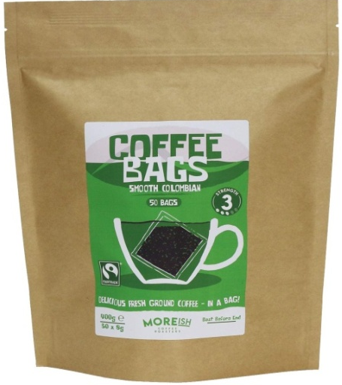
Fig 1: Example of products with sustainable issue
Source: Google image

In this paper, sustainablity related marketing communication or sustainability–advertising is defined as: “….sustainability advertising can be described as applying advertising messages promoting sustainable goods or services and/or informing stakeholders about the firm’s social, environmental or economic sustainability efforts” (Sander et al 2021 p: 431). This implies the fact that, sustianbility ad may or may not be about the sustainable probduct. Rather it is the promotional message focusing the organisations’ sustainable initiatives associated with the product or the company. In this study, ‘sutainability ad’ represents ads with sustainbility message.
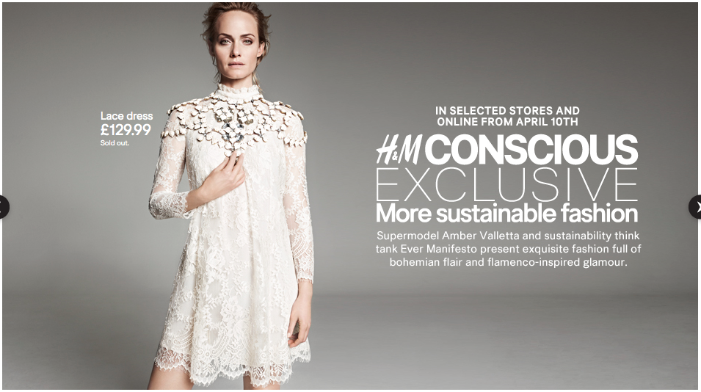
Fig 2: Examples of sustainable initiatives by the firms
Source: Google image

In today’s business practice it has become common to use ‘sustainability’ agenda (Huang and Rust 2011, Prothero et. al. 2010, Larceneux et al. 2012, Johnstone and Tan 2015), since consumers favours brands which have positive association with sustainability (Choi and Ng 2011). Two thirds of major brands like– Kimberly–Clark, HP and GE, have admitted that, incorporating sustainability related agendas in business are critical in order to remain competitive (Keller 2013, Larceneux et al. 2012). But these sustainability efforts of the brands neither guarantee brands’ success nor guarantee arousal of consumers’ mindfulness towards sustainabilty issues. Research on sustainability primarity rely on single theoretical lens such as- theroy of planned behaviour, marketing ethics theories, neutralization theories, construal level theory etc (Hassan et al 2021). This leads to the lack of studies which are concerned about issues like- how to change current consumption pattern, how consumers’ positive sustainability related attitude result can be turned into buying behaviour, how to nurture non-materialistic values, and how to foster sustainable behaviour (Fischer et al 2017). By definition sustainable–behaviour denotes– “consumer actions in product or service purchase, usage and disposal that minimize harm to the natural environment and to society” (Rowe et al 2019 p.276). An emerging phenomenon of the mordern world is, companies are loosing power over consumers and consumers’ consumption pattern is largely dependent on other consumers’ opinition of a particular product rather than company led advertisement (Angus 2018; Muniz and Schau 2007; Cova and Dalli 2009).
26% consumers report that they talk to friends, family and over online about brands that took a stance on social issues (Edelman 2018), yet not much is known about the effect of consumers’ opinion of companies’ ad with sustainability message that is shared in social media with other consumers. Though predominantly, promotional messages have been used to pursue the consumers, there is no guarantee that companies’ ads with sustainbility message will be accepted by the consumers positively. Because consumers’ response towards organisations’ societal and environmental initiatives may not always align with organisations’ expectation (Sen and Bhattacharya 2001). Even consumers who are concerned about sustainability may be sceptical about companies’ ad with sustainability message (Paço and Reis 2012). Firms’ sustainability related efforts may be deemed as a common business practice, yet their wrongdoings regarding sustainable issues will have major impact over consumer purchase behaviour (Mishina et al 2012). On the top of that, organisations’ promotion of their initiatives towards sustainability, is always at the risk of consumers’ perception to be self–serving and exploitive (Montororios et al 2008; Kilbourne 2004). For example, environmental campaign, run by energy, oil, and gas companies have less credibility and more susceptibility to be criticised for greenwashing (misleading green advertisement) practice (Fernando et al 2014). Companies’ such initiatives fail mostly due to the lack of trust on companies’ actions (Angus 2018). Company led ads with sustainbility message may also face the same problem. More importantly, the intensity of this problem is heightened due to interactive feature of web 2.0, which enables consumers to disseminate of their own opinion and affect other consumers worldwide (Fournier and Avery 2011; Habibi et al 2014).
The underlying role of consumers’ perception and opinion of the firms’ ads with sustainbility message is essential to understand because, because it will provide an insight of the adaptation process of the brands’ advertised product (Binder and Blankenberg 2017; Stern, 2000). This study focuses on the impact of single consumer’s positive or negative opinion (positive or negative caption) with the ads with sustainbility message when he/she posts it in social media on other consumers’ social media engagement and their subsequent purchase intention of the advertised products and other sustainable behaviour.

1.2. The context- social media
This thesis has taken social media as a context because mass media did not prove to be successful in promoting sustainable behaviour (Lin and Hsu 2015). It is argued that, new technology, i.e., social media, can be used to educate consumers about sustainable products and promote sustainale behaviour (Lim, 2016). Online customer engagement has proved to be one of the key reasons for firms’ success (Kumar et al 2017; Muntinga et al., 2011). From year 2014 to 2015 social–media content per brand increased by 35% (TrackMaven 2016). Recent data shows that, 87% of the marketers use social media for content marketing (Patel, 2021). In the context of sustainability, companies gain leverage if the companies’ sustainable messages are disseminated in the social–media by the consumers, reviewers or other stakeholders (Martin and Schouten 2012). But this also brings risk of misinterpretation of social media brand content (Hoffman and Novak 1996; Wirtz et al 2013). Consumers form a perception of the product depending on the social–media contents of the product and the brand. This may in turn affect the brand positively or negatively through the purchase decision of the consumer (Hutter et al. 2013; Zhu and Zhang, 2010; Mishina et al 2012). Likewise, consumers’ perception about the ads with sustainbility message over social media determines the success of their products.

1.3 Research and manegerial probelm

1.3.1. Managerial problem
Online platforms are used to express consumers’ opinions about companies’ sustainability related practices (Cho et al 2013). But, the unpredictability of the impact of the consumers’ opinion on social–media has become a powerful determinant of firms’ reputation and subsequent profit (Veloutsou and Moutinho 2009). As a matter of fact, consumers’ engagement of social media has become more powerful than the actions of other stakeholders. In 2018 ‘Iceland’s advertisement, depicting its stance against deforestation for palm oil cultivation, were banned form television for being ‘too political’. Yet this was no.1 campaign of that year’s Christmas, because this advertisement was widely shared and discussed across social media. This exposure was reflected on their sales (unilad.co.uk 2018). Brands like BP, Burberry, and Volkswogon have faced dire impact because of social–media in relation to their business practice. BP’s environmental malpractice has been the focus on YouTube videos and was presented in the White House (Sass 2010), Burberry had to stop their wasteful practice of burning their unsold products and using fur (Gibson, 2018) and Volkswagen had to apologise for their carbon emission case (Lareu, 2017). Soft drink company like Coca–cola has commited itself toward recyclable plant–based polyethylene bottles. In the line of their commitment, they have launched an advertisemnet claiming that– ‘single used bottle is not single used if they are recycled’ (Fig 3), which has faced backlash in twitter under #calloutcoke. Comsumers used the ‘hastag’ to accuse coca-cola of misleading consumers from the fact that they are the no 1 plastic pollutant of earth’s ocean (Citytosea.org.uk 2019). These examples illustrate the detrimental impact of consumers’ action on social–media on a company or brand. 89% of the marketers have confirmed the fact that, consumers have the power to elicit change over brands through social–media (Angus 2018).
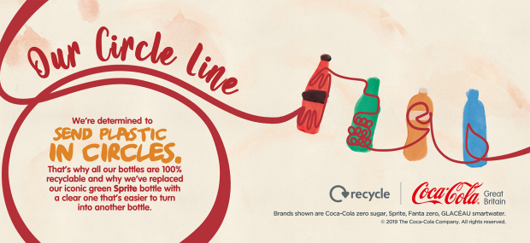
Fig 3: Coca–cola ad
Source: Google image

Social–media interactions with other consumers on a content, have proved to be more influential than brand/ company initiated communication, since consumers trust other consumers more for information than the company (Muniz and Schau 2007; Cova and Dalli 2009; Hutter et al. 2013; Veloutsou and Moutinho 2009). Social–media–engagement with a brand content represents "A set of brand related online activities on the part of the consumer that vary in the degree to which the consumer interacts with social–media and engages in the consumption, contribution, and creation of media content." (Schivinski et al. 2016, p. 66). Despite of consumers being the centre of promoting sustainable products, their perception on ads with sustainability message has never taken into account. In a nutshell, the recent surge of social–media use amongst consumers (Angus 2018; Muntinga et al. 2011) and the frequent use of sustainability themes to promote brands (Keller 2013), highlight the need to investigate how the interpretation of these ads with sustainbility message has affected not only other consumers’ social media engagement with those ads, but also their general intentions to purchase the advertised products. Managers need to identify customers value and concern, so that they can focus their attention to them (Martin and Schouten 2012).

1.3.2. Research problem
General publics’ sustainability concern does not ensure their adaptation of sustainable behaviour (Caprar and Neville 2012; Carrington et al 2010; Kilbourne et 2002; Carrington et al, 2014; Development, 2008). Even the formal definition of sustainable behaviour is narrowly focused on minimising consumption of individual consumer (Banbury et al 2012). This is problematic in consumption centric societies because, if consumers perceive sustainable behaviour is equivalent to consuming less, they may be reluctant to do it, since high consumption symbolises high status. This phenomenon may hinder the promotion of sustainable behaviour (Brooks and Wilson, 2015; Banbury et al 2012). This makes it important to understand the role of consumers’ perception of sustainability communication or ads with sustainability message.
The studies on consumers’ pro–environmental mindset and behaviour are inconsistent (Leary et al 2014; Johnstone and Tan 2015) and still unexplained (Frank and Brock, 2018), let alone giving a direction of how to promote sustainable behaviour. Lin and Hsu (2015) posed a question, if it is possible to make people realise their own actions and promote sustainable behaviour. In order to do this, general consumers need to be motivated to adopt sustainable behaviour (Binder and Blankenberg 2017; Stern 2000). There is a paucity of research which examine the underlying structure that inspires environmental concern and how it leads the consumer to choose sustainable product (Kilbourne et al 2002; Kilbourne 2004; Middlemiss, 2018).
The practice of limitless consumption can be minimised if the consumers can associate themselves with the product that contribute to sustainability (Cho et al 2013; Choi and Ng, 2011). Social–media has the capability to change consumer behaviour, and thus have an impact on firms, brands, and products (Muntinga et al., 2011). It has been observed that internet has the capability to increase awareness and inspire the consumer to pursue greater social responsibility goals (Angus 2018; McDonagh and Prothero 2014). Though, a few articles have been found regarding the social–media’s impact on firms’ CSR (Corporate social responsibility) initiatives (Bakker and Hellsten 2013; Fieseler and Fleck 2013; Lee et al 2013; Rivera–Arrubla and Zorio–Grima 2016; Saxton et al 2019), but the terms- CSR and sustainability, are fundamentally different. CSR is focused on managerial activities with four social responsibilities: economic, legal, ethical, and philanthropic (Carroll 1999). On the other hand, as per definition, sustainability is focused on social, economic, and environmental betterment of the present and future generation (Banbury et al 2012). To the best of knowledge, there is no study on the impact of consumers’ opinion of social media on the consumption pattern of sustainable products in the context of ads with sustainability message.

1.4. Rationale of using SCV (Self-Transformative consumption Vision), PAD (Pleasure-arousal-dominance) and social influence theory
Choice of consumption product is a social process, which is shaped by the perception of how other people will interpret it (Brooks and Wilson 2015). Sustainable behaviour is substantially dependent on the surroundings of the consumers. If people around them do not usually practice sustainable behaviour, it is highly unlikely that the consumers will see themselves practicing sustainable behaviour or consuming the products with sustainability association (Rettie et al 2012; Johnstone and Tan 2015). So, it is essential to understand, whether the ads with sustainbility message posted on social–media by one user with positive or negative caption, can make the consumers envision themselves using that advertised product. Therefore, our conceptual model of how sustainability–advertising to promote a brand affects the consumers, builds on the concept of Self–transformative Consumption Vision (SCV) (Yim 2018). SCV is defined as: “a person's mental visualization process of creating a self–involved imaginative future incident, story or narrative about a product or service in which the consumption outcome is envisioned” (Yim et al. 2018. p. 123).
But SCV may not be adequate to predict the influence of the ads with sustainbility message on sustainable behaviour (Yim 2018; Desmet 2010). Rather, it is more logical to state that, promotion of sustainable behaviour has greater possibility to be successful if suitability–ad can generate cognitive and emotional response (Davari and Strutton 2014 Desmet 2010; Yani–de–Soriano et al 2013; Richard and Chebat 2016; Holbrook and Batra 1987; Priester and petty 2003), as a result of mental imagery or consumption vision (Amit and Greene 2012). Measuring emotional response is especially important, because choice of products with sustainability association is largely emotional in nature (Bansal and Roth 2000; Rowe et al 2019, Martin and Schouten 2012). This elicited emotional response is expected to impact behavioural intention (Petty and Cacioppo 2018; Richard and Chebat 2016). Hence, companies should emphasis on creating emotional connection with the consumers by addressing consumers’ sustainability values. 62% consumers stand for companies those deals with sustainability related problems and 47% of the consumers stop patronizing the brands those have disappointing performance on social issues (Accenture 2018). This indicates that there is a need to measure the elicited emotion when the user is exposed to an opinion of other consumers/social media users regarding the ad with sustainbility message in social–media environment, which includes– the ad and the accompanying positive or negative caption by the actor/user. More specifically, it is required to understand to what extent the SCV generated by the ad with sustainbility message can affect the consumers emotionally.
This realisation leads to the emotional theory– Mehrabian–Russell Model [1996, also called Pleasure–Arousal–Dominance PAD model] as a tool to understand how the one social media user’s caption may affect other users in a social–media environment (see Huang 2001). PAD model should be especially effective to measure the emotion engendered in social media environment, because it is originated from environmental psychology (Massara et al 2010). Moreover, PAD dimensions can characterize all emotion related concepts like– moods, feelings etc. (Huang 2001). So, using these dimensions should provide broader perspective of emotion and more robust conceptual framework. Yim (2018) has already shown that ‘Pleasure’ acts as an emotional mechanism and a mediator between SCV and attitude. Walking on the same path, this research seeks to extend Yim (2018)’s study on SCV by introducing ‘Arousal’ and ‘Dominance’ dimensions along with Pleasure of PAD model to have a comprehensive account of emotional mechanism, which has never been tested before in sustainable–consumption literature.
However, emotions are not a direct predictor of behavioural intention (Desmet, 2010). In other words, aroused emotion from ads with sustainability message do not guarantee the sustainable behaviour. The more engage people are in social–media the greater number of people are exposed and aware of the consumption choices (Lin and Hsu 2015; Buenstorf and Cordes, 2008) or other information like– the correct use of the sustainable product or the symbolic meaning of the sustainable–consumption. For instance, sustainable certification holds symbolic meaning in the online consumer community, who are focused on sustainable behaviour (Discetti 2021). Because information found in social–media through engagement has the potentiality to become new norm and promote behavioural change (Bolton et al 2013). This phenomenon occurs due to the acquired sense of community through interaction and exposure to the new information in social–media, which influences people to re–examine their belief and reformulate their behaviour (Bolton et al 2013; Li 2013). It is posited that, creation of new normative belief can affect customers’ intention (Pickett–Backer and Ozaki 2008). Social networking sites were successful to educate general public about environmental issues used by non–profit groups (Fernando et al 2014). Purchase behaviour may also change towards sustainable one complementing the rising concern for environmental problems, since green consumption may signal social value (Brooks and Wiloson 2015). In other words, the urge to be liked others affects pro–environmental commitment, leads the consumers to adoption intentions of sustainable practices (Cho et al 2013).
Consumption, especially choice of sustainable product, is greatly influenced by social norm and information (Caprar and Neville 2012; Cho et al 2013; White and Simpson 2013; Chan et al 2008). Hence, it is proposed that normative social influence and informative social influence will be affected by social–media–engagement with the ad, which in turn should impact brand pucrhase intentions and other sustainable behavioural intentions (Deutsch and Gerard 1955).

1.5. Aims, Objectives, Research Question and Contribution
This study aims to fill the gap in sustainable behaviour literature as well as social media engagement literature from the context of social media engagement with the ads with sustainability message. This thesis posits that, social media users’ opinion about the message regarding sustainable product dictates sustainable behaviour of other consumers. The perceptions of the social media users are usully expressed in the captions /statement accompanying the ad with sustainbility message if they choose to post it. Since positive or negatively content /statement (eWOM) direct the subsequent engagement in online media (Van Doorn et al 2010), this study examines the difference in the imapct of positive and negative statements on subsequent social media engagement with the ad with sustainbility message and further sustainable behavioural intention. So far, no study has been conducted on the effect of the endorsing caption which reflects a user’s thought and emotion of the content.
This thesis fills this gap in prior research and investigates the antecedents (positive or negative captions accompanying a sustainability–ad) and consequences (users’ purchase intentions of the advertised product and further sustainable behavioural intentions) of social media engagement with an ad with sustainbility message. Specifically the purpose of this thesis is to look at: 1) the role of social–media users’ opinions, in the form of positive or negative captions accompanying an ad with sustainbility message (i.e., antecedent) on other users’ social–media engagement with the ad with sustainbility message (i.e., consequences) and 2) the role of social media engagement with an ad with sustainbility message (i.e., antecedent) on users’ purchase intentions of the advertised product, as well as further sustainable behavioural intentions (i.e., consequences) (Fig 4).
Sustainable behaviour intention

Positive vs negative caption accompanying ad with sustainability message

Social–media engagement with the ad

Purchase intention of product with sustainability association

Fig 4: Initial framework of the thesis
This denotes that the thesis has addressed the gap of contemporary contextual perspective of sustainbillity literature in terms of social media engagement. In the process of doing so, sustainable behaviour literature has also been enriched by incorporating wholesome approach of emotional theory and consumption vision theory. More specifically, the above mentioned obejctives are examined from the lens of ‘self–transformative consumption vision’ (SCV) and the Mehrabian Russel Model (otherwise known as ’Pleasure–Arousal–Dominance’: PAD theory of emotion), and social influence theory.
This leads to the first broad research questions- how do social media user’s positive and negative captions accompanying an ad with sustainbility message affect other users’ social–media–engagement with the ad? This question can be broken down into more specific research questions– 1) How do user’s positive and negative captions accompanying an ad with sustainbility message affect SCV of other users? 2) How does SCV affect Pleasure, Arousal and Dominance dimensions of emotion generated by ad with sustainability message? 3) How do the Pleasure, Arousal and Dominance dimensions of emotion affect social–media–engagement with the ad with sustainbility message? Second broad research question that is answered in this study is– How does social–media–engagement with the ad with sustainbility message influence purchase intention of the brand and other sustainable behaviour?
To the best of knowledge, the impact of users’ positive or negative caption accompanying an ad with sustainbility message on social–media–engagement and subsequent purchase intention of the products with sustainability association and other sustainable behaviour has never been studied before, especially form the point of SCV, PAD and social influence theory. This study extends the theory of consumption vision by incorporating all the dimensions of PAD theory of emotion with SCV to understand the role of SCV and emotion to influence ad attitude and resulting social–media–engagement in the context of sustainability. In addition to that, this thesis advances the literature on sustainable–behaviour by investigating the role of social–media environment on consumers’ acceptance of products with sustainability association and sustainable behaviour.
This thesis is inspired by the academic gap in social media engagement literature in the context of ad with sustainability message and the managerial requirement for the insight of how other consumers’ opinion on the ad with sustainability message may influence the purchase decision of sustainable product. Thus, this research contributes to the social media engagement literature by investigating the consequence of social media engagement in the context of ad with sustainability message. In addition to that, this study also advances sustainable behaviour literature by investigating sustainable behavioural intentions that may result from exposure to positive or negative caption on social media accompanying an ad with sustainability message.

1.6. Thesis and chapters overview
It is important for companies/brands to look into how single user’s notion of company’s ad with sustainbility message may influence other users. Since consumers have reported that they talk online about brands those has been positively associated themselves with social issues (Edelman 2018), social media engagement with the ad with sustainbility message may act as a competitive tool to build reputation for a company and result long term profitability (Keller 2013; Bansal and Roth 2000; Prothero et al 2010; Thøgersen et al 2012; Olsen et al 2014).
The next chapter, literature review starts discussing literature about sustainability. In this part sustainability related constructs (i.e sustainable behaviour and sustainability ad) are discussed along with a critical literature review of the antecedents of adopting sustainable behaviour, followed by the discussion about the aspects of ad with sustainability message. Literature review chapter proceeded with another pillar of the thesis- ‘social media engagement’. A thematic literature review has been reported to identify themes of antecedents of social media engagement and their consequences. It is conducted because, the research questions investigate how one user’s social media activity (positive and negative caption) on ad with sustainbility message act as an antecedent of social media engagement of other users and how it affects the purchase intention of sustainable product and other sustainable behaviour as a consequence. Hence, the thematic literature review provides an understanding of the antecedents and the consequences of social media engagement. Other relevant constructs and theories have also been included in the literature review chapter. The constructs those have been used in the conceptual framework are– source expertise, ad involvement, SCV, pleasure, arousal, dominance, ad attitude, sustainable purchase intention, sustainable behavioural intention. The rationale of relationships has been established in the hypothesis development chapter.
2 x 2 between group Experimental research design has been chosen as a methodological stance because of the requirement to manipulate the type of caption (Positive vs negative) and the level of source expertise (high vs low). The result and discussion chapter show the evidence that positive comment on ad with sustainability message have more influence on the sustainable purchase behaviour and other sustainable behaviour than a negative comment. The thesis concluded with the direction of future research and managerial implication. Fig 5 gives an overview of the thesis.
Fig 5: An overview of the thesis
Research question 2: How does social media engagement may influence sustainable purchase and other behavioural intention
Introduction:
Background: Consumers have trust issue regarding ad with sustainbility message of the company. Their positive or negative opinion of it disseminated on social media affect the reputation and sales of the brand
Literature review:
Thematic literature review to understand the antecedent and consequences of social media engagement.
Elaborate description of the theories and the constructs along with the rationale in incorporating those in the conceptual framework
Hypothesis development
Methodology
2 x 2 between group experiment conducted on fictitious brand by manipulating the types of captions and level of source expertise.
Analysis
Discussion
Review of the findings with explanation and implication. Limitation of the study
Conclusion
Managerial implication and future research
Research question 1: How does the positive and negative caption accompanying sustainability ad (i.e. antecedent) may influence social media engagement
Systematic literature review to identify recent studies conducted in digital engagement and sustainable behaviour literature

Chapter 2. Literature review

Natural resource consumption of global carrying capacity is increasing every year at an alarming rate (WBCSD 2018). If the current consumption rate retains, the planet will not sustain the population forecasted for mid to late 21st century (Mick, 2006). Sustainability is hard to achieve, due to the unsustainable consumption pattern of the modern society (Thøgersen and Schrader, 2012, Leary et al 2014, Kilbourne and Pickett 2008, WBCSD 2018). The aftermath of limitless consumption can be averted if the general consumers are motivated to adopt sustainable behaviour (Binder and Blankenberg 2017; Stern, 2000; Choi and Ng, 2011). It is argued that the best approach is to do so is through promotion (Belz and Peattie 2012). Yet till date, there is paucity of research on how to promote the sustainable behaviour (Kilbourne et al 2002, Lin and Hsu 2015).
Even though the general consumers are concerned about sustainability, they do not adopt sustainable behaviour (Caprar and Neville, 2012: Carrington et al, 2010; Kilbourne et 2002; Carrington et al, 2014; Development, 2008). Companies are capitalising consumers’ concern for sustainability by associating their products, services and business practices with sustainability and advertise those initiatives through ad with sustainability message (Prothero et. al. 2010; Huang and Rust 2011, Prothero et. al. 2010, Larceneux et al. 2012, Johnstone and Tan 2015; Statista 2016; Statista 20216, Cho et al 2013). Though this approach has proved to be fruitful (Choi and Ng 2011, Roberts, 1996, Bhattacharya and Sen 2003, Caprar and Neville 2012), but not guaranteed due to consumers’ scepticism of companies’ ad with sustainability message (Peattie and Crane 2005; Kilbourne 2004). In the age of social media, consumers’ positive or negative opinion of the ad with sustainability message has a dynamic impact on other consumers, which determine the success of advertised product with sustainability association (Veloutsou and Moutinho 2009).
This chapter discusses the key theories and constructs along with their rationale to be considered to investigate the research questions. This chapter starts with an in–depth discussion about the sustainability related constructs which includes– sustainable behaviour, sustainable purchase intention, and sustainability advertisement. A critical literature review has provided an understanding of the antecedents of adopting sustainable behaviour. This literature review chapter proceeds to discuss about social media engagement to give an overview how this behavioural construct affects the businesses and consumers; followed by a thematic literature review to understand the antecedent and consequences of social media engagement and to justify the claim regarding the gap in research on social media engagement on ad with sustainbility message and how the consumers’ options influence the intention to adopt sustainable behaviour. In the subsequent sections, discussion evolved around related antecedents like– captions on ad with sustainability message in social media, source expertise, ad involvement, self–transformative consumption vision (SCV), Pleasure, arousal and dominance (PAD) theory of emotion, advertisement (ad) attitude, and social influence. Previous research on these constructs and how they can explain the phenomenon of interest (sustainable behaviour intention) have also been reviewed in this chapter.

2.1. Sustainability
Sustainability refers to the betterment of current and future generations (Banbury et al 2012; WBCSD 2018) which encompasses environmental (e.g. conservation of natural resources), social (e.g. poverty eradication and equal benefits for all the actors involved in the business), and economic (e.g. long–term sustenance of organisations’ activity; voluntary simplicity, collaborative, and debt-free of consumption) dimensions, otherwise known as triple bottom–line (Lim 2017; Lim 2016; Huang and Rust 2011; Kemper and Ballantine 2019; Balderjahn et al 2013).
Problem with sustainability literature is that major part of it is focused on only environmental dimension of sustainability rather than incorporating all three dimensions (Lim 2017; Lim 2016; Huang and Rust 2011). Moreover, even if sustainability literature is a focus of academia since 1970 (McDonagh and Prothero 2014), it has not evolved with the context of modern-day sustainability related problems. Research to promote sustainable behaviour study should be action–oriented (Mick 2006). Early publications about sustainability were focused on clarification of the concept ‘sustainability’ and the importance of sustainable–behaviour. Though, later publications focused on how to implement sustainability concept, but those academic works were leaned toward discussing policies, which have the risk to be failures due to consumers’ rejection if the policies are formulated without changing consumers’ mindset (Schrader and Thøgersen 2011; Sedlacko et al 2014).
One of the major impediments of achieving sustainable development is overconsumption of mass consumers. If the current levels of consumption continue to rise, the planet will not be able to sustain the population forecasted in mid to late 21st century (Mick, 2006; Johnstone and Tan 2015). Natural resource consumption has increased to 125% of global carrying capacity and could possibly rise to 170% by 2040 (WBCSD 2018). Global material use is estimated to rise by 15% by 2030 and 75% by 2060, due to population growth coupled with high economic growth (datatopics.worldbank.org 2021). On the top of that, in 2015, fossil fuel consumption of the world is 79.68% of total fuel consumption (data.worldbank.org 2021).
Though Pickett–Backer and Ozaki (2008) treated products with sustainability association as a niche market, now a day the marketplace has changed. The market for green products has shifted from small niche market to mass market in early 90’s (Roberts 1996; VanDoorn and Verhoef 2015; Carrington et al 2010; weforum.org 2019). For instance, organic food has a 106 billion dollar global market in 2019 (Statista 2021)⁵. Yet consumers’ demand for product that is sustainable in nature, remains a small fraction of overall demand, whereas global consumption is also growing due to economic and technological growth and (Egea and de Frutos 2013; Peattie and Peattie 2009; Johnstone and Tan 2015; Luchs et al 2010).
There is a number of gaps in sustainability related research from the point of consumption. For example, the definition of sustainable behaviour in terms of consumption presented in 1994 Oslo Symposium is-
“The use of goods and services that respond to basic needs and bring a better quality of life, while minimizing the use of natural resources, toxic materials and emissions of waste and pollutants over the life cycle, so as not to jeopardize the needs of future generations.” (Banbury et al 2012, p 497).
This definition is criticised for giving emphasis on minimising the consumption and for not giving any direction of how to motivate the consumer to adopt it (Banbury et al 2012). Because, if sustainable behaviour is deemed to be equivalent of reducing consumption, consumers may be reluctant to adopt it (see, Lim 2017). Moreover, what sustainable behaviour means for consumer of different economic class, is also vague (Sedlacko et al 2014). Stern (2000) argues that since environmental attitude is different from environmental behaviour, theories only explaining environmentalism are insufficient to understand how to pursue consumers to adopt behaviour that is sustainable. This notion should also be true when it is extended to other dimensions of sustainability (i.e., social and economic). In other words, research on sustainable behaviour should start with the problem rather than theory and should simultaneously encompass multiple domain and level (Phipps et al 2013).
The business organisations are trying to capitalise sustainability (Huang and Rust 2011, Prothero et. al. 2010, Larceneux et al. 2012, Johnstone and Tan 2015). It was estimated that, there will be at least $12 trillion worth of market opportunity to rise by 2030 due to UN sustainable development goals (europeanbusinessreview.com, 2017). As seen from the appendix 2, studies those have taken contemporary perspective to promote sustainable–behaviour is limited even after almost 50 years of introduction of the topic around 1970 (McDonagh, and Prothero 2014, Banbury et al 2012, Stern, 2000, Kilbourne 2004, Lim 2017, Prothero et al 2010, Sedlacko et al 2014). The promotion of product with sustainable dimensions associated with it and adopting other sustainable behaviour needs to be assessed from modern day perspective. A research gap like this makes it hard for the firms to formulate applicable–managerial strategy, which is also scarce in this subject area (McDonagh and Protheo 2014, Caprar and Neville 2012, Lim 2017, White and Simpson 2013). This trend has hardly changed despite of recent shift of research focus from managerial perspective to more micro level concepts like, environmental value, dominant social paradigm etc (Kilbourne 2004). As seen in Appendix 2, lion portion of consumer centric studies tend to describe the impact of consumers’ general characteristics on sustainability rather than how the context affects consumers’ mindset to act towards sustainable behaviour.

2.2. Sustainable behaviour:
Sustainable behaviour ranges from product or service purchase, usage and disposal and concerned about the well–being of both natural environment and society (Rowe et al 2019). Sustainable behaviour has also been addressed as pro–environmental behaviour, sustainable consumption, societal consumption, ethical consumption, green consumption, environmental citizenship etc (Middlemiss 2018; Frank and Brock 2018; Huang and Rust 2011; Lin and Hsu 2015).
The definition of the term ‘sustainable behaviour’ is still not an established one. Above mentioned terms and other related terms usually do not encompass all three dimensions of sustainability, yet they have been used interchangeably in sustainability literature. For example, ‘ethical consumerism’ represents consumption that ensures the sustainability of earth resources and social responsibility (Lin and Hsu 2015). Furthermore, ‘ethical consumerism’ has also been used as synonymous to ‘green consumption’ (Lin and Hsu 2015). However, ‘green consumption’ and ‘environmental consumption’ are criticized for not including broader ethical issues like– human or animal rights (Valor and Carrero 2014). A broader term– ‘sustainable consumption’ is deemed to be an extension of ‘ethical consumption’ because it goes beyond environmental issue and encompasses global issues/ politics and sense of justice (e.g., fair trade) (Huang and Rust 2011; Lusch et al 2010). Moreover, similar term ‘Sustainable–product consumption’, can be extended to ‘organic products’ since it is associated with the welfare of all people and nature and the consumption decision is moral or ethical in nature (Juhl et al 2017; Larceneux et al 2012). Hence, the term ‘sustainable behaviour’ can denote all the other terms which encompasses the principles of green/ environmental/ organic/ ethical/ societal consumption behaviour. Most importantly, sustainable behaviour should not only mean minimising consumption (Banbury et al 2012).
For this thesis, this triple bottom line (social, environmental, and economic) has been considered as the scope of sustainability, rather than focusing on the green/ environmental aspect of sustainability like dominant part of the sustainable behaviour literature (table 1) (Lim 2017; Lim 2016; Huang and Rust 2011; Balderjahn et al 2013). This umbrella term encompasses all the all the other terms those have been used to define sustainable behaviour (Table 1). So, these topics were also considered to shape the thesis along with literature about sustainability.
Table1: Definition of sustainable behaviour from different perspective
Sustainable behaviour | “…consumer actions in product or service purchase, usage and disposal that minimize harm to the natural environment and to society” | Rowe et al (2019) p.276.
Pro–environmental behaviour | encompasses a range of activities and “behaviours that benefit the natural environment, enhance environmental quality, or harm the environment as little as possible”. | Larson et al., 2015, p. 113).
Sustainable consumption | Sustainable–consumption is a broad term referring to the various ways to reduce  the ecological footprint of consumption | (Eagea and De Frutos 2013, p 661)
green consumerism | “namely the voluntary consideration given to the eco–friendliness of manufacturing and the process of using and disposing of products” | Lin and Hsu (2015) P, 326
Ethical consumption | “is buying goods and services that are produced in circumstances that meet the consumer’s ethical criteria” | Huang and Rust (2011, p: 44)
societal consumption | “sensitive to aspects of environmental impact and social justice, even if altruistic motivations are absent” | Huang and Rust (2011), P. 39
Environmental citizenship behaviour | Civic perspective of pro–environmental behaviour | Song et al (2019)

As evident in table 1, though different terms vary in their definition, all of them can be covered as ‘sustainable behaviour’. Valor and Carrero (2014) took ‘ethical consumerism’ even further by proposing another term ‘responsible consumption’, which represents consumers choice of product on the basis of traditional dimension (i.e., quality, price etc) along with ethical dimension. However, they also associated ‘responsible consumption’ with ‘consumer activism’ and ‘political consumerism’. But these later two terms are mainly focused on consumers’ objective to alter corporate and government practice generated form their negative opinion about the firm (Valor and Carrero 2014; Discetti 2020; Prahalad and Ramaswamy 2004; Hollenbeck and Zinkhan 2006). This thesis focuses on the impact of general consumers’ positive and negative opinion about brand’s ad with sustainability message rather than their actions directed to change the brand’s practice. Hence, ‘consumer activism’ and ‘political consumerism’ are not in the scope of this research. Sustainability is hard to achieve, because the consumption pattern of the modern society is not sustainable (Thøgersen and Schrader 2012; Leary et al 2014; Kilbourne and Pickett 2008; WBCSD 2018).

2.2.1 Sustainable behaviour intention
Despite of pro-sustainable intent being an antecedent of the corresponding behaviour, that may not necessarily result into having any impact on consumers’ intention to adopt sustainable behaviour (Stern 2000; Kilbourne et 2002). Buying products with sustainable dimensions associated with it is a part of sustainable behaviour (Frank and Brock 2018). Point to be noted that, these products may or may not be sustainable itself, but have been produced and can be consumed in a sustainable manner. Consumers’ demand firm’s production practice to be sustainable. In other words, consumes prefer products those causes less environmental pollution and resource consumption (Lin and Hsu 2015; Egea and de Frtos 2013). For the point of three bottom-line of sustainability, Balderjahn et al (2013) have identified five key ‘environmental’ factors a consumer may consider while buying a product- recycling, packaging, resources and energy, local production (regionally), and climate. On the other hand, consumers associate ‘social’ dimension with a product in terms of human rights, decent working conditions, or fair practices in companies. Lastly, ‘economic’ dimension of a product is represented when consumers voluntarily reduce consumption, share resources, and avoid overspending.
Though consumers have favourable mindset of these types of products, but their purchase intention may not follow. Research on this topic do not show any consistent result. This is due to the fact that, consumers’ response may be subject to the issues of the study (see, Grimmer and Bingham 2013; Schuhwerk and Lefkoff–Hagius 1995). Moreover, the measurement of intention of sustainable–behaviour is self–reported which may be inflated because of social desirability bias. This results into dispersed gap between their response regarding the attitude toward a sustainability and their actual purchase behaviour (Carrington et al 2010; Johnstone and Tan 2015).
Since this study focuses on the antecedents of general consumers’ intention to purchase the featured product in sustainability related advertisement and adopt ‘sustainable behaviour’, a critical literature review was conducted to have an extensive understanding of this literature. Short description of the papers will be found in Appendix 2. In appendix 2, the articles are accumulated from three perspectives– firstly, articles those focuses on consumers’ perspective to adopt sustainable behaviour, secondly articles those considered both consumers and organisational perspective and lastly, articles those proposed strategies to promote sustainable behaviour intention. The antecedents are derived from those articles are grouped in Appendix 2.1. Table 2 shows the gist of it.
In table 2, antecedents are grouped together on the basis of their proximity of their definitions, because similar constructs should have similar effect on sustainable behaviour intention.
Consumers’ characteristics- this theme incorporates the antecedents of consumers’ innate characteristics those are exclusive to them.
Sense of community- The antecedents under this theme represents, how society influence the sustainable behaviour intention.
Attitude/ mindset- Antecedents related to customers’ perception of the sustainable product, belief on the brand or belief on their own ability are listed under this theme.
Emotional reaction- Internal feelings of the customer, which elicit intention to adopt sustainable behaviour have been included here. Antecedents like guilt, pride are included under this theme
Personal relevancy/ involvement: antecedents those denotes personal relevance associated with that products’ attributes, the attributes of the product (price, quality, dimension etc), and value (cost of acquiring and benefit derived) are grouped in this theme
Intention: the intention or the motivation to purchase of the product or to adopt sustainable behaviour has been themed separately as a consequential theme inspired by other antecedents. In this thesis, intention to adopt sustainable behaviour has been taken as the dependent variable.

Table 2: The antecedents of sustainable behaviour intention
 | Consumers' characteristics |  |  |  |  |  | Sense of community | Attitude/ mindset |  |  | Emotional reaction | Personal relevancy/ involvement |  |  | Intention
Consumers’ perspective | Socio demographic variable | Contextual factor | Personal capabilities | Personal characteristics | Previous behaviour | Environmental knowledge | Norm | Attitude | Behavioural control/ brand’s performance | Belief/ perception | Emotion | Product information/ attribute/ brand | Involvement | Value | Intention
Black et al (1985) | √
Stern (2000) |  | √ | √ |  |  |  | √ | √ |  |  |  |  |  | √
Heath and Gifford (2002) |  |  |  |  |  |  | √ | √ | √ |  |  |  |  | √
Kilbourne et al (2002) |  | √ |  |  |  |  |  | √
Kilbourne (2004) |  | √
Steenhaut and Kenhove (2006) |  |  |  |  |  |  |  | √ |  |  | √
Hirsh and Dolderman (2007) |  |  |  | √ |  |  |  | √ |  |  |  |  |  | √
Chan et al (2008) |  |  |  |  | √ |  |  |  |  | √ |  |  |  | √
Vermeir and Verbeke (2008) |  | √ |  | √ |  |  | √ | √ | √ |  |  |  |  | √
Jackson and Papathanasopoulou (2008) |  |  |  |  | √
Carrington et al (2010) |  | √ |  |  |  |  |  |  | √ |  |  |  |  |  | √
Lusch et al (2010) |  |  |  |  |  |  |  |  |  | √ |  | √
Lee et al (2010) |  |  |  |  |  |  |  |  |  |  | √ | √ |  | √
Bondy and Talwar (2011) | √ | √ |  |  |  |  |  |  |  |  |  | √ |  | √
Koller et al (2011) | √ |  |  |  |  |  |  | √ |  |  |  | √ |  | √
Urien and Kilbourne (2011) |  |  |  |  |  |  |  |  |  |  |  |  |  | √
Soyez (2011) |  |  |  |  |  |  | √ | √ | √ |  |  |  |  | √
Tucker et al (2012) | √ |  |  |  | √ |  |  | √ | √ | √ |  |  | √
Thøgersen et al (2012) |  |  |  |  |  |  |  |  |  |  |  | √
Luchs et al (2012) |  |  |  |  |  |  |  | √ |  | √ | √ | √ |  | √
Egea and de Frutos (2013) | √ |  |  |  |  | √ |  | √ |  | √ |  |  |  |  | √
Phipps et al (2013) |  |  |  |  | √ |  |  |  | √
Cho et al (2013) |  |  |  |  |  |  |  | √ | √ | √
Huang et al (2014) | √ |  |  |  |  | √ |  |  |  |  |  | √
Pagiaslis and Krontalis (2014) |  |  |  |  |  | √ |  |  |  | √
Vaino and Paloneimi (2014) |  |  |  |  |  | √ |  | √
Johnstone and Tan (2015) |  |  |  |  |  |  |  |  |  | √
Brooks and Wilson (2015) |  |  |  |  |  |  |  |  |  | √
Van Doorn and Verhoef (2015) | √ | √ |  |  |  | √ |  |  |  |  |  |  |  | √ | √
Lin and Hsu (2015) |  | √ |  | √ |  |  |  |  | √ |  |  |  |  |  | √
Minton, et al (2015) | √
Ertz et al (2016) |  |  |  |  |  |  |  | √ | √ | √
Wu et al (2016) | √ | √ | √ |  |  | √ | √ | √
Gonçalves et al (2016) |  |  |  |  |  |  |  |  |  |  |  |  |  | √
Grimmer et al (2016) |  | √ |  |  |  |  |  |  |  |  |  |  |  |  | √
Brough et al (2016) | √
Chen and Hung (2016) |  |  |  |  |  | √ | √ |  | √ | √ |  |  |  | √
Liobikienė, et al (2016) | √
Wei et al (2017) |  |  |  |  |  |  |  | √ |  |  |  | √ | √
Antonetti and Manika (2017) |  |  |  |  |  |  |  |  |  | √ | √ |  |  |  | √
Luchs and Kumar (2017) |  |  |  |  |  |  |  |  |  |  | √ |  |  | √
Ryoo et al (2017) |  |  |  |  |  |  | √ |  |  | √
Juhl et al (2017) |  |  |  |  |  |  |  |  |  |  |  | √
Kristensson et al (2017) |  |  |  |  |  |  |  |  |  |  |  | √
Yadav and Pathak (2017) |  |  |  |  |  |  | √ | √ | √ |  |  |  |  | √ | √
Evers et al (2018) |  |  |  | √
Perera et al (2018) |  |  |  | √
Song and Kim (2018) |  |  |  | √ |  |  |  |  | √ |  | √ |  |  | √ | √
Ibrahim and Al–Ajlouni (2018) |  |  |  |  |  |  |  |  | √ | √ |  |  |  | √
Sharma and Foropon (2019) |  |  |  |  |  | √ |  | √ | √ |  |  | √ |  |  | √
Rowe et al (2019) |  |  |  |  |  |  |  |  |  |  | √
Organisation’s and consumer’s perspective
Schuhwerk and Lefkoff–Haguis (1995) |  |  |  |  |  |  |  |  |  |  |  | √ | √
Schlegelmilch (1996) |  |  |  |  |  | √
Montororios et al (2008) |  |  |  |  |  |  |  | √ |  | √
Choi and Ng (2011) |  |  |  |  |  |  |  |  | √ |  |  | √
Larceneux et al (2012) |  |  |  |  |  |  |  |  |  | √ |  | √
Lyon, and Montgomery (2014) |  | √
Kalamas et al (2014) | √ |  |  |  |  |  |  |  |  | √
Davari and Strutton (2014) |  |  |  |  |  |  |  |  |  |  |  | √
Line et al (2016) |  | √ |  |  |  |  |  |  |  | √ |  | √
Herédia–Colaço and do Vale (2018) |  |  |  |  |  |  |  |  |  |  |  | √
Proposing strategy
Buenstorf, and Cordes (2008) |  |  |  |  |  |  | √ |  |  |  |  |  |  | √
White et al (2011) |  |  |  |  |  |  |  |  |  |  |  | √
Rettie et al (2012) |  |  |  |  |  |  | √
Axsen et al (2013) |  |  |  | √ | √ | √ | √ |  |  | √
Yang et al (2015) |  |  |  |  |  |  | √ |  |  |  |  | √
Han et al (2017) |  |  |  |  |  |  |  |  |  |  |  | √
Han et al (2019) |  |  | √ |  |  |  |  | √ |  |  |  | √

As seen in table 2, 38 articles have considered attitude related constructs as the antecedents of the sustainable behaviour. This denotes the importance of this construct in developing consumers’ sustainable purchase behaviour. It is also clear from the literature review that (Appendix 2) that, contextual factors are largely understudied. Situational and contextual factors like- interpersonal influences, government regulations, availability of recycling facilities, quality of public transport, pricing etc. have been considered in the studies (Ertz et al 2016; Kilbourne 2004) are normally beyond organisations’ control expect media. Media as a context, has been studied only by Lin and Hsu (2015) and Lyon and Montgomery (2014). They have considered public media (Lin and Hsu 2015) and social media (Lyon and Montgomery 2014) as the context of their study. However, in their attempt to understand consumers’ action in social media over organisations practice, Lyon, and Montgomery (2014) have confined their study on highly involved activists with only negative opinion about the company, whose objective is to change the questionable practice of the organisations. Since consumers’ perception of sustainability related attribute of the product affect their intention of sustainable purchase behaviour (Davari and Strutton 2014; Juhl et al 2017), Table 2 shows the requirement for the study regarding the differentiating effect of general consumers’ both positive and negative opinion in social media context on other consumers’ sustainable behaviour intention.
37 articles have encompassed the product related construct, which shows the importance of relevancy of the product with the consumers (involvement) while purchasing them. 36 articles included constructs related to customer as a person. However, consumers’ personal factors are also the constructs those are embedded in a consumer and cannot be controlled by the company. Other than these, constructs related to emotion and consumers’ sense of community have distinct impact on their intention to adopt sustainable behaviour. The categories of antecedents in Table 2 also gives a direction of which constructs should be included in the conceptual framework.
In practice, consumers’ reluctancy to follow their pro-sustainable attitude in terms of sustainable purchase behaviour can be attributed to number of reasons. Firstly, consumers perceive that environment–friendly (i.e., sustainable) products to be expensive (Davari and Strutton 2014; Roberts 1996; Johnstone and Tan 2015; Juhl et al 2017; Yang et al 2015). This effect of additional cost can be mitigated if companies can communicate and justify the added value of environmentally friendly purchase (Grimmer and Bingham 2013). Consumers may be motivated to adopt high-cost environment friendly consumption if it signals social value and status. 51% consumers are willing to pay high price for products with sustainability association (Herédia–Colaço and Vale 2018). Plus 66% of consumers surveyed across 60 countries are willing to pay higher prices for goods when bought from environmentally conscious companies (www.weforum.org, 2018). Admittedly, if the retailers reduce the price of the products with sustainable dimensions, it may signal as of lower quality and lose credibility. Market dictates that, the price of these products should be up to a point that is higher than the products without sustainable dimensions to ensure confidence of the consumers, but low enough to be demanded by major portion of consumers (Ngobo 2011; Van Doorn and Verhoef 2015). However, monetary barriers of the consumers were proved not to be significantly related with green behaviour (in this case sustainable behaviour) (Tanner and Kast 2003; Choi and Ng 2011; Davari and Strutton 2014; Lusch et al 2010).
Secondly, the reason for consumers not to choose products with sustainable attributes is, they are still associated with sacrificing consumption or non–hedonic experience in consumers’ mind (Herédia–Colaço and de Vale 2018). In fact, sustainable products are perceived to be underperforming (Lim 2016). Consumers are less likely to sacrifice utilitarian value for sustainability value than sacrificing hedonic value. But if either value (hedonic or utilitarian) is important to the consumers, they are unlikely to choose those products (Luchs and Kumar 2017). They will demand minimum level of functionality threshold to be guaranteed to choose those products (Luchs et al 2012). In other words, the extent to which the consumers will prefer a product with sustainable attribute depends on their valued benefit along with the product category. For example, environment friendly detergents are not supposed to use optical brightener additives, which will be perceived as poor performing detergent compared to conventional detergents. In this case, cleaning appliances are chosen for their strength of cleaning; consumers will not prefer a sustainable cleaning product, since generally, sustainability related products are perceived of having association with ‘gentleness’. Thus, added information about the sustainable cleaning product’s ‘strength’ is required for consumers to prefer them (Luchs et al 2010). In this case, added aesthetics of these products can mitigate the lack of confidence on them (Luchs et al 2012). This indicates the fact that, both hedonic and utilitarian benefit can be met with aesthetic product design and assuring information about sustainability products’ functionality.
This brings to the third reason for consumers to not choosing products with sustainable attributes. The problem resides in companies’ lack of initiative to educate the consumers regarding the product (Peattie and Crane 2005; Davari and Strutton 2014). Consumers may be concerned about sustainability, but due to lack of product specific knowledge they do not purchase the products with sustainable qualities (Pagiaslis and Krontalis 2014). Research shows that, innovative product design and effective communication can instil greater brand attitude for their sustainability related initiative (Olsen et al 2014). “Informational interventions should be considered to educate consumers, so that they can accurately identify which products are environmentally friendly and which are not” (Tanner and Kast 2003, p. 895). However, very detailed technical information or confusing information have failed to increase sales of those products (Johnstone and Tan 2015). So, it is important that the people are educated in a right manner regarding the brand. In order to achieve the objective of increased sales, the consumers should be properly communicated, and the added value should be properly conveyed (Grimmer and Bingham, 2013).
Fourth reason for consumers’ purchase behaviour not to follow their concern for environment, is – rather than understanding that sustainable behaviour may take various form, consumers think it is a dichotomous choice of going either be committed to full green of nothing (Johnstone and Tan 2015; Peattie and Crane 2005). On the top that, there is still room for confusion regarding terms related to choosing these products, especially when it is synonymous to minimising consumption (Kemper and Ballantine 2019; Lim 2017; Banbury et al 2012). Though products, like– organic foods, are deemed to be healthier, safer, and local economy supportive. Yet, added information regarding sustainability do not influence the demand much if the brand equity is high (Larceneux et al 2012). Strong ethical claim associated with a sophisticated product, which is consumed mainly for enjoyment, impairs that product’s evaluation. But ethical claim with the simple product, enhances the evaluation. This phenomenon occurs because consumers perceive sustainability related products not to be effective, hence cannot be associated with sophisticated products (Herédia–Colaço and Vale 2018). It signifies that, there is confusion in conveying consumers the information about sustainability related products. At this point, marketers have failed to communicate the socio ecological value as effectively as the traditional benefits and values, which leave the mainstream consumers in dark about the feature of sustainability related products and left with the perception that sustainable purchase requires sacrifice, inconvenience, higher cost, lower performance without added benefits (Lim 2016; Herédia–Colaço and Vale 2018; Johnstone and Tan 2015).
Nevertheless, it is evident that, with the increasing awareness of the sustainability, the symbolic meaning of the sustainable–consumption may change too (Brooks and Wilson 2015). Belz and Peatties (2012) also suggested for transformation of values to promote products with sustainability related attributes. In a nutshell, consumers need to be informed about these products and the meaning of sustainable behaviour in a proper manner, which they can believe and understand (Schaltegger and Wagner 2011). Research on battery–electric–vehicle shows that consumers may prefer these products if the value of it is conveyed properly (Axsen et al 2013). Pirus hybrid car managed to achieve a substantial portion of market share through radically innovative design (Schaltegger and Wagner 2011), which also signalled social status (Brooks and Wilson 2015). Due to these hidden symbolic attributes, sustainability products are often deemed as novelty products (Axsen et al 2013).
This brings to the fifth reason for consumers to no choosing the products with sustainable attributes. Societal norms and practices greatly influence the sustainable behaviour of consumers (Caprar and Neville 2012; Banbury et al 2012; Pickett–Baker and Ozaki 2008; Black et al 1985; Chan et al 2008). Form individual and household perspective, people’s choice about living arrangement, workplace, commuting options and other consumption decisions revolves around society and devolution of societal norms (Jackson and Papathanasopoulou 2008). People usually adopt sustainable–behaviour to be socially fit (Aagerup and Nilsson 2016). Consumptions increases due to consumers’ increasing social and psychological need to demonstrate ‘luxury consumption’ and economic mobility (Jackson and Papathanasopoulou 2008). Since consumption is associated with pleasure and psychological wellbeing (Craig 2019), consumption–intensive behaviour indicates high social status (Brook and Wilson 2015).
Lastly, it is hard to change consumption pattern (Lin and Hsu 2014; Chan et al 2008; Johnstone and Tan 2015; Thøgersen et al 2012) because this type of change requires substantial effort and resource (Black et al 1985; Tanner and Kast 2003; Juhl et al 2017). Consumers may not be inclined to change the consumption pattern because, changing consumption pattern will cause deviation from the convenience associated with prevailing practice (Chan et al 2008). The effort and time to acquire the products with sustainable attributed, cost associated to evaluate them, and risk associated with their performance decrease their value. But the value for those products increases if the consumers are convinced about the enhancement of the economic value, social value, hedonic value, and altruistic value (Papista and Krystallis 2013).
One of the main causes of environmental degradation is per capita consumption. The solution for this problem should be alternative behavioural pattern towards sustainable development (Tanner and Kast, 2003) and changing mind–set of the consumers (Lim 2017). Regarding a means of changing mindset, it has been suggested that “a sustainability mindset considers and internalizes the sustainability agenda by developing a sense of care for nature, self, and community, and translating this sense of care into environmental, ethical, and social responsibilities. These inner beliefs and felt responsibilities, in turn, govern consumers' attitudes and behaviours with regard to consumption practices” (Lim 2017 p. 76). The pressing question for sustainable–behaviour is, how the demand of the general population can be more environmentally and socially sustainable (Middlemiss, 2018) and whether consumers can be encouraged to act more sustainable manner, especially society at large (Lim 2017). As a means of sustainable marketing communication, ad with sustainability message should be contemplated, because advertisements can shape the consumption–pattern (Pickett–Backer and Ozaki 2008).
The sustainability promotion should be a holistic one that encourages to accept and adopt sustainable practice (Peattie and Peattie 2009; Prothero et al 2010, McDonagh, 1998). Unfortunately, it is still an ongoing struggle (Lim 2016). Point to be noted that, despite of considering consumers as the corner stone of promoting sustainable–behaviour by providing information about sustainable lifestyle, consumers’ perception of the sustainable communication/ information / ad has hardly been taken into account. Sustainability might have achieved if consumers have the understanding of the products and their objective (Kilbourne and Mittelstaedth 2012).

2.3. Sustainability–advertisement:
“….sustainability advertising can be described as applying advertising messages promoting sustainable goods or services and/or informing stakeholders about the firm’s social, environmental or economic sustainability efforts” (Sander et al 2021 p: 431). In simpler terms, this refers to the advertising messages promoting sustainable goods or services (Minton et al 2012; Craig 2019). But sustainability ad not only focus on the product or service but also the entire life cycle of the product and service (Belz and Peattie 2012). This thesis addresses ‘sustainability ad’ as ad with sustainbility message, in order to be represent a broader scope, which encompasses companies’ sustainability related initiatives, ad for sustainable product/service or other sustainability related message associated with the life cycle of the product/ service.
Fig 6: Athleta is promoting itself as a fair trade fashion brand, which denotes its commitment to social development

In sustainability literature, mostly ‘green advertisement’ has been denoted as sustainability advertisement (see Yang et al 2015; Bickart and Ruth 2012). Schuhwerk and Lefkoff–Hagius (1995) have differentiated green and non–green ad in a way that the former emphasises on environmental attribute and the later emphasises on other aspects despite of having environmental information in the ad. The term ‘sustainability–advertising’ has been used synonymously with other terms like ‘green advertising’, ‘environmental advertising’ or ‘eco–friendly advertising’ (Han et al 2019). All of these terms focus on only the environmental dimension of sustainability and ignored social and economic dimensions. Though Han et al (2019) and McDonagh (1998) has addressed it as ‘sustainability advertisement’ and ‘sustainable communication’ respectively, even they focused on only environmental dimension.
One thing to be clarified is, promotion of ‘corporate green image’ is not same as ‘green advertisement’ or sustainability ad in general. Green ad focuses on environmental need and concern about consumers instead of promoting companies with sustainability association. Ads for promoting corporate green image promote an awareness of environmental issue and may/ may not suggest behaviour to correct or minimise these issues. They may have the objective of profit generation or may be a non–profit initiative. While promoting the products, these promotions explicitly link sustainability with the product or experience (Fig 6 and Fig 7) (Craig 2019). This notion can be extended to other dimensions of sustainability (i.e., social and economic)
Fig 7: People tree promotes its commitment to the societal and environment development through fair trade and use of environment friendly material respectively

Nevertheless, poorly communicated marketing message, unnecessary detailed information, or confusing information have proved to hinder the adaptation of products with sustainable attributes (Johnstone and Tan 2015). This statement can be reflected in the study where ‘abstract appeal’ of sustainability advertisement, which proved that sustainability ads are more effective than ‘concrete appeal’. In this study, ‘concrete appeal’ is positioned as an ad with detail information (example: 18% reduction of Carbon dioxide emission) and ‘abstract appeal’ is positioned as an ad with unspecific subjective wordings (example– eco–friendly, non–toxic) (Yang et al 2015). In addition to that, the motivational impact of self-efficacy on sustainable behaviour is also significant (Thøgersen and Schrader 2012; Song and Kim 2018). This claim is reflected in the study of feasibility appeal (how to achieve sustainability) and desirability appeal (why to adopt sustainable behaviour), where feasibility appeal has been proved to be more influential to promote products with sustainability association (Han et al 2019).
Reborts (1996) has suggested that in order to motivate consumers to choose ecological product (in this case sustainable product), the advertisers should focus on conveying how their choice are being effective, rather than promoting only the environmental issue. The clear information of the attainable action can be helpful to promote sustainable consumption behaviour and reduce customers’ dissonance of choosing sustainable alternative over attributes and price (Thøgersen and Schrader 2012). In addition to that, people do not prefer to be confronted with negative environmental consequences of their behaviour so that they can preserve their self–image (Kilbourne and Pickett 2008). Rather, action–related knowledge is found to be more effective to inspire environmental behaviour than factual knowledge. So, the authors have suggested to promote the obtainable action rather than just to foster pro–environmental beliefs (Tanner and Kast 2003). “…… action is only of value for sustainability when positive impact can be proven” (Thøgersen and Schrader, 2012, p. 2). Similarly, Smith (1998) and Eagea and De Frutos (2013) have also argued that in order to bridge the gap between concern for environment of the consumers and their purchase behaviour, the ‘action marketing’ should motivate the concerned consumers to moderately change their behaviour and adopt a sustainable behaviour which makes them feel that their action was effective for the environment. Though promotion is the most important to promote products, marketers have failed to be effective to build brand equity for the ones with sustainability (Davari and Strutton 2014). This idea can be extended any ad with sustainability message.
There are a number of problems associated while ads with sustainability message. Firstly, if the ad is promoting a sustainable product, it is associated with non–enjoyable experience and hinders its acceptance from the point of consumerism, although 51% consumers are willing to pay high price for products with sustainability association (Herédia–Colaço and Vale 2018; Brooks and Wilson 2015). This happens because, in many instances consumption of these products refers to sacrificing consumption or buying only fair trade or organic products (Banbury et al 2012, Phipps et al 2013, Liobikienė, et al 2016; Eagea and De Frutos 2013; Valor and Carrero 2014). Secondly, Consumers may perceive that choosing sustainable products, is synonymous to consuming less like a lower status person. This notion can be deviated, if the information signals that the choice is intentional. In this instance, it may signal pro–social mentality and higher status (Brooks and Wilson, 2015). As a solution to these problems symbolic meaning of the products associated with sustainability needs to be changed. In this matter, ads with sustainability message are important not only for promoting the product, but also for establishing meaning and symbolic value for those commodities (Craig 2019). Ads with sustainability message should be able to convey that, choosing sustainable products does not represent ‘consuming less’, rather it is about consuming differently and efficiently in a way that improve the quality of life (Sedlacko et al 2014). Consumers need to be informed about the array of their sustainable choices.
Today’s business organisations have successfully of commodify the environment (Prothero et. al. 2010). Similar to today’s market situation for products with sustainability agenda, in 1990, it was thought that the ‘green tide’ is going to change the marketing practice (Peattie and Crane 2005, Thøgersen et al 2012) and there will be a dramatic shift towards green consumption (Prothero, 1990). Market responded with change in the product of 92% European multinationals and 85% of them had changed their production system, 11.4% increase in green product introduction of all household products between 1989–1990, which grew to 13.4% next year in US, 430% increase in green print ads and 367% increase in green TV ads (Ottman, 1993). But these initiatives failed to obtain results, due to consumers’ consumption behaviour did not match with their attitude toward sustainable products. On the top of that, consumers become cautious about the sustainability or green claims of the companies. As a result, the dramatic introduction of green products in 1990’s had started to decrease because, companies become wary of ‘greenwashing’ accusation. Specialised producers of green products like ‘Ecover’ or ‘Down to earth’ failed to sustain and specialist green ranges of major companies like ‘Lever brothers’ or ‘Sainsbury’ were discontinued (Peattie and Crane 2005; Kilbourne 2004).
The situation has not changed in present days too. Major U.S consumer packaged goods companies like– Coca–Cola, Colgate–Palmolive, General Mills, Procter & Gamble, Pepsico etc. have taken initiative to promote more environmentally–friendly product packaging (Olsen et al 2014). Product is the only element of green marketing mix that can affect brand equity (Davari and Strutton 2014). Yet, study on British cosmetics companies shows that, they labelled and sold the products claiming to have sustainable attributes, which ware bare minimum or have those attributes because of the very nature of the products. Larger portion of their product lines contain non–sustainable–products with no intention to discontinue those or to change into a production process which is sustainable (Prothero and McDonagh, 1992). Green marketing agendas by the marketers were not sufficient to transform to the magnitude that is required for sustainability, because products were only changed by the surface and firms kept doing what they normally do (Prothero and McDonagh 1992; Kilbourne 2010). Companies are reported to add ‘green’ or environment friendly product features so that products have more favourable association (Thøgersen et al 2012; Olsen et al 2014). This phenomenon is the reflection of Einstein’s saying, “we cannot solve the problems we have created with the same type of thinking we used to create them in the first place” (Kilbourne 2010). “Sustainability is not about doing business as usual but making sweeping and substantive changes” (Kilbourne 2010, p. 109). So, the companies should understand the consumers in terms of the level of price–performance trade–off they are willing to accept and marketing approach they might respond to (Lim 2017).
Consumers tend to be doubtful to the corporate claim on sustainability, which is a problem for promoting products associated with sustainability (Roberts 1996; Keller 2013; Kilbourne 2004). If consumers perceive that the companies are trying to pursue them, they may resist the marketing message (Phillips and McQuarrie 2010). In the age of web 2.0, mainstream media and brands have lost control over consumers (Habibi et al 2014). It has been reported on several occasions that green advertisement and sustainability program by different brands have faced antagonised responses in social media, when consumers have suspected greenwashing (Fernando et al 2014; Bickart and Ruth 2012). Similar phenomenon has been observed in terms of green marketing in twitter. According to Lyon and Montgomery (2013), if people feel that the company is promoting their environmental association excessively, consumers may react negatively. More importantly, superficial claims of sustainability may lead to negative brand attitude (Montororios et al 2008). Fernando et al (2014) have found that, environmental campaign, run by energy, oil, and gas companies have less credibility and more susceptibility of criticism of greenwashing (misleading green advertisement) practice. About 95% of the environmental/ sustainability ads are deemed to be contaminated with some misleading information (Craig 2019) and 33% of consumers are willing to verify brands’ sustainability claims by themselves rather than believing on the brands (ethicalhour.co.uk 2021).
Product’s specific wrongdoing or lawsuits may initiate some negative word of mouth (WOM) and affect the overall brand attitude and eventually cause decreasing loyalty for the brand. Consumers with sustainability concern tend to express their opinion in variety of means (see Cho et al 2013). A number of companies were forced to remove their advertising from controversial TV programme or internet content due to consumers’ opinion (Angus 2018). The right media can elicit trust of the consumers for the brand and eventually motivate them to purchase environment–friendly product, in other words, sustainable products (Davari and Strutton, 2014). Especially young consumers, like generation X and Generation Z, tend to share information online depending on their attachment with a cause (Angus 2018). Moreover, confirmation form other users of social network help to enhance their self–esteem (Wilcox and Stephen 2012). Social–media has proved to be a convenient option for people to raise awareness, lobby for change and confront brands for malpractice (Angus 2018). Thus, it may be instrumental to reform the meaning of products with sustainability association and Sustainable–behaviour (Kemper and Ballantine 2019). Contextual factor like social–media–engagement with the the ad with sustainability message may motivate to adopt sustainable behaviour (see Ertz et al 2016), because the sense of community will promote the congruency with social situation, which may in turn encourage consumers to purchase these products (Yang et al 2015; Wilcox and Stephen 2012).
Exposure to the sustainable issues is responsible to increase the concern. It has been seen when, increased media coverage between 1984 and 1988 caused the heightened concern for society and environment (Roberts, 1996). It should be possible for online media too. Online media like social media can be the answer of the challenge of making general consumers more sustainability conscious (see Middlemiss 2018). Evidence shows that environmental groups were successful in educating social–media users about climate change and other environmental issues (Fernando et al 2014). It has been observed that internet has not only increased awareness, but also inspired the consumer to pursue greater social responsibility (Angus 2018; McDonagh and Prothero 2014). Social–media can be used to disseminate the information about the attributes of the sustainability associated products and gain acceptance for it (Johnstone and Tan 2015). The more people will be concerned about the environment the more possibility there is to undertake ecologically conscious behaviour (ECCB) (Roberts, 1996). In other words, the more people will know about sustainability, the possible it is that they will adopt sustainable purchase behaviour and other types of sustainable behaviour. But mass media did not prove to be successful promoting sustainability (Lin and Hsu 2015).
As suggested by Belz and Peattie (2012) sustainability can be promoted though promotional activity. Beak et al (2021) showed the success of sustainability promotion over social media through the use of emoji (pictorial depiction of emotion) and assertive message on adopting sustainable behaviour. Minton et al (2012) studied cross cultural difference in social media and its impact on ad with sustainability message. sustainable ad in social media is more effective in terms of promoting sustainable behaviour in collectivist culture than the individualist culture.
Due to the unique interactive context of social media, the mechanism of how an ad exert impact on audience is different from mass media to social media. Previous research on social media ad shows that positive emotions of the social media users (Berger and Milkman 2012; Nikolinako and King 2018), emotional tone of the ad (Eckler and Boll 2011), features of the ad (Kulkarni et al 2020; Nisar and Man. 2018; Wei et al 2021), trust on social media ad (Cao et al 2021; Carlson et al 2021; Errmann et al 2019), trust on the source (Schouten et al 2020), consumers’ personality (Kulkarni et al 2020), congruency between the content of the ad and the consumers’ motivation (Carlson et al 2021), and social media platform (Nisar and Man. 2018) influence engagement with social media ad and purchase behaviour intention. The more consumers have social media engagement with the social media ad, the higher their brand attitude and purchase intention are (Burton et al 2019; Nisar and Man. 2018; Spotts et al 2014). This should be also true for ad with sustainability message posted on social media.

2.4. Social–media–engagement
Social media emerged as an outcome of web 2.0, which made it possible to have continuous one to one interaction throughout the globe (Habibi et al., 2014). Social–media is defined as “a group of Internets–based applications that build on the ideological and technological foundations of Web 2.0, and allow the creation and exchange of User Generated Content” (Kaplan and Haenlein, 2010, p. 61). Some scholars have used social media and social network interchangeably (Gavilanes et al 2018). This denotes that, the term ‘social media’ ranges from blogs, video communities, dating platforms, location–based services, analytics, and monitoring tools, etc. to other media vehicle to publish or disseminate certain contents like– Facebook, Tiktok, Twitter, Instagram, Youtube etc. These platform focuses on the humane aspect and social interaction among the users and enable consumers to be actively engaged with marketing communication process (Chiu et al 2006; Gambetti at al. 2012).
The term ‘social media engagement’ has its’ base in ‘consumer engagement’ and synonymously being used as consumer or customer engagement that takes place online (Gavilanes et al 2018). In broad term, continuous interaction in online platform is referred as digital engagement (Yoon et al., 2018; Scheinbaum, 2016). More specifically, the online or digital engagement occurs in social–media is classified as social–media engagement. That makes social–media–engagement a behavioural manifestation of users affective and cognitive drive (Dolan et al 2016; Verhoef et al 2010). Table 3 shows definition of different online/ digital engagement behaviour which are in the scope of social–media–engagement.
Table 3: Definitions of social–media–engagement and other online engagement
Concept | Definition | Source
Customer engagement | is a multidimensional state in terms of cognitive, emotional and behavioural aspects, resulted from interactive, co–creative customer experience with a brand, which may lead to trust, loyalty and involvement of the customer | (Brodie et al (2011), Hollebeek (2011).
Consumer engagement in a virtual brand community | “context–dependent, psychological state characterized by changing intensity levels that occur within dynamic, iterative engagement processes” | (Brodie et al 2013, p. 107).
Digital engagement | “From a consumer–centric standpoint, digital engagement is an online behaviour resulting from a consumer's thoughts, emotional connection, and intrinsic motivation to interact and cooperate with a brand or its community members in a digital, mobile, or social–media setting” | Scheinbaum, (2016), p. 342). Yoon et al., (2018)
Social–media engagement | A set of brand–related online activities on the part of the consumer that vary in the degree to which the consumer interacts with social–media and engages in the consumption, contribution, and creation of media content." | Schivinski et al., (2016), p. 66.

Due to the proximity of the concepts, this thesis will also incorporate studies on other engagement concepts taking place in online platform. However, there is a prominent difference between digital engagement and the current customer or consumer engagement (CE) literature. ‘Consumer engagement’ is referred to mainly cognitive, emotional, and behavioural dimensions (Hollebeek et al 2014). On the other hand, like ‘digital engagement’, ‘social media engagement’ is focused only on behavioural dimension in the form of social media/ online interaction, which is the result of thoughts, emotions, and motivation (Scheinbaum 2016; Schivinski et al., 2016). Verhoef et al (2010) and van Doorn et al. (2010) have confirmed that ‘social media engagement’ is a behavioural construct. According to them, engagement in social network is a behavioural manifestation, and a form of customer engagement happening in virtual media. In other words, ‘brand community engagement’, ‘brand engagement’, ‘consumer engagement’ or ‘customer engagement’ can refer both online and offline engagement, but social–media–engagement represents interactions only in virtual media. So, this thesis will consider consumer / customer/ brand engagement literature, but only the online behavioural aspect.
Like customer engagement (Kumar et al 2017), the scope of ‘social media engagement’ extends beyond transactional effort (e.g., digital buying) to any behavioural efforts, like– commenting and such (Yoon et al., 2018). The effectiveness of social media engagement is usually measured by quantitative matrices, such as – likes, shares, comments, opens, views, followers, or clicks. These social–media monitoring tools are used as an indicator of the level of engagement. In the context of advertisement, these matrices are deemed as an indicator of the success (Calder et al 2009). Social–media engagement activities are classified in three categories consumption, participation/ contribution, and production/ creation (Muntinga et al 2011; Shao 2009; Schivinski et al 2016). Firstly, ‘consumption’s behaviour (i.e., viewing, listening, watching, following, reading, reading, playing, downloading etc.) represents the participation in online network. Next ‘contribution’ behaviours (like, comment, share etc.) denotes the interactions of the users with the content or other users of social media; lastly, ‘creation’ of content (initiate a post, write review or create a content) on social media is motivated by the need for personal identity, integration and social interaction, empowerment, and entertainment (Muntinga et al 2011). ‘Creation’ is not in the scope of this thesis since the objective of this study is to understand the effect of brand-created ad with sustainability message as an antecedent of consumers’ sustainable behaviour, rather than consumer-created content.
Customers’ social media engagement may take the forms of, visual information, audio and video content, instant messaging, chatting, update notifications for the profiles of one's connections, word–of–mouth recommendations, helping other consumers, blogging, writing reviews, even engaging in legal action and so forth (van Doorn et al. 2010; Zaglia, 2013). In this virtual social environment, people exchange information, ideas and advice of their interest (Verhoef et al 2010; Habibi et al 2014). This in turn affects other users in social media, because the users of the social–media can be both the producers and consumers of information/ content (Khan 2017). This way, in one hand, the receivers have the required help, and on the other hand the providers have the sense of self–worth (Chan and Li 2010, Dholakia et al 2004, Marbach et al., 2016, Hennig–Thurau et al., 2004). As a form of electronic word of mouth (eWOM), commenting and reposting regarding a brand in social–media (Schivinski et al 2016) may be and act as a source of quality information, which eventually positively affect the purchase intention of that product (Kim and Johnson, 2016). This type of brand related EWOM intention of the social–media users can be affected by the experience with the brand and the perception of the brand (Lovett et al. 2013; Shan and King, 2015).
In the context of ad with sustainability message, it is posited in this thesis that, other consumers’ opinion about ad with sustainbility message will act as an antecedent to generate social media engagement, which will in turn influence the sustainable behaviour intention. In order to prove this statement, it is required to explore the antecedents and consequence of social media engagement. This leads to a thematic literature review of antecedents and consequences of social media engagement. The literature review is especially important because, demonstrating the relationship is not enough to develop a theory about how positive or negative opinion of the consumers may influence sustainable–behaviour. The rationale of the relationship has to be supported by the literature, without which the proposed theory can be questioned of having unrealistic underlying assumptions (Whetten, 1989).

2.5 Thematic literature review
249 articles have been extracted by searching keywords, ‘Social media’ OR ‘Social-media’ AND ‘Engage*’ OR ‘Participat*’ OR ‘Activ*’ in abstract from major databases for business articles- Proquest (20), EBSCOhost (219), and Emarald (10). Search was limited from 2006 to 2021. Articles not written from consumers’ perspective has been excluded have been excluded. Among 249 articles 43 articles have been chosen for thematic analysis to understand the major constructs that affect social media engagement (see Braun and Clarke2006; Braun and Clarke 2012; Terry et al 2017; Behl and Dutta 2019). As an inclusion criterion, articles written from social media users’ perspective has been extracted. Figure 8 shows the PRISMA of the selection process of the articles to study.

ProQuest (SE = 20)
EBSCOhost (SE= 219)
Emarald (SE=10)
ProQuest (SE = 12)
EBSCOhost (SE=53)
Emarald (SE = 0)

Excluded the articles which are not relevant to the objective (SE = 184)
Total (SE = 65)
Total (SE = 51)
Removed the duplicate references (SE = 14)
Business related (SE = 51)
Excluded the articles which are not business related by using ABS ranking (SE = 0)
Total (SE = 43)
After screening through the article those covers the excluding topics (SE = 8)

Figure 8: PRISMA for Social–media–engagement (SE)

A short description of the articles will be found in appendix 1. In appendix 1.1 shows the themes derived from the antecedents of the selected articles. The summary of these antecedents and the themes they are assigned to, has been presented in Table 4. The consequence of engagement by the brand or the other members of social media has been listed in table 5.
Table 4: Antecedents of Social media engagement behaviour
 | Source characteristics |  |  |  |  | Sense of community |  |  |  |  | Emotion |  | Involvement |  |  |  | Attitude |  |  |  | Social media users’ characteristics |  |  |  | Technological aspects
 | Expertise | Trustworthiness | Credibility | Ability | Familiarity | Similarities | Extent of commitment | Strength/ normative influence/ ability of ties/ | Belongingness | Interaction | Positive | Negative | Product/ brand involvement | Congruency with the use | Benefit and cost | Users’ control | Brand attitude | Attitude toward the influencer | Mindset/belief | Attitude towards risk | Demographic | Purchase situation | Knowledge | Psychological condition | Content | Platform
Shen et al (2010) | √ |  |  |  |  | √
Colliander and Dahlen (2011) | √ |  | √ |  |  |  |  |  |  |  |  |  |  |  |  |  |  |  |  |  |  |  |  |  |  | √
Pagani and Mirabello (2011) |  |  |  |  |  |  |  |  |  | √ | √ |  |  |  |  |  |  |  |  |  | √ |  |  |  |  | √
Li et al 2013 |  | √ |  |  |  |  |  | √ |  |  |  |  | √
Rishika et al (2013) |  |  |  |  |  |  |  |  |  |  |  |  |  |  |  |  |  |  |  |  |  | √ |  |  | √
Spotts et al (2014) |  |  |  |  |  |  |  |  |  |  |  |  |  |  |  |  |  |  |  |  |  |  |  |  | √
Benson et al (2015) |  |  |  |  |  |  |  |  |  |  |  |  |  |  |  |  |  |  |  |  |  |  | √ |  | √ | √
Zheng et al (2015) |  |  |  |  |  |  | √ |  |  |  |  |  |  |  | √
Pera et al (2016) |  |  |  |  |  |  |  |  |  |  |  |  |  |  |  |  |  |  |  |  |  |  |  |  | √
Susarla et al (2016) |  |  |  | √ |  |  |  | √
Akman and Mishra (2016) |  |  | √ |  |  |  |  |  |  | √ | √ |  |  |  |  |  |  |  |  |  |  |  | √
Chung and Cho (2017) |  | √ |  |  |  |  |  | √
Gunarathne et al (2017) |  |  |  |  |  |  |  |  |  | √
Huang et al (2017) | √ |  |  |  |  |  |  |  |  |  |  |  |  |  |  |  |  |  |  |  |  |  |  |  | √
Marder et al (2017) |  |  |  |  |  |  |  |  |  |  |  | √ |  |  |  |  |  |  |  |  |  |  | √
Stathopoulou et al (2017) |  |  |  |  | √ |  |  |  |  |  |  |  |  |  |  |  |  |  |  |  |  |  |  |  | √
Dindar and Yaman (2018) |  |  |  |  |  |  |  | √ |  |  | √
Karahanna et al (2018) |  |  |  |  |  |  |  |  | √ |  |  |  |  |  |  | √ | √
Munzel et al (2018) |  |  |  |  |  | √ |  | √ |  |  |  |  |  |  |  |  |  |  |  |  |  |  |  |  |  | √
Nikolinakou and King (2018) |  |  |  |  |  |  |  |  |  |  | √ |  | √ |  |  |  | √
Tang et al (2018) |  |  |  |  |  |  |  |  |  |  |  |  |  | √
Voorveld et al (2018) |  |  |  |  |  |  |  |  |  |  | √
Benson et al (2019) |  | √ |  |  |  |  |  |  |  |  |  |  |  |  |  |  |  |  |  | √ | √ |  | √ | √ |  | √
Hughes et al (2019) | √ |  |  |  |  |  |  |  |  |  | √ |  |  |  |  |  |  |  |  |  |  |  |  |  | √
Ki et al (2019) |  |  |  | √ |  |  |  |  |  |  |  |  |  |  |  |  |  | √ |  |  |  |  |  |  | √
Kiani and Laroche (2019) |  |  |  |  |  |  |  |  |  | √ |  |  |  |  |  |  | √ |  |  |  |  |  |  |  |  | √
Kim and Dennis (2019) | √ |  |  |  | √ |  |  |  |  |  |  |  |  |  |  |  |  |  | √
Kim et al (2019) | √ |  |  |  | √ |  |  |  |  |  |  |  |  |  |  |  |  |  | √
Kristen et al (2019) |  |  |  |  |  |  |  |  |  |  | √ |  |  |  |  |  |  |  |  |  |  |  |  | √
Lin et al (2019) |  |  |  |  |  |  | √ | √ |  |  |  |  |  |  |  |  |  |  |  | √ |  |  |  | √ |  | √
Majid et al (2019) |  |  | √ |  |  |  |  |  |  | √ | √ |  |  |  |  |  |  |  |  |  |  |  |  |  | √
Saxton et al (2019) |  |  |  |  |  |  |  |  |  |  |  |  |  |  |  |  |  |  |  |  |  |  |  |  | √
De Oliveira et al (2020) |  | √ |  |  | √ |  | √ |  |  |  | √ |  | √ |  |  |  |  |  |  |  |  | √ |  |  |  | √
Demmers et al (2020) |  |  |  |  |  |  |  |  |  |  |  |  |  |  |  |  |  |  |  |  |  | √ |  |  | √ | √
Wang et al (2020) |  |  |  |  |  |  |  |  |  |  |  | √ |  |  | √ |  |  |  |  |  |  |  |  | √
Table 5: Consequences of social media engagement
 | Purchase | Influence
 |  | Further engagement | Impact on brand/ users themselves
Colliander and Dahlen (2011) | Purchase
Goh et al (2013) | Purchase
Rishika et al (2013) | Purchase
Spotts et al 2014 |  | Influence search
Näsi et al (2015) |  |  | Influence on trust of the brand
Xie and lee (2015) | Purchase
Kumar et al (2016) | Purchase
Zheng et al (2015) |  |  | Influence brand loyalty
Susarla et al (2016) |  | Influence WOM
Akman and Mishra (2016) | Purchase
Chung and Cho (2017) | Purchase
Gunarathne et al (2017) |  | Influence other members | Feeling satisfied
Huang et al (2017) |  | Influence other members
Marder et al (2017) |  | Influence other members
Demmers et al (2018) | Repurchase
Munzel et al (2018) |  |  | Positive emotion
Voorveld et al (2018) |  | Influence for further engagement
Yoon et al (2018) | Purchase
Bapna et al (2019) |  | Influence engagement | Brand community growth
Meire et al (2019) | Purchase
Benson et al (2019) | Purchase
Demmers et al (2020) | Purchase
De Oliveira et al (2020) |  | Further engagement of the consumers | Firm’s performance

2.5.1. Antecedents of social media engagement:
Themes have been determined on the basis of the homogeneity among the variables and the heterogeneity among the themes. Themes like– characteristics of the users, community, source characteristics, technological aspects, attitude, and involvement have emerged from 35 articles which have discussed about the antecedents of the social media engagement (appendix 1.1). 22 articles explored beyond social media engagement and investigated the consequences of it (table 5).

Source characteristics:
This theme represents the features of the source of the message or content. Studies considered variables, those are related to sources’ influential ability in social media engagement, includes– the YouTube channel’s ability to influence (Susrala et al 2016), brand’s familiarity with the social media user (Stathopoulou et al 2017), type of the firm or the industry (De Oliveira et al 2020), attractiveness and prestige of the source (Ki et al 2019), source’s name and reputation (Kim and Dennis 2019; Kim et al 2019). On the other hand, sources’ intention was tested through the variables like– perceived relation of the writer with the brand (Colliander and Dahlen 2011), brands’ purpose to interact (Li et al 2013), sources self–disclosure about their own personal aspects (Chung and Cho 2017). In addition to that, viability of the source was tested through source credibility (Colliander and Dahlen 2011; Majid et al 2019) along with source rating (Kim and Dennis 2019) and source expertise (Shen et al 2010; Huang et al 2017; Hughes et al 2019; Ki et al 2019). Along this line, source trustworthiness (Chung and Cho 2017; De Oliveira et al 2020) was tested by the variables like– perceived ethics of the seller and trust on e–commerce (Akman and Mishra 2016; Benson et al 2019). In a nutshell, consumers engage in social media depending on sources’ innate characteristics as well as the on the perception of sources’ intention and ability to provide viable content.
Two types of sources are identified in from the articles: brands/ firms (Li et al 2013; Akman and Mishra 2016; Stathopoulou et al 2017; De Oliviera 2020) and other users (Shen et al 2010; Colliander and Dahlen 2011; Susarla et al 2016; Chung and Cho 2017; Huang et al 2017; Hughes et al 2019; Ki et al 2019; Kim and Dennis 2019; Kim et al 2019; Majid et al 2019). It is evident that when the message is coming from the brand or the business organisations, in order to be engaged in social media, consumers need to trust the source (Akman and Mishra 2016; Benson et al 2019; De Oliviera 2020) and be clear about their purpose (Li et al 2013; Stathopoulou et al 2017). Likewise, messages coming from bloggers or celebrities, or other sources should also signal clear intention (Colliander and Dahlen 2011; Chung and Cho 2017), rather than self–serving (Kim and Dennis 2019). This generates a sense of credibility, which is required for the users to engage in social media (Majid et al 2019). More specifically, trust on celebrities is reflected on the reputation of their endorsed brand and purchase intention (Chung and Cho 2017). Source expertise produce loyalty and informational influence (Shen et al 2010), which motivates customers’ engagement (Hughes et al 2019) and initial purchase (Huang et al 2017; Ki et al 2019). However, it failed to evoke normative influence (Shen et al 2010) or engagement in Facebook (Hughes et al 2019). If the source endorses any brand, the purchase intention is the result of social media engagement, which depends on the sources’ ability to influence (Susrala et al 2016), rating (Kim and Dennis 2019; Kim et al 2019), attractiveness and prestige (Ki et al 2019). It is evident that, for firm or marketer generated content, trustworthiness of the source is a salient characteristic, but if the post is received from another user, their expertise and other features are also important.

Sense of community:
This theme denotes the sense of belongingness with other members of the social media. This theme mainly included the variables those are related to the sense of affinity with a community. These variables represents the extent of similarity the user perceive with other members of the virtual community or (Shen et al 2010; Karahanna et al 2018), the extent of users’ commitment to the community (Zheng et al 2015; De Oliveira et al 2020), the strength of their ties, ability to imitate or subjective norm (Susrala et al 2016; Chung and Cho 2017; Dindar and Yaman 2018; Lin et al 2019); need for having a place to belong and to relate with other members of the community (Karahanna et al 2018). This theme has also included variables those show benefit and disadvantages aroused from social interaction. This theme encompasses– value from socialisation (Pagani and Mirabello 2011); consumers’ ability to influence other consumers (Gunarathne et al 2017), social pressure (Akman and Mishra 2016) or to what extent they can withhold the susceptibility of normative influence (Kiani and Laroche 2019), the act of interaction itself (Majid et al 2019). Variables those show the quality of the commitment have also been included in this theme, which shows the depth of the relationship with brand along with brand’s level of interaction in social media (Li et al 2013) and level of intimacy with the other contacts (Munzel et al 2018).
In all cases commitment related variables are result into social media engagement either directly (Pagni and Mirabello 2011; Li et al 2013; Zheng et al 2015; Susarla et al 2016; Dindar and Yaman 2018; Karahanna et al 2018; Lin et al 2019; Majid et al 2019) or indirectly through norm (Shen et al 2010) or feelings (Gunarathne et al 2017; Kiani and Laroche 2019; De Oliveira 2020). Not only engagement, commitment related variables also lead to initiation of purchase process (Akman and Mishra 2016; Chung and Cho 2017).

Emotion:
This theme represents the experience or feelings that motivate users to engage in social media. Among 11 articles those discussed about emotions, 8 considered only positive emotions, only two discussed about negative emotion- regret (Wang et al 2020) and social anxiety (Marder et al 2017). Moreover, only Voorveld et al (2018) has considered the generic experience gained through social media engagement, which can range from positive to negative. This implies very limited exploration of emotional theory in social media engagement literature the social media engagement. The articles mostly covered positive emotions like seeking inspiration, fun, entertainment (Pagani and Mirabello 2011; Majid et al 2019), satisfaction from the engagement experience (Akman and Mishra 2016), hedonic value derived by engaging in a post (Hughes et al 2019; Kristen et al 2019), gratification from the process in the form of pastime, escape, self–expression etc. as well as content in the form of sharing ideas, information etc (Dindar and Yaman 2018), awe, affection (Nikolinakou and King 2018). In short social media engagement literature revolves around satisfaction and positive emotion derived from the experience (De oliveira et al 2020).
The outcomes of these positive emotion range from being motivated to engage in social media (Pagani and Mirabello 2011; Dindar and Yaman 2018; Nikolinakou and King 2018; Kristen et al 2019; De Oliveira et al 2020), to evaluate the content (Voorveld et al 2018) and motivated to adopt new product (Hughes et al 2019) or to consider a new e–commerce website in social media (Akman and Mishra 2016). However negative emotion like regret generating form social overload and feelings of invasion of privacy may motivate users to discontinue using social media (Wang et al 2020). Similarly, brand interaction also reduces due to social anxiety, when social media audience do not respond as expected (Marder et al 2017)

Involvement
This theme evolves around social media users’ relevance with the brand related attributes or the media, (Zaichkowsky 1994, Zaichkowsky 1985). This theme incorporated users’ relevancy with the other aspects. In other words, to what extent the products in discussion are relevant with the users (Nikolinakou and King; De Oliveira et al 2020), users’ need fit with the supplied products, users’ value and personality fit with the other users’ value and personalities of social media (Tang et al 2018). This theme also incorporates the notion of the users themselves in terms of their value (benefit or cost) (Zheng et al 2015; Wang et al 2020) and their ability to effectively control their own surroundings (Karahanna et al 2018;)
It is posited that users engage in social media because of the need for freedom and ability to express themselves (Karahanna et al 2018). Social media engagement with a brand, increases with the product involvement (Nikolinakou and King; De Oliveira 2020) and users’ relevance with the brand, supplier, and the group (Tang et al 2018). This type of engagement has proved to be significantly influenced by perceived benefit from the engagement with brand but not by perceived cost of engagement with the brand (Zheng et al 2015). However, irrevocable sunk cost of time and effort may prevent the users to discontinue engagement in social media (Wang et al. 2020).

Attitude:
This theme represents users’ mindset about themselves and other entities of social media. Variables those have been included in the themes are– users’ attitude towards the brand (Nikolonakou and King 2018) and the influencer in social media (Ki et al 2019), users’ own belief (Kim and Dannis 2019; Kim et al 2019), users’ stance on taking risk and trusting others (Benson et al 2019) and attitude of sharing information considering the privacy risk (Lin et al 2019).
Favourable attitude for the brand and the content (Nikolonakou and King 2018) or positive attitude toward the influencers’ taste, opinion and mimicking them (Ki et al 2019) has increased consumers engagement with the brand and the content. Social media user tends to favour those content which confirms their mindset or previous belief (Kim and Dannis 2019; Kim et al 2019). consumers engage in e–commerce in social media is they have the high tendency to trust and willing to take the risk (Benson et al 2019). Similarly, information sharing activity in social media is the result of the attitude towards information sharing after considering the privacy risk (Lin et al 2019). The activity in social media is basically reflection of users’ self–identity (Karahanna et al 2018) and self–esteem (Kiani and Laroche 2019). Users of social media engage on the basis of their sense of themselves, how they can express themselves to others and how to maintain their self–identity (Karahanna et al 2018). Even the market experts (mavens) with high self–esteem are more comfortable making recommendation on social media than the ones with low self–esteem (Kiani and Laroche 2019).

Social media users’ characteristics:
Users’ persistent characteristics like– demographics, purchase situation, knowledge, and psychological conditions have been encompassed in this theme. Pagani and Mirabello (2011) have considered demographics in terms of gender. On the other hand, purchase situation has taken a number of aspects into consideration, like– purchase amount, focus on buying rather than glancing at the items, sensitivity towards the deal, purchase of premium products (Rishika et al 2013), pre–consumption, consumption or post–consumptions stage (Demmers et al 2020), and easiness of purchase (De Oliveira et al 2020). Knowledge of the users has been measured through, their proficiency of social media technology and awareness about information (Benson et al 2015; Akman and Mishra 2016; Benson et al 2019). In this line, users’ social media habit was also included in this theme (Wang et al 2020). Psychological conditions have been measured through user’s expectation of other users’ reaction, social expectation (Marder et al 2017; Lin et al 2019), priority of users’ safety, and information sharing need (Kristen et al 2019
Women proved to be more inclined into social engagement and men are significantly more interested in personal engagement (Pagani and Mirabello 2011). When comes to social media engagement directly with the firm, high level of engagement dependent on high purchasing power of the consumer (Rishika et al 2013) and required resources like time, effort, and information (De Oliveira 2020; Demmers et al 2020). The knowledge or awareness of the social media operation leads to sharing customer information (Benson et al 2015) and eventually adopting e–commerce in social media (Akman and Mishra 2016). Since purchase is supported by utilitarian motive it is comprehensible that the users should be concerned about safety. On the rother hand, if users’ have a motive to influence others, they will share information (Kristen et al 2019). In this case lower reaction from other user than expected may lead to deceased social media engagement (Lin et al 2019; Marder et al 2017).

Technological aspects:
Technological aspects denote the application–based content or hardware features those facilitates the social media engagement. These are tangible in nature. The articles revealed two types of technological features– one is related to the content and the other is related to the media platform. Content related variables are– number of message or review in social media (Rishika et al 2013; Huang et al 2017), the time, when the user was exposed to the advertisement disseminated on social media (Spotts et al 2014), the creativity of the advertisement (Stathopoulou et al 2017), incentive offered in the campaign, the type of the campaign which may have the objective to provide information or to invite to purchase (Hughes et al 2019; Demmers et al 2020), and the content itself (Pera et al 2016; Ki et al 2019; Saxton et al 2019; Majid et al 209). On the other hand, the aspects those have been studied besides the media platform (Colliander and Dehlen 2011; Kiani and Laroche 2019; De Oliveira 2020) are– social feature of the media (Pagani and Mirabello 2011; Dindar and Yaman 2018; Lin et al 2019; Demmers et al 2020), security features of social media those ensure security and enable users control their personal information (Benson et al 2015; Benson et al 2019), and size of the network (Munzel et al 2018).
Two types of technological variables have impact on engagement– content (Rishika et al 2013; Pera et al 2016; Benson et al 2015; Spotts et al 2014; Huang at al 2017; Stathepoulou et al 2017; Saxton et al 2019; Hughes et al 2019; Ki et al 2019; Kristen et al 2019; Saxton et al 2019; Demmers et al 2020) and the nature of media (Colliander and Dahlen 2011; Pagani and Mirabello 2011; Benson et al 2015; Dindar and Yaman 2018; Munzel et al 2018; Kiani and Laroche 2019; Lin et al 2019). Security aspect (Benson et al 2015; Benson et al 2019; Lin et al 2019; De Oliveira et al 2020) and social aspect of social media have proved to motivate the users more than a one–way communication media (Colliander and Dehlen 2011; Pagani and Mirabello 2011). Peer influence is more evident in terms of initial trial over media platform like Facebook (Huang at al 2017; Hughes et al 2019), but when it comes to engagement with the brand, twitter is more influential than Facebook and blog (De Oliveira 2020). More specifically, for information, media like blogs or twitter generates more engagement than peer focused media like Facebook (Kisten et al 2019; Demmers et al 2020; Hughes et al 2019; Huang et al 2017). Engagement also depends on the novelty and topic of the content (Stathepoulou et al 2017; Saxton et al 2019). The contents and media results into generating emotion (Munzel et al 2018; Kristen et al 2019; Pera et al 2016) along with engagement (Spotts et al 2014; Stathepoulou et al 2017; Saxton et al 2019; Kiani and Laroche 2019; Lin et al 2019; De Oliveira et al 2020; Demmers et al 2020) and subsequent purchase (Colliander and Dahlen 2011; Rishika et al 2013; Hughes et al 2019; Ki et al 2019).
From the above discussion it can be observed that, social media engagement starts either by the primary content creators, which can be the firms or the users or by the secondary users who take further initiative to engage with the content. The former type of social media engagement is called ‘creation’ and the latter one is called ‘consumption’ or ‘contribution’ (Schivinski et al. 2016). It implies that apart from antecedents like source, community, technological aspect, emotion, attitude, involvement, and users’ characteristics, users’ engagement in social media may also act an antecedent Table 4 shows that, among 36 articles, 22 articles gave emphasis on engagement on a given content and 16 of those contents are initiated by the brands. 14 of the articles discuss about user’s social media engagement in general.

2.5.2 Consequences of social media engagement
14 articles of table 5 focused solely on social media engagement/ interaction by the brand or other members of the social media as an antecedent and discussed about how the they inspire further engagement or feelings or purchase behaviour (Colliander and Dahlen 2011; Rishika et al 2013; Näsi et al 2015; Xie and lee 2015; Zheng et al 2015; Chung and Cho 2017; Gunarathne et al 2017; Huang et al 2017; Marder et al 2017; Munzel et al 2018; Demmers et al 2018; Yoon et al 2018; Bapna et al 2019; Meire et al 2019; De Oliveira et al 2020). 7 articles have considered the content/ message/ advertisement as a starting point/ antecedent of the outcomes mentioned in the table 5 (Goh et al 2013; Spotts aet al 2014; Kumar et al 2016; Susara et al 2016; Akman and Mishra 2016; Voorveld et al 2018; Demmers et al 2020). Benson et al (2019) have measured the relationship between consumers’ personal aspects regarding social media and their purchase behaviour.

Purchase
7 of the articles have reported positive connection with social media engagement and purchase (Colliander and Dahlen 2011; Rishika et al 2013; Akman and Mishra 2016; Chung and Cho 2017; Benson et al 2019; Demmers et al 2020). 5 articles exclusively taken social media engagement as the antecedent and have confirmed the fact that major consequence of brand related social media engagement is purchase intention (Goh et al 2013; Xie and Lee 2015; Kumar et al 2016; Yoon et al 2018; Meire et al 2019). More specifically speaking the source, content (Goh et al 2013; Kumar et al 2016; Yoon et al 2018; Meire et al 2019) have impact on the purchase intention. Both user generated content (Goh et al 2013) and firm generated content (Xie and lee 2015; Kumar et al 2016; Meire et al 2019) were proved to have significant influence on the purchase. Goh et al (2013) has examined the differentiating effect of user generated content (UGC) and marketer generated (MGC) content and found that, UGC has greater persuasive power than the MGC. In their study, MGC or brand generated content produced greater purchase intention when they cater consumers personally. Xie and Lee (2015) further investigated the brand contents which is disseminated either by the brand or by the consumers in contrast to in store promotion and found the effectiveness of social media engagement. Goh et al (2013) and Yoon et al (2018) have focused only of positive engagement, which proved to be substantially effective to generate revenue. On the other hand, rather than affecting the purchase directly, firm generated contents are usually moderated by consumers’ emotion (Meire et al 2019; De Oliveira et al 2020), customers’ characteristics (Kumar et al 2016), assurance of safe transaction of information (Benson et al 2019) and purchase situation (Demmers et al 2020).

Influence:
Brands seeks to influence the consumers for further engagement through advertisement (Spotts et al 2014; Voorveld et al 2018; De Oliveira et al 2020) or though organisations’ information (Bapna et al 2019). This in turn evoke brand loyalty (Zheng et al 2015) or the community loyalty and subsequent normative and informative influence (Shen et al 2010) through customer engagement with the content (Voorveld et al 2018; Munzel et al 2018). When it comes to users’ or consumers’ engagement, it has been reported that they aim to influence other members of the social media (Susarla et al 2016; Chung and Cho 2017; Gunarathne et al 2017; Huang et al 2017; Marder et al 2017; Lin et al 2019). If the users do not receive expected response from other members, it may discourage them for further social media engagement (Marder et al 2017; Lin et al 2019). On the flip side, negative content may have negative influence which may result into losing trust on the source (Näsi et al 2015; Demmers et al 2018)

2.5.3. Thesis roadmap:
People use social–media in order to fulfil their need of self–expression and self–presentation (Wilcox and Stephen, 2012; Back et al., 2010; Habibi et al. 2014; Cova and Pace 2006). “Social networks address three key dimensions that people typically look for while connecting with other people: who, when, and what” (Kumar et al 2017, p: 146). Engagement in social–media is affected by number of variables, like the platform itself, gender, contacts, contents, and media speed etc. (Voorveld et al 2018; Dholakia et al 2004). On for example, microblogging site twitter is mainly used for opinion sharing and disseminating information (Ibrahim et al 2017). On the other hand, in terms of gender, study on Youtube shows that women may be more actively engaged than male users, but they tend to be more protective about their anonymity (Khan 2017). In high density network, actors may feel the obligation to conform group expectation (Li et al 2018). Bond among members create higher participation and engagement and loyalty (Algesheimer et al., 2005; McAlexander et al., 2002; Schau et al., 2009). If the consumers identify themselves with the brand community, that may result in both positive and negative consequences. They may engage in the brand community, or they may feel pressured and avoid the community (Algesheimer et al 2005).
As observed from the thematic literature review that, studies on how users’ opinion affect further social media engagement, none of the study compared positive and negative opinion. On the top of that, majority of social media studies have taken only the specific positive emotions into account, which do not cover much the spectrum of other emotional construct (appendix 1). This is a key issue for this thesis, since it is exploring the role of social media engagement in the context of ad with sustainability message, which the deemed to be effective if they can generate emotional response (Bansal and Roth 2000; Rowe et al 2019). By keeping the context in mind, ad attitude and ad involvement and source characteristics should be considered in the conceptual framework in order to understand their impact on the social media engagement generated by the content (i.e., ad with sustainability message). However, pre–existing antecedents like– users’ characteristics and technological aspect have not been included in the conceptual framework, because ad do not have any effect on them.
Consumer brand engagement is affected by the relationship and the social context among consumers (Gambetti et al 2012; Dholakia et al 2004; Habibi et al 2014) because of the online media’s ability to facilitate the interaction in in more humane way (Chan and Li 2010). The likelihood of engaging in communication is higher if the sender is excited to share information and content online (Blazevic et al 2013), which should be the case in ad with sustainability message due to the raising concern about sustainability (McDonagh and Prothero 2014). Brand community has the capability to influence members’ perception, disseminate information, as well as to engage them with the brand (Algesheimer et al 2005). This suggests and as revealed in thematic literature review, that the positive or negative opinion of a customer expressed in social media regarding the ad with sustainability message has the possibility to engender social influence. This thesis goes even further by exploring whether this social influence have any effect in purchasing sustainable product and adopting sustainable behaviour.
To the best knowledge of the authors, till 23rd Feb 2021, there is no study that has considered social–media–engagement in relationship with ad with sustainability message. The closest the studies went were to consider B2C (business to customer) communication, in other words, companies CSR effect on consumer engagement on social media (Saxton et al 2019; Fieseler and Fleck 2013: lee et al 2013; Lyon and Montgomery 2013) and how to measure effectiveness of companies’ CSR initiatives (Rivera–Arrubla and Zorio–Grima 2016; de Bakker and Hellsten 2013; Basu and Palazzo 2008; Huang 2015; Nan and Heo 2007: Parguel et al 2011: Sen and Bhattacharya 2001: Sotorrı´o and Sa´nchez 2008). But CSR is different than sustainability. CSR is focused on managerial activities with four criteria: economic, legal, ethical, and philanthropic (Carroll 1999). On the other hand, as per definition, sustainability is focused on future and revolves around three dimensions– economic, social, and environmental (Middlemiss 2018). Broadly speaking, CSR literature forms a ground for sustainability literature, because both of their objectives focus on the well–being of the people (Carroll 1999, Middlemiss, 2018, Luchs et al 2010). Yet, majority of CSR literature encompass ethical and moral issues of corporate decision making (Choi and Ng 2011; Grimmer and Bingham 2013). This thesis is focused on C2C (Customer to customer) communication to examine the role of a user’s opinion on social on sustainable behavioural intention on other users. Companies’ business practice will eventually follow the mass consumers’ opinion (de Bakker and Hellsten 2013). The gap was confirmed when a search for ‘sustainability ad’ and ‘social–media–engagement’ yielded only 6 articles (Table 6). None of them considered online engagement from the point of consumers (Bocken and Short 2016; O'Brien et al 2015; Austgulen 2014; Freitas–da–Costa, and De Oliveira, 2015; Giddens et al 2016).
Table 6: Resulted article from search containing different keywords representing ‘digital engagement’ and ‘sustainable–consumption’ literature
Name of the author and journal | Title | Remarks
Bocken and Short (2016): Environmental Innovation and  Societal Transitions | Towards a sufficiency–driven business model: Experiences and opportunities | Written from the point of business organisation
Minton et al (2012); Journal of Advertising | Sustainable Marketing and Social Media | Focused on consumers’ reaction on brands’ sustainable advertisement depending on consumers’ culture.
Giddens et al (2016) Hawaii Int. Conference on System Sciences | Engaging Consumers in Ethical Consumption: The Effect of Real–time Environmental Information on Eco–friendly Consumer Choice | By ‘engaging’ this paper refers dissemination of information among the consumers
Austgulen (2014): Journal of Consumer Policy | Environmentally Sustainable Meat Consumption: An Analysis of the Norwegian Public Debate | This paper discusses the engagement of consumers in policy making.
O'Brien et al (2015) Journal of Services Marketing | Integrating social issues and customer engagement to drive loyalty in a service organisation | This paper discussed about corporate social responsibility and written from the point of organisation. Moreover, by ‘engagement’, authors have not solely signified online engagement.
Freitas–da–Costa, and De Oliveira, (2015): Teoria e Prática em Administração | Persuasive communication on the Internet via You Tube: Is It Possible to Increase Environmental Awareness and Consumer Engagement with Sustainability | Not an English article. In addition to that, it can be assumed form the English abstract that, by ‘engagement’ the authors denoted ‘involvement’.

Ads can call on consumers to engage with the brand. But how consumers act upon the ad as a content is a function of consumers’ social and cultural situation (Phillips and McQuarrie 2010) as well as the product itself (Zaglia 2011). The impact of ad with stainability message and the intention of adopting sustainable behaviour depends on how the consumers may interpret, recognise, analyse, and evaluate the sustainability message (Bickart and Ruth 2012). Social media has given consumers’ remark of their satisfaction /dissatisfaction a global reach (Habibi et al 2014), which make the ad with stainability message susceptible to be interpreted, accepted, and reacted differently depending on consumers’ culture and other pre–disposition (Minton et al 2012; Li et al 2018; Wirtz et al 2013).
Consumers’ stance on a content expressed in the caption, represents their perception and emotion regarding the content and act as a starting point of the forthcoming engagement by other actors of social–media (Seo et al 2018; Li et al 2018). Depending on the engagement in social–media contents, like positive or negative remarks, consumers’ perception of the product and the brand may be affected positively or negatively, which will be reflected in their purchase decision (Hutter et al. 2013; Voorveld et al 2018). This uncertainty calls for an investigation about the effect of captions accompanying an ad with stainability message on consumers’ purchase intention of the advertised product and their sustainable behaviour. For this thesis, consumers’ positive or negative opinion of firm’s ad with stainability message has been taken into account, which they express in the caption accompanying the ad with sustainability message they post.

2.6. The effect of positive or negative caption:
‘Caption’ is a form of electronic word of mouth (eWOM) (Hennig–Thurau 2004) that users of social media post with a content to express their opinion. Research on social–media shows that, the contents of social–media as well as the word of mouth (WOM) in social media, have a dire effect on brands, consumers’ attitude towards brands and eventually purchase intension (Rosario et al 2016; Folse et al 2016). Negative social–media–engagement behaviours are consumers’ unfavourable brand–related behaviour demonstrated during interaction, which ranges from– detachment, negative contribution and co–destruction (Hollebeek and Chen 2014; Dolan et al 2016). In contrast to that, positive social–media–engagement behaviours are the favourable brand related behaviour on social–media which includes–consumption, positive contribution and co–creation (Brodie et al. 2013; Dolan et al 2016). Among these, the accompanying positive or negative caption of a user which they post with the existing brand advertisement, will be in the category of positive contribution or negative contribution respectively, since users are engaging with an existing content within social–media community (Muntinga et al. 2011, Brodie et al. 2011, Hollebeek and Chen2014; Dolan et 2016). The positive or negative opinion of a user in a social media group may act as a starting point to understand how the other members are influenced by that community (de Valck et al 2009)
Study on narratives (stories) shows that users engage in online media depending on how they can connect with the story that evolves around a post over time (Escobar et al 2014). Generally, studies show that, negative information have greater influence than positive information over the evaluation process (Ito et al 1998). However, positive content of social media proved to generate more social media engagement than negative content (Berger and Milkman 2012, Eckler and Bolls 2011). The same phenomen has been observed when it comes to online review. Positive reviews tend to generate greater purchase intention and reduce perceived risk than the negative reviews (Yang et al 2016). Yet again there are studies showing no significant difference between the impact of positive or negative review/ information/ message in the large networks over the evaluation (Wu 2013) or the buying intention of the product (Jin and Phua 2013).
The difference in result may be due to the message itself. If the users are highly motivated to scrutiny the message, the positive and negative message will not make any difference, but if they do not, positive message has the capacity to generate more favourable attitude than the negative one (Andrews et al 1992; Batra and Stephens 1994). Moreover, if the positive review facilitates the scrutiny with useful information, it will produce further WOM intention than the negative review (De Pelsmacker et al 2018). A number of studies have included only the positive messages in social media (Kim and Johnson 2016: Hollebeek et al 2014; Lee et al 2013). Though to the best of knowledge the types of captions (positive or negative) on social media has never been studied in the context of sustainability.
Studies those have some relevancy with sustainability and consumers perception, were conducted from the point of corporations’ activities and consumers’ perception, but so far social media’s role in forming those perception and subsequent output has not been studied (Appendix 2). Sen and Battachariya (2001) defined consumers’ positive or negative perception of consumers as positive or negative CSR information. Huang (2015) have defined them more clearly by addressing positive corporate information as higher COP (corporate operation performance) and have greater impact than the general information of CSR activities. On the other hand, negative information acts as lower COP have more negative impact compared to CSI (Corporate social irresponsibility). Olsen et al (2014) mentioned about positive and negative framing of green message by the organisations, which denote claims of environmental benefit and prevention of harm of the environment respectively. These descriptions of positive and negative statements are not befitting to be a consumers’ opinion, rather showcase corporates’ management practice, hence not in the scope of this thesis. Yet it indicates the fact that, positive and negative messages regarding sustainability affect differently on consumers.
It has been proved that different arguments of the message produce different response (Berkowitz 1986). Basically, positive and negative both captions have the possibility to motivate the social media users for engagement if they can excite them (Lee et al 2013). Study shows that, positively worded picture entices positivity (Mitchelt 1986), but it is uncertain how the consumers will engage in unprecedented web–based media (Hoffman and Novak 1996; De Pelsmacker et al 2018). Positive judgement from the social media users do not guarantee positive perception of brand experience (Phillips and Mcquarrie 2010). Moreover, it has been observed that, supportive consumers expect the firms to continue their sustainability related initiative and thus act indifferent of the firm’s sustainability related initiative, but their wrong doings have a major impact on all over the consumer base (Mishina et al 2012). This implies that actual number of consumers who is evaluating the firm positively are higher than the consumers who are actively reacting to that message. This phenomenon has been mirrored in the study that shows, all consumers react negative CSR information but only the most supportive consumers react to positive CSR information (Sen and Bhattachariaya 2001). These findings provide support to the prevalent notion that, negative WOM may affect brands more than positive WOM (Hollebeek and Chen 2014; Sen and Bhattachariaya 2001).
Product’s specific wrongdoing or lawsuits may initiate some negative WOM and affect the loyalty for the brand. Eco–minded people tend to engage in wide variety of activities at their disposal (Cho et al 2013). Consumers may negatively engage toward firm’s viral message in social media if they suspect that the firm is trying to persuade them (Seo et al 2018). It is also true for company–led ads with sustainability message. According to Lyon and Montgomery (2013), if citizens feel that the company is promoting their environmental association excessively, they may react negatively. In fact, it will have negative attitude towards brands if the consumers perceive that the environmental claim is not credible (Montororios et al 2008’ Kilbourne 2004). From a company perspective, it is observed that, consumers tend not to react positively to low price if the firm is having poor commitment to the environmental sustainability (Choi and Ng 2011; Davari and Strutton, 2014, Herédia–Colaço and Vale 2018). Brand suffers severely for their negative sustainability related reputation. Volkswagen’s 20% of total value was diminished due to the gross violations of environmental standards by the company (www.weforum.org, 2018). This represents the impact of customers’ interpretation of how firms operate and handle specific issues (Hollebeek and Chen 2014). In a nutshell consumer engage online depending on their positive or negative thought about the brand. Hence different captions should have different impact on social–media–engagement with the ad with sustainability message, leading to different purchase intention of the advertised sustainable product and subsequent sustainable behaviour.
ads with sustainability message may fail because consumers do not trust company provided information (Angus 2018; marketingweek.com 2016; Martin and Schouten 2012). Only one fifth the consumers trust company–led brand claims and 83% of consumers prefer third–party verification (ethicalhour.co.uk 2021). Moreover, the people who are already concerned about sustainability, are the people attentive to environmental information (Kinnear, and Taylor 1973). Experiment have shown that, there are insignificant difference on how people react to the generic information about the product or the environmental information or they are certified by independent organisations provided by the brand itself (Montororios et al 2008). This understandable, because similar to lack of trust on brand’s sustainable claim (Angus 2018), consumers also have lower acceptance of sustainability certification due to their trust on the source and lacking empirical testing, standardisation and documentation of those certificates’ effectiveness (Kinnear, and Taylor 1973; Bickart and Ruth 2012; Martin and Schouten 2012). But study shows that the credibility of information may change the scenario (Wu 20187). In reality, consumer to consumer interaction has proved to have more powerful impact than traditional marketing and advertising (Muntinga et al. 2011). It implies that, for the ad with sustainability message to be effective, it should be trustworthy and come from source other than brands, which will in turn influence the attitude. An ad is effective, when it has the ability to persue the consumers. In this line of thinking, if an ad with sustainability message is positively accepted and effective, it has the potentiality to generate sustainable behaviour or action (Petty and Cacioppo 2018). Once again, this directs to the point of social media, ads with sustainability message will be more effective if it is circulated by consumers than the company, since consumers in social–media trust other members than the company (Muniz and Schau, 2007) and turn to other members for information (marketingweek.com 2016.,
Consumers show intuitive scepticism towards ads with sustainability message depending on the context of the ad. Among the context the source of the sustainability information has proved to be a salient one (Bickert and Ruth 2012). However, consumers will be sceptic if the information is not coming from right person or right channel (Jansson et al. 2017; Yadav and Pathak, 2017). Since consumers are cynical to the companies’ sustainability claim, products, even to the companies themselves, it is highly unlikely that the companies will be able to motivate consumers towards sustainability (Kangun et al. 1991; Peattie and Crane 2005; Thøgersen et al 2012). In fact, it will have negative attitude towards brands if the consumers perceive that the environmental claim is not credible (Montororios et al 2008; Kilbourne 2004). However, it has been reported that, ‘more than half, 62%, of online posts discuss various solutions to environmental issues’’ (Martin and Schouten 2012, p: 231). Hence, an ad with sustainability message will be able to influence consumers’ purchase intention or other sustainable behaviour, if they can trust the ad (Leila et al 2016). Consumers tend to believe information coming form an expert source (Shen et al 2010; Huang et al 2017; Kim and Dennis 2019), especially if the expert source is another consumer (Kim at al 2019)

2.7. Source expertise
Source expertise has been mentioned as a dimension of source credibility and defined as “the extent to which a communicator is perceived to be as source of valid assertion” (Hovland et al 1953, p. 21; Li 2013). In the settings for persuasive message, ‘source expertise’ construct has the same connotation– “the extent to which the source of a persuasive message is perceived to be capable of making correct assertions” (Yi et al 2013, p: 285). Source expertise has been synonymously used as ‘capability’, ‘authoritativeness’, ‘competence’, ‘qualification’ (Hovland et al 1953; Ohanian 1990).
Previous studies on source expertise have taken source expertise as a cue of evaluating message, which is more effective when the consumers do not have the capacity to evaluate than when they do (Berkowitz 1986). De Bono and Harinish (1988) has posited that, if the receiver of the message can adopt social changes easily, they will heuristically accept information coming from expert source, regardless the type of argument. But if the receiver is not flexible to adopt social changes, they will accept only the information with strong argument coming from expert source. In the perspective of positive message in social media, source expertise was not a significant influencer (De Pelsmacker 2018). Source expertise has not proved to have significant influence to promote general opinion, but the construct has proved to be influential for the acceptancy of information (Shen et al 2010). But when taken expert sources’ opinion is considered to evaluate a product, source expertise has positive influence on product decision making (Gilly et al 1998). Folse et al (2016) have studied the effect of source expertise over negative opinion and Huang and Chen (2006) have taken general opinion into account. In both instances, product attitude of users of social media aligns with the expert sources’ opinion, but not with the novice source’s opinion (Folse et al 2016; Huang and Chen 2006; Ki and Kim 2019). In addition to increasing acceptancy of information, source expertise reduces the risk (Yi et al 2013). This is the reason high source expertise has the potentiality to create awareness and motivate to try new products (Huang et al 2017; Hughes et al 2019).
The engagement represents higher level of connection, emotional bonding, trust and commitment among the users (Brodie et al 2011, Cova and Pace, 2006, Seo et al 2018, de Valck et al., 2009; Zaglia, 2011; Seo et al 2018). Consumers engage in posts those have been disseminated by their friends as a social cue, which signals appropriateness or social acceptance, psychological support and empathy (Barreto and Ramalho 2019). Users typically share information in virtual community because of social ties, reciprocity and identification with the group (Chiu et al 2006; Gambetti et al 2012) and accept that information depending on their expertise and the judgement of whether to perform the task the referents are suggesting depending on referents’ importance in their life (Venkatesh and Devis 2000). Users of social media is motivated to imitate a post, because if it can generate social interaction, it will act as a proof of their expertise, which will in turn enhance their ego (Barreto and Ramalho 2019).
The acceptance of sustainability related information by the consumers is one of the corner stones of promoting sustainable products (Kemper and Ballantine 2019). It is true that consumers favour the companies with sustainable stance (Choi and Ng, 2011), but companies’ initiative to promote their sustainable initiative may fail due to the non-acceptance of companies’ claim (Peattie and Crane 2005; Keller 2013). In fact, it will have negative impact towards brands if the consumers perceive that the environmental claim is not credible (Montororios et al 2008; Kilbourne 2004). If the audience cannot put faith on the communicator, the perception of the contents presented will be tarnished (Hovland et al 1953). Both in mass media and in social–media context, consumers resist the advertisement if they think that the company is trying to pursue them (Phillips and McQuarrie 2010; Seo 2018). Consumers hardly trust the information coming from companies about their sustainability claims (Roberts, 1996; Keller 2013), even though they use third party eco–label to signal their credibility of their claim. Distrust on third party labels incurs because of lack of standardisation and inspection criteria (Martin and Schouten 2012). Consumers are more critical and informed than the past (Gambetti at al. 2012). In reality, consumers are seeking more transparency related information from brands, due to escalating distrust in business organisation. So, only addressing sustainability or social responsibility in the ad is no longer enough (Angus 2018; Habibi el al 2014). Reviews of other consumers have significant effect of choosing products, especially if it is expressed by an expert source (Huang and Chen 2006). Hence, this thesis assumes that the consumers of social media will be influenced by the source expertise on sustainability (Fig 9)
Positive vs negative caption accompanying ad with sustainability message

Social–media engagement with the ad
Purchase intention of the advertised product

Fig 9: Influence of the Source
Source expertise High Low
Sustainable behaviour intention

The characteristics of source cues are more important when people are unable to process a message rather than the strength of the argument in a message (Berkowitz, 1986). This is exactly the problem with accepting sustainable behaviour. Even the ad with sustainability message may put strong argument by providing all the information, consumers may not understand the attribute of the products with sustainability association (Lim 2016) or may not trust the brand as a reliable source (Montororios et al 2008). The profile or characteristics of the source positively influence the confidence of the consumer, acceptance of the message, and the subsequent response of the consumer on the ad with sustainability message in social media environment (Leila et al 2016; Carlson et al 2018; Escober et al 2014). However, in social–media condition, where users try to tailor their behaviour to fit socially, source expertise does not have any significant effect in changing attitude (Bolton 2013; DeBono and Harnish 1988).
Though in many instances, the source of the message is judged on the basis of involvement with the message. Nevertheless, for highly involved issues like sustainability, consumers will judge the message on the basis of the information presented in the ad, along with source expertise (Andrews et al 1992; Berkowitz 1986; Cervellon 2012). Involvement may also change depending on congruency of the message with the recipient and the source expertise (DeBono and Harnish 1988). The people will be attentive to the ad with sustainability message, those who are already highly involved with sustainability and thus already will have purchase intention of products with sustainability association. In other words, there is hardly any room from persuasion to the highly involved consumers (Grimmer and Bingham, 2013). But ads with sustainability message have been also able to signicantly change the behaviour of the consumers with lower level of involvement (Schuhwerk and Lefkoff–Hagius 1995). This brings us to the need for considering the role of involvement with the ad with sustainability message in the conceptual framework.
Involvement with the sustainability influence the relationship of contextual factors of ads with sustainability message and the purchase intention and other sustainable behavoural intention. For example, contextual factors like– appeal, familiarity of the brand or ecological certification of the product generate more favourable outcome if the consumers have high environmental concern than if they have low environmental concern (Bickart and Ruth 2012). As an antecedent of the social–media engagement, involvement with the sustainability will dictate whether the caption will be positive or negative, as an expression of the user’s opinion (Vivek et al. 2012; Algesheimer et al 2005; Li et al 2018). In the case of this research, the fabricated positive and negative caption will be presented as a means to manipulate the condition, since the focus of his study is to examine how the consumers’ opinion influence the adaptation of sustainable behaviour. Hence, rather than including involvement with the sustainability, the involvement with content (the ad) is considered for the framework.

2.8. Involvement with the ad with sustainability message
Users of online media engage with a post if they are involved with the message (Escober et al 2014, Cervellon 2012). Involvement is mainly defined as personal relevance shaped by person’s values and need (Berkowitz 1986; Zaichkowsky 1994; Zaichkowsky 1985; Greenwald and Leavitt 1984). Involvement has both emotional and cognitive element in it, which can be related with the advertisement, product, or the purchase situation (Zaichkowsky 1994). Ad involvement is referred to the personal connection or receivers’ perception of relevancy of their own concern with the ad. Whereas product involvement denotes the relevancy of the product to consumers’’ needs and values. On the other hand, purchase decision involvement indicates the importance of the decision (Zaichkowsky 1985). For this thesis, only ad involvement has been taken into consideration because, it is focusing on users’ reaction to ads with sustainability message.
Consumers’ response is influenced by the content of the advertised message (Andrews et al 1992, Mishina et al 2012, Cervellon 2012). Since ‘involvement’ represents personal relevance (Zaichkowsky 1985), content regarding sustainability is a matter of personal relevance due to the concern about it (Caprar and Neville 2012; Cervellon 2012). The ad with sustainability message should be deemed as an ad with high involvement due to the concern for sustainability among consumers (see Caprar and Neville 2012; Huang and Rust 2011; Martin and Schouten 2012; Cervellon 2012). Users of social–media might express their concern for sustainability by engaging with sustainability related content (Blazevic et al 2013) because online engagement depends on how much significance actors give to a post/ object (Li et al 2018; Cervellon 2012).
Hussain et al (2018) has taken eWOM as an advertisement tool and involvement with that content dictates the creditability of the information. This notion has been seconded by Kim and Drumwright, (2016) who stated that involvement is the preceding of WOM referrals. Basically, involvement with the content influence the engagement on digital social networks (Dessart, 2017; Harvey et al., 2011; Loureiro et al., 2017). But as seen in the thematic literature review (appendix 1), there is a severe scarcity of research of ‘ad involvement’ in social media. When considered in the context of sustainability, involvement or concern about the environmental issues influences the corresponding behaviour (Arli & Tjiptono, 2017; Joshi & Rahman, 2016; Leary et al. 2014; Wei et al. 2017). This implies that, involvement with the ad with sustainability message promoting products with sustainability association should also inspire subsequent behaviour (social media engagement behaviour).
Involvement or commitment arises when a customer’s can relate their values, and self–image matched with a product (Bowden 2009; Bhattacharya and Sen 2003). In other words, consumers’ value for sustainability should be translated into involvement to the ad with sustainability message. Fair trade consumption, which addresses social justice and equity issues, has been linked with the way people think about the extent of their responsibility, the meaning of fair trade and the extent of their self–image of being an ethical consumer/ citizen. Fascinatingly though, the meaning of social justice or equity differ in terms of different cultures (Varul 2009). Ethical obligation is embedded in people’s self–image/ self–identity, which reflect in their choice (Varul 2009) and associated with higher subjective well–being (Binder and Blankenberg, 2017). Self–concept has found to be the most significant predictor of green consumption (Lin and Hsu 2015). It has been reported that, consumers have altered their lifestyle behaviour as per their identification with environmental issues in order to have positive self–identity (Cho et al 2013)
Involvement with the ad
Source expertise High Low
Fig 10: Role of SCV on Social media engagement
Positive vs negative caption accompanying ad with sustainability message

Social–media engagement with the ad
Purchase intention of the advertised product

Sustainable behaviour intention

Receiver of a message tends to be more accepting of the message if they can relate themselves with the content (Seo et al 2018). Involvement motive has been proved to be a main reason for the consumers to engage in social–media activity and sustainable behaviour (Minton et al 2012). When consumers can associate themselves with the ads with sustainability message it increases the possibility to readily evaluate the products with sustainability association (Han et al 2019). Consumers’ purchase intention is influenced by the companies’ environmental performance. This is especially true for consumers with higher environmental involvement (Grimmer and Bingham 2013; Bhattacharya et al, 1995; Cervellon 2012). Study shows that if any company advocated for a specific issue they cared about, 87% of Americans would purchase a product from a company (www.weforum.org, 2018). So, depending on to what extent the theme of the ad matches with consumers’ value of sustainability will dictates the level of their commitment or involvement to the ad (Fig 10).
Petty and Cacioppo (1984) has taken personal relevance as involvement. The more relevant the advertisement is the more vivid the mental image is (Yim et al 2018). Consumption vision may motivate to undertake purchase behaviour by envisioning themselves in the consumption vision as means to achieve self–relevant goal (Phillips 1996). Kidwell et al (2013)’s research on sustainable behaviour shows that the congruency of a person’s relevant issues with the message generates more fluency in mental process, which is similar to mental imagery in SCV (Yim et al 2018). Since consumers are likely to incorporate their self–concept or self–focused thoughts with the advertised product, while engaging into SCV (Yim et al 2018), concern of the sustainability problems (Davari and Strutton 2014; McDonagh and Prothero 2014) should cause ad with sustainability message to be more influential on SCV.

2.9. Self-transformative Consumption Vision (SCV)
“As a person's mental visualization process of creating a self–involved imaginative future incident, story or narrative about a product or service in which the consumption outcome is envisioned. The self–transformation occurs as a person allows himself or herself to mentally experience the personal consumption to such a degree that the incident may in some cases be so vivid as to be perceived as having actually occurred.” (Yim et al 2018, p. 2). Consumers tend to envision themselves in the tentative future consumption, which is a series of vivid mental images of product related behaviour and the resulting outcome. Thus, they can predict the actual outcome of the computation more accurately (Phillips et al 1995). This in turn influence the actual purchase behaviour of the consumers (Phillips 1996). Since consumption vision is a way to evaluate the products, it is particularly important for which consumers have limited experience or where the consumption problem is inadequately defined or where consumption is associated with motional consideration (Phillips et al 1995). Each of these scenario fits with the issues faced while promoting products with sustainability association, because consumers also have limited experience with these products (Axsen et al 2013). Hence, consumers’ evaluation process of a ad with sustainability message is assessed from the lance of SCV.
Yim et al (2018) has introduced SCV based on theories like– consumption vision, mental imagery process, self–projection etc. Phillips et al (1995) indicated that consumption vison may also take narrative form– “From a narrative perspective, consumption visions are "stories" created by the decision–making consumer” (p: 281). It implies there are similar concepts like SCV in literatures like– ‘narrative transportation’ (Green and Brock 2000; Phillips and McQuarrie 2010; Nielsen et al 2018; Escalas 2004; Phillips and McQuarrie 2010), ‘mental imagery’ (Barsalou, 2008; Shiv and Huber 2000), consumption vision’ (Phillips 1996; Phillips et al 1995), ‘anticipatory mental image’ (Christensen et al 2004), ‘evoked imagery’ (Bone and Ellen 1992) etc.
Yim et al (2018) have tested other theoretical constructs similar to SCV like– mental imagery, existing consumption vision, presence, and immersion against SCV and proved that SCV has greater empirical application than those afore mentioned constructs. Moreover, SCV is distinguished from those constructs for two reasons. Firstly, most constructs representing mental imagery have been defined as the individual visualising him/ herself in the act (Chang 2012; Christensen et al 2004; Christensen et al 2004; Hirschman 1983; Nielson et al 2018; Phillips 1996; Phillips et al 1995), yet the items did not focus on ‘self’. The underlying assumption of SCV construct is that, consumers are capable of producing self–related imagery with their subjective cognitive and affective mental resources. SCV focuses on ‘self–projection of the expected scenario, which might facilitate reliable redirection of future consumption intention (Yim et al 2018). When an individual can imagine themselves in the evoked consumption vision/ image, they can create greater imagery (Bone and Ellen 1992). Secondly, unlike broad range of imagery measures of prior theoretical constructs, the sub–dimensions of SCV are designed to capture the vividness of self–relevant physiological mental state and conditions (for example, engagement with the stimuli/ advertisement). The subdivisions are– image quality, mental fluency, engrossment, and self–projection (Yim et al 2018).
Image quality: This dimension refers to the vividness of the mental projection. The more vividly a consumer can imagine the actual experience the more the advertise will help the judge the product (Bone and Ellen 1992; Schlosser 2003).
Mental fluency: This dimension refers to the required effort of the individual to generate the image (ease of comprehension). The more relevant the marketing communication information is to the customer the more easily they can invest their cognitive resources for imagery processing (Kidwell et al 2013).
Engrossment: This dimension denotes the heightened state of attention toward the stimuli that dissociate the person from the reality to some extent (Yim et al 2018). This dimension is similar to the concept ‘narrative transportation’, which denotes individual’s escape from reality to the story world; in many cases advertisement (Seo et al 2018)
Self–projection: this distinguishing dimension which separates SCV with other mental imagery theories, represents the extent to which the consumers can envision themselves in the consumption situation (Yim et al 2018).
Previous studies looked into mental vision through different aspects, like– visual imagery was used to look into moral dilemma (Amit and Greene 2012), evoked imagery/ consumption vision/ mental stimulation was proved responsible for enhancing ad attitude (Bone and Ellen 1992; Chang 2012; Escalas 2004), and strategies that can evoke mental imagery (Walter et al 2007). Consumers formulate the consumption vision depending on the relevancy of that vision to themselves (Chang 2012; Christensen et al 2004). The intensity of evoked imagery from and ad has proved to positively effect ad attitude, which in turn increase the possibility of buying intention of the brand (Bone and Ellen 1992; Phillips 1996). Specially for hedonic aspect of a product, the imaginal response results into purchase intention through affective response (Lacher and Mizerski 1994; Chang 2012). Escalas (2004), Phillips and McQuarrie (2010), and Nielsen et al (2018) have considered the impact narrative transportation (immersion/ engrossed into the text/ ad) and found that people engaged in mental stimulation have the possibility to transport themselves in their self–generated stories. Hirschman (1983) suggested that the consumer use product in their self–included imagination to generate pleasant feelings. Nielsen et al (2018) have studied the effect of consumers’ engrossment in relation to new product and the subsequent generation of positive emotion.
It has been argued that mental imagery offers the best explanation of the working mechanism of a stimulation (Barsalou 2007). SCV can provide substantial rigor to assess the underlying mechanism to be engaged in social media on ad with sustainability message, because of two reasons– firstly, ad with sustainability message has rejected in the fear of attempting ‘greenwashing’. Secondly, consumers are uncertain about the sustainability products, since information may be ambiguous to the consumers. SCV may address both issues. For sustainable products with new, uncertain, and ambiguous properties, consumers will evaluate the product more favourably, when they have evoked image (Nielson et al 2018). The ‘greenwashing’ stigma of ad with sustainability message can also be explained by SCV, because, if consumers perceived the ad to a persuasive one, their resistance to it do not allow them to immerse/ engross in the ad, which confine them from evaluating the product (see Phillips and McQuarrie 2010). Any difficulty in creating the mental imagery do not produce preference towards the product (Shiv and Huber 2000).
Mental image is activated consciously or unconsciously and initiate visual and cognitive process. As a result, the mental imagery generate knowledge. More elaborately speaking, when a conceptual knowledge about an object is presented through stimulation (in this case the ad with sustainability message) the brain is activated to perceive its properties (Barsalou 2008; Phillips and McQuarrie 2010). Prior knowledge, experience, importance, and involvement level significantly affect the willingness of the consumers to envision themselves (Yim et al 2018; Chang 2012). Substantial knowledge of sustainability may generate more vivid SCV, because more knowledge and familiarity an induvial have on the promoted scene the more easily and vividly they will be able to process the imagery (Bone and Ellen 1992). In the same line of thinking, mental imagery formed by ad with sustainability message should denote how the consumers are perceiving the products with sustainability association. The more congruent the ad is with the consumers belief, value and moral the more easily the consumer can comprehend the message (Kidwell et al 2013). In other words, the relevancy of the sustainability may generate greater SCV (Chang 2012; Christensen et al 2004). Even consumers tend to be more favourable to the new products because of the product category knowledge and the extent of how vividly consumers can picture themselves in the evoked imagination of using that product (Nielsen et al 2018).
Same argument can be made for ads with sustainability message. Mental stimulation like SCV has the potentiality to generate favourable mind set for the ad and in turn to be more persuasive (Yim et al 2018). This is also true for the ads in social–media (Seo, et al 2018). The phenomenon occurs, because the SCV triggers emotional and cognitive response and in turn contribute to purchase behaviour intention (Amit and Greene 2012; Escalas 2004; Walters, et al 2007). Since, visual imagery tends to heighten the focus on moral consideration, an ad with sustainability message has the possibility to enhance the salience of that ad (Amit and Green 2012). This behavioural intention will be influenced in even greater way for video advertisement than paper advertisement, since it will facilitate SCV in terms of 4 dimensions (Yim et al 2018; Chang 2012). Since consumers use consumer vision for product adoption decision, the underlying adoption process of the products with sustainability association can be effectively analysed from the lens of SCV (Yim and Yoo 2020). SCV stimulates behavioural response, like purchase intention (Yim 2018; Seo et al 2018). Similarly, as a behavioural construct (Dolan et al 2016; Verhoef et al 2010), social–media–engagement should also be influenced (Fig 11).
Involvement with the ad
SCV
Source expertise High Low
Fig 11: Role of SCV on Social media engagement
Positive vs negative caption accompanying ad with sustainability message

Social–media engagement with the ad
Purchase intention of the advertised product

Sustainable behaviour intention

To what extent the ad in social–media may induce a narrative transportation or engrossment influence the users’ engagement with the ad. As a form of engagement, the number of ‘likes’ or ‘reviews’ affect the persuasiveness of the ad. This engagement causes mental stimulation and empathetic processing (Seo et al 2018). External stimulation like advertisement, make the consumers engage in forming CV (Nielsen et al 2018). As an interactive media, social–media can facilitate the stimulation /ad, which cause the CV to be more easily formed for digital media than the traditional media (Yim and Yoo 2018; Yim 2018).
Consumption vision generated by ad has the potentiality to elicit emotions and thus the imagery processing affects the persuading power of the ad message (Phillips et al 1995; Green and Brock 2000; Hirschman 1983; Lacher and Mizerski 1994). Emotions are evoked by the informative as well as the transformative characteristics of an ad, shows how effective the ad is. transformative characteristics represents the transformation of experience of using the product as portrayed in the ad in the mind of the consumer (Edell and Burke 1987; Nielson et al 2018). More importantly positive and negative emotion may follow depending on the how (positively or negatively) the person has been mentally stimulated (Escalas 2004). Since, mental imagery or consumption vision shape the cognitive and emotional responses (Amit and Greene 2012; Christensen et al 2004; Batra and Stephens 1994), which are desirable promote sustainable behaviour (Davari and Strutton 2014). So, it is required to understand to what extent the SCV generated by ad with sustainability message can affect the consumers emotionally. Mental imagery studies have mostly considered positive emotion (Lacher and Mizerski 1994; Hirschman 1983; Nielson et al 2018) except Phillips and McQuarrie (2010). This is apparent that, there is a paucity of research to consider both ends of emotion. Given the fact that, visual imagery produces emotional response (Amit and Greene 2012) and both positive and negative emotion can co–occur by an ad (Edell and Bruke 1987), it is important to consider overall spectrum of emotion. PAD theory of emotion may serve the purpose. Yim et al (2018) has already tested the applicability of SCV theory on pleasure and learning, In the line of this argument, this research has extended SCV theory by examining all the dimensions of PAD theory of emotion like arousal (closely related to learning) and dominance along with pleasure. Though social media ad has proved to generate emotional response (Burton et al 2019), but this phenomenon has never been examined through the lens of PAD and has never been used in the context of sustainability. Therefore, it has been included to shed new perspective on the sustainability advertisement literature.

2.10. Pleasure Arousal Dominance (PAD) model
Emotion is deemed as an affective construct and closely related with other affective constructs like– feelings, moods, drives or other general affects (Erevelles 1998; Aaker et al 1988; Batra and Holbrook 1990). In many instances, ‘emotion’ has been used synonymously as ‘affect’, ‘mood’, ‘feelings’ etc. However, consumption emotions are different in character from ‘emotions’ experienced in other contexts (Chamberlain and Broderick 2007, Russel et al 1981). “……emotional responses are relatively brief, phasic events that are accompanied by physiological processes, often expressed physically (for example, in gestures, posture, facial features) and may result in specific actions to affirm or cope with the emotion depending on its nature and meaning for the person experiencing the emotion” (Chamberlain and Broderick 2007, P 202). Bowden (2009) has emphasised on emotional response to customer consumption situation, which is especially true for ad with sustainability message context, because, it has been argued that emotional appeal is more influential than intellectual argument to promote sustainability (Martin and Schouten 2012; Binder and Blankenberg, 2017).
The term ‘affect’ encompasses almost all the typology of emotions like– emotions, mood, feelings, drive etc. However, independently, each of these typologies is incomplete. Studies of emotional categories cannot include all categories. In addition to that, these typologies differ depending on the objective, method, and other stimulus domains. Hence, in order to address their multidimensionality, the affective responses generated by ad with sustainability message have been studied from dimensional point. However, too many dimensions to categorise the emotional responses may not serve the purpose (Batra and Ray 1986). Batra and Holbrook (1990) have classified affective responses elicited from an ad in 12 types and stated that, only 3 types together can explain majority of the responses. The 3–dimensional emotional theory– PAD suggests that affective/ emotional responses to any stimuli have its core in three independent dimensions– pleasure, arousal, and dominance. PAD theory posits that individuals’ emotional state is the result of physical and social stimuli in the environment, which affect their behaviour (Mehrabian and Russell 1974) and can be adequately described by these three dimensions (Mehrbian 1996).
Pleasure– refers to the extent of positive or negative feelings toward a stimulus and is associated with cognition and affection (Mehrbian 1996; Bakker et al 2014). It is related with the feelings of satisfaction, contentment, or happiness (Richard and Chebat 2016)
Arousal– refers to the level of mental alertness or mental activities along with cognition for being connected with thinking ang thoughts (Mehrbian 1996; Bakker et al 2014). In other words, it represents the feelings of being stimulated or excited in comparison to feeling relaxed, sleepy, or bored (Richard and Chebat 2016).
Dominance– this dimension denotes the feeling of control or influence over an individual’s circumstances caused by physical and social barrier. This makes it a conative dimension for being related to freedom or limitations of individual’s behaviours (Mehrbian 1996; Bakker et al 2014). It represents the feelings of being important, in control and autonomous (Richard and Chebat 2016).
Point to be noted, PAD theory focuses on the emotional response of an environmental stimuli, in this case, ad with sustainability message in social–media environment (Chamberlain and Broderick 2007). PAD model has been successfully used to investigate the reactions to concepts and compare the objects and events (Mehrbian 1996). This study aspires to analyse and compare the reactions of different situations arouse by being exposed to positive or negative caption accompanying ad with sustainability message in social–media environment. Therefore, in order to assess how the ad with sustainability message elicit different emotional response depending on situations in social media, this thesis is grounded on Pleasure–Arousal–dominance (PAD) model. Moreover, as seen in the critical literature review, previous research on sustainable–consumption used theories like– ABC (Attitude behaviour and context), TPB, TRA, VBN (Value belief and norm), DSP (Dominant social paradigm), ELM (Elaboration Likelihood Model), SCT (Social cognitive theory), construal level theory etc. Each of them shows how sustainable consumers act in a given context, rather than investigating the reason of acting like a certain way. In other words, mechanism of sustainable choices has never been tested. Rowe et al (2019) has tested only pride and guilt; Gonçalves et al (2016) and Koller et al (2011) have examined emotional value along with other values; Perera et al (2018) mentioned about resulting positive emotion for sustainable products. To the best of knowledge, specific emotions like– distress, guilt, pride, and confidence has been taken into consideration in sustainability context before (Luchs and Kumar 2017; Luchs et al. 2012); but they are treated as the outcome of choosing sustainable products rather than how emotion influences the adaptation of sustainable products. Though influence of underlying emotions on sustainable consumption has been investigated, but in a very limited context. Steenhaut and Kenhove (2006) have only considered guilt as an influencing factor of choosing sustainable products. Point to be noted that, indefinite number of emotional responses make it impractical to include them separately in studies on advertisement (see Holbrook and Batra 1987). In order to understand the underlying reason of creating a favourable mind set of the consumer, a wholesome picture of the role of emotion is required. PAD theory is known for explaining all emotion related concepts (Huang 2001), which makes it suitable for obtaining a comprehensive picture. It is also evident from critical literature review on sustainable behaviour, emotion has hardly been considered let alone using PAD theory of emotion. Especially the models used to explain sustainable behaviour, are predominantly focused on cognitive multi–attribute model, which are not adequate to explain purchase decisions. Moreover, there is hardly any research seeks to explore consumers’ internal mechanism of choice. Richer understanding is required to formulate marketing theory, which can come by considering ‘affect’.
Though other theories of emotions like– differential emotions theory, PANAS (Positive and Negative Affect Schedule), circular model of emotions, affective responses to Ad Categories, Ad Feeling Clusters, consumption emotions set (CES), Ad feeling dimensions etc. have been used in marketing, they have mostly identified various types of emotions and categorising them or have been used as a scale. In comparison to that, PAD dimensions characterise all emotional stages like– moods, emotions, feelings, drivers, and any other feeling–related concepts (Huang 2001). According to Batra & Holbrook (1990) all emotional responses can be organised in PAD dimensions, which gives PAD the ability to represent all other theories of emotions. So, PAD is more appropriate to understand the underlying mechanism of eliciting emotions by ad and its’ effect on ad attitude.
In addition to that, as a product of environmental psychology PAD has been successfully measured the impact of emotions on social experience, the perception of the online environment (websites), and other marketing stimuli (Mazaheri et al 2011; Huang et al 2017; Foxall et al 2005). PAD theory has been successfully used in online environment (Miniero et al 2014; Richard and Chebat 2014). PAD theory is used to explain the impact of stimuli presented in website environment on people’s purchase intention and subsequent behaviour (Huang et al 2017). Similarly, this thesis attempts to explore the scope of formation and effect of emotions in social–media environment (Bakker et al 2014).
Environment or situational setting has a significant effect on emotional responses (Foxall et al 2005; Foxall and Yani–de–Soriano 2005). This is especially true because social media presents a unique environment in terms of other actors’ disposition and characteristics of the platform itself (Li et al 2018). Users’ online behaviour depend on the positivity or negativity of their psychological state arouse from environmental contingencies, stimuli, pictures, words, film clips, perception and situation they come across (Li et al 2018). Since emotions are subject to specific marketing context (Erevelles, 1998), an emotional theory generated from environmental psychology (Mehrbian 1996), PAD should be most suitable to translate the process of how ads in social–media environment influence ad attitude. PAD theory has been successfully used to in study for website environment and taken situational context into account (Mazaheri et al 2011; Huang et al 2017). “Empirical studies on the social transmission in social media suggest that messages that induce both positive and negative ends of the emotional spectrum spread faster across the social network than those in the middle” (Lee et al 2013, p: 796).
Though PAD model has limited predictability of shopping behaviour in store setting (Massara et al 2010), that is not an issue for this thesis, because it is based on social media, not a retail shop. Moreover, rather than focusing on shopping behaviour, PAD is considered as a preceding construct of social–media–engagement behaviour. Another limitation of PAD is that it only measures the extent of emotions rather than distinguishing among them (Massara et al 2010). But this makes it especially suitable for this thesis, because the aim is to find the extent of generated emotions from ad with sustainability message within different condition. PAD has been criticised for not considering other environmental (situational) variables (Massara et al 2010), which is also not true for this study since it has considered other influential variables of social–media–engagement like– source expertise, and involvement. On the top of that in this thesis, as claimed in the introduction, academics are emphasising on applied knowledge to motivate consumers in sustainable behaviour (Lin and Hsu 2015; Kilbourne et al 2002). PAD theory of emotion is applied to understand the underlying cause of ad with sustainability message to have any impact of the consumers’ behaviour, therefore last criticism of PAD’s application for not being studied properly (Massara et al 2010), is also refuted.
Earlier studies showed that the dimensions of PAD theory may not act similarly to each other (Foxall et al 2005). Among the three dimensions, ‘dominance’ has proved to act differently than the other two dimensions (Russel et al 1981). A linear relationship has been found for pleasure and arousal, but not with dominance. This leads a number of studies to consider only pleasure and arousal dimension (Poel and Dewitte 2008; Desmet 2010). It is assumed that ‘dominance’ dimension is different than the ‘pleasure’ and ‘arousal’, because unlike the latter two dimensions, it requires an interpretation of the stimuli (Desmet 2010). On the flip side, Miniero et al (2014) found that, arousal and dominance evoke pleasure which leads to future recommendation. Actually, it is hard to compare between research findings about PAD. Yet, in order to assess complete gamut of human responses, all three dimensions should be included (Bakker et al 2014). But this thesis will consider dominance along with pleasure and arousal to have a complete account of emotional responses.
Koller et al (2011) have found that, higher ecological value results into higher emotional value. Choice for sustainability product or behaviour is emotional in nature (Bansal and Roth 2000; Rowe et al 2019). Problem is, majority of consumers value short term benefits over long–term benefits of products with sustainability association, they do not choose the later. Promotion for sustainable goods can be successful if the ad with sustainability message can generate emotion in the consumers and convey the value, (Davari and Strutton 2014; Accenture 2018; Aaker et al 1988). Question comes to what extent emotion generated by ad with sustainability message has the capability influence subsequent behaviour. Brands use online media to evoke emotion, co–create consumption experience and encourage brand–related behaviour e.g. positive word of mouth (WOM) (Gambetti at al. 2012). Hedonic benefit or experiential benefit associated with sustainable products may influences pleasure, arousal and dominance and be positively related with the intention to engage in social media (see Carlson et al 2018; Huang et al 2017). Since emotion can predict behavioural change by acting as a mediator (Desmet 2010; Yani–de–Soriano et al 2013; Erevelles 1998), social–media–engagement behaviour and resulting sustainable–behaviour has been examined through the lens of PAD theory of emotion (Fig 12).
SCV
Positive vs negative caption accompanying ad with sustainability message

Social–media engagement with the ad
Purchase intention of the advertised product

Fig 12: Role of emotion on Social media engagement

Source expertise High Low
Involvement with the ad
Pleasure
Arousal
Dominance
Sustainable behaviour intention

Depending on the situation presented in social–media environment, as an emotional response to the ad with sustainability message, people may be motivated to engage in social media, but the emotions generated by the ad do not affect purchase behaviour directly (Desmet, 2010). It has been observed that, due to pleasure and arousal, users of social–media become motivated to share social–media content and engage with the brands and recommend it to others (Kim and Johnson 2016; Miniero et al 2014). Emotions elicited by an ad influence behaviour though ad attitude. Previous research has noted that, attitude is formed as a result of elicited emotion/ feelings by being exposed to an ad (Erevelles 1998; Aaker et al 1988; Edell and Bruke 1987; Holbrook and Batra 1987; Richard and Chebat 2016; Priester and petty 2003; Batra and Stephens 1994) and favourable attitude leads to purchase behaviour (Berkowitz, 1986). Likewise, emotion can influence another behavioural construct– social–media–engagement (Dolan et al 2016; Verhoef et al 2010) through ad attitude. Emotional response correspondent to these antecedents may mediate the engagement behaviour in social media, which is the result of the attitude to the stimuli or advertisement (Yani–de–Soriano et al 2013). PAD theory has already been successfully incorporated with attitude theory ABC (Affect, cognition, and behaviour/ conation) (Bakker et al (2014). In their research on online consumer behaviour, Mazaheri et al (2011) and Richard and Chebat (2016) found that, PAD dimensions are responsible for developing attitude for the product and the site, which leads to developing purchase behaviour intentions. Emotions, generated from advertisements (Havlena et al 1989; Holbrookand Batra 1987), are deemed to be the antecedent of basic cognitive judgement or developing attitude or preference (Mehrbian 1996; Desmet, 2010). The features of an ad tend to induce emotional response (Poel and Dewitte 2008; Edell and Bruke 1987). Holbrook and Batra (1987) “have found that pleasure, arousal, and domination clearly mediate the effects of ad content on ad attitude” (p: 417). This indicates the types of captions with ad with sustainability message may also produce different attitude in the consumers. In this case, emotions evoked by the advertisement or stimuli, act as a mediator, which affects the attitude towards the advertisement (Holbrook and Batra 1987; Mehrbian 1996).

2.11. Ad attitude:
‘Ad attitude’ is an affective construct denotes consumers’ favourable or unfavourable feelings toward the ad. This construct has been deemed to show the effectiveness of advertisement (MacKenzie et al 1986). On the other hand, persuasion attempt like advertisements is directed to influence audiences’ attitudes, beliefs and behaviours (Petty and Cacioppo 2018). Feelings manifested by an ad influences ad attitude (Aaker et al 1988). Attitude denotes the general and persisting positive or negative feeling about some person, object, or issue, which is a summary of beliefs or information on that person, object or issue and servers as a predictor of behaviour/ action (Petty and Cacioppo 2018). According to Keller (2013) brand attitude is the evaluation of brand’s quality and level of satisfaction. Previous research has shown that stronger purchase intention is the result of more favourable attitude towards the ad which is an emotional and cognitive response of SCV or evoked mental imagery (Amit and Greene 2012; Escalas 2004; Walters, et al 2007; Yim et al 2018; MacKenzie et al 1986)
Smith (1998) has argued that in order to bridge the gap between environment concern and the sustainability behaviour marketing should motivate the concerned consumers to moderately change their consumption behaviour and adopt sustainable–consumption behaviour. Therefore, “Marketers should seek to change consumers’ attitudes so that they can influence consumers’ decision making and behaviour” (Pickett–Baker and Ozaki 2008, p 282). The possibility to adopt sustainable behaviour will increase if the ad with sustainability message can produce favourable attitude for the products with sustainability association (see Voorveld et al 2018).
Changed ad attitude caused by evoked emotion is an indicator of advertisement fulfilling its purpose (Richard and Chebat 2016; Holbrook and Batra 1987; Priester and petty 2003; Edell and Burke 1987). In the context of social media, emotions evoked by the advertisement or stimuli, affects the attitude towards the advertisement (Holbrook and Batra 1987; Mehrbian 1996) and reflected in the behavioural pattern of social–media–engagement in terms of like, share, comment etc. (Voorveld et al 2018). Point to be noted, heightened interaction does not ensure favourable mindset toward the object (Andersen 2005). This attitude can also differ depending on brands of different product categories (Montororio et al 2008). In social–media environment, attitude formed due to the information presented affects consumer choice (Foxall and Yani–de –Soriano 2005). The positive or negative caption may also act as information for other users of social–media and thus affect their attitude and subsequent social–media–engagement behaviour (Fig 13).
SCV
Positive vs negative caption accompanying ad with sustainability message
ad

Social–media engagement with the ad
Purchase intention of the advertised product

Fig 13: Role of emotion on Social media engagement
Source expertise High Low
Involvement with the ad
Pleasure
Arousal
Dominance
Ad attitude
Sustainable behaviour intention

If marketers add new beliefs and target normative belief, they can affect consumers’ attitude and intensions by changing their evaluation (Pickett–Backer and Ozaki 2008). So, if ad with sustainability message with the positive or negative caption is exposed to a social–media users as information, it may be the starting of new belief. With the increasing level of awareness regarding sustainability the symbolic meaning of sustainable consumption may also be changed and become a new norm (see Brooks and Wilson 2015). The impediments of promoting sustainable products like– consumers intention to prevail their existing practice (Chan et al 2008), reluctance to change consumption pattern (Lin and Hsu 2014), perception of products with sustainability association to be expensive (Davari and Strutton, 2014) and require effort and resource (Tanner and Kast 2013) or sustainable–consumption means less consumption (Brooks and Wilson 2015), can be overcomes with social interaction. this is posited because “….participant perceptions change in part through social negotiation of meaning, lifestyle and identity” (Axsen et al 2013, p 96).
Commitment arises when a customer’s values, self–image and attitude has matched with a product (Bowden 2009). So heightened concern for sustainability may match position the products with sustainability association with their value and self–image. If the consumers identify themselves with their peers online, their engagement will represent their level of agreement with the norm and objective of that virtual community (Venkatesh & Brown 2001; Algesheimer et al 2005). Since, higher level of social pressure influences individual to perform or not perform a specific behaviour regardless their belief and attitude (Kaplan & Miller, 1987), question comes to what extent social–media–engagement behaviour may influence the purchase intention of advertised the products with sustainability association and other sustainable behaviour.

2.12. Social influence theory by Deutsch and Gerard (1955):
Adopting sustainable behaviour is both intellectual and judgemental in nature, given the fact that, consumers require information about the attributes and the use of the products with sustainability association to adopt them (Lim 2017) as well as adaptation of sustainable behaviour is a social choice (Aagerup and Nilsson 2016). Intellective issues (where the receiver of the message focuses on true or correct answer) are influenced by informative social influence. On the other hand, judgemental issues (where the receiver of the message focuses on moral valued and appropriate position) are influenced by normative social influence (Kaplan and Miller 1987). In other words, both social norm and information influence the intention to adopt sustainable behaviours (Caprar and Neville 2012; Cho et al 2013; White, and Simpson 2013; Black et al 1985). Therefore, social influence theory by Deutsch and Gerard (1955) is adopted to understand whether social–media–engagement can stimulate the behavioural intension to adopt sustainable practice. According to Deutsch and Gerard (1955)’s philosophy, though people are affected by social influence, but there are two distinctive types of social influences:
Normative social influence: It has been defined “as an influence to conform with the positive expectations of another” (Deutsch and Gerard 1955, p 629). This represents the social pressure to conform the expectations of colleagues, friends etc. The conformation of the norm occurs as means to receive a reward or avoid punishment (Lee et al 2011). This is the validation of one’s judgement and behaviour by the group members, who acts as a source of need satisfaction through prior experience. Confirmation of positive self–expectation results into positive feelings of self–esteem and self–approval and failing to conform results into anxiety and guilt (Deutsch and Gerard 1955). This compliance of behaviour is denoted as ‘subjective norm’ (Venkatesh and Devis 2000).
Informative social influence: This refers to as “an influence to accept information obtained from another as evidence about reality” (Deutsch and Gerard 1955, p 629). This represents accepting information from others as a means to solve problem or to cope with some aspects of environment (Lee at al 2011). This acceptance of information has also been denoted as ‘internalisation’ (Venkatesh and Devis 2000). However, normative influence is not significant if the group members’ judgement is not a trustworthy source of information (Deutsch and Gerard 1955) and the receiver of the message re–evaluate their position in the group (Kaplan & Miller 1987). Information disseminated through other users of the social media, has the capability to direct the consumers to purchase the product (Kim & Johnson, 2016).
Social media has proved to be a tool to both provide information and inspire social bonding. “…… public media can influence human thinking, preferences and behaviour through two mechanisms: one prompts people to change directly through information, stimulation and guidance; the other uses the media to unite people into social networks and communities, further providing natural incentives and continued personalized guidance to create the anticipated desired change” (Lin and Hsu 2015 p, 328).
People share contents online which are relevant to them or they perceived as worth sharing (Escobar et al 2014). 26% consumers reported that they talk brands, those took a stance on social issues to friends, family and online (Edelman 2018). In addition to that, the consumers do not prefer to patronise companies with non–sustainable practice (Davari and Strutton, 2014). Depending on how people are engaging over a period of time with each other in a given situation, a pattern of people’ perception, thought and feelings is formed in an online community (Escobar et al 2014). As a means of social–media engagement, the actors share information and shape the knowledge and practice of that network, which in turn reformulate the standard and norms of the system or society (Li et al 2018). Thus, the information of social media might become the new norm (Bolton et al 2013). When consumers identify with new social situation which supports sustainable behaviour, they may also get motivated to purchase sustainable behaviour (Yang et al 2015), because society shapes the environmental belief, attitude and desires of consumers (Melville 2010). Social media can enhance and redefine the flow of information regarding environmental issues (Lyon and Montgomery 2014). The more consumers engage with each other, the more they are influenced by other consumers in social media which in turn change their behaviour (Bolton et al 2013; Venkatesh & Brown, 2001). The phenomenon occurs, because consumers’ social–media–engagement may result into higher level of cognitive evaluation, which may influence their choice (Grimmer and Bingham 2013).
People’s behaviour may change towards sustainability because of the need to conform the social norms (Caprar and Neville 2012; Yang et al 2015), and attachment with the society (Minton et al 2012; Angus 2018). So, if users of social–media observe that their contacts are supporting sustainable–consumption behaviour, their attitude towards it should align with their peers (Leary et al 2014). The decision for green consumption is influenced by personal outcome expectation and social sanctions (Lin and Hsu 2015). Plus, probability of undertaking sustainable consumption behaviour increases with the perception of the consumers’ ability to influence other’s behaviour (Leary et al 2014). Personal variables and social norm play a significant role in adopting sustainable behaviour, especially, if the behaviour does not require much effort and resource (Balck et al 1985). For example, despite of public awareness, the predominant force of global plastic crisis– fast moving consumer good (FMCG) still prevails, because consumption pattern of the society is hard to change (Greenpeace international 2018). Problem is, since consumers do not think much to purchase these products, ad with sustainability message or additional sustainable attributes to the products have proved to ineffective to inspire new consumers to adopt sustainable purchase behaviour (Thøgersen et al 2012). Nonetheless, social–media has the potentiality to influence the behavioural intention of its users (Fig 14) (Muntinga et al., 2011; Hutter et al. 2013; Lyon and Montgomery 2013). Social–media has already changed the marketplace and society (Bolton et al 2013).
The goals of sustainable communication, in this case ad with sustainability message, are mainly focused on changing consumption practice and moving society from hyper consumption to a sustainable one (Kilbourne 2004). Sustainability behaviour changes depending on both normative and informational influences. Consumers will be motivated to purchase sustainable products if they have proper information about those. However, if they do not have sufficient information, other people’s actions may motivate consumers to adopt sustainable practice (White and Simpson 2013). Group role, prestige, status and validity are influential factors while choosing a product (Vaughn 1980). Adopting sustainable behaviour is susceptible to social settings (Perera et al 2018; Davies and Gutsche 2016; Phipps and Brace–Govan 2011).
Intention of adopting sustainable behaviour is influenced on how much that behaviour is similar to other people (Cho et al 2013). Societies like USA, consumers achieve sense of enhanced self–image through materialism rather than environmentalism (Kilbourne and Pickett 2008). On the other hand, it is also true that, in order to preserve their self–image people do not prefer to be confronted with negative environmental consequences of their behaviour (Kilbourne and Pickett 2008). Though consumers chose sustainable product to be socially fit, but it is also true that they chose it for self–enhancement. Since sustainable product has desirable social meaning, by associating with it, consumers experience self–enhancement. This brings favourable reaction from other members of the society and maximise social reward (Aagerup and Nilsson, 2016).
Normative influence
Informational influence
Ad attitude
Pleasure
Arousal
Dominance
SCV
Involvement with the ad
Source expertise High Low
Fig 14: Role of social influence on behavioural intention of adopting sustainable behaviour
Positive vs negative caption accompanying ad with sustainability message

Social–media engagement with the ad
Purchase intention of the advertised product

Sustainable behaviour intention

Support or similarity in the mindset of the social groups influence the adaptation sustainable behaviour (Valor and Carrero 2014). People’s behaviour is the interactions of environmental factors (like, social normality) and the behaviour itself (experience associated with the specific behaviour) (Lin and Hsu 2015, Vaughn1980). In other words, norm of the society influences the sustainable behaviour (Black et al 1985, Leila et al 2016). In this line of argument, the disseminated post in social media (ad with sustainability message with positive or negative caption) should also have social influence.

2.13. Importance of examining the relationships among the constructs
Cova and Pace (2006) has advocated to have marketing strategies that will enable the participants of the brand community to interact and encounter with each other, since their sense of empowerment comes from self–exhibition. Marketers usually hope that their ad in social network will be viral (Shan and King 2015, Nikolinakou and King 2018). Additionally, consumer brand engagement positively affects consumer self–brand connection (Hollebeek et al 2014). Sharing interest may create a bond by enhancing affinity (de Valck et al. 2009; Zaglia 2011) and thus engaged consumers shows higher level of consumer loyalty, satisfaction, empowerment, connection, emotional bonding, trust, and commitment (Brodie et al 2011; Cova and Pace 2006). Marketers can create context upon which the interaction of consumers can occur (McAlexander et al. 2002). But the context of online engagement is still need be researched (Rodgers and Thorson, 2018).
In terms of context, consumers have displayed positive favour to companies with environmental commitment (Choi and Ng 2011; Roberts, 1996). In other words, organisations should take business approach that take sustainability into consideration, which will give them favourable reputation through online engagement (Caprar and Neville 2012; Kemper and Ballantine 2019). Though online engagement may differs depending on the brand (Zaglia 2011), consumers tend to affiliate with the organisations with worthy cause or those, which have undertaken policies and are radically different from industry practices. They tend to engage in both favourable and unfavourable company related behaviour, depending on the stance of the consumer and company over a cause (Bhattacharya and Sen 2003; Saxton et al 2019). This implies that, consumer engagement over organisations’ sustainability initiative which they use in attempt to promote through ads with sustainability message may shift in any direction depending on the consumers’ positive or negative perception of that ad, which will be reflected on the sales.
As per the research objective this thesis focuses on the social media content that denotes consumers’ evaluation of a brand’s ad with sustainability message. In other words, this thesis emphasises on the impact of positive and negative caption regarding an ad with sustainability message. In broader term, as an antecedent, brand generated content and users generated content both have a consequence of inspiring purchase intention of social media users (Goh et al 2013; Xie and Lee 2015). This should be also true for sustainability context. Hence this thesis aims to investigate the impact of consumers’ positive or negative caption accompanying brand’s ad with sustainability message on the sustainable purchase intention and other sustainable behavioural intention. To have a more precise idea, this study first taken the positive and negative caption as the antecedent and the resulting social media engagement as consequence. Then, the social media engagement over the post by the other users (consisting of the positive/ negative caption and the ad with sustainability message) was considered as the antecedent and the subsequent sustainable behavioural intention as the consequence. As mentioned in the critical literature review on sustainable behaviour and thematic literature review on social media engagement, no study has been found on this topic.
In many studies, sustainable behaviour has been synonymously used as sustainable consumption behaviour. But oxymoron term ‘sustainable–consumption’ contradicts with consumption theory, by posing that ‘sustainable consumption’ represents minimising consumption (Lim 2017). So, the ad with sustainability message to promote sustainable consumption behaviour (i.e purchase intention of advertised product for this thesis) may fail to convey the symbolic meaning of products with sustainability dimensions. This failure may be attributed to the lack of information, peer pressure and social norm. But it is possible for sustainable–behaviour and materialism to be compatible and to reform the symbolic meaning of sustainable consumption. However how to achieve the sustainable behaviour is still undefined (Kemper and Ballantine 2019). This thesis proposes that, social media engagement may act as the source of reliable information, create peer pressure and reformulate social norm. Social–media use has already changed the marketplace and society (Bolton et al 2013; Hutter et al. 2013). For instance, social–media use of generation Y has affected their behaviour in many facets, like– their identity and habit formation, expectation from products, and purchase behaviour (Bolton et al 2013). If changing practice in the society is the salient goal of sustainable communication (Kilbourne 2004; Kemper and Ballantine 2019), consumers’ value and belief should be the main focus of it (Kilbourne and Pickett 2008). Consumers’ mindset moderates the extent of impact of positive or negative sustainability message, the easiness of understanding the message and the intention of adopting promoted specific sustainable behaviour, which may result into further adaptation of other sustainable behaviours (see White et al 2011). Hence, it is absolutely important to stay tuned to customer value and concerns (Martin and Schouten 2012) and their opinion about the ad with sustainability message.
Lack of information may hinder the promotion of sustainable products (Olsen et al 2014). In addition to that, provided information though the ad with sustainability message should also be accepted by the consumers to adopt sustainable behaviour. According to Lyon and Montgomery (2013) have argued that social–media is more suitable media rather than traditional media for green companies to communicate their sustainability efforts. They have also stated that social–media is accessible to consumers with full control on the content, where they can measure and demand the authenticity of information through two-way communication. This makes it less likely that firms will be able to greenwash the consumers. Social and interactive nature have made social–media a suitable platform to study consumer behaviour in the context of ad with sustainability message (see Dessart et al 2015; Malthouse and Hofacker, 2010; Kuo and Feng, 2013; Habibi et al., 2014). Ashforth and Mael (1989), if company’s image, reputation, mission, social initiatives, operating principles can elicit meaningful social identities to consumes and if consumers can identify themselves with the company, they are not only become loyal but also act as advocates who promotes the company and the product by themselves. (Bhattacharya and Sen 2003; Hawkin 2019).
Product information coming from other members of the virtual community will be more acceptable (Nikolinakou and King 2018), because acceptability of the information of the product and the product depends on the context (Pckett–Backer and Ozaki 2008). But members of social media may be more accepting of the information circulated in social media, because brand communities mediate the contents, information and communication among the members of the community (Andersen 2005). Consumers can be more influential to each other than the brand itself to the other consumers through interaction or engagement in social network. One reason for this is, consumers are increasingly depending on other consumers for information rather than the company (Muniz and Schau 2007; Cova and Dalli 2009, Hutter et al. 2013). On the other hand, ease of connectivity has facilitated consumers in social media give unsolicited feedback to other consumers and the company and thus provide more credible references and recommendation (Prahalad and Ramaswamy 2004; Brodie et al 2011; Porter and Donthu, 2008; Schau et al., 2009; Gambetti et al. 2012). In the case of brand switching, word of mouth has proven to be four times more effective that persuasion of sales assistance (Pickett–Baker and Ozaki 2008). Word–of–mouth or opinion of influencers are pivotal factor for choosing products (Vaughn, 1980). This shows that the initiator of the message, the advertiser/ brand, can influence social media engagement (Seo et al 2018). In social media, when an individual initiates an event by posting a content (i.e., ad with sustainability message), other users engage on that and interpret the post depending on the course of this engagement. This interpretation is influenced by the source and the issue (Escobar et al 2014).
In the context of ad with sustainability message, when accepting information is one of the reasons to adopt sustainable behaviour (Kemper and Ballantine 2019), it is necessary to measure the impact of source expertise on the social media engagement. Because information coming from expert source has the capacity to influence the social media users (Shen et al 2010). As seen in the thematic literature review (Appendix 1) that, the message/ post in social media (e.g., positive and negative caption and ad with sustainability message) is only persuading if the source is dependable. Because information dissimianted by a dependable source is perceived as a reliable one, hence more persuading (Colliander and Dahlen 2011; Majid et al 2019; Kim and Dennis 2019; Chung and Cho 2017; De Oliveira et al 2020). Given the fact that, one of the reasons that sustainable products failed to appeal to the consumer is due to lack of proper information about their use and attributes (Pagiaslis and Krontalis 2014; Olsen et al 2014; Kemper and Ballantine 2019), directs the need to understand how the characteristics of the source may influence the evaluation of the ad with sustainability message. Among the source characteristics, information coming from expert source generate further social media engagement as well as increase awareness and stimulate trail of new product (Hughes et al 2019; Huang et al 2017; Ki et al 2019). Henceforth, to what extent social media users become stimulated by the positive or negative caption of a source regarding ad with sustainability message has been explored from the point of sources’ expertise. Participation and communication of the members of virtual community depend on the characteristics of the community members (Casalo´ et al 2008). Peer qualities is one of the influential factors in online network to elicit feelings, which may drive the consumers to a certain behaviour (Carlson et al 2018).
Additionally, consumers also employ higher mental resources depending on their involvement with the ad with sustainability message (see Berkowitz 1986). Ad involvement should be incorporated for a study of social media engagement in the context of ad with sustainability message, not only for the fact that, sustainability is deemed to have high involvement due the awareness of general people regarding sustainability (McDonagh and Prother, 2014), but also social media engagement depend on users’ involvement with the topic (as discussed in the thematic literature review).
Posts on social–media initiated by an individual may shape discussions (Martin and Schouten 2012). As an antecedent, the positive or negative captions also have the possibility to formulate the direction of the future social media engagement of the other consumers. This is also true for ad with sustainability message because, because people engage in social–media over the content, they are excited about (Blazevic et al 2013). Hence concern for sustainability should inspire more engagement. Especially because consumers prefer messages regarding sustainability, which convey actionable solution for sustainability related problem, rather than focusing on sustainability related problems (Thøgersen and Schrader 2012; Song and Kim 2018; Han et al 2019). But, as a context, effectiveness of ad with sustainability message may be dependent on whether consumers can envision themselves using the product (see Rettie et al 2012; Johnstone and Tan 2015). As evident from the critical literature review (table 2), ad with sustainability message has never been scrutinised from the perspective of consumption vision, which is measured through SCV in this thesis.
Theory of SCV dictates that, consumers attitude is influenced if they can visualise themselves using the product, the (Escalas 2004, Yim 2018). This elevated attitude will lead to the purchasing behaviour (Petty and Cacioppo 2018) or other behavioural intention like social media engagement. This should be true for the ad with sustainability message context too. In other words, ad with sustainability message will motivate the consumers to engage in social media based on their attitude toward the ad (see Petty and Cacioppo 2018). However, SCV influence ad attitude through emotions (Richard and Chebat 2016; Yim 2018), which should lead to behavioural construct– social–media engagement (Dolan et al 2016, Verhoef et al 2010). This statement is mirrored in the thematic literature review (appendix 1), where it is mentioned that emotion moderates the impact of social media content over subsequent behavioural intention (Meire et al 2019; De Oliveira et al 2020). Moreover, consumers are emotionally attached with sustainability (Bansal and Roth 2000; Rowe et al 2019; Martin and Schouten 2012). Consumers share a post on social media if they are emotionally stimulated; especially if they feel positive emotion (Nikolinakou and King 2018). Hence it is only natural that, consumers will engage over ad with sustainability message depending on the extent of emotion is generated by the post, which consists of positive and negative caption accompanying the ad. This requires analysing overall spectrum of the emotion which ranges from positive to negative. As observed in the thematic literature review, social media engagement literature is mainly governed by positive emotions. So, this thesis has considered PAD theory of emotion to encompass overall dimensions of emotional constructs (Huang 2001).
This thesis has also taken the study further and explored the purchase intention of the advertised sustainable products and other sustainable behaviour inspired through social media engagement. This is posited because social–media–engagement has the potentiality to influence the behavioural intention of the users of social media. Individual’s behaviour in a social–media is influenced by others, because this way that can conform the communities’ behavioural pattern (Venkatesh & Brown, 2001; Davies and Gutsche 2016; Bolton et al 2013). Consumers convey their view, opinion and impression to others through consumption activities that balance personal views and social opinions (Hawkin 2019). Since social media engagement may create substantial awareness about sustainability (Lin and Hsu 2015), proper information about the products with sustainability association, their attributes and availability, and other aspects, which may help the consumers to have understanding of the situation and better plan to implement sustainable purchase intention (Grimmer et al 2016). This may be fruitful to combat unsustainable–consumption choices that is shaped by social norm (Banbury et al 2012; Hutter et al. 2013; Black et al 1985; Johnstone and Tan 2015).
The relationships of the variables are elaborated in the next section.

3. Hypothesis development

This section is dedicated to present the rationale of postulated relationships between constructs. In order to have a legitimate value–added contribution to theory development, demonstrating the relationship among variables is more important than only adding new variables in existing theory. Nevertheless, the most fruitful and desired way of developing a theory is to present the rationale of the proposition. This is most critical and challenging part because a proposed theory can be questioned if underlying assumptions are unrealistic (Whetten, 1989).
It has been proved that consumers’ value dictates their environmental belief, which in turn affects their concern for the environment (Kilbourne and Pickett 2008). An early study on sustainability shows that the higher the buyers concern for ecology is, “the more salient is the ecological dimension in perception” (Kinnear and Taylor 1973. p 196). In other words, the more concern a consumer is about sustainability, the more their perception will be shaped by it. Furthermore, the more they become concerned about it, the more their desire for changing behaviour increases. However, this study has also accepted the fact that, values are formed depending on the congruency of new information with their primary value and proposed a framework that even explains the formation of new value (Kilbourne and Pickett 2008).
This thesis focuses on the information coming from other consumers in the form of positive and negative caption accompanying an ad with sustainability message. Moreover, since the concern for sustainability dictates the perception of the ad with sustainability message, this should in turn, enhances awareness and intention for adopting sustainable behaviour. Hence, all of the hypotheses are based on the notion that heightened awareness of sustainability should make the consumers mentally stimulated. As an extension of this notion, it has also been assumed that, due to the heightened attention towards sustainability, an exposure of other consumers’ positive and negative opinion regarding the ad with sustainability message on social media should also have an impact on behavioural change. In this chapter the rationale of the hypothesis has been presented with the respective hypotheses.

3.1. Impact of caption on social–media engagement
Consumers express their positive or negative sentiment regarding their experiences in Facebook those arouse from marketer-generated-content. Though previous study proved that social media advertising results into negative consumer behaviour (for this thesis-cosumers’ social media engagement behaviour) (Meire et al 2019), but it is different for the ads with sustainability message because of general people’s heightened awareness about sustainability (Segev et al 2016). Study also shows that ad with sustainability message are more effective in terms of persuading consumers to undertake sustainability related behaviour, if the advertisement shows that the consumers action is fruitful to combat sustainability related problems, rather than focusing on sustainability related problems (Tanner and Kast 2003; Thøgersen and Schrader; Smith 1998; Eagea and De Frutos 2013; Reborts 1996). On the other hand, earlier research on consumer engagement over online media show consumers gravitate more towards messages that instil positive thoughts is them than that of the negative one (Hollebeek and Chen 2014, Berger and Milkman 2012). The likelihood of engaging in communication is higher if the sender is excited to share information and content online (Blazevic et al 2013). Hence it can be assumed that since consumers prefer positive news about sustainability rather than negative ones when it comes to initiate behavioural response (Thøgersen and Schrader 2012; Reborts 1996; Kilbourne and Pickett 2008), positive caption for ad with sustainability message should also elicit more social–media–engagement behaviour than the negative caption.
H₁: positive caption accompanying ad with sustainability message will lead to higher level of social–media–engagement than negative caption accompanying ad with sustainability message.

3.1.1 Moderating role of source expertise
The influence of negative caption should be greater than for positive caption accompanying the ad with sustainability message on social media, because negative eWOM have greater impact on the users than the positive eWOM (Trusov et al 2009; Ito et al 1998). Since, consumers tend to believe more negative message than the positive ones (Ito et al 1998), when this negativity bias is coupled with high source expertise, the negative caption with the sustainability–ad should generate higher acceptance of the content, which will lead to higher social–media engagement. However, if the consumers have positive predisposition, higher source credibility is less persuasive than lower source credibility (Sternthal, et al 1978). The same effect may be observed in the context ad with sustainability message, since consumers prefer positive news about sustainability related issues over negative ones (Thøgersen and Schrader 2012; Reborts 1996; Kilbourne and Pickett 2008).
Previous research has shown that the characteristics and merit of the contacts or souces determine the level of social media engagement (Chiu et al 2006; Gambetti et al 2012). Source expertise also proved to influence the perception and acceptance of the message. However, consumers rely on source expertise when they do not have the ability to assess the message (Berkowitz 1986). Hence source expertise has proved to be ineffective in case of knowledgeable consumers (Bolton 2013; De Bono and Harnish 1988). This is also evident in social media. Knowledgeable users regarding a topic tend to be less influenced by the persuasion techniques, like word–of–mouth or the high number of review (Park and Kim 2008; Gilly et al 1998). In fact, in this case, source expertise may have negative impact on accepting their opinion and they tend to generate more counterargument and dissonance (Berkowitz 1986; Gilly et al 1998). This may be the case for a well–known topic like sustainability. Previous research showed that, in the context of sustainability, people may avoid other consumers’ opinion if they are perceived to be overly self–righteous (Johnstone and Tan 2015).
Depending on the context, social media engagement may differ for high or low source expertise. Engagement on a post may be neutral or even negative if the users suspect ulterior motive of the source, despite of posted by an expert. In this situation, low source expertise may cause positive impact (Hughes et al 2019). In other words, impact of source expertise diminishes with the extremity of advertising claims (Goldberg and Hartwick 1990). This affect can be observed in the context of ad with the sustainability message, since consumers are already wary about greenwashing (Peattie and Crane 2005; Kilbourne 2004). Positive caption with the ad with sustainability message may be deemed as a persuading attempt by highly expert source, which may cause lower level of if social media engagement. Overly persuasive techniques, word–of–mouth or the high number of reviews already proved to have negative impact on social media engagement (Park and Kim 2008; Gilly et al 1998). Hueshes et al (2019)’s study proved that high source expertise was less effective than low source expertise to generate engagement when a sponsored post occurred in Facebook. However, negative caption is free from this suspicion, hence high source expertise should yield more social media engagement.
H₂: For negative captioned Sustainability–ad, when source expertise is high, Sustainability–ad will lead to higher social–media engagement than when source expertise is low, but the effect will be reversed for positive captioned ad with sustainability message.

3.2 Impact of caption on Self–transformative consumption vision (SCV)–
SCV is based on theories like- consumption vision, mental imagery process, self–projection etc (see Yim et al 2018). Form the point of people’s reaction to stimuli, similarities can be found in the notion of SCV and theories of ‘mental image’ (Phillips et al 1995) and ‘narrative transportation’ (Green and Brock 2000; Phillips and McQuarrie 2010; Nielsen et al 2018; Escalas 2004; Phillips and McQuarrie 2010), ‘mental imagery’ (Barsalou, 2008; Shiv and Huber 2000), consumption vision’ (Phillips 1996; Phillips et al 1995), ‘anticipatory mental image’ (Christensen et al 2004), ‘evoked imagery’ (Bone and Ellen 1992). So, the studies on these theories can be attributed to SCV.
Research on consumption vision shows that the intensity of consumption vision depends on the message of an ad. The more consumers can associate themselves with the message, the more extensively the process the message (Chang 2012). The more intently people process the information the more vivid SCV is (Yim et al 2018). This urge to process the information from a stimulus depends on the person’s interest evoked by the stimuli (e.g advertisement) (Petty and Cacioppo 1984; Berkowitz 1986). A deliberate attempt to revoke working memory associated with information about interesting issues, yield greater mental imagery (Barsalou 2008; Bone and Ellen 1992). By extending this notion of ‘mental imagery’ to the similar construct SCV, it can be suggested that the enhanced interest for sustainability may facilitate SCV, because sustainability related messages have the potentiality to evoke this interest, since they are of great concern of substantial number of consumers at present time (McDonagh, and Prothero, 2014).
Along with the fact that consumers’ imaginary ability depends on the type of messages, especially if they are interesting (Petrova and Caildini 2005), the quality of narrative influences mental imagery, especially if it produces positive self-image (Phipps et al 1995). Since consumers prefer positive information about sustainability (Tanner and Kast 2003), they should be able to process the information easily. More easily consumers can assess the information, more vivid is their mental imagery of experiencing the product in future (Petrova and Caildini 2005). In addition to that, consumers tend be more readily access memory for positive information than negative ones, which results into generating greater mental imagery for positive message than the negative ones (Kisielius and Sternthal 1986). More specifically speaking, Consumers tend to direct their mental imagery effort toward something positive rather than negative (Staats and Lohr 1979; Yim et al 2018). This phenomenon should also be true for similar construct like SCV. So, it can be posited that, an ad with widely discussed issue like sustainability, should be more mentally stimulating in terms of SCV for positive caption than a negative one.
H₃: Positively captioned ad with sustainability message will generate higher level of SCV than Negatively captioned ad with sustainability message among the users of social media.

3.2.1 Moderating role of source expertise
Research on impact of source expertise on information processing of the audience shows that, the confidence upon communicator’s knowledge and intelligence substantially dictates an individual’s tendency of giving attention to a message and accepting that message (Hovland et al 1953; Berkowitz 1986; Greenwald and Leavitt 1984; De Bono and Harnish 1988). This phenomenon is observed because, consumers tend to employ less effort in thought process if the source is credible/ expert on a given subject (Berkowitz 1986). In the case of word of mouth in online platform regarding brands or product, higher the perceived source expertise, more readily consumers accept the message (Gilly et al 1998; Claffey and Brady 2017; Hollebeek, 2018). This differentiating impact occurs because those sources are perceived to be less risky, less irrigative, more likely to be noticed and read (Shan and King 2015). Hence, people do not need to think much to accept their message.
On the other hand, if the consumers have less cognitive load (do not have to think much), they have more vivid mental imagery (Shiv and Huber 2008). This implies that, SCV should be more vivid if the consumer perceived the source to have high expertise than to have low expertise, since mental imagery is facilitated by the source of information (Shiv and Huber 2000; Yim et al 2018). Mental stimulation like, SCV, generated by ad is dependent on the environment of the media (Seo 2018). For this study, the environment of social media has been studied in terms of source expertise and the types of captions (positive and negative) in the context of sustainability ad. Consumers will be able to produce more vivid image for information source of higher importance to them, of higher reliability (i.e possess high source expertise) and with good argument (in this case the caption) (Yim et al 2018; de Pelsmackera et al 2018).
Previous research about online arguments shows, positive reviews significantly motivate other online users to engage mentally when they are more willing to accept the opinion of the source (de Pelsmackera et al 2018). High source expertise has more influence on receivers compared to low source expertise when they are evaluating issue related information (Berkowitz 1986). In case of considering sustainability related information, consumers tend to prefer positive information showing the effectiveness of sustainability initiative than negative information about sustainability (Han et al 2019; Reborts 1996; Tanner and Kast 2003). Research shows that, ad with sustainability message showcasing attainable action, is more persuading than the one that only showcasing sustainability problems (Thøgersen and Schrader 2012; Reborts 1996; Kilbourne and Pickett 2008). In other words, the consumers prefer positive news than negative one.
Especially, for an involving topic like sustainability in question, high source trustworthiness proved to be more persuading than low source trustworthiness (Andreoli and Worchel 1978). Same assumption can be made for source expertise since source expertise and source trustworthiness is part of source credibility which influence consumer acceptance of information (Hovland et al 1953). Segev et al (2016) study shows that consumers are increasingly willing accept ads with green claim or sustainability claim. This indicates that, they may be inclined to retain that positive thought through the post of ad with sustainability message
On the top of that, this effect high and low source trustworthiness is amplified if the message is congruent of audiences’ notion. Recipients of the message tend to have a mental reactance if source is having a counter argument than their expectation (Andreoli and Worchel 1978). This type of mental resistance will generate mental load and thus hamper generating SCV (Petrova and Caildini 2005). This positive feeling gained from a WOM will in turn heightens the motivation to process the information (see Bloch et al 1986), which should be easier for information coming from source with high expertise than that of source of low expertise (Claffey and Brady 2017; Hollebeek, 2018) and result into having more prominent SCV (Shiv and Huber 2000; Yim et al 2018). Therefore, high source expertise and positive caption with the sad with sustainability message should cause more SCV than the negative caption.
H₄: When source expertise is high, ad with sustainability message will lead to higher SCV than when source expertise is low, but the effect will be stronger for positively captioned ad with sustainability message than negatively captioned ad with sustainability message.

3.4 Impact of Involvement on Self–transformative consumption vision (SCV)
It is observed in previous studies that people are highly involved with sustainability related issues. The relevancy with the sustainability makes them concerned (see Zaichkowsky 1985, Caprar and Neville 2012, Huang and Rust 2011, Martin and Schouten 2012). Sustainable–consumption behaviour has been proven to be of high relevance to the consumers (Chan et al 2008). Extending this notion, ad with sustainability message is deemed as high involvement ad, which should lead the consumers process the information from the ad extensively (Huang 2015). The more relevant the issue is to the consumers, the more cognitive effort they put to evaluate it (Mishina et al 2012; Greenwald and Leavitt 1984)
On the other hand, consumption visions are deemed as self–relevant images, because envisioning self in a decision making and consumption situation as means of fulfilling self–relevant goals (Phillips 1996). This consumption vision is mostly triggered by the stimulation (Barsalou 2008; Phillips et al 1995; Walters et al 2007), which is ad with sustainability message for this thesis. Individuals will identify the relevant attributes depicted in an ad and depending on the level of involvement or the importance of their values and goal, consumers will engage in more elaborate information processing and forming more vivid and complex consumption vision (Phillips et al 1995; Bone and Ellen 1992; Chang 2012). On other words, higher involvement/ personal relevancy with the ad will produce higher SCV (Yim et al 2018).
It is argued in previous research that perceived relevance or involvement is subject to that person’s values and interests (Zaichowsky 1985, Shan and King 2015). Considering the fact that consumers are increasingly relating with sustainability as part of (Davari and Strutton, 2014; McDonagh, and Prothero, 2014), user’s involvement with the ad with sustainability message should have heightened impact on their mental effort to process the ad (Prendergast et al 2010). So, since higher ad involvement leads to higher level of information processing (Zaichkowsky 1994) and facilitate recall of the message (De Bono and Harnish 1988), higher ad involvement with the ad with sustainability message should influence SCV accordingly.
H₅: Higher involvement with the ad with sustainability message will generate higher level of SCV.

3.5. Impact Self–transformative consumption vision (SCV) on Social media engagement
Yim et al (2018) have found the positive causal relationship between SCV and behavioural construct–purchase intention. They suggested this notion based on the fact that mental imagery generated from the ad allows consumers to assess actual and potential behaviour (Amit and Greene 2012; Escalas 2004; Walters, et al 2007; Phillips 1996). In consumption situation, consumers tend of project themselves to engage in activities which serves as an intrinsic motivation for particular behavioural (Hirschman 1983). Taking this idea further, it can be suggested that, as a behavioural construct social–media–engagement (Dolan et al 2016) should also be influenced by SCV. Since intensity of evoked imagery results in behavioural intention (Bone and Ellen 1992), the more people are engrossed in an ad in social media, the more they interact with the ad. The mental transportation occurred by the ad in social–media may act as a motivator for social interaction in (Seo 2018).
H₆: SCV will positively and significantly influence the level of social–media–engagement with the ad with sustainability message.

3.6. Impact Self–transformative consumption vision (SCV) on Emotional dimensions (PAD)–
Earlier research has linked consumption experience with imaginal and emotional response (Lacher and Mizerski, 1994). Mental image can stimulate sensory fantasy (Christensen et al 2004), which in turn can initiate anticipation of satisfaction (Shiv and Huber 2008).

Pleasure:
‘Pleasure’ dimension has been addressed as the extent of hedonic feeling evoked by a stimulus (Batra and Ray 1986). Researchers have suggested the same relationship of pleasure dimension or the extent of hedonic experience in consumption situation. When the product is consumed for self–gratification, the consumers derive ‘hedonic experiences’ from the consumption experience, which results into pleasurable emotional response (Miniero et al 2014). Positive or negative feelings or ‘pleasure’ dimension of PAD model comes with consumers’ imagination of themselves experiencing a product (Yim et al 2018; Miniero et al 2014). It has been proved thar SCV is a predictor of affective (pleasure) (Yim et al 2018). Consumption vision is more compatible with the pleasant experience of the product (Chang 2012; Hirschman 1983; Nielson et al 2018; Phillips and McQuarrie 2010). On the other hand, unpleasant imagery may result in unpleasant feelings (Phillips and McQuarrie 2010). Users may come across these experiences in social–media environment when stimulation is presented in the form of consumers opinion (Bakker et al 2014).
If the ad with sustainability message is considered as a context in this relationship, it has been observed that, consumers experience hedonic feelings by consuming sustainable products due to their high ethical claims (Here´dia–Colaco and do Vale 2018). More specifically speaking, individuals tend to adopt green/ sustainable consumption behaviour because this gives them a sense of accomplishment and they can uphold their self-image (Lin & Hsu 2015; Davies & Gutsche, 2016; Huang and Rust 2011; Roberts, 1996; Kilbourne and Pickett 2008). Consumption situation associating with fulfilment generate more pleasure (Foxall et al 2005). Hence, it is proposed that the imagined consumption situation (i.e., SCV) evoked by the ad with sustainability message should generate the feeling of pleasurable emotion of consuming the sustainable product. Posts in online platform, social–media in this case, has the capacity to generate pleasant or unpleasant emotion (Li et al 2018). So, by envisioning themselves consuming sustainable products, which is induced by the ad with sustainability message on social media should elicit greater form of pleasure among consumers.
H₇: SCV will positively and significantly influence the level of pleasure towards ad with sustainability massage.
Arousal:
State of arousal is positively related with the ‘level of information’ through the stimulus (Mehrbian 1996). This mental/ cognitive alertness, or arousal has proved to be higher for other cognitive activities like information reinforcement. Past experiences or learning history is linked with arousal dimension of PAD theory (Foxall and Yani–de–Soriano 2005).
On the other hand, SCV has the potentiality to predict learning as a form of cognitive information processing (Yim et al 2018). The cognitive/ information processing aspect of mental processing proved SCV a predictor of arousal, because arousal increases with the repeated exposure of information regarding consumption situation (Yani–de–Soriano et al 2013). This cognitive information processing may act as an informational reinforcement, which in turn generate arousal (Foxall et al 2005). On the top of that, ‘arousal' dimension is high for novel, complex, intense, unfamiliar, improbable, changing and uncertain consumption setting (Foxall et al 2005), which is true in the context of product with sustainability association. Because These types of products are considered as novelty product (Jung et al. 2016) along with the fact that they are also considered as unfamiliar and complex due to lack of understating of their features (Luchs and Kumar 2017). In the context of this thesis, exposure of the information is inevitable when exposed to the ad with sustainability message in social media. Moreover, SCV initiated by the ad with sustainability message acts as a source of information and facilitate the cognitive processing of information (i.e., make consumer feel aroused). This leads to the idea the more vividly the consumers can envision the mental image, the more aroused they should be.
H₈: SCV will positively and significantly influence level of arousal towards ad with sustainability massage
Dominance:
Dominance refers to the degree of freedom to act (Bakker et al 2014). On the other hand, since SCV represents the mental image of consuming a product, consumers should have a proper understanding of their consumption act in a particular way (Christensen et al 2004; Phillips et al 1995; Yim et al 2018). This makes SCV an antecedent to the feelings of freedom to act. Individuals even project themselves not only in consumption situation, but also in problems that they expect to encounter and act accordingly (Hirschman 1983). SCV represents the mental image, when consumers picture themselves consuming the product (Yim et al 2018). So, visualising themselves at the event of consumption, should give them a better understanding of the consequence and product related behaviour (Walker and Olson 1997). This way SCV should understand and imagine the degree of freedom of how to behave, which otherwise known as ‘dominance’ (Bakker et al 2014). This implies that, envisioning themselves in consumption situation (i.e., SCV) will enable the consumers to have feelings of having control over the situation (i.e., dominance).
Sustainability literature suggests, if the consumers believe that they cannot control the situation, the intention to adopt sustainable behaviour will also diminish (Johnstone and Tan 2015). Consumers face uncertainty to choose sustainable products on the basis of their attributes and price due to lack of information (Luchs et al 2010). In this situation, information about how their attainable actions can be helpful to achieve sustainability in the form of caption and the ad with sustainability message may influence consumers’ intention to take action (Thøgersen and Schrader 2012). The heightened interest of the consumers increases the feelings of dominance. Because research shows dominance increases depending on the openness of the consumer behaviour setting (Foxall et al 2005). The feature of social media, which enables consumers to interact freely (Habibi et al., 2014; Schivinski et al. 2016), and visualisation of themselves at the event of consumption, should give them an understanding that how much possible it is to act that way. Hence it has been posited that SCV influences dominance.
H₉: SCV will positively and significantly influence level of dominance towards ad with sustainability message

3.7 Impact of Emotional dimensions (PAD) on Ad attitude
Positive feeling of pleasure (affective response), and arousal (cognitive response) has proved to result into favourable ad attitude and subsequent purchase decision (Yim, 2018). In the same way, in the context of ad with sustainability message, understanding of attainable action to counter sustainability problems has proved to be significantly influential on adopting sustainable–consumption behaviour (Kidwell et al 2013, Thøgersen and Schrader 2012, Reborts 1996, Tanner and Kast 2003). However, emotions generated by the ad, affect purchase behaviour through manifested ad attitude (Desmet, 2010, Aaker et al 1988, Batra and Ray 1986). Therefore, it can be assumed that the higher level of pleasure, arousal and dominance should elicit higher level of ad attitude.
The role of emotion on ad attitude has been proved for emotional dimension ‘pleasure’ (Yim et al 2018). On the other hand, cognitive process, which denotes mental activities of information processing, has also proved to be a predictor of ad attitude (Yim et al 2018). Point to be noted that, emotional dimension– ‘arousal’ also represents mental activity (Bakker et al 2014), hence has the possibility to be the predictor of ad attitude. In the line of the same argument, other dimensions– ‘dominance’, should also influence ad attitude.
Study shows that pleasant emotion evoked by social media ad, generates positive ad attitude (Eckler and Bolls 2011). It has been observed in previous research that, people are more willing to do something if they enjoy doing it (Martin and Schouten 2012). Consumers’ attitude is positively related with the feelings of pleasure (Richard and Chebat 2016). In the context of sustainability, consumers get psychic reward when they sacrifice for the environment (Huang and Rust 2011). Fulfilment of this type of hedonic need evoke pleasurable feelings (Miniero et al 2014; Foxall and Yani–de–Soriano 2005; Yani–de–Soriano et al 2013). So as a novelty product, acquisition of the products with sustainability association should also generate pleasing feeling (Jung et al., 2016). Hence, a product promoted through ad with sustainability message that gives the consumers a hint of pleasure acquired by consuming it should also increase the ad attitude.
H₁₀: Pleasure will positively and significantly influence ad attitude towards ad with sustainability message
Customers feel aroused with the prospect of receiving information (Carlson et al 2018). Arousal increases with the informational reinforcement of consumer situation, like it does in social–media (Yani–de–Soriano et al 2013). More specifically speaking, arousal has been associated with the information rate of feedback from the environment, which increases with the novelty (Foxall and Yani–de–Soriano 2005; Yani–de–Soriano et al 2013) and the products with sustainability association are deemed to be novelty (Jung et al., 2016). In case of sustainability, the demand for information is a direct result of consumers’ lack of trust in business organisation, which lead them to have greater emotional involvement and action (Angus 2018; Algesheimer et al 2005).
Advertisement in social media, which generates higher level of arousal tend to be more successful than the ones which generates low level of arousal (Berger and Milkman 2012). Information gained from the social–media post of the ad with sustainability message will be able to influence the attitude of the consumer (see Richard and Chebat 2016; Holbrook and Batra 1987). So, increased feeling of arousal generated form ad with sustainability message should have greater influence on attitude.
H₁₁: Arousal will positively and significantly influence ad attitude towards ad with sustainability message
Previous research shows that, when people perceive that their action have some impact, they have positive attitude towards adopting sustainable behaviour (Dermody et al 2018). This is especially true when individuals who believe that they have the capability to make a difference to the environmental problem (Markkula and Moisander 2012, cited by Thøgersen and Schrader 2012). In other words, their attitude regarding ad with sustainability message will change depending on their perception of their ability to act.
Study shows the more control consumers have, the more favourable attitude they exhibit towards that object (Richard and Chebat 2016). If consumers can anticipate the outcome of the consumption while they watch an advertisement, it enhances the advertisement attitude (Phillips 1996; Walker and Olson 1994). So, it is likely that, if they can understand the impact of their action on the band and environment by choosing sustainable product, they may have greater attitude towards the product’s advertisement
H₁₂: Dominance will positively and significantly influence ad attitude towards ad with sustainability message.

3.8. Impact of Ad attitude on Social media engagement
Attitude towards the advertisement has been directly linked with the social–media–engagement with it (de Gregorio and Sung 2010). Consumers’ attitude of the product and the brand may be influenced positively or negatively due to the social–media contents (Hutter et al. 2013). Online engagement or social–media–engagement has been characterised with consumer’s values, self–image and attitude with the subject (Bowden 2009).
Similarly, attitude towards an ad represents the favourable or unfavourable feelings for the ad resulting from observing the ad, which dictates consumers’ further behaviour (MacKenzie et al 1986; Berkowitz, 1986). This should also be true in the context of ad with sustainability message. Ad attitude engendered through ad with sustainability message in social media will decide the behaviour of the of the users. This implies that consumers’ social media engagement behaviour should be impacted depending on their attitude towards the content, which is the ad with sustainability message accompanied by positive or negative caption.
H₁₃: Ad attitude will positively and significantly influence social–media–engagement with the ad with sustainability message.

3.9 Impact of social–media engagement

3.9.1 Normative influence
The essence of normative influence is– individuals are influenced by the majority of the community (Li 2013). In the context of social media, the sense of community gained through the interaction in social–media affects users’ self-esteem (Bolton et al 2013). The more people are engaged in social–media the more possibility for them to be influenced by others who engage in similar actions (Blazevic et al, 2013; Bolton et al 2013). This phenomenon occurs because of their desire to maintain harmony, which leads them to be socially influenced to comply positively with the expectation of others (Aronson et al 2005; Hsieh and Chang 2016). Consumers gain sociability by interacting in social–media (Carlson et al 2018). If the consumers identify themselves with their peers online, their engagement will represent their level of agreement with the norm and objective of that virtual community (Venkatesh and Brown 2001; Algesheimer et al 2005).
However, this may not be always true. Consumers may deviate from the positive comments of the majority audience in a branded webpage, if they suspect brands are eliminating the negative comments (Morrongiello et al 2017). Only 9% of time consumers act negatively in response to positive social media engagement (Delbaer et al 2021). In other words, social media engagement will not have normative influence if the audience do not trust the content of social media. This phenomenon is also observed in the case of social media ad. Consumers will not be normatively influences if they cannot trust the social media ad (Cao et al 2021) or the source (Errmann et al 2019).
However, when we consider the context ‘sustainability’, consumers prefer positive news than negative news, especially when it shows that consumers’ action may bring some positive change (Thøgersen and Schrader 2012; Song and Kim 2018; Han et al 2019). On the top of that, in the context of sustainability, consumers behaviour is significantly influenced by social norm (Caprar and Neville 2012; Cho et al 2013; White and Simpson 2013; Chan et al 2008; Stern 2000; Heath and Gifford 2002; Vermeir and Verbeke 2008; Soyez 2011; Wu et al 2016; Chen and Hung 2016; Ryoo et al 2017; Yadav and Pathak 2017). Hence, it is posited that, since social media has the capability to inspire new norm (Bolton et al 2013), positive caption regarding the ad with sustainability message should be readily accepted by other consumers and have a normative influence.
Hence, it is posited that, higher level of engagement with the post (i.e., ad with sustainability message) by the people in social media, the higher should be the normative social influence
H₁₄: Social–media–engagement with ad with sustainability message will have positive and significant impact on normative influence

3.9.2 Impact of Normative influence on purchase intention
Social–media has the potentiality to change the behaviour of people through engagement (Muntinga et al., 2011; de Pelsmacker et al 2018), because the more people engage with others in social media, the more possibility there is to re–examine their own norm and behave accordingly (Bolton et al 2013). Research on young people, like generation Y shows that they are susceptible to have a change in their norm, and behaviour due to their extensive level of engagement in social–media (Blazevic et al, 2013; Bolton et al 2013). Social norm formed in social media has been found to influence users’ behaviour (Nikolinakou and King 2018). Intention for sustainable behaviour is influenced depending on how much that behaviour is similar to other people (Cho et al 2013). Normative messages proved to be effective on the intention of adopting sustainable practice for people with collective mentality (White and Simpson 2013).
H₁₅: Normative influence will positively and significantly impact purchase intention.

3.9.3 Informational influence
Technologically proficient people, like generation Y members, tend to seek information in the social media (Bolton et al 2013). In online platform, if majority act in a certain manner, that may cause informational cascade, where the users adopt the information provided by others and reshape their own (Huang and Chen 2006, Bolton et al 2013; Hamilton et al 2017). This especially true for uncertain products (Huang and Chen 2006), like the products with sustainability association, where consumers are unsure about the performance and features of the product (Lim 2017). Information from external sources can influence people’s confidence toward some objects and educate them (Lee et al 2006 cited by Li 2013). In fact, getting information from social–media has become so typical, that, it has been defined as a by–product of using social–media (Voorveld et al 2018; Scheinbaum, 2012). Moreover, members exchange information as a reciprocating behaviour (Chan and Li 2010). This dictates that, interaction in online social network enables participants to generate new ideas, influence others regarding an issue or product, and validate a decision already made or buying a product (Dholakia et al 2004; Marbach et al., 2016). Due to the lack of trust on organisations, consumers are proactively seeking information (Angus 2018). The need for making good decision leads to informational influence (Henningsen et al. 2003, cited by Li 2013). So, the more information people will receive regarding sustainability in social–media, the more it will influence them
H₁₆: Social–media–engagement with ad with Sustainability message will have positive and significant impact on informational influence.

3.9.4 Impact of informational influence on purchase intention
New information influences people to re–examine their belief and attitude and in turn change the behaviour (Li 2013). Thus, the information found in social–media has the potentiality to become new norm (Bolton et al 2013) and behaviour should reflect that. Consumers are motivated to choose the products with sustainability association to conform social norms (Caprar and Neville 2012). Normative messages proved to be effective on the intention of adopting sustainable practice for people with collective mentality as well as individualist mentality. Information regarding other consumers’ action and preferences may motivate consumers adopt sustainable practice. (White and Simpson 2013). People even can change their preference on brand depending on firms’ pursuit of sustainability (Cho et al 2013). Furthermore, consumers purchase intension are influenced by the company’s environmental commitment (Choi and Ng 2011; Roberts, 1996). Since people are confused about the products with sustainability association, sustainable practice, or firms’ actions (Lim 2017), information about these products may influence the purchase behaviour intention.
H₁₇: Informational influence will positively and significantly impact purchase intention.

3.10 Impact of purchase intention on other behavioural intension–
Favourable attitude to the claim made in the ad influence the behavioural intention of the consumers (Fernando et al 2014; Tanner and Kast 2003; Bickart and Ruth 2012). However, distrust in business organisation (Angus 2018) has made consumers sceptic about the brands sustainability claims (Keller 2013). People’s attitudes influence their behaviour through thought and feelings (Pickett–Baker and Ozaki 2008; Petty and Cacioppo 2018). If the consumers can believe in and identify themselves with company’s social agenda, they tend to evaluate the company more favourably (Sen and Bhattacharya 2001). The more people feel associated with the ad, the more possibility there is, that it may lead to formation of attitude as well as change in attitude (Grimmer and Bingham, 2013). Cause–related marketing (CRM) (Nan and Heo 2007), has the capability to induce favourable consumer attitude toward the company (Caprar and Neville 2012). This notion can be extended to ad with sustainability message. Influence of attitude towards sustainability on purchase intention has been observed in food industry. sustainable–consumption of food is the result of positive attitude towards sustainability related issues like – environmental protection, fair trade, local products, and availability of action–related knowledge (Tanner and Kast 2003). So, if the consumers develop a positive attitude towards the sustainability–ad, their purchase behavioural intention should also be affected
H₁₈: Ad attitude will positively and significantly influence the purchase intention of advertised brand
Kiswell et al (2013) has proved that there is “……. increased intentions to engage in sustainable disposition behavior enhance intentions to engage in sustainable acquisition and consumption behaviors.” (p: 350). Prothero and McDonagh, (1992) have shown that the consumers who are interested in cruelty free products have also expand their horizon by taking into account other sustainability aspects of the products. Schlegelmilch, et al (1996) and Juhl, et al, (2017) indicated that, in order to fulfil the same goal, consumers who purchase the products with sustainability association may adopt other sustainable behaviours, which represents that, buying of a specific product may influence other related behaviour. Therefore, it has been posited that–
H₁₉: Purchase intention of the advertised brand will positively and significantly influence other sustainable behaviour.

3.11. Conceptual framework
In a nutshell, this thesis aims to shed light on the impact consumers’ positive and negative caption accompanying a sustainability ad on social media on other consumers’ intention to purchase the products with sustainability association and adopt other sustainable behaviours. This study posits that consumers’ will be motivated to adopt sustainable behaviour depending on the opinion of their peers in social media, because social–media–engagement have the potential to reformulate consumers’ choice and behaviour (Bolton et al 2013; Hutter et al. 2013). When the actors of social–media initiate a post containing their positive or negative opinion along with the sustainability–ad, as form of EWOM (Hennig–Thurau 2004), has a greater impact than the company led advertisement (Muniz and Schau, 2007; Martin and Schouten 2012). In online settings, the stimuli and the situation (source characteristics) play major role on online behaviour (Li et al 2018). Furthermore, the expected experience from the product leads consumers to engage for greater value in online media (Kumar et al 2017). In this line of thinking, the value consumers derive from a product depends on their level on involvement (Lemke et al 2011). This infers that, consumers online behaviour on the post they are exposed to, is based on their involvement with it and the source of it. Consumers engage positively or negatively on social–media because of their predisposition on an issue (Li et al 2018). It should be true for sustainability–ad, because of products with sustainability association are deemed as novelty (Jung et al. 2016). Since purchase intention is a function of, how people see themselves experiencing the product (Yim et al 2018; Vaughn1980), how they feel about that (Yani–de–Soriano et al 2013) this research also employed SCV and PAD theoretical lens to understand the mechanism of adopting sustainable behaviour. Moreover, ethical behaviour is shaped by the aroused emotion as the individual confirm or violated the social norm (Steenhaut and Kenhove 2006), this conceptual framework posits that the widespread awareness of sustainability, should motivate the social–media users to engage and initiate the normalisation process of adopting sustainable behaviour. Actors in a network are expected to share norms within that network and act according to the social norms and beliefs of other actors. Through engagement the actors shape the knowledge and practice of that system, which in turn reformulate the standard and norms of the system (Li et al 2018). Bolton et al (2013) showed that, social–media use of Generation Y has affected the social norm and their behaviour. Situational context should be considered in order to formulate an integrated and holistic model of promoting sustainable–consumption practice (Carrington et al 2010).
It is well documented that purchase intention is influenced by virtual community. In addition to that, learning and knowledge sharing on of the key motivators to engage in a virtual community or in this case social–media (Lowe and Johnson 2017). On the other hand, the reasons for not adopting the products with sustainability association include– normative influence along with lack of information regarding company and the product (Kilbourne 2004; Peattie and Crane 2005; Lim 2016). In this case, social–media platform has proved to be helpful for consumers to learn and improve their knowledge (Algesheimer et al., 2005; Nambisan and Baron, 2009; Zaglia, 2013). So, engagement in social–media regarding the products with sustainability association may influent the intention to implement sustainable practice (Fig 15).
Next chapter describe the methodology that has been undertaken to verify the hypotheses. The chapter includes– ontological and epistemological stance of this research, approach taken to test the hypotheses, sampling technique, reliability test and assessment of assumptions for the statistical analysis.

Informational influence
Fig 15: Conceptual Framework
H₁₅+
H₁₉+
Sustainable behaviour intention

H₁₄+
Social–media engagement with the ad
Normative influence
Involvement with the ad
SCV
Arousal
Dominance
Source expertise High Low
Pleasure
Ad attitude
Advertised product purchase intention
H₁₃+
Positive vs negative caption accompanying ad with sustainability message

H₃+
H₅+
H₄
H₂
H₇+
H₈+
H₁₀+
H₁₁+
H₁₂+
H₉+
H₆+
H₁+
H₁₈+
H₁₆+
H₁₇+

4. Research philosophy and methodology:

4.1. Philosophy
The objective of this thesis is to observe social phenomenon through measuring and understanding the causal relationship of the variables, leads this research to follow post positivism philosophy, which has its origin in positivism (Sayer 2004; Hindess 1977; Siliquini–Cinelli 2019; Fox 2012). However, unlike positivism, which considers the phenomena of research as objects to be unaffected by the research activities (Collis and Hussey 2014), post positivism is more suitable for social science studies, because social sciences are concerned about activities and behaviour of people (Collis and Hussey 2014). As a subject of study, people get affected by their own backgrounds and other social circumstances along with the means of the study. Hence, they cannot be treated as unaffected objects, like natural science treats the object of study. Therefore, social phenomenon cannot be considered as only observable objects as considered in positivism (Hindess 1977; Rosenberg 1995). Post–positivism can be seen as the social production of all scientific knowledge in both natural and social science steam (Fox 2012). This is also named as ‘critical rationalism’ with the assumption that natural and social science may differ in content but not in the logical form of their content (Blaikie 1993). This research aspires to understand causal relationships in social context. Post positivism has accepted the use of both objective nature of theories and subjective nature of interpretation depending on context (Salkind 2010; Fox 2012). Hence this research embraces the post positivism philosophy.

4.2. General research approach
The study focusses on revealing causal relationships among the constructs like– emotion, involvement with the ad, self–consumption vision (SCV), ad attitude, social media engagement with the ad, social influence and behavioural intentions, through hypothesis testing, which are posited in the light of previous theories, makes the study leans toward deductive approach (Saunders et al 2016). Online experiment has been conducted as the means of data collection, because for this study, it is necessary to manipulate the independent variables– caption (positive and negative) and source expertise (high and low) (Fairweather and Tornatzky 1977). Table 7 shows the outline of the philosophical approach to this research.

Table 7: Outline of the Philosophical and methodological stance
Philosophical assumption | Post–Positivism
Ontological assumption – This refers the fundamental idea of social reality/ phenomena (Salkind 2010) | This research denotes objects as a part of social world (see Fox 2012)
Epistemological assumption– This refers the relationship between the researcher (knower) and the knowledge (known) and dictated how the study will conducted and analysed (Salkind 2010; Saunders et al 2016). | Context specific knowledge is derived objectively and in a detached manner from the practical commitments and interests of the researcher’s subjects (Fox 2012)
Axiological assumption– The role of researcher and the participants’ value (Saunders et al 2016) | The phenomenon– behavioural intentions – social media engagement, purchase intention of branded sustainable products and intention of adopting sustainable behaviour– have been studied in an unbiased and value–free manner (see Collis and Hussey 2014; Saunders et al 2016).
Approach | Deductive – this study tests the SCV theory, PAD theory of emotion and social influence theory in the context of sustainable product. Specially, this research focused on causal relationship between constructs. Furthermore, the conclusion is derived by testing hypothesis from collected data to generalise (see Collis and Hussey 2014; Saunders et al 2016).
Strategy | Experiment– social phenomenon like, behavioural intentions, are explored by manipulating relevant variables like, types of captions and level of expertise, and creating artificial conditions (see Fairweather and Tornatzky 1977).
Time horizon | Cross sectional – The data was collected once from each respondent from February to April (see Saunders et al 2016)

4.3. Methodological approach: Online Experiment
This is a 2 x 2 (two types of captions accompanying sustainability ad: positive vs negative; and source expertise: high vs low) factorial design to explore the interactions among the independent variables. Experimental study is the best fit to measure the interaction effect between variables like–the level of source expertise and types of users’ caption have (see Collis and Hussey 2014; Zikmund et al 2010). Though experiment as a method is not suggested in social science, because it is hard to replicate social phenomenon in laboratory and susceptible of Hawthorne effect (Quinlan, 2011; Zikmund et al 2010). Yet, the need to manipulate those factors and to understand their interaction lead to the between group experiment (Zikmund et al 2010; Malhotra and Das 2013).

4.3.1 Fictional brand and chosen product category
Coffee has been chosen for this study, because of the sustainability footprint of this industry. In Paris climate meetings 2015 Conservation International, launched ‘Sustainable coffee challenge’, which has 100 international partners till 2019. They have taken account of all the dimensions of sustainability– economy, society and environment and taken initiative to improve sustainability by ensuring income to the producers and the raw material supplying communities, sustainable agricultural practice, and conserving forests and other natural resources (sustaincoffee.org, 2019). On the top of that, since sustainability advertisement influences differently depending on product category (Herédia–Colaço and do Vale 2018), choice of coffee as a product, ensures minimum confounding effect. Because Coffee is a moderately involved product according to Foote, Cone, and Belding (FCB)’s product map based on emotion and involvement (Ratchford 1987). Coffee is a product from the mid region of the map, so that the feeling or thinking process associated with the product do not substantially affect the respondents (see Zaichkowsky, 1987; Ngobo, 2011). A fictitious coffee brand was used for the experiment to eliminate prior associations with the brand name, which may have a confounding effect on the level of social media engagement with the brand related post and the purchase intention of the branded product (Gilly et al 1998; Zikmund et al 2010). A google search of the coffee brand used shows no evidence of existing coffee brand. The use of fictitious brand is also expected to eliminate the effect of environmental association/ involvement associated with brand and product category (Montororio et al 2008). Moreover, a fictitious brand name also increases the internal validity (Zikmund et al 2010).

4.3.2. Pre-test:
A pre–test has been conducted with 8 students as respondents before the experiment to identify lack of the proposed experimental model (Quinlan 2011). It was limited to 8 because no new information was being found after 6th respondent. Yet to be sure another 2 respondents were added in the pre-test The ad and the questionnaire was changed according to the immediate interview. Five of them commented that since the visual of the ad do not have any human element, it is hard to visualise themselves in the ad. In other words, it was hard for them to relate with the items of SCV in the questionnaire. Hence, the print of the ad was changed where human hands were visible. Later another pre-test of 15 respondents confirmed that it is an acceptable ad. The respondents also mentioned that the use of word ‘normal coffee drinker’ was vague to represent low source expertise (hence changed to ‘working in coffee industry for 5 years’ for ‘high expertise’ and ‘not a coffee drinker’ for ‘low expertise’), In addition to that, wordings of the questionnaire was also changed to be more relevant with the context of the study (Table 8). All of the first pre-test respondents scored quite low and stated their confusions about the ‘creation’ items of the ‘social media engagement’ variables. According to them, the items (1. I Initiate post related to the brand, 2. I initiate post social media issues of brand, 3. I post pictures or graphics related to the brand, 4. I Write reviews related to the brand) are not relevant with the study, since they did not make the ad. According to respondent 3 ‘company made this ad, right? Then how can I answer this?’ Hence, the ‘creation’ scale was omitted. Some items seemed redundant to them and irrelevant to them. These were corrected in the final questionnaire.

Table 8: the rationale for changing and omitting the items
Engrossment  While watching the ad, I felt that time was disconnected from my real world  While watching the ad, I lost track of time and heavily focused on the images described in the ad.  While looking at the ad, I felt I was in a different world.  I felt like I was a different person while looking at the ad. | While looking at the advertisement posted on Facebook, I felt that I was disconnected from my real world.  While looking at the advertisement posted on Facebook, I lost track of time and focused on the images described in it  While looking at the advertisement, posted on Facebook, I felt I was in a different world.  I felt like I was a different person while looking at the advertisement posted on Facebook. | Wordings has been made more relevant to the study, to facilitate the understanding of the respondents
Self–projection  I had images of myself in the ad.  I pictured myself using the product.  The mental images that came to mind formed a picture in my mind in which I was a part.  I could easily construct a story about myself and the featured product based on the mental images that came to mind.  I was easily able to project myself into the story in the ad. | I had images of myself in the advertisement posted on Facebook.  I can picture myself drinking the coffee like the advertisement posted on Facebook.  This advertisement posted on Facebook inspires mental images in me as if I am a part of the scenario shown in it.  I could construct a story about myself and the featured coffee based on the mental images that came to my mind.  I was easily able to project myself into the picture in the advertisement posted on Facebook. | Wordings has been made more relevant to the study, to facilitate the understanding of the respondents
Mental fluency  How much effort was required to retrieve the images you saw in the ad?  How much effort was required to imagine yourself being in the scene(s) described in the ad?  How long did it take to recreate in your mind the image(s) you saw in the ad? | I can easily retrieve the images I saw in the advertisement posted on Facebook.  I can easily imagine myself being in the scenario described in the advertisement posted on Facebook.  It takes no time to recreate the image I saw in the advertisement posted on Facebook in my mind. | Along with the change of the wordings, the format of the items has been changed from questions style to statement style to be more aligned with the rest of the items
Consumption  I have read the post of the brand on social media  I have read related pages of brand on social media  I have Watched pictures or graphics of the brand  I Follow Facebook page where they talk about the brand  I Follow pages on social media where they are talking about brand  Contribution  I Comment on the advertisement related to the brand  I Comment on posts related to the of brand  I Comment on pictures or graphics related to the brand  I Share post related to brand  I ‘Like’ pictures or graphics related to the brand  I ‘Like’ posts or graphics related to the of brand | When I saw the advertisement on Facebook, I spend a couple of seconds watching it.  When I saw the advertisement on Facebook, I wanted to comment on it.  When I saw the advertisement on Facebook, I wanted to share it with other Facebook friends.  When I saw the advertisement on Facebook, I wanted to ‘Like’ it on Facebook. | Respondents commented that the stimulation was an ad. Hence, statements about page, post or graphics are not relevant. In the questionnaire those were changed to ‘advertisement on Facebook’. Though there is debate among the scholars about which items to left out, but it is agreed that the considered items should be representative (Hair et al 2017). In this case the criteria were fulfilled by the pre-test. The original scales are reflective, and items are interchangeable (Schivinski, et al. 2016). Hence, the items which are deemed to be not relevant are dropped. Plus, satisfactory reliability of the retained items will be found in table 8 (Hair et al 2017).
Informational influence  When I use this product I often consult other people for useful information to help choose the best alternative available  When I use this product, I often ask my friends for useful information to solve problems  When I use this product, I frequently gather information from friends or colleagues  Normative influence  It is important what my friends or colleagues think about how I use this product  I often identify with people by using this product  I like to know that how use this product makes a good impression on my friends or colleagues  I implement product under the expectations of my friends and colleagues  I achieve a sense of belonging with my friends and colleagues by using this product | Other people’s reaction on such advertisements on Facebook are useful when choosing among brands of coffee  When I think of which type of coffee to buy, I will ask my friends for information to make a choice  When I think of purchasing coffee, the information from Facebook connections is helpful.  It is important what others think about the brand of coffee I drink  I feel like I am similar to other people who are using the same brand of coffee as me  I would like to know whether using the advertised coffee brand makes a good impression on others.  The brand of coffee I use depends on what others expect me to use  I achieve a sense of belongingness with my others by using this brand of coffee | 3 of the respondents have mentioned that words like ‘consult’, ‘solve problems’, ‘identify’ and ‘alternative’ are not used in everyday language. This made the statements hard to relate with. Therefore, the language has been adopted that is more associated with the context of the study.

The ad (fig 16) is created using ‘Photoshop’ and the text of the imaginary brand ad is formulated in a way that gives the consumers sense of self–efficacy as expected from a sustainability ad (see Song and Kim 2018, Kidwell et al 2013). The pre–test also ensures that, the text makes them feel that they have the capacity to do something about the sustainability related problems. This advertisement was presented to the respondents after narration of the conditions and before the survey questionnaire.
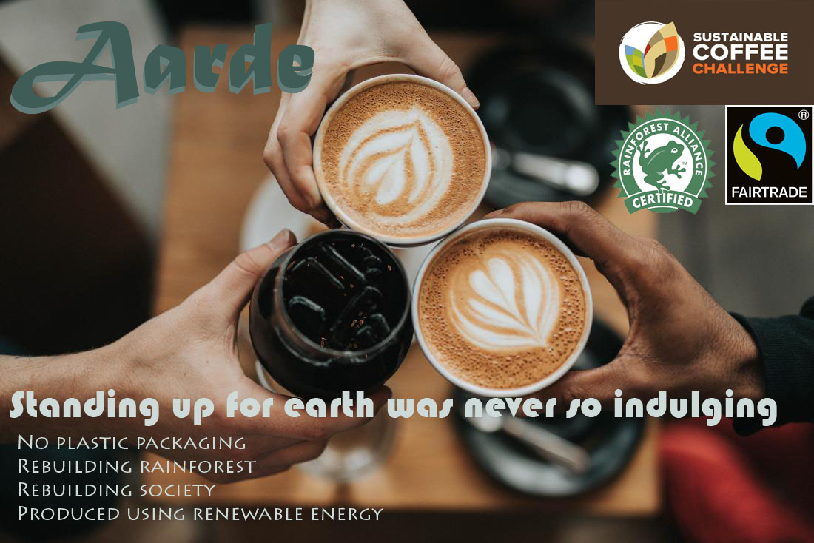
Fig 16: Stimulation (Sustainably ad of fictitious coffee brand)

4.3.3 Experimental Manipulations and Checks
The captions– ‘At last companies are joining the fight for the planet’ and ‘Fight for the planet is an advertising tool now’ have been used as positive and negative caption respectively. Level of ‘Source expertise’ was manipulated by mentioning if source of the Facebook post is a professional or a novice as high or low source expertise respectively (adopted from Yi et al 2013; Berkowitz, 1986). Source expertise has been measured in 7–point semantic differential scale containing 5 items (Ohanian 1990). Groups presented with the condition ‘5 years expertise in the industry’ measured significantly high in ‘source expertise’ (M = 4.78, SD = 1.14) than the group presented with the condition ‘Not a coffee drinker’ (M = 3.86, SD = 1.4, t (268.78) = –5.98, p = .000). This indicates successful manipulation. Point to be noted, equal variances were not assumed, in this case. So, the t statistics, where the equal variances were not assumed, has been reported (see Pallant 2010)

4.3.4 Population, Sampling Frame and Sampling Technique
FMCG (fast moving consumer goods) is the main factor to contribute to pollution (Greenpeace international 2018) and as one of the top most polluters of the world, this material is responsible to pollute land (as landfill), water (ocean pollution) and air (greenhouse gas emanation) (Nelson 2019; Ritchie and Roser 2018). Since FMCG industry has been developed depending on household consumption, student subjects have been used for this research because of their similarity to the household consumers, which is the target population for this research (Zikmund et al 2010). Like typical students, majority of the users of #1 social media ‘facebook’ are of 18–34 years of age (Statista 2021³; Statista 2021⁴) This cohort of population are addressed as Generation Y (birth year 1981–1999) are native to digital environment (Teng et al 2014; Shan and King 2015; Bolton et al 2013; Barreto and Ramalho 2019; Kumar et al 2013). Hence students as the expert on the social media engagement behaviour have considered suitable for this study in the context of social media (see Zikmund et al 2010; Lee et al 2011). Student sample will also ensure the required education level to aware and knowledgeable about sustainability (see Malhotra and Das 2013; Etikan et al 2016; Priester and Petty 2003). Homogeneous student sample is more common for experiments, because experiment settings are primarily aimed to test theory and requires to have internal validity (Calder et al. 1981; Shan and King 2015; Kim and Benbasat 2009; Yim and Yoo 2020). This study aims to test the theory about the intention of adopting sustainable behaviour caused by positive or negative caption on social media. Sustainable behaviour depends on consumers’ family size, income, age, college education, occupation level etc. (Ngobo 2011). The use of general respondents would not provide the confidence of this cause-and-effect relationship, in other words internal validity, since there will be numerous other factors that may influence their responses (Calder et al 1981).
Because of students’ familiarity and reliance on technology for information, entertainment, interaction, socialising and sense of community, the student panel of behavioural lab at SBM, QMUL were chosen (see Bolton et al 2013). The required ability to understand the questionnaire about social media, direct this research towards a non–probability self–reported sampling technique (see Saunders et al 2016). Students were contacted via mail and offered ₤10 per hour for their time. Data was collected during February to April 2020 through student panel. Experiment conducted in February was held Queen Mary behavioural lab using Qualtrics, but due to COVID–19 lockdown, experiment link was sent to students those were scheduled to take the experiment on April. Lab experiment was indented to control extraneous variable, which was undermined due to the pandemic situation. Similar to Li, & Kaplanidou (2013) and Lordeet al (2011)’s study where two groups of samples were examined through t-test for their similarity, the data collected from February sample and April sample were tested against all of the variables. However, no significant difference at .05 level was found (Appendix 3.7). Hence, both of the datasets were considered as one.
Demographic variables may confound the respondents’ social media engagement behavioural intention as well as sustainable brand purchase and sustainable behavioural intention. Engagement in social media is influenced by disposable income, education level, occupation, social class, culture etc (Bolton et al 2013). On the other hand, in the aspect of sustainability, consumers’ outlook for sustainability varies depending on age (Cho et al 2013; Keller 2013; Angus 2018), gender (Egea and de Frutos 2013; Wu et al 2016; Brough et al 2016), culture (Bondy and Talwar 2011; Varul 2009; Zaglia 2011), education (Egea and Frutos 2013) too. For example, young consumers are more likely to change their consumption preference than older consumers (Pickett–Backer and Ozaki 2008). Since the demographic variables may cause systematic error, the subjects were assigned randomly to the condition to balance subject characteristics (Zikmund et al 2010).
As can be seen from Table 9 respondents are mainly from Europe and Asia. Sample is also ruled by female students. Student pool is substantially homogeneous in terms of income, age and education. Along with demographic variables, frequency of product usage and frequency of social media usage has been considered. The number of students of different continents are also moderately representing the distribution of worldwide social–media users, where it shows that, majority of social media users are from Asia and Europe (Statista 2020).
Table 9: Demographics of the respondents

Table 1: Characteristics |  | Frequency | % |  |  | Frequency | %
Gender | Male | 83 | 29.7 | Continent | Africa | 12 | 4.3
 | Female | 194 | 69.5 |  | Asia | 106 | 38
 | Neutral | 1 | . 4 |  | Australia | 2 | ,7
 | I do not want to disclose | 1 | .4 |  | Europe | 144 | 51.6
Income | Under £15,000 | 64 | 22.9 |  | North America | 9 | 3.2
 | £15,000–£24,999 | 49 | 17.6 |  | South America | 6 | 2.2
 | £25,000–£34,999 | 39 | 14.0 | Age | 18–25 | 225 | 80.6
 | £35,000–£44,999 | 17 | 6.1 |  | 26–35 | 47 | 16.8
 | £45,000–£54,999 | 14 | 5.0 |  | 36–45 | 5 | 1.8
 | £55,000–£64,999 | 9 | 3.2 |  | More than 45 | 2 | .7
 | £65,000–£74,999 | 6 | 2.2 | Education | GCSE | 4 | 1.4
 | £75,000 and over | 26 | 9.3 |  | A level or equivalent | 81 | 29
 | Prefer not to specify | 55 | 19.7 |  | Master degree | 71 | 25.4
 |  |  |  |  | Bachelor's degree | 113 | 40.5
 |  |  |  |  | Doctorate degree | 6 | 2.2
 |  |  |  |  | Other | 4 | 1.4

4.3.5. Sample size:
344 students have been contacted from 11th Feb to 10th April 2020. After discarding 15 responses with missing value detected using SPSS and 50 wrong answers to the attention check question, the final sample size is 279. A trap question was (appendix 3.2) used to check the attention of the respondents in order to ensure the validity of the research (Oppenheimer et al 2009).
The power chart suggested by Cohen (1988, p 387) shows that 279 is a substantial sample size for ANOVA and Two-way ANOVA, which are to be conducted to test the hypothesis. In the case of ANOVA, for .95 desired power, .40 effect size, u =1 (2 means to be compared – 1) and .05 level of significance, a sample of 42 is adequate. On the other hand, in the case of two-way ANOVA, for .95 desired power, .40 effect size, u = 3 (4 means to be compared – 1) and .05 level of significance, a sample of 34 is enough. This study also needs to undertake multiple regression. In the case of multiple regression, Tabachnick and Fidell (2014, p. 159) have presented a formula to calculate sample size- “N >= 50 + 8m (where m is the number of IVs) for testing the multiple correlation and N >= 104 + m for testing individual predictors”. According to this formula, the minimulm sample size for 4 independent variable is – 82 to calculate their combine effect and 108 to calculate each independent variable.
Though, social innovative experiments similar to this study, do not have previous statistical information that permits to estimate sample size, but, as a rule of thumb, Simmons, et al (2013) have suggested to have 50 observations per condition. 50 respondents for an experimental model is deemed to be sufficient to yield result with acceptable degree of statistical confidence (Fairweather and Tornatzky 1977). Table 10 shows that the requirement was meet.
Table 10: Respondent distribution among the conditions
 | Source expertise
 |  | High | Low
Types of captions | Positive | Group 1  n = 66 | Group 3  n = 76
 | Negative | Group 2  n = 70 | Group 4  n = 67

On the top of this, Malhotra and Das (2013) have suggested that sample size can be decided on the basis of similar studies. Previous studies on sustainability, which have taken experiment as a method, are listed below in table 11. It is clear through the list that, if the experiment involves university students, the sample size did not exceed more than 281, unless the respondents extensively contacted. Only if the online panel like MTurk is employed or the experiment is conducted on setting where large crowd is available, the sample size is bigger. Hence, a sample size of 279 is in the line of other studies of sustainable behaviour engaging student sample.
Table 11: list of sample size of previous experiment on sustainable behaviour
Autor | Methodology
Steenhaut and Kenhove (2006) | Sample: 78  Frame: University student
Lusch et al (2010) | Sample: 42, 148, 68, 281  Frame: university students
Tucker et al (2012) | Sample: 420  Frame: members of a church, an informal recreational group, clerical/technical university staff of workers union, and their referred people
Ibrahim and Al–Ajlouni (2018) | Sample: 471  Frame: University student recruited through email, flayer, notice around the campus and announcement on student doorway.
Brough et al (2016) | Sample: 127, 194, 131, 403, 472 and 322  Frame: Mechanical Turk (MTurk)
Ryoo et al (2017) | Sample: 148  Frame: online mail
Rowe et al (2019) | Sample: 152, 328  Frame: University, MTurk respectively
Schuhwerk and Lefkoff–Haguis (1995) | Sample: 85  Frame: Undergraduate students
Montororios et al (2008) | Sample: 828  Frame: convenience of public places
Choi and Ng (2011) | Sample: 219  Frame: electronic telephone–based list
Larceneux et al (2012) | Sample: 122  Frame: customer at Monoprix store.
Herédia–Colaço and do Vale (2018) | 1st study– Sample: 100  Frame: University students
White et al (2011) | Sample: 390, 119 & 107  Frame: North American Metropolitan, university student
Yang et al (2015) | Sample: 89, 156, 165 Undergraduate students  Frame: business course of a university
Han et al (2019) | Sample: 142, 122  Frame: University students

4.3.6 Measurements
Pre–existing scales have been used on the basis of their reliability for this study. ‘Involvement’ is taken from Zaichowsky' (1994), ‘Source expertise’ is taken from Ohanian (1990), ‘SCV’ is Adopted from Yim et al. (2018), ‘PAD’ is taken from Russel et al (1981), ‘Ad attitude’ is taken from Russel et al (1981), ‘Social media engagement’ is adopted from Schivinski et al., (2016), ‘Informational’ and ‘normative influence’ is adopted from Li (2013), and ‘purchase intention’ and ‘sustainability behavioural intention’ is adopted from Chandran, and Morwitz (2005) and Manika et al (2017). The original scales and questionnaire used for this study will be found in Appendix 3.1 and Appendix 3.2 respectively.
Appendix 3.2 shows scale items, which are modified according to the context of the study from the pre-existing scales (see Parasuraman 2005; Salkind 2007). For example, the ‘contribution’ predictor of the social media engagement variable has been omitted from the final questionnaire, because the thesis is about pro–sustainable branded ad, which is created by the brand, not about user generated content in social media (Appendix 3.2). The questions for manipulation check and confounding check were placed at the end of the questionnaire to avoid their impact on dependent variable measures (see Perdue and Summers 1986). The wording of the questionnaire was changed as per the pre-test feedback of the respondents.
The questionnaire was programmed using Qualtrics, which allowed allocating respondents to the conditions randomly. Data was collected only once in this single cross sectional research design (see Malhotra and Das 2013). The value of the items of ‘ad attitude’ and ‘source expertise’ constructs were reversed along with the 4th item of the ‘purchase intention’ and ‘sustainable behaviour intention’. The final constructs are the mean score of the respective constructs’ items.

4.3.7. Reliability and assumptions checks
Few constructs were having more than absolute z value– 3.29 for kurtosis and skewness (table 12) representing they are significantly skewed or peaked distribution at p< .001 level. Nevertheless, as shown in appendix 3.3, all constructs were distributed along zero–line of Q–Q plot suggesting their normality (see Field 2018). Even if data is not normally distributed, sample size of more than 200 respondents, do not account for substantial differences in outcome, than if they were normally distributed (see Pallant 2010; Field 2018; Manika et al 2017). For example, according to Tabachnick and Fidell’s (2014), if the sample size is as big as N= 40, MANOVA is said to be robust to the violation of normality of variable. The point is proved for this study with non–significant, Box’s M test at significant level of p = .064 for MANOVA and p = .066 for two–way MANOVA. This non–significant results show robustness of the analysis by fulfilling the assumption of homogeneity of variance–covariance. Likewise, non–significant p= .057 results in Levene’s test shows the robustness of two–way ANOVA by satisfying the assumption of Equality of Error Variances.
Table 12: Skewness and Kurtosis of the constructs
 | Skewness | SE | Z | Kurtosis | SE | Z
Involvement | –0.393 | 0.146 | –2.69 | –0.167 | 0.291 | –0.57
SCV image | –0.378 | 0.146 | –2.59 | –0.564 | 0.291 | –1.94
SCV engrossment | 0.691 | 0.146 | 4.73 | 0.078 | 0.291 | 0.27
SCV self-projection | 0.109 | 0.146 | 0.75 | –0.841 | 0.291 | –2.89
SCV mental fluency | –0.553 | 0.146 | –3.79 | 0.004 | 0.291 | 0.01
Pleasure | –0.319 | 0.146 | –2.18 | 0.168 | 0.291 | 0.58
Arousal | 0.349 | 0.146 | 2.39 | 0.423 | 0.291 | 1.45
Dominance | 0.341 | 0.146 | 2.34 | 1.458 | 0.291 | 5.01
Ad attitude | –0.714 | 0.146 | –4.89 | 0.011 | 0.291 | 0.04
Engagement | 0.193 | 0.146 | 1.32 | –0.556 | 0.291 | –1.91
Buying intention | –0.247 | 0.146 | –1.69 | –0.437 | 0.291 | –1.50
Behavioural intention | –0.973 | 0.146 | –6.66 | 1.518 | 0.291 | 5.22
Information | –0.325 | 0.146 | –2.23 | –0.415 | 0.291 | –1.43
Norm | 0.495 | 0.146 | 3.39 | –0.305 | 0.291 | –1.05
Expertise | –0.319 | 0.146 | –2.18 | –0.388 | 0.291 | –1.33

Other than this, box plots in appendix 3.3 show no extreme outlier (see Pallant 2010; Field 2018).
In order to detect multicollinearity, variance inflation factors (VIF) and tolerance have been tested on 3 models– model 1 with Social media engagement as dependent variable, model 2 with purchase behaviour intention as dependent variable and model 3 with sustainable behaviour intention as dependent variable. None of the VIFs exceeded 5 and none of the Tolerance value is below .20 (table 13) for any construct. This indicates that the constructs can be used to test hypotheses without any concern of multicollinearity (Antonetti et al 2019; Pallant 2010; Field 2018).
Table 13: Multicollinearity test
 | Model 1: DV engagement |  | Model 2: DV purchase behaviour |  | Model 3: DV Sustainable behaviour
 | Tolerance | VIF | Tolerance | VIF | Tolerance | VIF
Involvement | 0.31 | 3.233 | 0.302 | 3.309 | 0.294 | 3.397
SCV_Image | 0.53 | 1.887 | 0.526 | 1.901 | 0.515 | 1.941
SCV_engrossment | 0.83 | 1.204 | 0.805 | 1.243 | 0.792 | 1.263
SCV_self_projection | 0.39 | 2.592 | 0.366 | 2.735 | 0.361 | 2.77
SCV_mental_fluency | 0.45 | 2.206 | 0.445 | 2.248 | 0.445 | 2.25
Pleasure | 0.30 | 3.343 | 0.27 | 3.7 | 0.269 | 3.716
Arousal | 0.59 | 1.692 | 0.555 | 1.801 | 0.551 | 1.816
Dominance | 0.91 | 1.103 | 0.899 | 1.113 | 0.898 | 1.113
Attitude | 0.37 | 2.722 | 0.362 | 2.762 | 0.361 | 2.769
Expertise | 0.75 | 1.34 | 0.715 | 1.398 | 0.712 | 1.404
Engagement |  |  | 0.454 | 2.202 | 0.446 | 2.243
Information |  |  | 0.604 | 1.656 | 0.598 | 1.671
Norm |  |  | 0.551 | 1.816 | 0.551 | 1.816
Purchase |  |  |  |  | 0.463 | 2.162

Before conducting the analysis, it is also necessary to check, whether the data satisfy the assumptions of the analysis. This study has included, MANOVA, two–way MANOVA, ANOVA, two–way ANOVA, multiple regression and regression analysis.
MANOVA should have minimum sample size of 24 for this study (4 Dependent variable x 2 levels of Independent variables x 3). With the same formula, in the case of two–way MANOVA minimum sample size is 48 due to 2 levels of independent variable (IV)– ‘types of caption’ and 2 levels of IV– ‘source expertise’. Box plots of appendix 3.3 with no extreme outliers fulfil the assumption of no univariate outliers. Assumptions for multivariate outliers and multivariate normality were tested through mahalanobis distance. Since there were only 3 cases among 279 respondents, where the values exceeded the critical value of 18.47 for 4 DVs those cases were included in the analysis (see Pallant 2010).

Fig 17: Matrix of scatter plots between each pair of DV
Two way MANOVA
MANOVA

SCV_mental image

SCV_engrossment

SCV_self_projection

SCV_mental fluency

SCV_mental image

SCV_engrossment

SCV_self_projection

SCV_mental fluency

SCV_mental image

SCV_engrossment

SCV_self_projection

SCV_mental fluency

SCV_mental image

SCV_engrossment

SCV_self_projection

SCV_mental fluency

SCV_mental image
SCV_mental image
SCV_engrossment
SCV_engrossment
SCV_Self_projection
SCV_self_projection
SCV_mental_fluency
SCV_mental_fluency

Table 14: Correlation matrix of DVs of MANOVA and two way MANOVA
SCV_Image |  | SCV_  engrossment |  | SCV_self_  projection |  | SCV_mental_  fluency
SCV_Image
SCV_engrossment | .202**
SCV_self_projection | .529** |  | .369**
SCV_mental_fluency | .449** |  | .199** | .696**

MANOVA is a most effective with moderately related dependent variables (DV). Correlation of .8 or .9 represents the risk of multicollinearity. Matrix scatter plot (Fig 17) shows moderate linear relationship and correlation matrix (table 14) shows moderate relationship except correlation between SCV_image vs SCV_engrossmennt and SCV_mental_fluency vs SCV_engrossmennt. However, non–significant Box’s M test of Equality of Covariance Matrices shows robustness of the MANOVA and two–way MANOVA analysis, which are of p = .064 and p = .066 respectively. So even if the assumptions are not met properly, the analysis still generates valid results (see Pallant 2010)

According to Cohen (1988, p, 387), for analysis like ANOVA sample size should be N = 42 for level of significance .05, u = 1 (2 means to be compared – 1), .40 effect size, which is deemed to be large effect size and .95 desired power, which is higher than the adequate desired power .80. For two–way ANOVA the minimum sample size should be N = 34 for u = 3 (4 means to be compared – 1). The assumptions for ANOVA and two–way ANOVA were met with 279 sample size and non–significant Levene’s test representing heterogeneity of variance. For ANOVA the level of significance of Levene’s test is, p = .171 and for two–way ANOVA it is p = .057 (see Pallant 2010).
For multiple regression, the sample size should be “N >= 50 + 8m (where m is the number of IVs) for testing the multiple correlation and N >= 104 + m for testing individual predictors” (Tabachnick and Fidell 2014, p. 159). In this study the minimum sample size should have been 82 (50 + 8*4) to calculate the combined effect and 108 (104 +4) to calculate the individual predictor’s effect. The criterion is met with a sample size of 279 in this research. For linear regression, assumption of not having multicollinearity and singularity among IVs are met when none of VIF is greater than 10 the tolerance is less than .10. of the 4 first order constructs of SCV– mental image (Tolerance .707, VIF 1.414), engrossment (Tolerance .857, VIF 1.167), self–projection (Tolerance .414, VIF 2.414), and mental–fluency (Tolerance .502, VIF 1.991) for separate multiple regression analysis with pleasure, arousal, dominance, and engagement as dependent variable (see Pallant 2010).
In the multiple regression analysis, there were number of residual outliers detected– 1 for DV ‘engagement’, 2 for DV ‘pleasure’, 1 for DV ‘arousal’ and 3 for DV ‘dominance’. In the case of big sample size, it is only common to find a number of outlying residuals with standardised residual value more than +– 3. Since there are only a few, no action was taken. The assumption of not having extreme outliers is met judging the Normal P–P Plot of regression standardized residual and scatter plot. As shown in figure 18 none of the PP plot shows any major deviation from the line and the points are forming a reasonably straight line. The scatter plots of residuals also showing roughly rectangular distribution with most score scattered along the 0 point. This represents the fulfillment of the assumption of normality, homoscedasticity, independence of residuals (see Tabachnick and Fidell’s 2014; Pallant 2010).
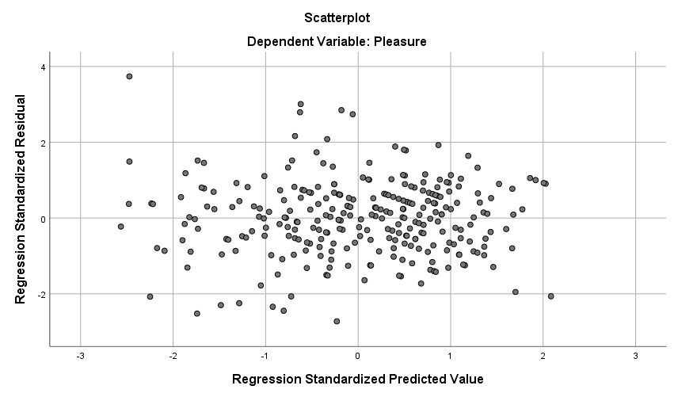
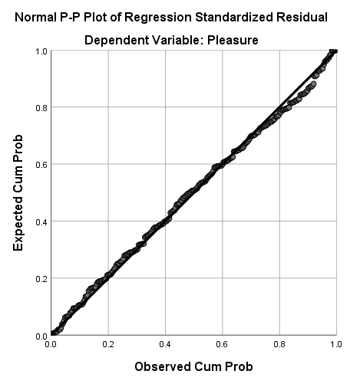
Fig 18: Test of outliers of multiple regression for independent variable SCV, second order reflective construct with 4 first order constructs

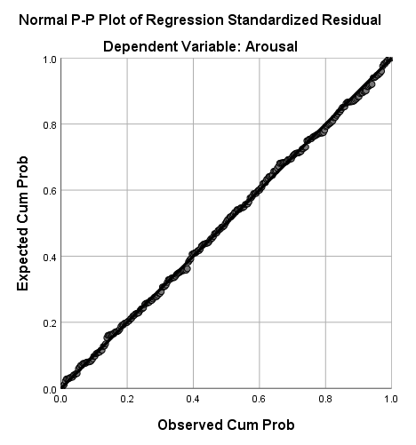
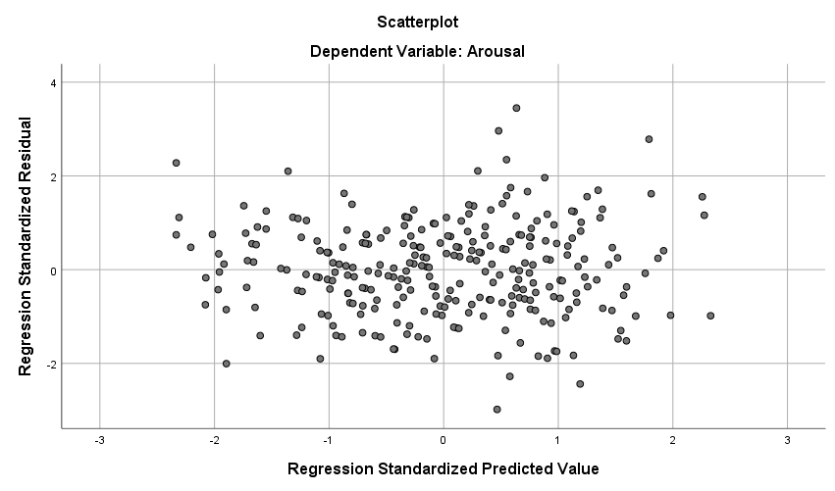

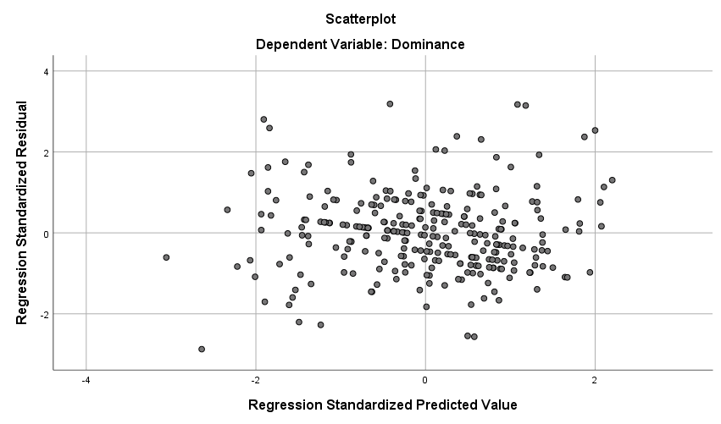
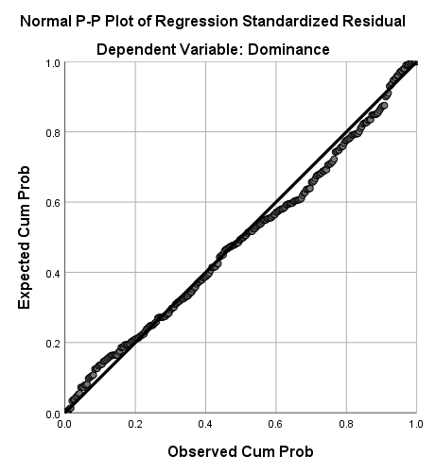

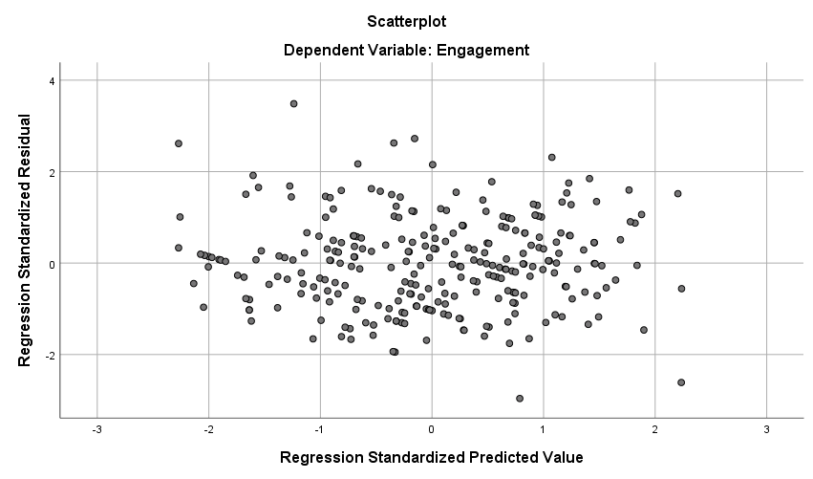
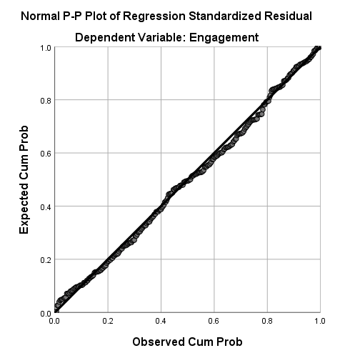

The same conclusion of satisfied assumptions of normality, homoscedasticity, independence of residuals can be derived from the residual scatter plots and the scarcity of outliers (Fig 19) of all the regression analysis with single predictor (Field 2018)
Fig 19: Scatter plot of residual
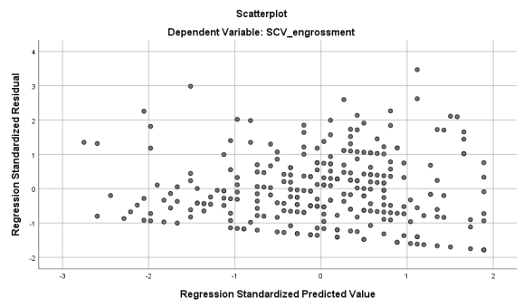
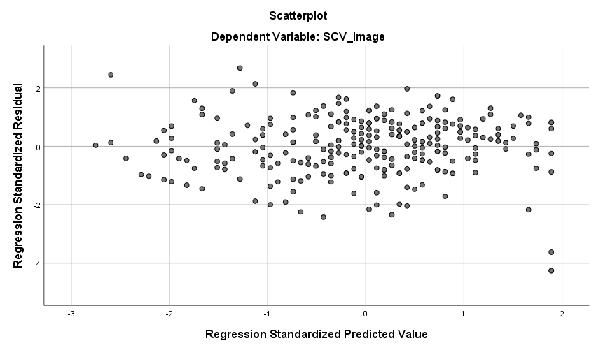
Outlier – 1
Outlier – 3

For IV= Involvement

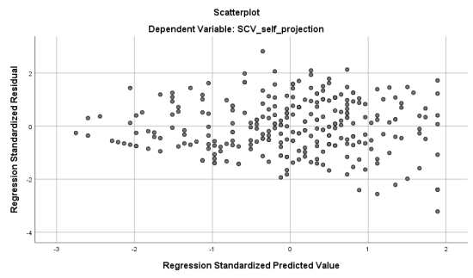
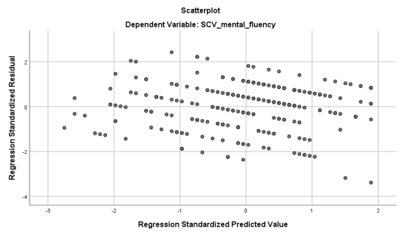
Outlier – 2
Outlier – 1

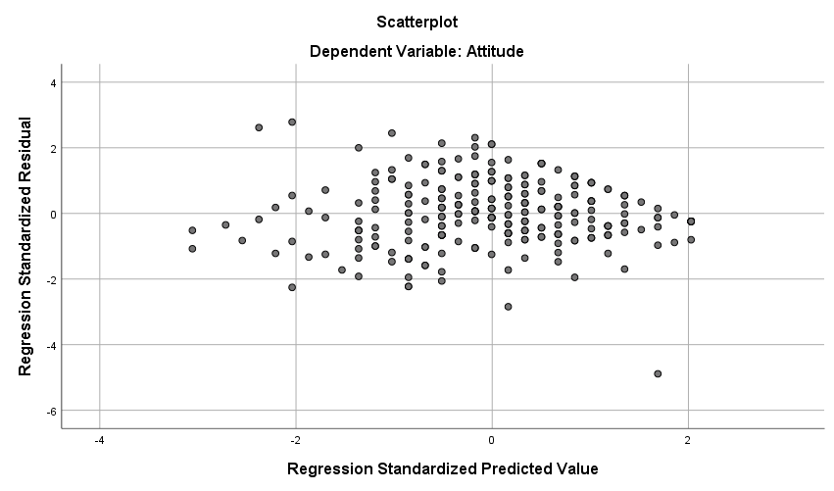
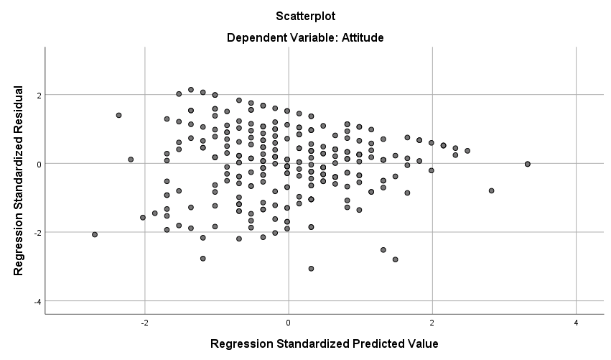
For IV= Arousal
Outlier – 1
Outlier – 1
For IV= Pleasure

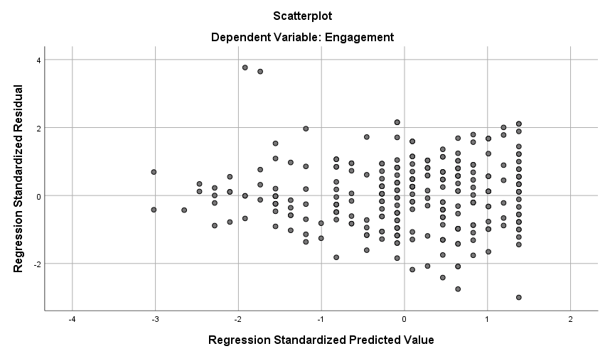
Outlier – 2
For IV= Ad Attitude
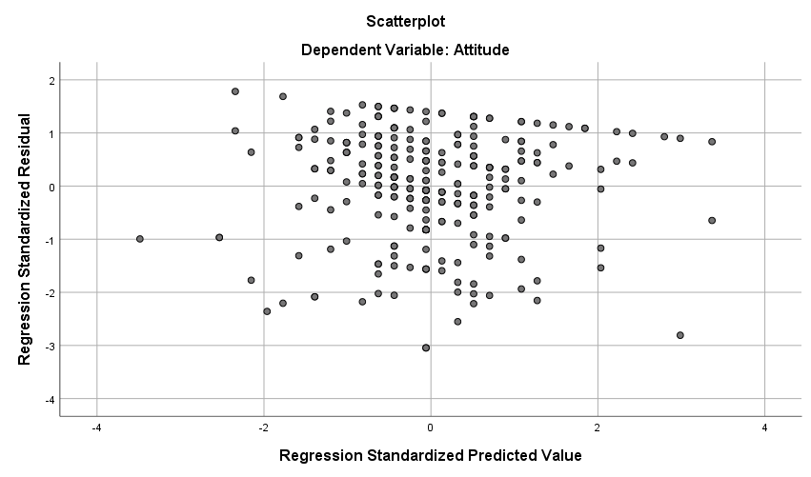
For IV= dominance
Outlier – 2

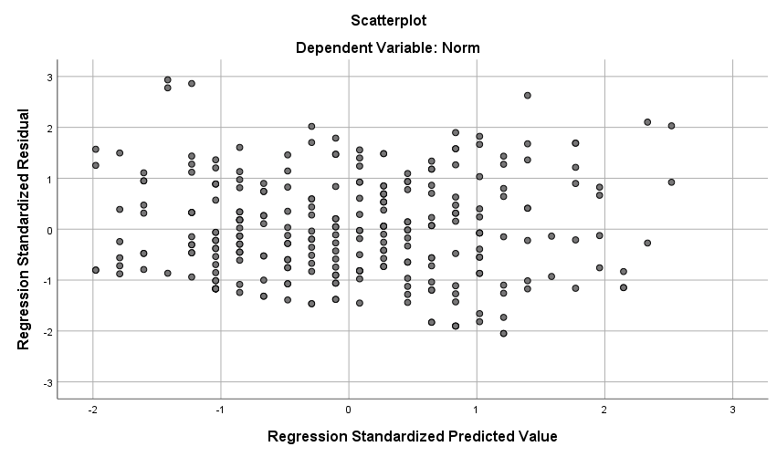
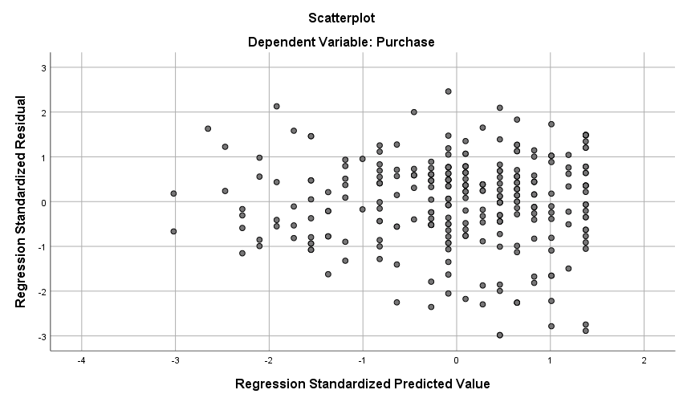
Outlier – 0
For IV= Ad Attitude
For IV= Engagement
Outlier – 0

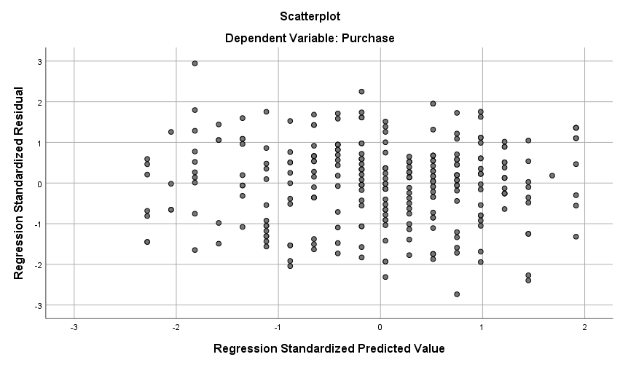
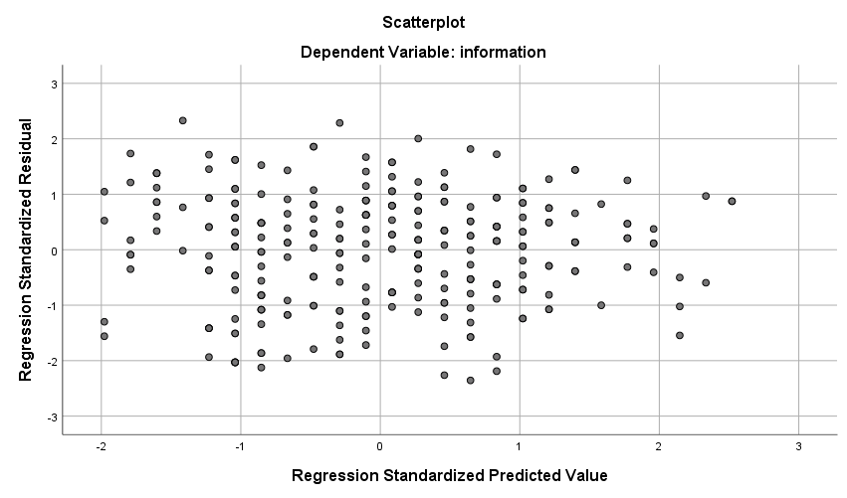
Outlier – 0
Outlier – 0
For IV= Engagement
For IV= Information

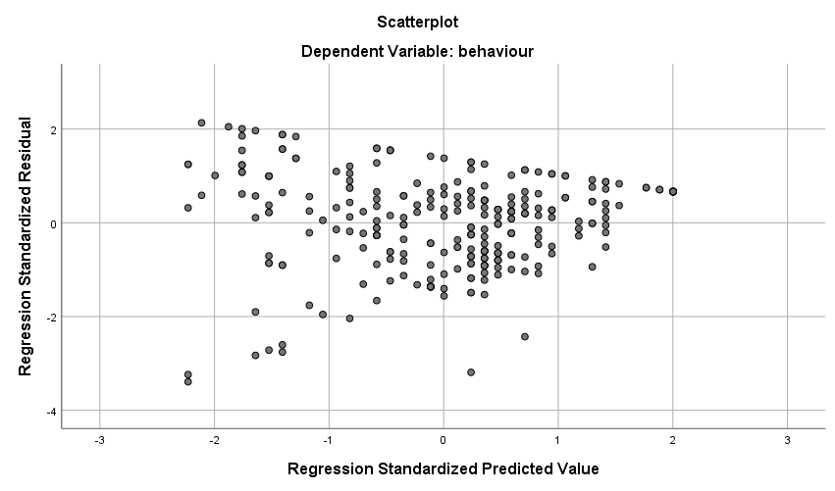
For IV= Purchase
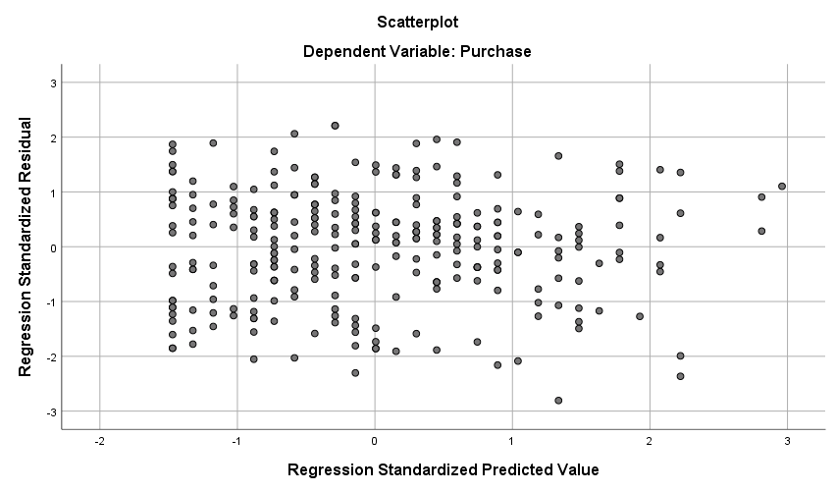
Outlier – 3
For IV= Norm
Outlier – 0
In Table 15, the Cronbach Alpha (α) shows reliability of the scales and Composite reliability (CR) shows the convergent validity of the scales (Malhotra and Das 2013, Hair et al 2017). Table 15 shows high level of reliability and convergent validity since all CR and α are above 0.7. this table also shows the satisfied factor loading of exploratory factor analysis (EFA).
In terms on Confirmatory factor analysis (CFA), only ‘Dominance 4’ (.380) and ‘Dominance 5’ is showing less than 0.5 outer loading. Yet, when cross loading was considered (Appendix 3.8), .308 of Dominance 4 was observed to be the highest loading compared to other constructs of the row. However, Dominance 5 have marginal higher loading under ‘Behavioural intention’ with .117 than the construct ‘Dominance’.
Table 15: Items, Cronbach’s Alpha with standardised item, Outer loadings and Composite reliability
Constructs | EFA | CFA
Involvement (Zaichowsky' 1994) α = .944; CR=.95 | Factor Loading | Outer loading
1. Unimportant – Important  2. Boring – Interesting  3. Irrelevant – Relevant  4. Unexciting – Exciting  5. Means nothing – Means a lot to me  6. Unappealing – Appealing  7. Mundane – Fascinating  8. Worthless – Valuable  9. Uninvolving – Involving  10. Not needed – Needed | .825  .860  .784  .851  .846  .787  .786  .817  .781  .818 | 0.825  0.863  0.779  0.854  0.843  0.794  0.785  0.809  0.785  0.816
Image Quality (Yim et al. 2018) α = .922; CR = .94
1. Vague – vivid  2. Sketchy– detailed  3. Unclear– clear  4. Dim– sharp | .868  .911  .911  .911 | 0.874  0.909  0.910  0.908
Engrossment (Yim et al. 2018) α =.832 ; CR = .89
1. While looking at the advertisement posted on Facebook, I felt that I was disconnected from my real world.  2. While looking at the advertisement posted on Facebook, I lost track of time and focused on the images described in it  3. While looking at the advertisement, posted on Facebook, I felt I was in a different world.  4. I felt like I was a different person while looking at the advertisement posted on Facebook. | .751  .796  .876  .840 | 0.688  0.810  0.881  0.863
Self–projection (Yim et al. 2018) α = .888; CR= .92
1. I had images of myself in the advertisement posted on Facebook  2. I can picture myself drinking the coffee in the advertisement posted on Facebook.  3. This advertisement posted on Facebook inspires mental images in me as if I am a part of the scenario shown in it.  4. I could construct a story about myself and the featured coffee based on the mental images that came to my mind.  5. I was able to project myself into the picture in the advertisement posted on Facebook. | .773  .775  .877  .850  .880 | 0.769  0.780  0.877  0.849  0.878
Mental fluency (Yim et al. 2018)
I can easily imagine myself being in the scenario described in the advertisement posted on Facebook. | n/a | 1.000
Pleasure (Russel et al 1981) α = .909, CR=.93
1. Annoyed – pleased  2. Dissatisfied – satisfied  3. Unhappy – happy  4. Bored – relaxed  5. Despairing – hopeful | .882  .893  .872  .810  .825 | 0.879  0.889  0.866  0.813  0.835
Arousal (Russel et al 1981) α = .845, CR= .89
1. Sluggish – Frenzied  2. Unaroused – aroused  3. Sleepy Wide awake  4. Calm – exited  5. Relaxed – stimulated  6. Dull – jittery | .750  .719  .705  .775  .767  .784 | 0.768  0.756  0.722  0.723  0.710  0.804
Dominance (Russel et al 1981) α = .726, CR=.82
1. Submissive – dominant  2. Influenced – influential  3. Controlled –controlling  4. Guided –autonomous  5. Cared for –in control  6. Awed –important | .625  .735  .726  .746  .508  .570 | 0.732  0.600  0.587  0.380  0.108  0.808
Ad–attitude (Tucker et al 2012) α = .949, CR=.96
1. Favourable–unfavourable  2. Good–bad  3. Like–dislike  4. Positive–negative | .922  .955  .931  .915 | 0.922  0.954  0.933  0.913
Social media engagement (Schivinski et al., 2016) α = .756, CR=.85
1. When I saw the advertisement on Facebook, I spend a couple of seconds watching it.  2. When I saw the advertisement on Facebook, I wanted to comment on it.  3. When I saw the advertisement on Facebook, I wanted to share it with other Facebook friends.  4. When I saw the advertisement on Facebook, I wanted to ‘Like’ it on Facebook. | .496  .779  .894  .849 | 0.500  0.743  0.892  0.877
Informational influence (Li 2013) α = .750; CR= .86
1. Other people’s reaction on such advertisements on Facebook are useful when choosing between brands of coffee  2. When I think of which type of coffee to buy, I will ask my friends for information to make a choice  3. When I think of purchasing coffee, the information from Facebook connections is helpful. | .814  .806  .830 | 0.792  0.745  0.891
Normative influence (Li 2013) α = .861; CR=.90
1. It is important what others think about the brand of coffee I drink  2. I feel like I am similar to other people who are using the same brand of coffee as me  3. I would like to know whether using the advertised coffee brand makes a good impression on others  4. The brand of coffee I use depends on what others expect me to use  5. I achieve a sense of belongingness by using this brand of coffee | .798  .771  .836  .814  .790 | 0.787  0.761  0.828  0.792  0.832
Purchase intention (Chandran, and Morwitz 2005 and Manika et al 2017) α =.923; CR= .94
1. Unlikely – Likely  2. Improbable – Probable  3. Impossible – Possible  4. Uncertain – Certain  5. Definitely would –Definitely would NOT  6. No Chance – Certainly | .928  .937  .870  .753  .711  .897 | 0.929  0.936  0.866  0.753  0.719  0.894
Sustainable behaviour intention (Chandran, and Morwitz 2005; Manika et al 2017) α = .946; CR= .96
1. Unlikely – Likely  2. Improbable – Probable  3. Impossible – Possible  4. Uncertain – Certain  5. Definitely would –Definitely would NOT  6. No Chance – Certainly | .935  .932  .905  .891  .740  .917 | 0.937  0.935  0.906  0.890  0.733  0.918
Source expertise (Ohanian 1990) α =.950 ; CR=.96
1. Expert—Not an expert  2. Experienced—Inexperienced  3. Knowledgeable—Unknowledgeable  4. Qualified—Unqualified  5. Skilled–Unskilled | .889  .935  .908  .917  .916 | 0.885  0.936  0.913  0.914  0.917

Satisfactory α and CR value was also found for February and April sample showing high level of reliability and convergent validity (Appendix 3.6). This is also true for EFA for February and April sample (Appendix 3.5)
In Table 16, it can be observed through satisfied Fornell-Larcker criterion and can be stated that all of the constructs are having discriminant validity. Table 16 shows that the value is highest in each corresponding construct compared to other constructs of the row. Point to be noted, discriminant validity has been measured through SMART-PLS. This software requires a second order construct SCV, to attach the items of it’s all sub-constructs (Image quality, engrossment, Self-projection and Mental fluency) with it. That is the reason table 16 is also showing the discriminant value of SCV along with separate discriminant values of Image quality, engrossment, Self-projection and Fluency.
Since the scale of social media engagement has been deviated from the original scale quite substantially, the new scale has followed Churchill (1979) procedure for developing measures. The first step to ‘specify domain of construct’ was satisfied through extensive literature review. For the second step to ‘Generate sample of the items’, initial items were generated through previous literature of Schivinski et al, (2016). Third step of ‘collecting data’ was fulfilled by the means of pre-test. In the fourth step, measures were purified according to the feedback of the respondents’ comment in the pre-test. In the fifth step, ‘reliability was assessed’ through Cronbach Alpha, which shows satisfied score of .756. In the step to ‘Assess validity’, CR was measured, which shows satisfied score of .85. Lastly, as the step to ‘Develop norms’, this scale was adopted.

Table 16: Discriminant validity: Fornell-Larcker criterion
 | Arousal |  |  | Behaviour |  | Purchase | attitude | dominance |  | engage | engross | expert | fluency | image |  | info | invlv | norm | pleasure |  |  |  | projection
Arousal | 0.748
Behaviour | 0.221 |  |  | 0.889
Purchase | 0.499 |  |  | 0.337 |  | 0.854
attitude | 0.440 |  |  | 0.338 |  | 0.555 | 0.931
dominance | 0.311 |  |  | 0.156 |  | 0.340 | 0.422 | 0.584
engagement | 0.488 |  |  | 0.283 |  | 0.577 | 0.531 | 0.359 |  | 0.769
engrossment | 0.237 |  |  | 0.002 |  | 0.142 | 0.093 | 0.039 |  | 0.248 | 0.814
expertise | 0.327 |  |  | 0.159 |  | 0.407 | 0.412 | 0.226 |  | 0.459 | 0.165 | 0.913
fluency | 0.402 |  |  | 0.252 |  | 0.474 | 0.491 | 0.314 |  | 0.455 | 0.205 | 0.328 | 1.000
image | 0.417 |  |  | 0.231 |  | 0.538 | 0.498 | 0.358 |  | 0.436 | 0.222 | 0.392 | 0.448 | 0.900
info | 0.299 |  |  | 0.253 |  | 0.423 | 0.330 | 0.317 |  | 0.481 | 0.127 | 0.276 | 0.326 | 0.290 |  | 0.811
involvement | 0.604 |  |  | 0.335 |  | 0.641 | 0.701 | 0.334 |  | 0.594 | 0.240 | 0.420 | 0.467 | 0.622 |  | 0.402 | 0.816
norm | 0.398 |  |  | 0.069 |  | 0.331 | 0.172 | 0.198 |  | 0.389 | 0.315 | 0.273 | 0.359 | 0.240 |  | 0.542 | 0.329 | 0.800
pleasure | 0.557 |  |  | 0.386 |  | 0.612 | 0.759 | 0.382 |  | 0.652 | 0.170 | 0.427 | 0.553 | 0.569 |  | 0.373 | 0.747 | 0.241 | 0.857
projection | 0.470 |  |  | 0.243 |  | 0.532 | 0.454 | 0.340 |  | 0.543 | 0.392 | 0.391 | 0.696 | 0.527 |  | 0.384 | 0.539 | 0.440 | 0.511 |  |  |  | 0.832

4.3.8 Common method bias (CMB) –
In order to minimise common method bias, respondents were assured about the confidentiality of the data. Moreover, the importance of the survey was conveyed extensively to motivate the respondents for taking the survey. Questionnaire was designed using simple and straightforward language, as well as all the constructs were presented in the different screen to facilitate their understanding. In addition to that, the capability to answer the question were also ensured by taking student sample for the study of social media context (see MacKenzie and Podsakoff 2012). In order to assess potential influence of CMB, a marker question – “I prefer warm colours (i.e., containing yellow and red) over cold colours” has been added in the questionnaire with 7 Likert scale to identify common method bias. But Appendix 3.4 shows that there is significant relationship between the marker variable and other 4 constructs SCV_self_projection, SCV_mental_fluency, Pleasure, and Norm. This indicates the marker variable did not work (See Podsakoff et al 2003). Though CMB does pose a significant threat to the validity of the research findings (Fuller et al 2016), Single factor test has also been conducted to be sure. Harman’s single–factor test shows that single factor accounts for 42.79% of variance when all the constructs are loaded into one factor and run exploratory factor analysis. This represents the absence of common method bias since it is less than 50% (see Podsakoff et al 2003; Tehseen et al 2017).

4.4. Ethics.
Ethical procedure has been followed and the respondents are notified about the purpose, scope of the study, people who will have access to the data, sponsor of the study and the information of the contact persons if there is any complain at the beginning of the survey and in the debriefing. Moreover, due to COVID–19 pandemic, this research has changed the data collection method to online experiment, where the respondents required to come to the lab to the online experiment, where the questionnaire link was sent to the consented respondents by mail. In both instances, this project has maintained the legal and local standards of regulation and have been approved by the university.

4.5. Limitation:
Although the experiment was conducted in two batches, data collection was interrupted due to covid–19 lockdown. First one was held in February and the second one was in April. Though these two groups proved to be similar while comparing them in by t-test (Appendix 3.7), but the requirement for uniform environment for all experiment subjects was not met due to unavoidable situation.
In addition to that, the items of sub–construct ‘Mental fluency’ of SCV scale was not reliable. Hence only one item has been retained which fits with the definition of SCV. Since, SCV emphasis on self–inclusion in the consumption situation (Yim et al 2018), among the 3 items, the item which measures the easiness of the respondents to visualise themselves in the advertised situation, was selected. According to Hair et al (2017), interchangeable items can be left out if the meaning of the construct is not changed, especially when the items are semantically redundant.
Though there is an argument that small sample size and use of student sample in experiments undermine external validity or generalisability of the research (Nan and Hao 2007). Nevertheless, the use of student sample, whose social media engagement behaviour is similar to the social media engagement behaviour of general population, ensures external validity (Shan and King 2015; Lee et al 2011)
Overall, the data are free from common method bias, multicollinearity, and outliers. The scales have proved to be reliable in table 15. The demographics of the respondents are adequately homogeneous.

5. Result

5.1. Hypothesis testing

5.1.1 Impact of different types of Captions and source expertise
H₁ was tested using ANOVA to compare the effect of positive and negative caption of social media engagement and for H₂, two–way ANOVA was used to test the interaction between the types of captions and the level of source expertise on social media engagement. One way ANOVA was conducted to compare the score on social media engagement on positive caption (M = 3.71, SD = 1.3) and negative caption (M = 3.56, SD = 1.36) which was not significant (F (1, 277) = 0.87, p = .351). In other words, there is no significant difference between positive caption and negative caption in terms of social media engagement. H₁ was not confirmed, but H₂ was confirmed by two–way ANOVA, which shows significant interaction effect of types of captions and level of source expertise (F (1, 274) = 7.55, p = .006). But the main effect for types of captions (F (1, 274) = 1.153, p = .284) and source expertise (F (1, 274) = 1.3, p = .255) both were not significant. This represents, though there is no significant difference on ‘social media engagement’ for ‘types of caption’ or the ‘level of source expertise’, but when ‘types of caption’ and the ‘level of source expertise’ are considered together there is a significant difference in terms of ‘social media engagement’. Figure 20 shows that, when the source expertise is high, users engage in social media more for negative caption than the positive one, but when the source expertise is low, this effect is opposite.

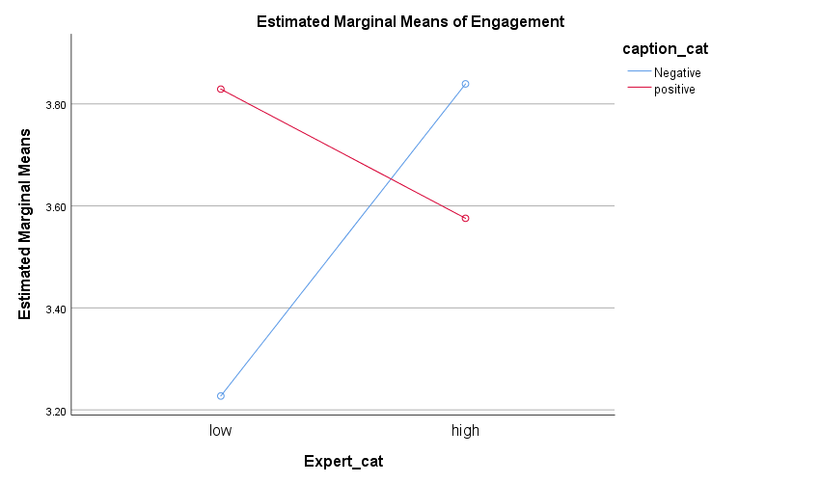
Fig 20: Interaction between types of caption and level of expertise.

MANOVA analysis was employed in order to test whether the positive caption with sustainability ad generates more SCV than the one with the negative one (H₃). This was conducted by taking positive and negative caption as independent variable (IV) and 4 dimensions of SCV (image quality, engrossment, self–projection and mental fluency) as dependent variable (DV). These 4 dimensions make SCV a second order formative construct. MANOVA is undertaken when difference in groups to be identified in terms of multiple, but related variables (Pallant 2010). Table 17 shows that, all the SCV dimensions are moderate to highly correlated.

Table 17. Correlation table
 |  | 1 | 2 | 3 | 4 | 5 | 6 | 7 | 8 | 9 | 10 | 11 | 12 | 13 | 14 | 15
1. Involvement |  | 1
2. Image quality |  | .620** | 1
3. Engrossment |  | .214** | .202** | 1
4. Self–projection |  | .538** | .529** | .369** | 1
5. Mental fluency |  | .466** | .449** | .199** | .696** | 1
6. Pleasure |  | .745** | .570** | .156** | .513** | .553** | 1
7. Arousal |  | .587** | .393** | .217** | .462** | .387** | .529** | 1
8. Dominance |  | .164** | .226** | –0.013 | .199** | .162** | .180** | .226** | 1
9. Attitude |  | .700** | .498** | 0.081 | .455** | .491** | .757** | .420** | .164** | 1
10. Engagement |  | .589** | .438** | .226** | .543** | .456** | .652** | .476** | .172** | .538** | 1
11. Purchase |  | .641** | .539** | 0.116 | .535** | .475** | .613** | .488** | .192** | .555** | .571** | 1
12. Behaviour |  | .333** | .232** | –0.004 | .244** | .251** | .381** | .214** | .163** | .338** | .282** | .337** | 1
13. information |  | .380** | .252** | .125* | .361** | .309** | .348** | .270** | .150* | .310** | .449** | .391** | .258** | 1
14. Norm |  | .323** | .238** | .304** | .439** | .362** | .237** | .396** | 0.089 | .167** | .364** | .323** | 0.067 | .541** | 1
15. Expertise |  | .418** | .391** | .150* | .389** | .327** | .424** | .330** | 0.070 | .410** | .450** | .409** | .156** | .254** | .268** | 1
** Correlation is significant at the 0.01 level (2–tailed).
* Correlation is significant at the 0.05 level (2–tailed).

Since, Pillai’s trace is most robust test for equal sample size (Negative caption = 137 and positive caption = 142) (Field 2018), in this case Pillai's Trace confirmed H₃ by showing that there is significant difference between positive and negative caption on SCV as a whole (V = .035, F (4, 274) = 2.48, p = .045) (Table 18). However, this difference is only due to ‘image quality’ (F (1, 277) = 8.15, p= .005). Other dimensions of Engrossment (F (1, 277) = 0.051, p = 0.821), self–projection (F (1, 277) = .201, p = .655) mental fluency (F (1, 277) = .615, p = .434) did not have significant contribution (Table 19). The original output from SPSS has been included in appendix 4.1

Table 18: Multivariate Testsª

Effect |  | Value |  | F |  | Hypothesis df |  | Error df |  | Sig. |  | Partial Eta Squared
Types of caption | Pillai's Trace |  | .035 |  | 2.476^{b} |  | 4.000 |  | 274.000 |  | .045 |  | .035
a. Design: Intercept + Types of caption
b. Exact statistic

Table 19: Tests of Between–Subjects Effects

Source | Dependent Variable | Type III Sum of Squares | df | Mean Square | F | Sig. | Partial Eta Squared
Types of caption | Image quality | 18.010 | 1 | 18.010 | 8.146 | .005 | .029
 | Engrossment | .075 | 1 | .075 | .051 | .821 | .000
 | Self–projection | .417 | 1 | .417 | .201 | .655 | .001
 | Mental fluency | 1.583 | 1 | 1.583 | .615 | .434 | .002

More elaborate profile analysis shows (figure 21) that positive caption has greater effect than negative caption on three of the SCV dimensions. Positive caption (M = 4.52, SD = 1.39) inspire greater image quality than that of negative caption (M = 4.02, SD = 1.58), Positive caption (M = 3.48, SD = 1.35) generate greater self–projection than that of negative caption (M = 3.4, SD = 1.53), and positive caption (M = 4.47, SD = 1.59) generates greater mental fluency than negative caption (fluency M= 4.32, SD= 1.62). However, in terms of, engrossment, negative caption (M = 2.63, SD=1.28) has greater effect than positive caption (M = 2.60, SD = 1.13) (see Tabachnick and Fidell 2014).
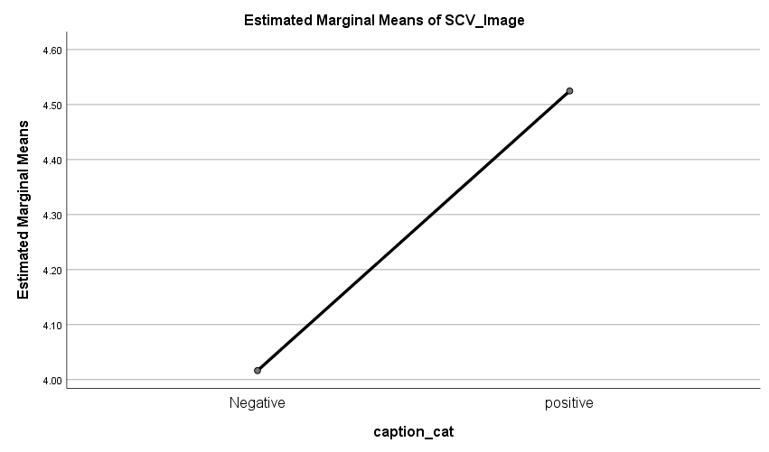
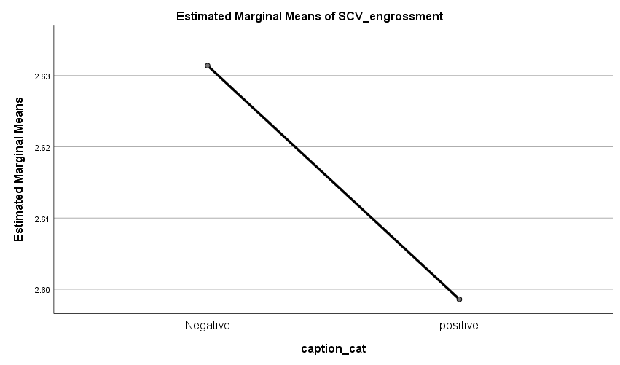
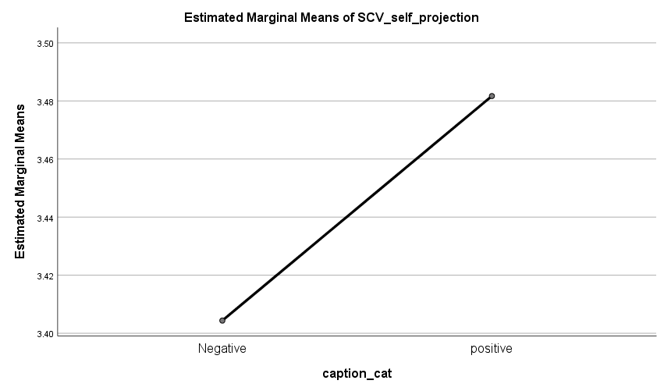
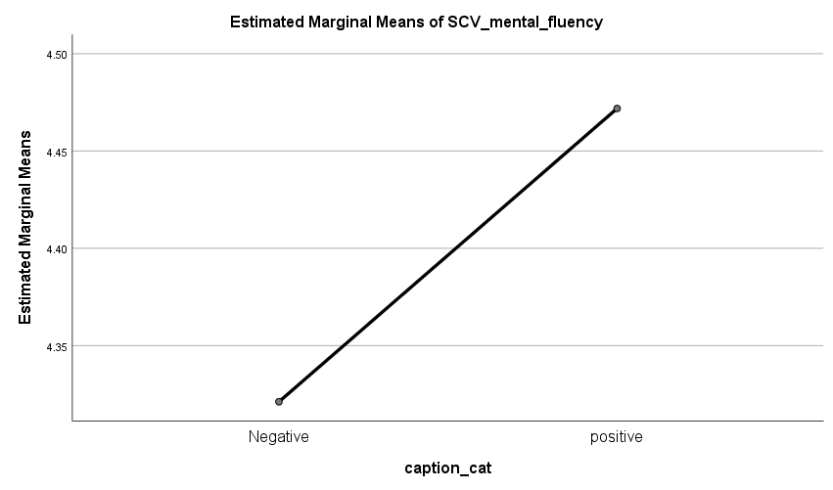
Fig 21: Profile graphs of dimensions of SCV

Since this is an experiment and captions are manipulated, it can be implied that the positive caption is the cause of higher image quality, self–projection and mental fluency. On the other hand, negative caption causes higher engrossment with the sustainability ad. However, only the deviance in image quality is significant.
MANOVA analysis was followed by Discriminant analysis to show how the 4 dimensions of SCV differentiate the two groups exposed to conditions with positive and negative caption. Subsequent discriminant analysis assures that the discriminate functions explains 100% of the variance representing that the overall difference between two groups with positive and negative caption is due to 4 dimensions of SCV, but the contribution is low (canonical discriminant function coefficient R² = .035). The discriminate function significantly differentiated the groups with positive and negative caption (Wilk’s lamda Λ =0.97, Chi square χ2(4) = 9.76, p = 0.045). The correlations among SCV dimensions and the discriminant functions also supports the fact that image quality is the most discriminating factor of all four SCV dimensions because image quality is loaded highest in the discriminant function (image quality r = .902, mental fluency r = .248, self–projection r = .142, and engrossment r = –.072). The original output from SPSS will be found in appendix 4.1 (see Field 2018).

H₄ has been tested using two–way MANOVA to explore the interaction of types of captions (positive and negative) and level of source expertise (High and low) the second order formative construct SCV. H₄ is partially confirmed by the means of above–mentioned test. Pillai's Trace revealed non–significant interactions between types of captions and level of source expertise on SCV (V= 0.019, F (4, 271) =1.34, p = .254) (table 20). Main effect of the types of captions is significant on SCV (V = .039, F (4, 271) = 2.75, p = .028), but impact of level of source expertise was not significant (V = .013, F (4, 271) = .925, p= .450) (table 20). The significant result is mainly due to Image quality (Table 21). The original result has been reported in appendix 4.1.

Table 20: Multivariate Testsª

Effect |  | Value | F | Hypothesis df | Error df | Sig. | Partial Eta Squared
Types of caption | Pillai's Trace | .039 | 2.755^{b} | 4.000 | 271.000 | .028 | .039
Level of Expertise | Pillai's Trace | .013 | .925^{b} | 4.000 | 271.000 | .450 | .013
caption * Expertise | Pillai's Trace | .019 | 1.343^{b} | 4.000 | 271.000 | .254 | .019
a. Design: Intercept + types of caption + level of Expertise + caption * Expert
b. Exact statistic

Table 21: Tests of Between–Subjects Effects

Source | Dependent Variable | Type III Sum of Squares | df | Mean Square | F | Sig. | Partial Eta Squared
Types of caption | Image quality | 20.399 | 1 | 20.399 | 9.330 | .002 | .033
 | Engrossment | .018 | 1 | .018 | .012 | .912 | .000
 | Self–projection | .616 | 1 | .616 | .298 | .586 | .001
 | Mental fluency | 2.088 | 1 | 2.088 | .810 | .369 | .003
Level of expert | Image quality | 7.136 | 1 | 7.136 | 3.264 | .072 | .012
 | Engrossment | .003 | 1 | .003 | .002 | .963 | .000
 | Self–projection | .913 | 1 | .913 | .442 | .507 | .002
 | Mental fluency | .200 | 1 | .200 | .077 | .781 | .000
caption * Expertise | Image quality | .005 | 1 | .005 | .002 | .964 | .000
 | Engrossment | 2.543 | 1 | 2.543 | 1.771 | .184 | .006
 | Self–projection | 3.961 | 1 | 3.961 | 1.918 | .167 | .007
 | Mental fluency | .052 | 1 | .052 | .020 | .888 | .000

More specifically, the same result emerges when a series of t–tests have been conducted again by taking all possible pairs of 4 groups, which represents the 2 types of captions and 2 levels of expertise (Table 22). These t–tests took SCV dimensions (Image quality, Engrossment, Self–projection, and mental fluency) as dependent variable and caption and expertise as independent variable. Among the pairs, only conditions with captions are showing the significant differences in terms of image quality.

Table 22: Pairwise comparisons of positive and negative caption between the high and low expertise level on the 4 dimensions of SCV
 | Positive caption |  |  |  | Negative caption
 | High expertise | Low  expertise |  |  | High expertise | Low  expertise
Image quality | 4.7 | 4.37 | t (140) = 1.4, p= .162 |  | 4.15 | 3.9 | t (135) = 1.01, p = .313
 | 1.4 | 1.38 |  |  | 1.5 | 1.6
Engrossment | 2.49 | 2.69 | t (140) = –1.04, p= .298 |  | 2.7 | 2.6 | t (135) = .64, p = .525
 | 1.17 | 1.09 |  |  | 1.2 | 1.3
Self–projection | 3.42 | 3.5 | t (140) = –0.5, p= .587 |  | 3.56 | 3.2 | t (135) =1.2, p=.22
 | 1.35 | 1.36 |  |  | 1.6 | 1.5
Mental fluency | 4.5 | 4.4 | t (140) = 0.3, p = .764 |  | 4.3 | 4.3 | t (135) = –.051, p=.96
 | 1.7 | 1.5 |  |  | 1.6 | 1.6
 | High expertise |  |  |  | Low expertise
 | Positive caption | Negative  caption |  |  | Positive caption | Negative caption
Image quality | 4.7 | 4.15 | t (134) =2.2, p = .029 |  | 4.4 | 3.9 | t (141) = 1.95, p=.05
 | 1.4 | 1.5 |  |  | 1.4 | 1.6
Engrossment | 2.5 | 2.7 | t (134) = –1, p=0.319 |  | 2.7 | 2.6 | t (128.07) = .639, p=.52
 | 1.17 | 1.25 |  |  | 1.1 | 1.3
Self–projection | 3.4 | 3.56 | t (134) =–0.57, p=0.57 |  | 3.5 | 3.2 | t (141) = 1.257, p=.211
 | 1.35 | 1.57 |  |  | 1.4 | 1.5
Mental fluency | 4.5 | 4.3 | t (134) =0.713, p=.48 |  | 4.4 | 4.3 | t (141) = .4, p=.69
 | 1.7 | 1.6 |  |  | 1.5 | 1.6
 | Positive caption high Expertise | Negative  caption  low Expertise |  |  | Positive caption  low expertise | Negative caption  high Expertise
Image quality | 4.7 | 3.9 | t (131) =3.1, p= .002 |  | 4.4 | 4.15 | t (144) = –.929, p=.354
 | 1.4 | 1.6 |  |  | 1.4 | 1.5
Engrossment | 2.5 | 2.6 | t (131) =–.31, p= .757 |  | 2.7 | 2.7 | t (144) =.048, p= .962
 | 1.2 | 1.3 |  |  | 1.1 | 1.2
Self–projection | 3.4 | 3.2 | t (131) =.708, p=.48 |  | 3.5 | 3.56 | t (144) =.084, p=.933
 | 1.4 | 1.5 |  |  | 1.4 | 1.6
Mental fluency | 4.5 | 4.3 | t (131) =.654, p=.514 |  | 4.4 | 4.3 | t (144) = –459, p= .647
 | 1.7 | 1.6 |  |  | 1.5 | 1.6
The top value in each cell is the mean; the bottom value is the standard deviation
There is no significant difference among the pairs when they were compared on the basis of source expertise. But, for high expertise condition, significant difference can be observed due to caption in terms of SCV–Image {(M Positive caption high expertise = 4.7, SD = 1.4) and (M = 4.15 Negative caption high expertise, SD = 1.5; t (134) = 2.2, p = 0.029)}. Similarly for low expertise condition, difference has been observed due to type of caption in terms of SCV–image (M _{Positive caption low expertise} = 4.4, SD = 1.4) and (M _{Negative caption low expertise} = 3.9, SD = 1.6; t (141) = 1.95, p = 0.05). Yet, the congruency between caption type and level of expertise have caused the greatest difference between groups (M Positive caption high expertise = 4.7, SD = 1.4) and (M _{Negative caption Low expertise} = 3.9, SD = 1.6; t (131) = 3.102, p = 0.002) in terms of SCV Image. Whereas there is no significant difference on any of SCV dimensions for incongruent groups – Positive caption low expertise and Negative caption high expertise.

5.1.2. Relationships among the variables
The relationship between ‘involvement’ as IV and 4 dimensions of SCV as DV (H₅₎ was tested in a series of 4 separate linear regression. Involvement positively and significantly influenced image quality (β = .722, p = .000) in a way that it accounts for 38.4% variance (F (1,277) = 172.69, p = .000) in image quality.
Image quality = b₀ constant/intercept + b₁ involvement
= .985 + .722 involvement
Similarly, involvement positively and significantly influenced Engrossment (β = .200, p = .000) in way that it accounts for 4.6% variance (F (1,277) = 13.3, p = .000) in engrossment.
Engrossment = b₀ constant/intercept + b₁ involvement
=1.703 + .200 involvement
Likewise, involvement positively and significantly influenced self–projection (β = .599, p = .000) in way that it accounts for 29% variance (F (1,277) =112.89, p= .000) in self projection.
Self–projection = b₀ constant/ intercept + b₁ involvement
= .713+ .599 involvement
Involvement positively and significantly influenced mental fluency (β = .578, p = .000) in way that it accounts for 21.7% variance (F (1,277) = 76.8, p= .000) in mental fluency.
Mental fluency = b₀ constant/ intercept + b₁ involvement
=1.764+ .578 involvement
On the basis of the causal relationship, it can be inferred that Involvement has positive and significant influence on all four dimensions of SCV. The SPSS output has been reported in Appendix 4.2.

Relationship between SCV and ‘engagement’ (H₆) has been tested through multiple regression model where the four dimensions of SCV (image quality, engrossment, self–projection and mental fluency) are the predictors of ‘social media engagement’ (See Hair et al 2003). H₆ was confirmed since SCV as a whole explains 33.5% (R² = .335, p = .000) variance in ‘social media engagement’. Further comparison of standardised beta shows ‘self–projection’ (β = .339, p = .000) is the largest contributor, followed by ‘image quality’ (β = .195, p = .001). Nevertheless ‘engrossment’ (β = .037, p = .492), and ‘mental fluency’ (β = .126, p = .072) did not significantly contribute to the variance of ‘social media engagement’. The SPSS output has been reported in Appendix 4.2.
Engagement = b₀ constant/ intercept + b₁ Image quality + b₂ Engrossment + b₃ Self–projection + b₄ Mental fluency
=1.255 + .173 Image quality + .040 Engrossment + .314 Self–projection + .104 Mental fluency
Relationship between SCV and ‘pleasure’ (H₇₎ has been tested through multiple regression model where the four dimensions of SCV (image quality, engrossment, self–projection and mental fluency) are the predictors of pleasure. H₇ was confirmed since SCV, as a whole, explains 43.9% (R₂ = .439, p = .000) variance in pleasure. Further comparison of standardised beta shows ‘image quality’ has the largest contribution (β =.379, p =.000), followed by ‘mental fluency’ (β = .318, p = .000). However, engrossment (β = –.020, p =.689), and self–projection (β =.099, p =.161) did not significantly contribute in the variance of ‘pleasure’. The SPSS output has been reported in Appendix 4.2.
Pleasure = b₀ constant/ intercept + b₁ Image quality + b₂ Engrossment + b₃ Self–projection + b₄ Mental fluency
=2.080+ .297 Image quality + (–.019) Engrossment + .081 Self–projection + .234 Mental fluency
Relationship between SCV and ‘arousal’ (H₈) has been tested through multiple regression model where the four dimensions of SCV (image quality, engrossment, self–projection and mental fluency) are the predictors of ‘arousal’. H₈ was confirmed since SCV as a whole explains 25.2% (R² = .252, p = .000) variance in ‘arousal’. Further comparison of standardised beta shows only ‘image quality’ has significant contribution (β = .195, p = .002) and ‘self–projection (β = .266, p = .001). Contribution of ‘engrossment (β = .059, p = .297) and ‘mental fluency’ (β = .102, p = .166) are not significant in the variance of arousal. The SPSS output has been reported in Appendix 4.2.
Arousal = b₀ constant/ intercept + b₁ Image quality + b₂ Engrossment + b₃ self–projection + b₄ Mental fluency
=2.097+ .129 Image quality + .049 Engrossment + .184 self–projection + .064 Mental fluency
Relationship between SCV and ‘dominance’ (H₉) has been tested through multiple regression model where the four dimensions of SCV (image quality, engrossment, self–projection and mental fluency) are the predictors of ‘dominance’. H₈ was confirmed since SCV as a whole explains 6.9% (R²= .069, p= .001) variance in ‘dominance’. Further comparison of standardised beta shows ‘image quality’ has significant contribution (β = .169, p= .016). Contribution of engrossment (β = –.101, p = .109); self–projection (β = .142, p = .119); mental fluency (β = .007, P = .929) are not significant in the variance of ‘dominance’. The SPSS output have been reported in Appendix 4.2.
Dominance = b₀ constant/ intercept + b₁ Image quality + b₂ Engrossment + b₃ Self–projection + b₄ Mental fluency
=3.511+ .098 Image quality + (–.073) Engrossment + .086 self–projection + .004 Mental fluency
Subsequent relationship of pleasure with ‘ad attitude’ (H₁₀) is has been explored through linear regression model by taking pleasure as independent variable and ‘ad attitude’ as dependent variable. The function confirms H₁₀ since ‘pleasure’ positively and significantly influenced ad attitude (β = .876, p = .000) in way that it accounts for 57.3% variance (F (1,277) = 372.4, p = .000) in ‘ad attitude’. The SPSS output has been reported in Appendix 4.2.
Pleasure = b₀ constant/ intercept + b₁ ad attitude
=1.087 + .876 ad attitude
Subsequent relationship between ‘arousal’ with ‘ad attitude’ (H₁₁) is has been explored through linear regression model by taking ‘arousal’ as independent variable and ‘ad attitude’ as dependent variable. The function confirms H₁₁ since ‘arousal’ positively and significantly influenced ‘ad attitude’ (β = .576, p = .000) in way that it accounts for 17.7% variance (F (1,277) =59.45, p= .000) in ‘ad attitude’. The SPSS output have been reported in Appendix 4.2.
Arousal= b₀ constant/ intercept + b₁ ad attitude
=2.997+ .576 ad attitude
Subsequent relationship between ‘dominance’ with ‘ad attitude’ (H₁₂) is has been explored through linear regression model by taking ‘dominance’ as independent variable and ‘ad attitude’ as dependent variable. The function confirms H₁₂ since ‘dominance’ positively and significantly influenced ad attitude (β = .255, p = .006) in way that it accounts for 2.7% variance (F (1,277)= 7.62, p= .006) in ad attitude.
Dominance= b₀ constant/ intercept + b₁ ad attitude
=4.087+ .255 ad attitude
Linear regression has also been used to test the relationship between independent variable ‘ad attitude’ with dependent variable ‘social media engagement’ (H₁₃). The hypothesis was confirmed since ad attitude has positive significant influence (β = .526, p = .000) on ‘social media engagement’ in way that it accounts for 29% variance (F (1,277) = 112.93, p = .000) in ‘social media engagement’. The SPSS output has been reported in Appendix 4.2.
Ad attitude= b₀ constant/ intercept + b₁ engagement
=.945+ .526 engagement
Linear regression analysis was used to assess H₁₄, to explore the relationship between social media engagement and normative influence. The independent variable ‘social media engagement’ has affected dependent variable ‘normative influence’ positively and significantly (β = .370, p = .000), confirming H₁₄ in a way that it accounts for 13.3% variance (F (1,277) =42.4, p= .000) in ‘normative influence’. The SPSS output has been reported in Appendix 4.2.
Engagement= b₀ constant/ intercept + b₁ norm
= 1.646 + .370 norm
Subsequently ‘normative influence’ also has positive and significant effect as an independent variable on the ‘purchase intention’ as the dependent variable (β = .338, p = .000), confirming H₁₅ in a way that it accounts for 10.4% variance (F (1,277) = 32.19, p= .000) in ‘purchase intention’.
Norm = b₀ constant/ intercept + b₁ Purchase
=3.151+ .338 Purchase
On the other hand, linear regression analysis also shows that the independent variable ‘social media engagement’ has affected dependent variable ‘informative influence’ positively and significantly (β = .481 p = .000), confirming H₁₆ in a way that it accounts for 20.2% variance (F (1,277) =70.02, p= .000) in ‘informative influence’. The SPSS output has been reported in Appendix 4.2.
Engagement= b₀ constant/ intercept + b₁ information
=2.513+ .481 information
Subsequently ‘informative influence’ has also has positive and significant effect as an independent variable on the ‘purchase intention’ as the dependent variable (β = .388, p = .000), confirming H₁₇ in a way that it accounts for 15.3% variance (F(1,277) =50.1, p= .000) in ‘purchase intention’.
Information = b₀ constant/ intercept + b₁ Purchase
=2.506+ .388 Purchase
Linear regression also showed the causal relationship between independent variable– ‘ad attitude’ and ‘purchase intention’ and confirmed H₁₈ by showing positive and significant influence of ‘ad attitude’ on ‘purchase intention’ (β = .576 p = .000), in a way that it accounts for 30.8% variance (F (1,277) =123.07, p= .000) in ‘purchase intention’. The SPSS output has been reported in Appendix 4.2.
Ad attitude= b₀ constant/ intercept + b₁ Purchase
=1.211+ .576 Purchase
Lastly causal relationship between independent variable– ‘buying intention’ and dependent variable– ‘sustainable behaviour intention’ was also proved, confirming H₁₉. The linear regression function showed positive and significant influence of ‘purchase intention’ on ‘sustainable behaviour intention’ (β = .271 p = .000), in a way that it accounts for 11.3% variance (F (1,277) = 35.39, p = .000) in ‘sustainable behaviour intention’. The SPSS output has been reported in Appendix 4.2.
Purchase = b₀ constant/intercept + b₁ Behaviour
=4.385 + .271 Behaviour
All the causal relationships are summarised in table 23.

Table23: Summary of causal relationships
Hypothised relationships | Beta | SE | Sig | R² | Hypothesis  Supported?
H₅: Involvement → Image quality  Involvement → Engrossment  Involvement → Self–projection  Involvement → Mental fluency | .722  .200  .599  .578 | .055  .055  .056  .066 | .000  .000  .000  .000 | .384  .046  .290  .217 | Yes
H₆: SCV → Social media engagement | Image quality (β =.195, p =.001); Engrossment (β =.037, p = .492), Self–projection (β =.339, p = .000), Mental fluency (β =.126, p =.072) |  | .000 | .335 | Yes
H₇: SCV → Pleasure | Image quality (β =.379, p =.000) Engrossment (β = –.020, p =.689), Self–projection (β =.099, p =.161), Mental fluency (β = .318, p =.000) |  | .000 | .439 | Yes
H₈: SCV → Arousal | Image quality β = .195, p =.002; Engrossment β = .059, p =.297, Self–projectionβ = .266, p =.001, Mental fluency β =.102, p =.166 |  | .000 | .252 | Yes
H₉: SCV → Dominance | Image quality (β =.169, p=.016); engrossment (β =–.101, p =.109); self–projection (β =.142, p=.119); mental fluency (β = .007, P=.929) |  | .001 | .069 | Yes
H₁₀: Pleasure→ Ad attitude | .876 | .045 | .000 | .573 | Yes
H₁₁: Arousal → Ad attitude | .576 | .075 | .000 | .177 | Yes
H₁₂: Dominance → Ad attitude | .255 | .092 | .006 | .027 | Yes
H₁₃: Ad attitude → Social media engagement | .526 | .049 | .000 | .290 | Yes
H₁₄: Social media engagement → Normative influence | .370 | .057 | .000 | .133 | Yes
H₁₅: Normative influence →Brand Purchase intention | .338 | .06 | .000 | .104 | Yes
H₁₆: Social media engagement → informational influence | .481 | .058 | .000 | .202 | Yes
H₁₇: informational influence → Brand Purchase intention | .388 | .055 | .000 | .153 | Yes
H₁₈: Ad attitude → Brand Purchase intention | .576 | .052 | .000 | .308 | Yes
H₁₉: Brand Purchase intention → Sustainable behaviour intention | .271 | .046 | .000 | .113 | Yes

5.2. Testing control variables: Age gender and education:
All the postulated causal relationships have been tested by controlling age, gender and education. Table 24 shows that R2 change is significant in all the cases. This implies that control variables do not have significant R2, but when independent variables are introduced the relationships changed significantly. In other words, the cause of change in dependent variable are due to the independent variables but not due to difference in age, gender or education.
Table 24: Impact of control variable
Overall sample of 279
Results of regression analysis by controlling variables - age gender and education
Dependent variable | Independent variable | β | R² | ΔR²
 | Control variables |  | 0.003
SCV_image | Involvement | .723*** | 0.385 | .382***
 | Control variables |  | 0.014
SCV_engrossment | Involvement | .197*** | 0.059 | .045***
 | Control variables |  | 0.006
SCV_self projection | Involvement | .597*** | 0.291 | 0.285***
 | Control variables |  | 0.005
SCV_mental fluency | Involvement | .200*** | 0.053 | .049***
 | Control variables |  | 0.008
Social media engagement | SCV_image | .186*** | 0.33 | .322***
 | SCV_engrossment | 0.032
 | SCV_self projection | 0.385***
 | SCV_mental fluency | 0.013
 | Control variables |  | 0.002
Pleasure | SCV_image | .328*** | 0.422 | .420***
 | SCV_engrossment | -0.039
 | SCV_self projection | 0.22***
 | SCV_mental fluency | .171***
 | Control variables |  | 0.005
Arousal | SCV_image | 0.136** | 0.25 | .245***
 | SCV_engrossment | 0.041
 | SCV_self projection | 0.235***
 | SCV_mental fluency | -0.017
 | Control variables |  | 0.003
Dominance | SCV_image | 0.1* | 0.078 | .075***
 | SCV_engrossment | -0.075
 | SCV_self projection | 0.076
 | SCV_mental fluency | 0.058
 | Control variables |  | 0.028
Ad attitude | Pleasure | .874*** | 0.598 | .570***
 | Control variables |  | 0.028
Ad attitude | Arousal | .579*** | 0.206 | .178***
 | Control variables |  | 0.028
Ad attitude | Dominance | .242** | 0.052 | .024**
 | Control variables |  | 0.008
social media engagement | Ad attitude | .530*** | 0.293 | .286***
 | Control variables |  | 0.002
Purchase intention | Ad attitude | .595*** | 0.32 | .318***
 | Control variables |  | 0.018
Normative influence | Social media engagement | .372*** | 0.151 | .133***
 | Control variables |  | 0.023
Informative influence | Social media engagement | .474*** | 0.217 | .194***
 | Control variables |  | 0.002
Purchase intention | Normative influence | .347*** | 0.11 | .108***
 | Control variables |  | 0.002
Purchase intention | Informative influence | .401*** | 0.161 | .159***
 | Control variables |  | 0.054
Behavioural intention | Purchase intention | .267*** | 0.164 | .110***
***p < .001 | The first of row of every cell represents model 1with the control variables and the second row represents the model 2 with the independent variables from the model
**p < .005
*p < .05

In Appendix 4.4 also shows almost the same results while the impact of control is tested in February and April sample. The only exception was the relationship between ad ‘dominance’ and ‘ad attitude’. Though there was no significant impact of the control variables on ‘ad attitude’ (non-significant R²), but introduction of ‘dominance’ did not change is significantly either (non-significant ΔR²). In any case control variables are not showing any significant impact on any dependent variable.

5.3 Testing the impact of COVID-19 lockdown
Given the special circumstances of this project, arose from COVID 19, which compelled the data to be collected two separate manners- in February 2020 (experiment lab, before COVID-19 lockdown) and in April (experiment-based survey, during lockdown). In order to check the robustness of the model, all the hypotheses were tested separately for two samples (February N = 158 and April N = 121). The results of the statistical tests of both samples are significantly similar compared to the overall sample of N = 279 (Table 25). 17 out of 19 hypotheses have similar result. For H₃ and H₄, which were marginally supported and partially supported respectively for overall sample of N = 279, the February and April sample did not agree with the overall sample. Apart from that, overall, two way ANOVA result for H₃ matched with February sample, but not with April sample.
Table 25- Comparison of the results of hypothesis testing among the samples
Hypothesis  & Analysis | Whole sample | February | April
 | N=279 | N=158 | N=121
H₁  ANOVA | Positive Caption (M= 3.71, SD = 1.3); Negative caption (M= 3.56, SD= 1.36) | Positive Caption (M= 3.76, SD = 1.28); Negative caption (M= 3.79, SD= 1.34) | Positive Caption (M= 3.65, SD = 1.3); Negative caption (M= 3.25, SD= 1.34)
 | F (1,277) = .87, p= .35 | F (1,156) = .029, p= .87 | F (1,119) = 2.616, p= .108
 | Not supported | Not supported | Not supported
H₂  Two-way ANOVA | Interaction effect F (1, 274) = 7.55; p=.006 | Interaction effect F (1, 157) = 6.129; p= .014 | Interaction effect F (1, 117) = 1.63; p=.205
 | Caption's main effect F (1, 274) = 1.153; p = .284 | Caption's main effect F (1, 157) = .002; p= .963 | Caption's main effect F (1, 117) = 1.258; p = .111
 | Source Expertise's main effect F (1, 274) = 1.34; p= .255 | Source Expertise's main effect F (1, 157) = 0.033; p = .856 | Source Expertise's main effect F (1, 117) = 2.002; p= .160
 | Supported | Supported | Not Supported
H₃  MANOVA | Pillai's test V = .035, F (4, 274) = 2.48, p = .045 | Pillai's test V = .026; F (4, 153) = 1.010; p=.404 | Pillai's test V = .062; F (4, 116) = 1.902; p = .115
 | Supported | Not Supported | Not Supported
H₄  Two way MANOVA | Interaction effect Pillai's Trace (V= 0.019, F (4, 271) =1.34, p = .254) | Interaction effect Pillai's Trace (V= 0.004, F (4, 150) =1.54, p = .961) | Interaction effect Pillai's Trace (V= 0.057, F (4, 114) =1.737, p = .147)
 | Caption's main effect (V = .039, F (4, 271) = 2.75, p = .028) | Caption's main effect (V = .032, F (4, 150) = 1.227, p = .302) | Caption's main effect (V = .063, F (4, 114) = 1.918, p = .112)
 | Source Expertise's main effect (V = .013, F (4, 271) = .925, p= .450) | Source Expertise's main effect (V = .023, F (4, 150) = .895, p= .469) | Source Expertise's main effect (V = .014, F (3, 117) = .401, p= .808)
 | Partially supported | Not Supported | Not Supported
H₅  Regression | image quality (β = .722, p = .000); Engrossment (β = .200, p = .000); self–projection (β = .599, p = .000); mental fluency (β = .578, p = .000) | Image quality (β = .751, p = .000); Engrossment (β = .207, p = .009); self–projection (β = .648, p = .000); mental fluency (β = .603, p = .000) | Image quality (β = .69, p = .000); Engrossment (β = .186, p = .014); self–projection (β = .545, p = .000); mental fluency (β = .553, p = .000)
 | Supported | Supported | supported
H₆  Multiple regression | R² = .335, p = .000 | R²= .373 p = .000 | R²=.323; p=.000
 | Image quality (β =.195, p =.001); Engrossment (β =.037, p = .492), Self–projection (β =.339, p = .000), Mental fluency (β =.126, p =.072) | Image quality (β = .234, p =.001); Engrossment (β =.057, p = .417), Self–projection (β =.192; p = .039), Mental fluency (β =.179; p =.016) | Image quality (β =.119, p =.121); Engrossment (β =-.024, p = .816), Self–projection (β =.459; p = .000), Mental fluency (β =.021; p =.815)
 | Supported | Supported | Supported
H₇  Multiple regression | R²= .439, p = .000 | R²=.433; p = .000 | R²=.456; p=.000
 | Image quality (β =.379, p =.000) Engrossment (β = –.020, p =.689), Self–projection (β =.099, p =.161), Mental fluency (β = .318, p =.000) | Image quality (β =.321, p =.000); Engrossment (β =.013, p = .825), Self–projection (β =.036; p = .652), Mental fluency (β =.232; p =.000) | Image quality (β =.277, p =.000); Engrossment (β =-.074, p = .372), Self–projection (β =.140; p = .111), Mental fluency (β =.236; p =.001)
 | Supported | Supported | Supported
H₈  Multiple regression | R² = .252, p = .000 | R² = .297; p= .000 | R²=.207; p=.000
 | Image quality β = .195, p =.002; Engrossment β = .059, p =.297, Self–projection β = .266, p =.001, Mental fluency β =.102, p = .166 | Image quality (β = .132, p =.015); Engrossment (β =.055, p = .299), Self–projection (β =.192; p = .007), Mental fluency (β =.054; p = .336) | Image quality (β =.124, p =.059); Engrossment (β =.031, p =.726), Self–projection (β =.177; p = .062), Mental fluency (β =.077; p = .327)
 | Supported | Supported | Supported
H₉  Multiple regression | R²= .069, p= .001 | R² = .084; p=.009 | R²= .086; p = .032
 | Image quality (β =.169, p=.016); engrossment (β = –.101, p =.109); self–projection (β =.142, p=.119); mental fluency (β = .007, P= .929) | Image quality (β = 024, p =.666); Engrossment (β = -.093, p = .098), Self–projection (β =.174; p = .021), Mental fluency (β =-.010; p = .861) | Image quality (β =.167, p =.); Engrossment (β =-.035, p = .659), Self–projection (β = -.008; p = .924), Mental fluency (β =.014; p = .840)
 | Supported | Supported | Supported
H₁₀:  Regression | β = .876; SE = 0.045; p = .000; R²= 0.573 | β = 0.957; SE = .059; p = .000; R² = .627. | β = .784; SE = .070; p = .000; R² = .516
 | Supported | Supported | Supported
H₁₁  Regression | β = 0.576; SE = .075; p = .000; R2 = 0.177 | β = 0.677; SE = .108; p = .000; R2 = 0.203 | β = .472; SE = .103; p = .000; R2 = .150
 | Supported | Supported | Supported
H₁₂  Regression | β = 0.255; SE = 0.092; p = 0.006; R² = 0.027 | β = 0.267; SE = 0.128; p = .039; R² = 0.027 | β = .239; SE = .133; p = .075; R² = .026
 | Supported | Supported | Not supported
H₁₃  Regression | β = 0.526; SE = 0.049; p = .000; R² = 0.29 | β = 0.577; SE = 0.058; p = .000; R² = .390. | β = .442; SE = .086; p = .000; R² = .181
 | Supported | Supported | Supported
H₁₄  Regression | β = 0.37; SE = 0.057; p = .000; R² = 0.133 | β = .325.; SE = 0080; p = .000; R² = 0.095 | β = 432.; SE = .081; p = .000; R² = 0.193
 | Supported | Supported | Supported
H₁₅  Regression | β = 0.338; SE = 0.06; p = .000; R² = 0.104 | β = 0.324; SE = .081; p = .000; R² = 0.092 | β = .356; SE =.087; p = .000; R² = 0.122
 | Supported | Supported | Supported
H₁₆  Regression | β = 0.481; SE = 0.058; R²= 0.202 | β = .476; SE = .078; p = .000; R² = 0.194 | β = .480; SE = .088; p = .000; R² = 0.201
 | Supported | Supported | Supported
H₁₇  Regression | β = 0.388; SE = 0.055; p = .000; R² = 0.153 | β = .407.; SE = 0.077; p = .000; R² = 0.153 | β = .365; SE = .079; p = .000; R² = 0.153
 | Supported | Supported | Supported
H₁₈  Regression | β = 0.576; SE = 0.052; p = .000; R² = 0.308 | β = .586 SE = .069; p = .000; R² = 0.318 | β = .560; SE = .080; p = .000; R² = 0.291
 | Supported | Supported | Supported
H₁₉  Regression | β = 0.271; SE = 0.046; p = .000; R² = 0.113 | β = .299; SE = .062; p = .000; R²= .130 | β = .230.; SE = .067; p = .000; R² = .090
 | Supported | Supported | Supported

As evident from the table that the conceptual framework is substantially robust. The next chapter is dedicated to provide explanation of the results

6. Discussion:

This study represents a unique attempt to understand the impact of other consumers’ positive or negative opinion over social media regarding ad with sustainability message on the consumers’ sustainable purchase and subsequent sustainable behaviour. It is postulated that, when one user of social media expresses his or her opinion about the ad with sustainability message as the positive or negative caption while posting the ad on social media, it will motivate other users to engage in social media. This process of being motivated for social media engagement has been explained through self–transformative consumption vision and pleasure–arousal–dominance theory of emotion. Furthermore, it is also assumed that consumers’ social media engagement will result into purchase intention of the advertised product with sustainability message and other sustainable behaviour. Social influence theory has been used to explain the phenomenon of being influenced through social media engagement.

6.1. Positive and negative caption’s influence on social media engagement
When it has been tested that whether ad with sustainability message accompanying positive caption will lead to higher level of social–media–engagement than sustainability–ad with negative caption (H₁), there is no significant differential effect found for positive and negative caption with the ad with sustainability message on social media engagement. The non–significant difference of positive and negative caption found by testing H₁ can be explained from the study on the comments of twitter, which shows that, compared to positive of negative comments, consumers engage in neutral comments more than 80% times (Ibrahim et al 2017). Positive and negative reviews in Amazon failed to have significant difference (Wu 2013). Especially positive or negative execution tone of the ad did not make any difference over the outlook of the consumers if they demonstrate high ad involvement (Andrews et al 1992), which should be the case of high involving issues like sustainability paired with positive or negative caption posted by the social media user with the ad with sustainability message. It is also true for a community with greater number of members (Jin and Phua 2014). As pointed out in 2016, content engagement in social media decreased by 17%, despite of increment of contents in social–media (Barreto and Ramalho 2019). Users usually do not interact with brand related content in Facebook, unless they are highly involved with the emotional brand (Triantafillidou and Siomkos 2018). Moreover, study shows users do not experience feelings of flow, challenge, escapism, and communities while engaging with a brand in Facebook (Triantafillidou and Siomkos 2018). Since a fictitious brand has been used as a stimulation, it is natural of not being emotionally involve with the brand. It is also because users of Facebook do not like to be exposed to advertisement on Facebook (Voorveld, et al 2018). Previous research has found that positive brand post increases the number of likes. Consumers engage into liking the brand post and positively commenting on it, when the brand post conveys the sentiment and appraisal (Kim et al 2019). Point to be noted that this study revolves around brand circulated positive post, rather than consumer circulated positive or negative opinion.
On the other hand, the interaction effect of type of caption (positive and negative) and level of source expertise (High and low) has been tested by H₂. According to this hypothesis, negative captioned sustainability–ad coupled with high source expertise will produce higher social–media engagement than that of with low source expertise. But the effect should be opposite for positive captioned sustainability–ad. H₂ hypothesis test reveals that neither type of caption (positive and negative caption), nor the level of source expertise (high and low) have any effect on social media engagement on their own. However, these two constructs have significant combined effect on users’ social media engagement. Common belief suggests that message from high source expertise should affect the consumers more than that of low source expertise. Unfortunately, in the context of ad with sustainability message, findings were contrary to this popular belief. Positive caption from high expert source proved to generate low social media engagement. The phenomenon may be explained from the theory of Bishop (2007), who has the doubt of the effectiveness of message to persuade the people who does not participate (lurkers) in online communities. Ibrahim et al (2017) and Wu (2013) have mentioned in their studies that, now a day, online users hardly take any side while confronted by positive or negative content on online community or get affected by positive or negative contents. Non–participants may not engage in the online community if they perceive that the online community environment may not serve them to fulfil their goal. Nevertheless, reliability of the source of the message are deemed to be influential for the message to have impact on the non–participants group of online community users in terms of accepting new information (Bishop 2007), which complements the result of H₂. Majority of the respondents said that they log into FB for less than 2 hours, which is the world average. Personal nature of social–media instils credibility of the source (Colliander and Dahlén 2011). Though Facebook is mainly used to be connected with the close contacts like friends, it may not be seen as a source of expert information (Chang et al 2013). Hence, an engagement antecedent, source expertise construct, was not proved to be a motivating factor to engage in Facebook. Another wrong assumption is that the online audience is young people, but fastest growing online audience is of 35–54 years old and second fastest growing audience is older than 55 years (Martin and Schouten 2012). The respondents of this study do not represent this group. Though the sample is representative to consumer group, but it turns out their social media usage is skewed away from Facebook, which result into non–significant social media engagement behaviour. Previous study on expertise of influencers shows that, brand advertisement circulated by them may inspire even the consumers with low level of social activities to display favourable behavioural appraisal, but it is subject to influencers’ fit with the advertised brands (Breves et al 2019).
Moreover, when SCV is considered as the outcome of the type of caption and level of source expertise in H₄, it turns out there is no interaction effect between them over SCV, but SCV is influenced by the positive and negative caption. “Differences among profiles are causally attributed to differences in treatments among groups if, and only if, groups are formed by random assignment, levels of IVs manipulated, and proper experimental controls maintained” (Tabachnick and Fidell 2014, p 359). Since it is an experiment, it can be implied that the positive caption is the cause of higher SCV. Visual mental image enhances the salience of judgment for moral actions (Amit and Greene 2012). This should be also true for sustainable products, which is mainly chosen for moral and ethical reasons. Visual mental image is more active for immediate activities than for the future well–being of greater number of people (Amit and Greene 2012). By definition, sustainability represents the wellbeing to future generation (Middlemiss 2018). Hence, sustainability ad may be believed to be a message focusing on distant future, which may not be able to influence the consumers (Ryoo et al 2017; Line et al 2016) and not generate visual imagery for being deemed as distant future (see Amit and Greene 2012). On the top of this, almost everyone in the modern world has knowledge about sustainability, which implies as a knowledgeable consumer they may be prone to not accept expert source’s opinion (see, Berkowitz 1986). Thus, it can be assumed that information from an expert source regarding sustainability did not have any effect in terms of generating visual mental image (see Amit and Greene 2012; Line et al 2016; Ryoo et al 2017).
Among the sub–constructs of SCV, image quality, self–projection and mental fluency is more influenced by positive caption than negative one. On the other hand, negative caption causes higher engrossment with the sustainability–ad. However, only the deviance in image quality is significant partially confirming H₃, which states that sustainability–ad with positive caption should produce higher level of SCV than the one with a negative caption. Point to be noted that, non–significant result of ‘mental–fluency’ can be explained from the point that, previous experience dictates how fluently consumers generate consumption vision (Yim et al 2018). Having previous experience is impossible for a fictitious brand, which was used as a stimulus in the experiment. Lastly, the more people give attention to a message the more engross they will be. Since negative eWOM have the capacity to elicit greater interest in people (Trusov et al 2009; Ito et al 1998), it is only natural that consumers were more engrossed by the negative caption than the positive one. Nevertheless, ‘engrossment’ was also non–significant. Apparently, in order to produce significant response to the subconstruct of the SCV, the caption has to stimulate working memory, which is activated to process consumption vision (Yim et al 2018; Barsalou 2008). More elaborately speaking, verbal massage affects image quality as a subconstruct of SCV along with self–projection. As a subconstruct of SCV, image–quality and self–projection are both representation of working memory, which is stimulated by verbal massage like caption on the social–media (Yim et al 2018; Barsalou 2008). On the other hand, these verbal messages tend to motivate people to adopt a moral judgement which favours the mass rather than the individual (Amit and green 2012). Similarly, consideration for sustainability is deeply associated with the greater good for the future generation rather than the personal good. Hence, the significance of ‘image–quality’ can be explained from the point that, the positive captions activated working memory of the social media users in greater extent than the negative caption, which caused significant image quality. Though self–projection has not been proved significant in H₃, but it was significant in H₆, which states that social media engagement will be positively influenced by SCV. Point to be noted that for H₆, SCV is the predictor of social media engagement. Significance of ‘self–projection’ dimension of SCV complements the proposition that consumers engage over a brand when their self–image is lined with the product (Crosby and Taylor 1983; Bowden 2009). In other words, consumers are inclined to engage in social media depending on the extent they can project themselves consuming sustainability product and the quality of that image. All the dimensions of SCV are significantly influenced by ‘ad involvement’ proving H₅ cannot be rejected. As seen in other hypotheses regarding SCV, ‘image quality’ and self–projection proved to be most affected by ad involvement. As a predictor, SCV has significantly influenced all emotional dimensions– pleasure (H₇), arousal (H₈), and dominance (H₉). Even in this case, ‘image quality’ is the most significantly influence all the dimensions of emotion. Apparently, ‘image quality’ is the major dimension that represents SCV.
Significant H₁₀, H₁₁ and H₁₂’s result shows that emotional responses from sustainability ad affect attitude towards that ad, which results into social media engagement. Choice of sustainable product is deemed as an emotional choice (Bansal and Roth 2000). Effect of specific emotions have been discussed in the context of sustainability, like– guilt, pride and confidence (Luchs and Kumar 2017; Luchs et al. 2012; Steenhaut and Kenhove 2006; Rowe et al 2019), Anger and compassion (Antonetti and Danae 2016). Yet, there is room for a comprehensive understanding of emotional influence on the acceptance of ad with sustainability message. The study shows that, when consumers can visualize themselves by being exposed to the ad with sustainability message, consumers mostly feel pleasure; closely followed arousal. The least affected dimension is dominance. This denotes that, consumers are appreciate the sustainability initiative by the company and they become alert when they are exposed to the information. However, they have limited idea of how their action can have any impact. This result aligns with the fact that, pleasure and arousal dimensions act more similarly than the dominance dimension (Russel et al 1981; Poel and Dewitte 2008; Desmet 2010). This also explains sustainability ad generates emotions those are highly pleasurable and make the consumer aware and represents to some extent of dominance. For example, feeling of ‘pride’ can be attributed as positive in pleasure, alertness (arousal) and control (dominance). Rowe et al (2019) study found that, when consumers are feeling proud of past sustainability related behaviour, it increases their sustainable purchase intention. On the other hand, where emotion like ‘anger’ arouse due to the misconduct of the companies, can be registered in negative in pleasure and dominance dimension along with positive in arousal dimension, since they are not happy about it and they have no control over the situation, but they are highly aware of the situation. This leads the consumer to engage in negative word of mouth (Antonetti and Danae 2016). This implies that if the ad with sustainability message generates the emotions those are positive in the pleasure–arousal–and dominance dimensions, there is a possibility that it will inspire favourable sustainable purchase intention among the consumers. On the contrary, if the sustainability ad generates emotions those registered on the negative region of the dimensions, consumers may have negative reaction.
Relationship between ad attitude and behavioural intention is a well-established phenomenon. Attitude towards the brand (Nikolonakou and King 2018), the source (Ki et al 2019), and platform’ privacy policy (Lin et al 2019) has been studied in relationship with social media engagement. But, to the best of knowledge, impact of ad attitude in social media engagement behaviour has not been explored much. This research demonstrated that ad with sustainability message generates complementary social media engagement behaviour.

6.2. Social media engagement’s influence on sustainable behaviour
Previous study showed that, normative influence enforces social media users’ own norm, which increases social media engagement over the advertisement circulated in the social media (Gironda and Korgaonkar 2014). Contrary to that, this study examines social media engagement as an antecedent of social influence of product choice. The experiment shows that, as a consequence of social media engagement, the consumers are influenced in two aspects– normative influence (H₁₄) and informational influence (H₁₆). Specially, when the social media influence is directed towards a product or brand, consumers’ purchase behaviour is influenced by other consumers’ opinion over online (Huang and Chen 2006). This has also been observed through the significant result of H₁₅ and H₁₇, where it is suggested that normative and informational influence inspired by the sustainability ad cause increase in sustainable product purchase intention. Consumers engage in social media to fulfil the need of conformity as well as for social reward through information sharing (Hamilton et al 2017; Chen et al 2019; Raghunathan and Corfman 2006). More importantly, group’s opinion has the ability to influence the purchase decision by altering information. Due to informational influence, consumers filter the information from other sources and accept the information from the group as more accurate information. On the other hand, due to normative influence, consumers feel similar and superior among group members (Harmeling et al 2017; Huang et al 2012; Raghunathan and Corfman 2006). Both of the influences proved to be effective when consumers preferences are not well–defined and they have lack of information. In this situation, they choose an option by observing other people (Huh et al 2014). This may be the case for sustainable products. General consumers also do not have proper information about sustainable product, which impede the purchase (Peattie and Crane 2005; Davari and Strutton 2014; Luchs and Kusmar 2017). Yet, consumers ethical or sustainable product purchase intention is influenced by other consumers (Shang and Peloza 2016; Johnstone and Hooper 2016). As the hypothesis supports the social influence theory, it can be explained from the point of research that shows that green consumption behaviour is adopted to be socially fit rather than to be distinguished (Brooks and Wilson 2015; Aagerup and Nilsson, 2016). Antonetti and Danae (2017) has observed that, consumers’ those who express their dissatisfaction on the corporations’ sustainability related misconduct over online media, will also expand their behaviour over offline negative word of mouth. Similarly, consumers’ specific sustainability related behaviour (i.e., purchase) can also expand in other sustainability related behaviour. H₁₉ has supported the same phenomenon– consumers’ sustainable product purchase intention which generated by being exposed to a ad with sustainability message on social media and shaped by other consumers’ opinion, also influence other sustainable behaviour intention.

6.3. Contribution to theory
Robust sustainable communication theories that focus on engendering positive sustainable change, is the crying need of the hour (McDonagh 1998). This study advances the theoretical understanding of social media engagement from the context of ad with sustainability message. The emphasis on the interactive characteristics of social media has set this study apart from the other advertisement related studies on focused on mass media. This contribution is essential because, customer to customer interaction has more influence on the revenue of the brand than the company led advertisement on mainstream media (Habibi et al 2014). According to the available data, only Minton et al (2012) has considered impact of social media on ad with sustainability message, but the focus of their study is cross cultural impact of different social media platforms. Another study took only the negative electronic word of mouth into account (Antonetti and Manika 2017). However, their study is about the ethical malpractice of the organisations rather than ad with sustainability message. This thesis emphasises on how one consumer’s positive or negative opinion shapes the social media engagement behaviour of other consumers.
This study addresses the necessity of better understanding the process of encouraging sustainable thoughts and behaviour among the consumers and the consequence of it. In other words, this study has extended the literature of ad with sustainability message/ sustainability ad by incorporating emotion and SCV to examine the effectiveness of it in terms of arousing purchase intention and other sustainable behaviour intention. More specifically speaking, this thesis underlines the consequence of social media engagement on the sustainable behaviour intention of the consumers.
Only Antonetti and Manika (2017) has researched the consequence of negative online engagement, on negative offline engagement, but not on sustainable purchase intention. On the other hand, Discetti (2021) has studied consumer movement on sustainability certification and used netnography as a means to collect data. Nevertheless, the study has dealt with certification bodies and consumers of a specific community, which cannot be generalized to the purchase behaviour of mass consumers. As far as is known, the impact of social media engagement has never been studied on sustainable purchase intention or other sustainable behaviour.

6.4. Managerial contribution
This research gives a guideline for success of sustainable ad to the marketers. For example, recently, ASDA is taking initiative of selling second–hand clothes to prevent old (Bbc.co.uk 2021) and Co–op is stopping to sell plastic ‘bag for life’ as an initiative to reduce plastic pollution (theguardian.com 2021). But there is no guarantee of how consumers will perceive it. Moreover, number of general people it will reach is also uncertain if it is circulating in mass media, since daily usage of social media is increasing and daily usage of TV is decreasing (Statista 2021¹ and Statista 2021²). The argument should also be true for the ad with sustainability message. Ad about company’s sustainability effort is susceptible to the acceptance by the consumers.
A study by Yannopoulou et al (2018) has explored the phenomenon, how social media facilitates the social movement when people are dissatisfied with political parties. In this case, social media empowered the people by giving them a voice and a means for social mobilization, which is inspired by anger, frustration and disbelief for the institution and their gratification found through engaging in social media and acting on their emotions. Likewise, consumers may initiate a post on social media depending on their positive or negative belief regarding the ad with sustainability message. This may encourage other consumers and to change their behaviour towards sustainable behaviour (see Yannopoulou et al 2018). Managers should understand the impact of consumers’ opinion of social media on the success of sustainability ad to motivate consumers for adopting the advertised sustainable product and other sustainable behaviour.
The positive or negative opinion of one consumer on social media has the possibility to influence the sales and revenue generating from a group of consumers exposed to the opinion of that. Recent years have seen surge of companies’ sustainable initiatives. Marketers have struggled to promote sustainable products because of the lack of guideline to be successful. Due to lack of prior research, empirical knowledge about social media’s role in promoting ad with sustainability message is limited. This gap is fulfilled by the current study, where it has been examined who to focus while attempting to influence the intention of adopting sustainable product and subsequent sustainable behavioural intention. This research proposes that, consumers’ acceptancy of sustainability ad depends on other people. Marketers should be vigilant of the early signs of negative public opinion in the social media, especially, of the social media users with perceived expertise on sustainability.

6.5. Limitation of the study and direction for the future research
In order to explore the future research aspect, it is necessary to have a thorough understanding of social media engagement and sustainable purchase behaviour (is a part of broader field- ‘sustainable consumption’).
Research regarding online engagement is being shifted towards social–media from virtual communities in recent years. The recent research on social network should be more reliable, because in social media, even the fan pages of brands on social networks, allow interaction of the general people. Unlike virtual communities, which mainly consists of small groups of heavy users, and mediated by the organisation itself (Dholakia et al., 2004). This mirrors the findings of Dessart (2017), which shows, community members of the facebook pages of the brand have significant brand engagement. Moreover, brands usually solicit with the brand community members, who have long term positive satisfactory relationship and make substantial engagement (Tsai et al., 2012). So rather than studying brand community or brand pages in social media, the research should be about the brand on the social–media platform itself.
On the top of that, Voorveld et al. (2018) have stated that the engagement depends on the type of social–media platform too. Study on social media– youtube, shows that, the more frequently people visit the more engaging behaviour they demonstrate (Escobar et al 2014). Since the respondents showed substantial difference in preference of social media platform use rate, future research should consider other social media platforms to assess the impact of social ties on the mechanism of choosing sustainable products.
In addition to that, the results derived from different matrices used by different media cannot be attributed to all social medias. Very limited number of articles have taken into account social media metrics and no articles have considered all of the social media. Barry and Graça (2018) have taken the matrices of youtube, (comment and views) as a measure of engagement. Khan (2017) and Triantafillidou and Siomkos (2018) have included questions regarding YouTube and Facebook engagement matrices respectively in their survey questionnaire. So, articles of social–media–engagement have shown that there is an enormous gap of research those take into account the measurement of actual social–media–engagement behaviour rather than self–reported survey questionnaire.
Inconsistency occurs when it comes to sustainable–behaviour in relation to Environmental performance index (EPI) ranking (Dermody et al. 2015; Dermody et al. (2018; Minton et al. 2015; Jung et al. 2016; Liobikiene et al. 2016; Minton et al. (2018) Dermody et al. (2015) studied difference in self–identity between UK and China; so did Dermody et al. (2018) on Poland (EPI: 50) and China; Minton et al. (2015) tried to figure out the difference between religions of US and South Korea (EPI: 60); Jung et al. (2016) studied China and South Korea to investigate whether ethical consumption is different between cultures; Liobikiene et al. (2016) have compared the culture of the European Union to find its’ effect on Planned behaviour; lastly Minton et al. (2018) researched whether cultural determinates have any influence on sustainable behaviour (EPI 2020). There is no concrete evidence found regarding the antecedents of sustainable behaviour. The results will be different depending on the countries of study. Depending on the socio–economic perspective the response of different economy is compelled to be different. Apparently, unlike developed markets, government policy for environmental protection is not a priority for emerging markets. This should also reflect on the mind set of citizens of those countries.
Moreover, it is clear that the meaning of sustainable behaviour is different in different countries. For example, Polish respondents were having lower post–environmental self–identity than that of Chinese respondents. The reason for this may be, Unlike Chinese respondents, Polish respondents perceived sustainable consumption means consuming less (Dermody et al., 2018).
This result complements with the criticism that, definition of sustainable consumption, which is perceived as ‘minimisation of consumption’, is not helpful to promote sustainability related behaviour. One reason may be because, if ‘sustainable consumption’ is associated with ‘consuming less’, it will contradict with consumption theories (Banbury et al., 2012). Definition of ‘sustainability’ is also not consistent in ‘sustainability consumption’ literature. Majority of sustainable behaviour research have considered it as an act of consuming less (Leary et al., 2014; Pinto et al., 2014). On the other hand, from the point of dimensions, very limited of them have taken both social and environmental angle let alone economic (Antonetti & Maklan, 2014; Pepper et al., 2009; Salazar et al., 2013; Wu et al., 2016). In addition to this, surprisingly, given the fact that every product category has different factors influencing their consumption decision, yet hardly any study taken multiple product categories into account (Frank & Brock, 2018).
When individuals share information, they share knowledge as a fair interaction with other members, rather than due to their level of trust on the community (Chiu et al 2006). On the top of this, perceived advertisement credibility or trustworthiness, which is generated on the basis of friends’ recommendation on social media, is subject to cultural pre-disposition. Friends’ recommendation diminishes the persuasiveness of advertisement, if the social media recommendation is provided in an individualist culture like US, UK and other European countries (Errman et al 2019). Hence it is only natural that recommendation, in the form of captions, form UK respondents has not been able to yield any substantial response.
As an experiment, this study has limited external validity. Use of real social media engagement behaviour and analysing them through ‘NodeXL’ or using data scrapping methods may have produce more externally valid result. However, in this thesis not only the social media engagement of consumers inspired by positive or negative caption of one social media user has been investigated, but also the impact on purchase intention of those consumers has been explored. Gathering real data on consumers’ purchased items may be ethically questionable since it may contain collecting their shopping data. Furthermore, socio–economic variables dictate the consumption pattern. Hence, consumers from different economies should also be considered and compared to measure to have a wholesome understanding of the process of consumers’ intention formation to adopt sustainable behaviour. Potential future research questions have been listed in Table 26.
Table 26: Future research
 | Future research questions
1. | What is the influence of eWOM about sustainable advertisement on the purchase intention of sustainable products? This question can be answered by taking ‘information adoption model’ (Sussman and Siegal 2003) into account, since consumer to consumer conversation as well as consumers’ credibility play pivotal role on purchase intention of sustainable products. Survey on general consumers through Prolific or Mturk on pre-existing scales should be able to generate data with external validity. The hypothesis can be tested by using regression analysis
2. | What is the diffusion speed and its determinants in social media for a sustainable ad? Application of ‘information diffusion theory (IDT)’ is suitable to address the question. Among the number of IDTs ‘independent cascade’ and ‘linear threshold’ are most suitable for the study, which allow to focus on the three determinants- influence of the source, content, and timing (Yoo et al 2016). For different social media, the data collection techniques should be different. For example, Twitter’s search API allows the collect tweets and retweets, which may be used to identify which tweet initiated how many retweets.
3. | How do consumers engage with the sustainable ads in different social media context? Content analysis may indicate the positive and negative sentiment of the posts. This can be done manually or by using social media data analysis tool. For example, Hawksey (tags.hawksey.info 2021) and Chorus (chorusanalytics.co.uk 2021) may offer tools to capture real twitter feeds to analyse the sentiment of the consumers. Netlytic (netlytic.org 2021) and NodeXL (nodexl.codeplex.com 2018) also allows to collect all the public posts from twitter, Facebook, Youtube, Instagram and Youtube. Use of Python or R programming language may facilitate sentiment analysis (Ahmed 2018). Use of computerised programme may allow big data analysis, which can be generalised.
4. | Do consumers from developed market, developing market and frontier market show different levels of reaction to sustainability ad circulated over social media in terms of intention to adopt sustainable behaviour? The proposed conceptual framework in this thesis can be extended to other countries for a comparison study. But the experiment should be conducted on samples that represent the population of different countries. Survey panels like- MTurk or Prolific may help in this perspective. This also means that, rather than lab experiment, survey-based experiment may be more suitable.
5. | Do consumers react differently to the sustainability ad depending on their involvement with the product category? Products from all the four quadrants of Cone and Belding (FCB)’s product map may be used to compare the results. For example- Auto insurance may be chosen for high involvement and thought inducing product, sports car may represent high involvement and feeling oriented product, liquid bleach may represent low involvement and thought inducing product and lastly snack can be deemed as low involvement and feeling oriented product (see, Ratchford 1987). A comparison study may give more in-depth knowledge of the consumers’ mental process to choose sustainable product and behaviour. Since purchase data is not available, this study should also take the form of survey-based experiment.

7. Conclusion

Though sustainability is a pressing concern, in today’s world, but favourable value for sustainability does not interpret into the adaptation of sustainability in terms of managerial agenda, which predominantly focus on profitability (Caprar and Neville 2012; Huang and Rust 2011). Majority of the business measure growth by the means of increasing sales and profit, which will eventually exhaust resources and undermine sustainable development goal (Metzger et al 2017). Managers should understand that the consumerist culture is increasingly being questioned in the rise of sustainability related issues, which makes mass consumers’ choice a key factor in the global struggle of attaining sustainability (Discetti 2021).
This thesis has proved that single consumers’ opinion regarding ad with sustainability message may influence not only the purchase intention but also the other sustainable behavioural intention of multiple consumers, who are exposed to that initial consumer’s positive or negative opinion. Now a day consumer can disseminate their belief with the help of social media, which may mobilise consumer movement toward adopting sustainability. On the top of that, social media usage is increasing compared to the mass media like TV usage (Statista 2021¹ and Statista 2021²). Discetti (2021) propose that, social change may occur when a group of consumers take action. Demand for sustainable products or green product is rising and consumers are markedly accepting of the advertisement of those products. Advertisers mainly target general publics’ concern for the planet, yet the product related claims and the image those are depicted in the ads may be perceived as misleading (Segev et al 2016). This study shows that, the notion of consumers may have a domino’s effect on other consumers and the revenue of the company.
Brands can establish an emotional link with the consumers by taking their social and psychological standpoint into account (Gambetti at al. 2012) to remain competitive (Menguca and Ozanne, 2005). If the brands undertake sustainable business practice ab initio, it may cushion them at the time of crisis. Kim (2013) has posited that companies’ reputation built through advertisement before crisis will influence the consumers to retain their positive attitude towards the corporation at the time of crisis. Plus, consumers’ attitude regarding that brand is susceptible to social media engagement. The embedded fact can be that relationship with brands cause brand community identification and eventually consumer engagement, (Algesheimer et al, 2005). It has been advocated that; marketers should focus on maintaining long term relationship with customers rather than focusing on just on exchange (Andersen 2005; Veloutsou and Moutinho 2009). As Schau et al (2009) have stated that, companies should give consumers more opportunity and materials to communicate, which will encourage them to involve in more interactive practices with each other and foster consumer brand engagement (Veloutsou and Moutinho 2009). Sustainability marketing practice can be the answer to the challenge of providing material and opportunity for the customer to engage in social media. If the companies’ sustainable messages are disseminated in the social media by the consumers, reviewers or other stakeholders, companies gain leverage (Martin and Schouten 2012; Ibrahim et al 2017). Firm’s sustainable marketing communication should meet triple–bottom–line values, should consider all stakeholder and should reflect transparency, accountability, and integrity of the organisation.
“Finally, the concept “SC” implicitly places the ecological crisis squarely on the shoulders of individual consumers and focuses our attention and effort upon our individual choices in the marketplace as the primary mechanism for solving the crisis. The concept plays upon the old neoclassical assumption deeply embedded in our cultural and economic rhetoric, the “American dream” no less: that through the market mechanism we will ultimately attain the greatest good for society — the good now being sustainability. It is a fallacy” (Banbury et al 2012. P. 503).” This research seeks to understand individual consumer’s action or effort on social media (e.g the post with sustainability ad and the caption) and how that may influence larger group of consumers.
On a practical note, BCG analysis shows that the companies those take actions for maximizing positive societal impact, have the potentiality to opportunities like, entering into new markets, decreasing costs by reducing waste, and forming a more inclusive and reliable supply chain. This implies that, the companies those perform high in environmental, social, and governance areas have the capability to improve their valuations against competitors and margins and eventually reduce the risk of significant negative events, such as manufacturing accidents (bcg.com, 2018). “There has recently been much discussion about a preferred ecological outcome for late capitalism to work toward, that is sustainable consumption. Related to this is a fundamental question, can business in Western industrial society (some now use the label risk society) be transformed into ecologically sustainable organizations? If we optimistically assume the answer to this question to be yes' how would these organizations communicate with the world in which they operate?” (McDonagh 1998, P: 591). Corporation taking initiatives to address social and environmental issue to congruent social expectation has become common. If sustainable consumption become the new norm, their production process will also align to conform the norm (Basu and Palazzo 2008). “Green consumer behaviour can induce industries to develop green production methods and convert wasteful patterns of consumption into green consumption patterns” (Lin and Hsu 2015, p. 326). If the attitude of a substantial number of consumers’ change towards sustainability and they demand it, the business organisations may change their practice.

Appendix 1: Antecedents to engage in social media
Authors | Context and method | Antecedents | Result
Shen et al (2010) | Virtual community (VC); survey | Perceived familiarity of VC members, Perceived similarity among VC members, Perceived expertise of VC members | VC loyalty is affected by perceived familiarity and perceived expertise, but not by perceived similarity. Informational influence is affected by perceived similarity and member expertise, but not by perceives familiarity, Normative influence is affected by perceived familiarity and similarity. But it was negatively affected by member expertise. Normative influence also mediates between three antecedents and VC loyalty
Colliander and Dahlen (2011) | Positive online articles on brand, Survey | Type of media, perceived relation of the writer with the brand, writer's credibility | Blog proved to have higher score that online magazine in terms of para social interaction, brand attitude, purchase intention. In blogs, attitude and purchase intention are higher for high perceived relationship than that of for low. This difference is non–significant for online magazines. High writers' credibility has greater impact on attitude and purchase intention than low writers' credibility for blogs. But for online magazine, only purchase intention has shown significant difference.
Pagani and Mirabello (2011) | Social TV, Survey | Social interactive engagement (value from socialisation), social feature of social media, gender, personal engagement (seeking of inspiration, fun etc), | Personal engagement positively affects active and passive use. social interactive engagement positively affects active use and passive use. different engagement and usage occur in different social TV features and gender.
Li et al 2013 | Content from a brand; Experiment | Relationship depth, corporate involvement with the community, Channel purpose to interact | User engagement is high if corporation has deep relationship with the community, high corporate involvement and the twitter channel is used for specific purpose. If the corporation is managing the twitter channel for generic purpose their high degree of participation/ involvement decreases user engagement.
Goh et al (2013) | Business fan page brand  community on Facebook, survey | Source of content (User Generated/ Marketer generated), undirected/ directed (targeted) communication, richness of the content, valence | Purchase intention is more influenced information richness, valence of UGC than that of MGC. MGC generates greater purchase intentions with directed communication.
Rishika et al (2013) | Firm's page on Social media; Quasi Experiment | Customer engagement, no of messages, purchase amount, focus in buying, deal sensitivity, share of premium product purchase (customer profitability) | Customer engagement positively related with shopping visits and customer profitability. This effect increases with number of messages, customers' purchase amount, low buying focus and low deal sensitivity.
Spotts et al (2014) | Brand content social media, secondary data analysis | Advertisement | Advertisement influences google search of the brand and social media engagement (conversation with other people,). This in turn inspired engagement with the ad and subsequent brand engagement.
Benson et al (2015) | Social media; survey | Control over personal information, user awareness, security notice | Information disclosure is negatively related with control over personal information and positively related with user awareness and security notice.
Näsi et al (2015) | Social media; survey | Hate message sent by other users | Negative images reduce trust that is placed both on a close acquaintance or a general group of people. But the effect is greater for the acquaintances.
Xie and lee (2015) | Business fan page communities on Facebook; secondary data (brand purchase record) | Earned (brand activities initiated by customer) and owned (Brand initiated activities) social media activity | Both social media activities have increased brand purchase, but there was no impact on in–store promotion.
Kumar et al (2016) | Social media page of the brand; survey | Firm generated content, TV ad, Email, customer characteristics | Customer spending on cross buying has proven to be influenced by FGC and moderated by Tv ad, email and customer characteristics
Zheng et al (2015) | Social media Fan Page; Survey | Perceived benefit and cost through user engagement, online community commitment | Users’ engagement was directly influenced brand loyalty, indirectly through mediator– ‘community commitment’. Perceived benefit is a significant antecedent of engagement, but perceived cost is not.
Pera et al (2016) | Airbnb's Social media page; qualitative multi–method | Story that is told in social media | Storytelling enables rational, emotional, and relationship experience.
Susarla et al (2016) | Social media (youtube); secondary data | Ability to influence, susceptibility of ties with other members, imitability of others' behaviour | Word of mouth is influenced by users' (addressed as channel for YouTube context) ability to influence others. Cascade of conversation is caused by the tie and imitability
Akman and Mishra (2016) | Social commerce; Field study | Satisfaction, perceived ethics of the seller, trust on e–commerce, enjoyment /easiness, social pressure, awareness. | Users' intention to adopt e–commerce in the social media depends on perceived trust, enjoyment, social pressure, satisfaction, and awareness. This intention later results into actual purchase.
Chung and Cho (2017) | Celebrity endorsement in Social media; survey | Para–social interaction, self–disclosure, para–social relationship, source trustworthiness | Social media interaction directly and indirectly influences customer–celebrity social relationship through celebrity self–disclosure, and negatively influenced celebrity source trustworthiness. The source trustworthiness gained through social relationship and social media interaction results into brand credibility and purchase intention.
Gunarathne et al (2017) | Social media; secondary data set | Customers’ complain on twitter (process or outcome related) and customers’ influence on social media | Consumers feel satisfied if they can exert influence on others on social media. Consumers with repetitive complaints and process related complaints are less likely to be satisfied.
Huang et al (2017) | Social media; text mining | Comment on movie (pull based– actively searched and push based– subscribed for the post) and peer comment, no of review, Source expertise | Initially movie's box office receipt is influenced by expert review and pull–based peer comments. No of review on micro blog platforms has significant.
Marder et al (2017) | Consumers’ post of the brands, survey | Audience expectation, social anxiety | When people observe that their audience is not reacting to their content as expected, that promote social anxiety and decrease their own brand interaction
Stathopoulou et al (2017) | Tv ad in social media; survey | Advertisement creativity (Novelty, resolution, and elaboration), brand familiarity | Customer branded hashtag engagement is influenced by novelty and resolution and moderated by brand familiarity. This Hashtag engagement initiate further share of the ad.
Demmers et al (2018) | Customer service intervention in social media; experiment | Privacy violation feeling, satisfaction feeling, addressee, consumer response, perceived usefulness | When the firm is not the addressee of the customer message, means they simply mentioned about the firm rather than sending the message to them, a customer service intervention by the firm may evoke the feeling of privacy violation and subsequent dissatisfaction. But if the intervention is perceived as useful it may evoke the feelings of satisfaction and subsequent purchase intention. Positive message intervention, satisfaction will be higher. Repurchase intention will depend on these feelings.
Dindar and Yaman (2018) | Social media (twitter); data mining | Process gratification (pass time, escape, self–expression etc), social, technology, and content gratification (sharing ideas, information) | Twitter engagement
Karahanna et al (2018) | Social media, conceptual paper | Need for autonomy, competence, self–identity, relatedness, having a place | Social media engagement
Munzel et al (2018) | Social media, survey | Size of the network, intimacy of social network, social capital (bridging: engaging with acquaintances and bonding: engaging with close contacts) | Users' wellbeing and happiness is influenced by the intimacy and size of social network and mediated by social capital. Bridging have more mediating impact than bonding.
Nikolinakou and King (2018) | Viral video ad on social media; | Positive emotion (awe and affection), brand attitude, product involvement | Positive emotion like – inspire users to share the ad as a means of expressing their emotional connection and generosity. However, when it comes to recommending a brand or providing brand information, brand attitude and product involvement is more influential than positive emotions.
Tang et al (2018) | Brand fan page on social media, survey | Person–brand fit, need–supplies fit, value–based group fit (whether the user's value is similar to other users' value), personality–based group fit. | Followers continue following if their needs are fulfilled, characteristics and match with the brand. Personality based group fit was not significant.
Voorveld et al (2018) | Brands ad in social media, survey | Social media engagement, social media advertisement engagement, social media platform experience | Social media engagement is positively related with ad engagement and subsequent ad evaluation, but these relationships differ depending on experience gained from different social media platform.
Yoon et al (2018) | Companies' Social media page, data mining | Number, valence, length, authenticity of the comment | Positive engagement and high number of comments increase the revenue of the firm. Authenticity and length were found to be non–significant
Bapna et al (2019) | Online brand community, | Firms post to convey credibility, professional organising, organisational achievement, seeking opinion, monetary incentive | Brand engagement is higher when firms' post convey credibility through product and industry knowledge; organisational achievement through milestones, partnership or award information; promotional offer and seek opinion
Meire et al (2019) | Social media marketer generated content; | MGC, event outcome | Marketers emotional and informational content can initiate users' digital engagement and purchase behaviour
Benson et al (2019) | Social media; survey | Perceived control over personal information, users’ trust on the vendor, willingness to take risk, trusting tendency of the user and technical efficiency, | Social media engagement in the form of purchase intention increases, when social media uses are assured that they have control over their information, trust the vendor as well as the user have greater risk propensity and trustworthiness. Technical efficiency was not found significant. these relationships are moderated by age and gender
Hughes et al (2019) | Advertisement on facebook and blog; experiment and real in–market customer response data | Bloggers' expertise, campaign incentive, type of campaign (awareness/ information and trial/ purchase), hedonic value of the post | Blogger expertise generates more engagement when the post is about awareness, but no effect when the post in on Facebook. hedonic post is more effective on Facebook when the ad intent is to increase trial. Incentives have positive impact on blogs and negative impact on Facebook.
Ki et al (2019) | Social media influencers, Survey | Influencers' characteristics (attractiveness, prestige, expertise, information, interaction), targets' attitude (taste leadership, opinion leadership, desire to mimic). | Consumers' engagement and purchase intention is the result of influencers' characteristics and attempt, which is mediated by targets' attitudinal effect and desire to compliance.
Kiani and Laroche (2019) | Market maven (expert) in social media; | Media platform, self–esteem and susceptibility of normative influence of the maven, | Market mavens engage more frequently than non–market mavens. But this difference is due to market mavens' susceptibility to normative interpersonal relationship and self–esteem. Plus, if they have lower self–esteem they will prefer online platform than face–to–face media.
Kim and Dennis (2019) | Articles in social media; experiment | Confirmation bias (previous belief), source–primacy format, source rating | User believes the articles and endorse the source with high rating, which fits with their previous beliefs and focuses on headline rather than the source. Users belief will in turn influence them to engage with the article.
Kim et al (2019) | Articles in social media; experiment | Confirmation bias (previous belief), source reputation, source rating by the users | Lower reputation has greater effect on belief of the article than the higher rating. Users believe the article more when other users rate the source, rather than the experts or the other users rate the article itself. They believe the article more easily which confirms their previous belief. High belief on the articles lead to higher
Kristen et al (2019) | Social media; content analysis and SEM | Motivation (Hedonic– feelings and utilitarian (functionality), focus of the user (safety or sharing knowledge) | Hedonic motivation like–emotional and belongingness aspects of social media engagement are influential for those who wants to share knowledge. On the other hand, utilitarian factor influence engagement for those who are focused on innovativeness and safely.
Lin et al (2019) | Social media; Experiment | Technology feature (interactivity, social presence), social capital (commitment, social ties), privacy risk, attitude toward sharing information, subjective norm, outcome expectation | Technology features, social capital factors and outcome expectation influence the information sharing behaviour directly and indirectly through attitude toward information sharing.
Majid et al (2019) | Brands' social media message; in dept interview | Interactivity, credibility, information, and entertainment | Positive or negative engagement with the marketing message is dependent on the mentioned variables.
Saxton et al (2019) | Corporate social responsibility (CSR) message on social media; secondary data | CSR Message appeal | Environment and education–oriented message are most influential CSR message to generate engagement.
De Oliveira et al (2020) | Customer engagement in social media (CESM) done by business; meta-analysis | Trust, commitment, satisfaction, positive emotion, convenience, type of firm, type of industry, product involvement, product value (experience derived from the product), type of media. | Customer engagement is influenced by trust and commitment through satisfaction. Though commitment did not affect emotion, but emotion affected CESM. This CESM leads to behavioural intention, further engagement with other users and firm's performance. The result of previous study of CESM is dependent on the sample size and publication type.
Demmers et al (2020) | Brand generated content on social media; multilevel approach | Type of content (entertainment vs information), vividness of the environment, activation (opportunity to be engaged), stages of purchase | Consumers engage more to informational content than to entertaining content in the pre–consumption stage and to entertaining content than informational content in post–consumption stage. Activation initiate engagement in both pre–consumption and post consumption stage and vividness initiate pre–consumption, consumption’ and post–consumption stages.
Wang et al (2020) | Social media, | Regret from– social overload, invasion of privacy and inertia from – social media habit, sunk cost and affective commitment | Intention to discontinue on social media increase due to regret (influenced by social overload and invasion of privacy) and reduces due to level of inertia (influenced by social media habit, sunk cost and affective commitment).

Appendix 1.1: Classification of Antecedent of social media engagement
 | source characteristics |  |  |  |  | sense of community |  |  |  |  | emotion |  | involvement |  |  |  | attitude |  |  |  | social media users characteristics |  |  |  | technological aspects
 | expertise | trustworthiness | credibility | ability | familiarity | similarities | extent of commitment | Strength/normative influence/ability of ties/ | belongingness | interaction | positive | negative | product/ brand involvement | congruency with the use | benefit and cost | users control | brand attitude | attitude toward the influencer | mindset/belief | attitude towards risk | demographic | purchase situation | knowledge | psychological condition | content | Platform
Shen et al (2010) | perceived expertise of virtual community members |  |  |  |  | perceived familiarity and similarities of other VC members
Colliander and Dahlen (2011) | perceived relation of the writer with the brand, |  | source credibility |  |  |  |  |  |  |  |  |  |  |  |  |  |  |  |  |  |  |  |  |  |  | Type of Media
Pagani and Mirabello (2011) |  |  |  |  |  |  |  |  |  | social interactive engagement | personal engagement |  |  |  |  |  |  |  |  |  | gender |  |  |  |  | social feature of social media
Li et al 2013 |  | channel's purpose to interact |  |  |  |  |  | relationship depth |  |  |  |  | corporate involvement with the community
Rishika et al (2013) |  |  |  |  |  |  |  |  |  |  |  |  |  |  |  |  |  |  |  |  |  | customer engagement,purchase amount, focus in buying, deal sensitivity, share of premium product |  |  | number of message
Spotts et al (2014) |  |  |  |  |  |  |  |  |  |  |  |  |  |  |  |  |  |  |  |  |  |  |  |  | advertisement
Benson et al (2015) |  |  |  |  |  |  |  |  |  |  |  |  |  |  |  |  |  |  |  |  |  |  | user awareness |  | security notice, | ontrol over personal information
Zheng et al (2015) |  |  |  |  |  |  | community commitment |  |  |  |  |  |  |  | perceived benafit and cost
Pera et al (2016) |  |  |  |  |  |  |  |  |  |  |  |  |  |  |  |  |  |  |  |  |  |  |  |  | story in social media
Susarla et al (2016) |  |  |  | YouTube channel’s ability to influence |  |  |  | susceptibility of ties wth other members, imitability of others' behaviour
Akman and Mishra (2016) |  |  | perceived ethics of the seller |  |  |  |  |  |  | social pressure | satisfaction, enjoyment |  |  |  |  |  |  |  |  |  |  |  | awareness
Chung and Cho (2017) |  | sources self–disclosure, source trustworthiness |  |  |  |  |  | para social interaction, social relationship
Gunarathne et al (2017) |  |  |  |  |  |  |  |  |  | customers' influence on social media
Huang et al (2017) | expertise |  |  |  |  |  |  |  |  |  |  |  |  |  |  |  |  |  |  |  |  |  |  |  | comment on movie and peer comment, no of reviews
Marder et al (2017) |  |  |  |  |  |  |  |  |  |  |  | social anxiety |  |  |  |  |  |  |  |  |  |  | audience expectation
Stathopoulou et al (2017) |  |  |  |  | brand’s familiarity with the social media user |  |  |  |  |  |  |  |  |  |  |  |  |  |  |  |  |  |  |  | ad creativity
Dindar and Yaman (2018) |  |  |  |  |  |  |  | social technology |  |  | process gratification, content gratification
Karahanna et al (2018) |  |  |  |  |  |  |  |  | relatedness, having a place |  |  |  |  |  |  | Need for autonomy, competence | self-identity
Munzel et al (2018) |  |  |  |  |  | social capital |  | intimacy of social network, |  |  |  |  |  |  |  |  |  |  |  |  |  |  |  |  |  | Size of the network
Nikolinakou and King (2018) |  |  |  |  |  |  |  |  |  |  | positive emotion |  | product involvement |  |  |  | brand attitude
Tang et al (2018) |  |  |  |  |  |  |  |  |  |  |  |  |  | Person–brand fit, need–supplies fit, value–based group fit, personality–based group fit.
Voorveld et al (2018) |  |  |  |  |  |  |  |  |  |  | social media platform experience
Benson et al (2019) |  | Users' trust on vendors |  |  |  |  |  |  |  |  |  |  |  |  |  |  |  |  |  | willingness to take risk |  |  | technical efficiency | trusting tendency of the user |  | perceived control over personal information
Hughes et al (2019) | expertise |  |  |  |  |  |  |  |  |  | hedonic value of the post |  |  |  |  |  |  |  |  |  |  |  |  |  | campaign incentive, type of information
Ki et al (2019) |  |  |  | influencers' characteristics |  |  |  |  |  |  |  |  |  |  |  |  |  | Targets' attitude |  |  |  |  |  |  | information/ content
Kiani and Laroche (2019) |  |  |  |  |  |  |  |  |  | susceptibility of normative influence of the maven, |  |  |  |  |  |  | self esteem |  |  |  |  |  |  |  |  | media platform
Kim and Dennis (2019) | source rating, |  |  |  | source primacy format |  |  |  |  |  |  |  |  |  |  |  |  |  | confirmation bias (previous belief)
Kim et al (2019) | source rating |  |  |  | source reputation, |  |  |  |  |  |  |  |  |  |  |  |  |  | confirmation bias (previous belief)
Kristen et al (2019) |  |  |  |  |  |  |  |  |  |  | Motivation |  |  |  |  |  |  |  |  |  |  |  |  | Focus of the users
Lin et al (2019) |  |  |  |  |  |  | commitment | Social capital, Subjective norm, social ties, |  |  |  |  |  |  |  |  |  |  |  | attitude toward sharing information, Privacy risk |  |  |  | Outcome expectation, intention to share information |  | Technology feature (interactivity, Social presence)
Majid et al (2019) |  |  | credibility |  |  |  |  |  |  | interactivity | entertainment |  |  |  |  |  |  |  |  |  |  |  |  |  | information
Saxton et al (2019) |  |  |  |  |  |  |  |  |  |  |  |  |  |  |  |  |  |  |  |  |  |  |  |  | Message appeal
De Oliveira et al (2020) |  | trust |  |  | type of the firm or the industry, |  | commitment |  |  |  | Positive emotion, Product value, Satisfaction |  | Product involvement |  |  |  |  |  |  |  |  | convenience |  |  |  | Type of Media
Demmers et al (2020) |  |  |  |  |  |  |  |  |  |  |  |  |  |  |  |  |  |  |  |  |  | Stages of purchase, activation |  |  | Type of content, | vividness of environment
Wang et al (2020) |  |  |  |  |  |  |  |  |  |  |  | regret, feelings of invasion of privacy |  |  | sunk cost and affective commitment |  |  |  |  |  |  |  |  | inertia from social media habit

Appendix 2: Papers on sustainable behaviour intention
Table 2: Theories considered in sustainable–behaviour literature:
Article | Theory and context | Proposition | Methodology | Result
Consumer personal factors
Black et al (1985) | ABC theory; residential electricity consumers in Massachusetts | Contextual variables affect the personal variables, which in turn affect the behaviour. | Sample: 478  Frame: Consumers of Massachusetts Department of Public Utilities,  Method: Survey  Analysis: path analysis {lnter correlation and ordinary least squares estimation (OLS)} | The more unfavourable the context (high price of the gas), the more it will affect constrained actions (activities concerning major economic sacrifice) than unconstrained actions (activities require less effort). Personal variables (norms, attitude) strongly affect unconstrained actions
Stern (2000) | Value–beliefs–norms | The more consumers hold altruistic value, the more likely for them to adopt new environmental paradigm (NEP). On the other hand, the more consumers hold egoistic value, the more unlikely they are to accept NEP. | Not applicable | Proposal
Heath and  Gifford  (2002) | Extended theory of planned  Behaviour (TPB); mid–sized Canadian university | TPB constructs along with descriptive norm and the interaction effect between intention and perceived behavioural control will be able to change the attitude and behaviour | Sample: 175  Frame: UG classes  Method: longitudinal study with two surveys  Analysis: Hierarchical multiple regression analyses and paired–sample t tests | All the constructs significantly predicted the change in attitude and behaviour regarding transportation mode with the implementation of universal bass pass
Kilbourne et al (2002) | Dominant social paradigm (DSP); countries– England, USA, Austria, Spain, Netherlands, Denmark, Australia. | They proposed that, if peoples’ belief in DSP increases, their environmental concern decreases. But if the environmental concern increases their willingness to change for the betterment of the environment also increases. | Sample: 742  Frame: major universities  Method: Survey  Analysis: Multiple regression | In support of the model, it has been observed that, individual’s position on the DSP influences his/her attitude, which is related to expressed willingness to change. Environmental concern positively affects behavioural attitude.
Kilbourne (2004) | Dominant social paradigm (DSP); western industrial society | Changes are necessary to have any effect of sustainable communication, which is highly unlikely due to prevalent DSP of western industrial nations. | Not applicable since it is a qualitative paper. | This article aims to position green advertising and sustainable communication within the DSP of western industrial society.
Steenhaut and Kenhove (2006) | Hunt–Vitell model | Anticipation of guilt shapes the ethical behaviour | Sample: 120, 78  Frame: general public, University  Method: Survey, experiment  Analysis: SEM, t–test | The moral philosophies of consumers promote anticipation of guilt and shapes the ethical judgement of the consumers, which in turn reflected in ethical decision making.
Hirsh and Dolderman (2007) | Big five personality traits; Canada, Toronto | Since consumerism and environmentalism are two opposite constructs, both can be predicted by personality traits and values. | Sample: 106  Frame: UG student students of university of Toronto  Method: survey  Analysis: Correlation | Consumerism deemed to be negatively related with agreeableness and environmentalism is positively related with both agreeableness and openness
Chan et al (2008) | General Theory of Marketing Ethics (called the H–V theory hereafter) education has been controlled. Check how. | Identify the antecedents (habit, deontological evaluation, teleological evaluation, and ethical judgment) of green consumer behaviour, along with moderating effect of perceived importance | Sample: 250  Frame: Beijing households  Method: survey  Analysis: multiple regression | All of the antecedents proved to be effective except ethical judgement significantly predicted behavioural intention. In addition to that, the consumers who perceive the green consumption behaviour to be more important, have higher corresponding behavioural intention.
Vermeira, and Verbeke (2008) | Theory of Planned Behaviour (TPB) | Attitudes, perceived behavioural control, social norms should affect Sustainable–consumption intention. | Sample: 456  Method: Survey  Analysis: multiple regression model | Different levels of confidence and value orientation have different effect on the relationship between Sustainable–consumption behaviour and other determinants like– attitudes, perceived social influences, perceived consumer effectiveness and perceived availability
Jackson and Papathanasopoulou (2008) |  | The change in fossil fuel consumption pattern in UK from 1968–2000 | Secondary research | Increment of fossil fuel consumption is attributed to recreation and entertainment purpose and commuting and business travel
Carrington et al (2010) | Theory of Planned Behaviour (TPB) | In order to propose a wholesome model of TPB for ethical consumption, with moderators: actual behavioural control (ABC) and situational context (SC) and mediator: implementation intention. | Not applicable | Proposal
Lusch et al (2010) | Halo effect | The presence of ethical attributes of a product may influence consumers’ perception of other attributes of the product, which may result into prefer of reject the product | Sample: 42, 148, 68, 281  Frame: university students  Method: survey, experiment  Analysis: repeated measure analysis, ANOVA, logistic regression | Consumers associate gentleness with product with high ethical claim. Hence if they value strength as a product attribute, they will not prefer ethical products. this potential negative impact of sustainability claim on product preference can be minimised if explicit cue are provided regarding product’s strength.
Lee et al (2010) | Theory of image formation; USA green hotel | Cognitive, affective and overall image positively influence behavioural intension. | Sample: 416hotel users  Frame: company’s database  Method: Survey  Analysis: confirmatory factor analysis (CFA) | Affective image influences the hotels’ over all image. Cognitive image component influence both affective and over all image, which in turn affect favourable behavioural intention.
Bondy and Talwar (2011) | Theory of Planned Behaviour (TPB); Canada, UK and the US | Fair trade consumption is related with consumer behavioural norm | Sample: 306  Frame: social network  Method: online survey  Analysis: Wilcoxon test | Occasional Fairtrade consumers became more price conscious at the time of recession. Whereas active consumers remain loyal. This discrepancy is more evident in US and Canadian consumers than that of UK consumers.
Koller et al (2011) | Attachment theory and signalling theory; car industry | Ecological value affects indirectly to the loyalty through functional, economic, emotional and social value | Sample:6 and 228  Method: focus group and paper and pencil interview  Analysis: | Perceived ecological value have a significant impact on all four value dimensions.
Urien and Kilbourne (2011) | Theory of generativity; France and USA | People with high generativity, are more concerned about environment and inclined to change their behaviour than people with high level of self enhancement need | Sample: 283(US) and 198 (France)  Frame: University  Method: survey  Analysis: ANOVA and Multivariate analysis of variance | People, who are more concerned about the consequence of their actions on the future generation, are likely to change their behaviour. Self enhancement has an interaction effect with generativity, which suggests that self–enhancement occurs through the welfare of others.
Soyez (2011) | Theory of Planned Behaviour (TPB; Canada, US, German, Russian and Australian | Pro–environmental value orientation is different from national cultural value | Sample:1,096  Frame: Urban area  Method: survey  Analysis: SEM | Except for Russia, other countries have individualistic cultural value and eco–centric value orientation. Russians protect environment for altruistic reason, since it is a collectivist culture.
Tucker et al (2012) | Assimilation contrast model and Elaboration Likelihood Model (ELM); Midwestern state in the United States. | Consumers’ perception of the credibility of ecologically themed ad is influenced by perceived consumer effectiveness and ecological attitudes and behaviours, which result into ad attitude, brand attitude, and purchase intention | Sample: 420  Frame: members of a church, an informal recreational group, clerical/technical university staff of workers union, and their referred people  Method: Experiment  Analysis: ANOVA and SEM | Positive attitude of consumers towards environmental protection is positively related with perceived consumer effectiveness (PCE) and ad credibility and ad involvement
Thøgersen et al (2012) |  | Adding green attributes to the consumer product make the product more favourable than the conventional product | Sample: 185  Frame: walk–in consumers of 1 supermarket and 1 discount store in Denmark.  Method: quantified data from observation and interview  Analysis– t–test | Organic consumers do not employ more time and effort than conventional consumers. the information about green attributes simply added into the heuristics
Luchs et al (2012) | Regulatory focus theory | Consumers will choose functionally superior product over sustainably superior product. this relationship in mediated by emotion | Sample: 119, 308  Frame: University, US  Method: online survey  Analysis: bootstrap mediation analysis | Consumer prefer functionality over sustainability to a certain threshold due to avoid distress. When the minimum requirement of functionality is met, they prefer sustainable attributes. The level of guilt and confidence is dependent on the level of importance sustainability has. The lack of confidence on Sustainable–products can be mitigated by superior aesthetics.
Egea and de Frutos (2013) | Theory of reasoned action (TRA), norm–activation model (NAM), theory of planned behaviour (TPB) and expectancy–value theory | Ecological motivations (i.e., altruistic and egoistic motivations) affects psychographics variables (i.e., environmental attitudes, motivations, and knowledge), which in turn affects sustainable consumption | Sample: 30,170  Frame: EU  Analysis: SEM | Environmental knowledge has interrelated effects on ecological motivation. Moreover, perceived environmental threat, gender, age, education, and country value orientation
Phipps et al (2013) | Social cognitive theory (SCT) | Since people regulate their behaviour according to their internal standard and self–evaluation of the outcome of their own behaviour, Sustainable–consumption will be influenced by the consumer perceived effectiveness of their behaviour and their behaviour will in turn affect their personal and environmental factors. | Not applicable | Proposal
Cho et al (2013) | Value–belief–norm theory (VBN) and cultural dimensions; US and South Korea | The level of alike or different people think of themselves in respect of others, influence their perception of effectiveness (PCE) of their action, which affect pro–environmental commitment | Sample:726  Frame: University  Method: Survey  Analysis: SEM | PCE is influence by horizontal collectivism and vertical individualism. As a result, PCE influence environmental attitude, which in turn affect pro–environmental commitment and along the line inspire specific behavioural intention
Huang et al (2014) | Motivation crowding effect; hotel industry | Consumers with different kinds of environmental consciousness would have different green consumption behaviour. Extrinsic motivational drive like cash incentives may negatively internal motivation to adopt green behaviour. | Sample:458  Frame: hotel  Method: Survey  Analysis: Confirmatory factor analysis, Hierarchical regression analysis, ANOVA | Environmental protection conscious–ness positively affects green consumer behaviour of hotel industry rather than financial incentives. Females and young adults behave more environmental consciously
Pagiaslis and Krontalis (2014) | Consumer belief | Purchase intention of biofuel depends on concern for the environmental belief, knowledge of the environmental knowledge | Sample: 1695  Frame: Greek  Method: Survey  Analysis: t test, SEM | Consumers concern about the environment form the positive /negative belief about the aspect of the green product. More importantly, green consumption is hampered due to lack of product specific knowledge
Vaino and Paloneimi (2014) | System justification theory | Highly positive attitude toward science may lead to biased evaluation among consumers since they perceive that the current system is fair, legitimate and beneficial | Sample: Denmark= 1305, Finland=1211, Iceland =798, Norway= 1382, Sweden= 1181).  Method: survey  Analysis: SEM | Consumers found to avoid pro–environmental behaviour when they have positive attitude toward science. However, when they believe that pro– environmental behaviour is unnecessary due to science, their pro–environmental consumption increases
Johnstone and Tan (2015) | Theory of planned behaviour (TPB) | Consumers are reluctant to adopt green consumption behaviour because of unfavourable perception of green consumers and green product | Sample: 51  Frame:  Method: 7 focus group interviews  Analysis: used NVivo | Consumers do not adopt green behaviour because ‘it is too hard to be green’, ‘Green stigma’ and ‘Green reservation’
Brooks and Wilson (2015) | Costly signalling theory | Consumers do not adopt consumption reducing behaviour if it indicates lower status and this perceived status depends on the environment orientation of the observer. | Sample: 484  Frame: U.S university undergrad students  Method: Survey  Analysis: Mixed effect linear regression | Perceived status will be higher if the contextual information indicating that consumption–reducing behaviour is the choice of the consumer rather than necessity. However, consumption –intensive behaviour is more suitable than consumption–reducing behaviour to convey status to other.
Van Doorn and Verhoef (2015) | Cost–benefit | Supply–side factor and consumer characteristics drive or hinder organic purchases | Sample: 1246 households  Frame: Dutch GfK household panel  Method: Survey  Analysis: Logistic model | There is low share of organics products in the indulging (vice) product category. Non–human (biospheric) values is the silent driver of organic product purchase and they are willing to pay premium price. Curiously, consumers motivated for health purpose, their purchase of organic food depends on discount.
Lin and Hsu (2015) | Social Cognitive Theory (SCT); Taiwan | Self–regulatory behaviour is the result of external environmental factor, personal cognition, self–awakening, personal characteristics and their interaction. | Sample: 231  Frame: Facebook  Method: Survey  Analysis: SEM | Personal self–concepts, personal outcome expectation and social sanction have significant affect. Whereas expected outcome of green consumer behaviour effect of mass media was insignificant.
Minton, et al (2015) | self–determination theory and inoculation theory; South Korea and US | Highly religious people are more likely to adopt sustainable behaviour. | Sample: 388  Frame: EZ Survey, a company of Micro Mills Embrain (South Korea) and Amazon.com's Mechanical Turk service (US)  Method: Survey  Analysis: Descriptive statistics | Highly religious Buddhist are more likely to be practicing sustainable behaviour than Christians and Atheists. Location is not a significant factor to undertake sustainable behaviour.
Ertz et al (2016) | ABC theory | The context of the pre–environmental–behaviour mediates the environmental attitude and behaviour of the consumers | Sample: 400  Frame: MTurk  Method: Survey  Analysis: PROCESS Macro | Contextual factors (busyness and wealth) have indirect effect on attitude factors (importance and cost). Another contextual factor– perceived power has direct effect on PEB
Wu et al (2016) | Theory of Planned Behaviour (TPB), Norm Activation Theory, Value Belief Norm (VBN), Interpersonal behaviour model, System Theory of Behaviour Change, Sustainable consumer behaviour influence factors model; china | Sustainable consumer behaviour is affected by variables including two–type attitude (individual's attitude and general attitude), two–type knowledge and skills (individuals' recognition of resource and environment issues along with the knowledge and skills needed for sustainable consumption), life values, age, gender | Sample: 4207  Frame: Central and western regions of China  Method: Survey  Analysis: SEM and regression analyses | Individual’s both types of attitudes and sustainable behaviour is influenced by contextual factors (like, social norms). Sustainable behaviour is different for different consumers because of their demographic factors.
Ibrahim and Al–Ajlouni (2018) | Protection motivation (PMT), deontic justice (DJT) and construal level (CLT) | Scrutinises three theories to find which one explains green purchase intention | Sample: 471  Frame: University  Method: Laboratory experiment  Analysis: SEM | PMT and DJT has proved be suitable to explain Sustainable–consumption through the concept of coping appraisal and moral obligation respectively. The moderating constructs of CLT was also significant
Gonçalves et al (2016) | Theory of consumption values; Portugal | Consumption values can predict green buying behaviour | Sample: 197 people of 18+ of age  Frame: university email  Method: online survey  Analysis: fuzzy–set qualitative comparative analysis. | Emotional, conditional and social values combined individually with the functional value have successfully predicted green buying. But absence of functional value ascertains non–purchase of green products.
Grimmer et al (2016) | Intention–plans–behaviour model; Australia | Purchase situation should explain the reason for attitude–behaviour gap. | Sample: 772  Frame: commercial research panel  Method: Survey  Analysis: linear regression | Purchase situations like time, price, willingness to drive long distances, availability, and ease of purchase moderate intention–behaviour relationship.
Brough et al (2016) | Social identity theory | Gender identity influence green behaviour | Sample: 127, 194, 131, 403, 472 and 322  Frame: Mechanical Turk (MTurk)  Method:6 experiments | Green behaviour is deemed to be associated with femininity, so men tend to avoid it.
Chen and Hung (2016) | Extended theory of planned behavioural (TPB). | Whether social impression, environmental consciousness, and environmental ethics and beliefs act as determinant of the intention to purchase green product along with other constructs of TPB | Sample: 406  Frame:  Method: online survey  Analysis: SEM | Attitude, perceived behavioural control, environmental consciousness, and environmental ethics and beliefs are positively related with using green products
Liobikienė, et al (2016) | theory of planned behaviour (TPB); EU | Assess the determinants of green purchase behaviour | Sample: not mentioned  Frame: TNS political & social network  Method: survey  Analysis: linear regression | Subjective norm is the most influential factor of green purchase behaviour and also depend on economic development
Wei et al (2017) | cognitive behaviour theory; Taiwan | Consumers’ attitude toward the green product affects their intention to purchase and in turn purchase behaviour. | Sample: 375  Frame: Undergraduate students of China  Method: Survey  Analysis: SEM | Environmental involvement, informational utility, green advertising scepticism and green trust affect consumers’ attitude regarding green products.
Antonetti and Manika (2017) | Stakeholder theory | Consumers’ cognitive, emotional, and behavioural online and offline reaction to the perceived corporate malpractice | Sample: 291 USA and 156 UK  Frame: Amazon MTurk and Prolific  Analysis: SEM with cross sectional and longitudinal data | Consumers feel anger and compassion by corporate irresponsible behaviour. If they feel compassion, they partake in online petition to help others, but if they feel anger, they do so to punish the institute. In both instances, consumers’ online behaviour have an spill over effect on their offline behaviour in the form of negative word of mouth
Luchs and Kumar 2017 |  | Consumers’ response and emotion varies depending on the types of trade–off they make between sustainability value and hedonic/ utilitarian values while choosing sustainable–products | Sample: 149, 247, 141  Frame: University students  Method: Survey  Analysis: Series of logistic regression and bootstrapped parallel mediation analysis | Consumers are likely trade off hedonic value (e.g. aesthetic) for sustainability than utilitarian value (e.g. functional performance). This willingness to trade–off weakens if the importance for hedonic or utilitarian value increases. The trade–off of hedonic value lower distress and the trade–off of utilitarian value enhances confidence
Ryoo et al (2017) | Construal–level theory; South Korea | Since provincial norm and general norms have differential effect due to an individual’s perception of closeness with the group (Spatial distance), so types of norms will be affecting the sustainable behaviour of the customer and moderated by the level of control in message | Sample: 148  Frame: online mail  Method: experiment  Analysis: ANCOVA | When reference group is close (provincial norm) is more effective to encourage consumers to participate in sustainability campaign with events those are perceived to occur in near future (low construal level message) than that of when the reference group is distant (general norm). However, neither norm is significant with high construal level message
Juhl et al (2017) | Behavioural spill–over and Moral licensing | Understanding the general pattern of adopting organic product | Sample: 8704  Frame: Customer with loyalty card of a Danish retailer  Method: hidden Markov model | Consumers who buy organic products, will extend their buying practice to other products categories
Kristensson et al (2017) | Question behaviour effect | If nudging questions are presented, consumers with pre–existing intention are motivated to engage in pro environmental behaviour. | Sample:400, 400  Frame: grocery stores  Method: 2 studies  Analysis: Chi square tests, Chi square tests | The difference between consumers’ perception about the factors that may change their behaviour and the factors actually does it, influences whether the question–based nudging in retail scenario of environment friendly products
Yadav and Pathak (2017) | Extended theory of planned behaviour (TPB); India | Whether perceived value and willingness to pay premium (WPP) along with other constructs of TPB affect green purchase behaviour. | Sample: 620  Frame: Urban area  Method: Survey  Analysis: SEM | The additional constructs perceived value and willingness to pay premium (WPP) have significantly predicted the green purchasing behaviour along with TPB
Evers et al (2018) | Self–determination Theory | Identity of frugal consumers in closely related with their intention of extracting the value of their money | Sample: 398  Method: online Survey  Analysis: PLS–SEM | Frugal intention of the consumer affects materialistic intention which motivate them to find alternative methods of product disposal
Perera et al (2018) | Practice Theory | Explore the experience of young environmentalist, who have undertaken green consumption. | Sample: 21  Method: Interview | They proposed that Sustainable–consumption is adopted in three phases: learning and acquiring alternative products that evoke positive emotion, but adopting the practice is susceptible to social settings.
Song and Kim (2018) | Theory of virtue of ethics | Individuals’ virtuous traits leads them to ethical behaviour, which is an expression of their good personality traits | Sample: 400  Frame: US university  Method: online survey  Analysis: generated classification tree predictive model | Virtuous traits like– self–efficacy, courage, and self–control, and personality traits like– openness and conscientiousness have successfully predicted socially responsible behaviour
Sharma and Foropon (2019) | theory of planned behaviour | Replaced subjective norm and perceived behavioural control with environmental knowledge and PCE respectively. Moreover, purchase behaviour was classified in 3 purchase patterns– unconditional, conditional and accidental purchase. | Sample: 395 (app)  Frame: not mentioned  Method: not mentioned  Analysis: Path analysis and ANOVA | Green product attributes influence the green purchase intention
Rowe et al (2019) | Appraisal theory | Emotions like pride and guilt form past behaviour may influence future Sustainable–consumption | Sample: 152, 328  Frame: University, MTurk  Method: Experiment  Analysis: ANOVA | Unlike guilt, pride in the last buying behaviour increase the possibility to purchase Sustainable–products. but the anticipation of future feelings of pride and guilt both affects the sustainable consumption.
Organisation’s and consumers perspective
Schuhwerk and Lefkoff–Haguis (1995) | Salience theory/ literature | Consumers’ level of involvement influences their response to green /non–green ad. | Sample: 85  Frame: Undergraduate students  Method: Experiment  Analysis: ANOVA and t test | Type of ad or type of argument do not affect consumers with high involvement with environment. But they do affect consumers with high involvement with environment.
Schlegelmilch (1996) |  | Propose a scale to calculate environment consciousness and how it influences green behaviour | Sample: 160 UG student  and 600 general public  Frame: University and database of professional  sampling agency (CACI)  Method: Survey  Analysis: regression and MANOVA | Environmental–consciousness is more appropriate than socio–demographic or personality traits variables to profile green consumers. more variance is found in general purchasing behaviour than specific purchasing items. However, student data differs from general public data.
Montororios et al (2008) | Elaborative likelihood model (ELM) and Dual mediation model; Spain | Product category and brand condition the relationship between environmental associations and attitude | Sample: 828  Frame: convenience of public places  Method: experiment  Analysis: SEM | Environmental association with the brand will have higher effect to form brand attitude with High involvement and familiarity than brands with low involvement and/low familiarity
Choi and Ng (2011) | Social identity theory and Stakeholder theory; USA purchase intention was measured | Economic dimension of sustainability of the firm along with environmental and social dimension may influence consumers’ sustainable purchase choices. They are likely to patronise companies which offers employment, opportunity and economic development of local communities they care about. | Sample: 219  Frame: electronic telephone–based list  Method: Experiment  Analysis: ANOVA | Consumers favour companies with sustainability dimensions (environmental and economic), especially companies with environmental sustainability. They do not response to low price favourably, if the company is having poor environmental sustainability reputation.
Larceneux et al (2012) | Cobranding theoretical framework | Organic labels affect the perception of product quality and moderated by brand equity | Sample: 122  Frame: customer at Monoprix store.  Method: experiment  Analysis: one–way MANOVA, 2 x 2 ANOVA and 2 x 2 MANOVA | For high brand equity, the organic label is less effective. But regardless brand equity, organic labels signals high product quality in terms of environment friendly attributes
Lyon, and Montgomery (2014) | Communication theory | Enhanced the theory by proposing that social–media can enhance and redefine the flow of information form the companies to the consumers regarding environmental issues | Not applicable | Proposal
Kalamas et al (2014) | Locus of control theory; Canada | Customer pro environmental behaviour is affected by their attribution of environmental responsibility to the external forces. | Sample: 263  Frame: street of urban area  Method: survey  Analysis: Exploratory and confirmatory factor analysis | Consumers who think government or corporates are environmentally responsible engage in pro–environmental behaviour; whereas it is a natural phase, will not engage in such behaviour
Davari and Strutton (2014) | consumer–based brand equity (CBBE) | Marketing mix 4P (product, price, place and promotion) affect the dimensions of CBBE (Brand association, Loyalty, quality and trust). These effects will be moderated by Environmental concerns and consideration of consequence | Sample: 286  Frame: University students  Method: Survey  Analysis: Linear regression analysis | All 4ps are related to loyalty.  Product influences association  Product & place influenced quality  Product &price influenced trust  Price has negative affect o loyalty and trust.  Promotion & place has least effect  Environmental concerns and consideration of consequence have significant moderating effect
Line et al (2016) | Construal level theory and information processing theory; USA restaurant consumers | How the CSR message of the company can be more effective | Sample: 232  Frame: Amazon Mechanical Turk  Method: Survey  Analysis: ANCOVA (3way interaction) and ANOVA (to interpret) | If the sustainable messages depicts a far future, consumers do not look for additional information and have positive attitude, but if the message present a near future, consumers critically evaluate the message. In the 2nd case, the message generate more positive attitude with it incorporating close social groups and close physical surroundings.
(Herédia–Colaço and do Vale 2018) |  | The fit between product type and ethical claims type influences the consumers evaluation of the product. Additionally, people are more likely to choose non Sustainable–product if the main purpose is to enjoy the product | 1st study– Sample: 100  Frame: University  Method: experiment  Analysis: t–test, MANOVA, model 8 in Heyes (2013) for mediation  2nd study– 143  Frame– Mturk  Method– Survey  Analysis: t–test, MANOVA | Strong ethical claim impairs the evaluation of sophisticated products and enhances the evaluation of simple products. and consumers prefer non Sustainable–products for hedonic gratification.
Proposing strategy
Buenstorf, and Cordes (2008) | Learning theory of consumption | Proposed that, even the population is accustomed to consume environmentally harmful products; Sustainable–consumption can be promoted through social learning. The knowledge transmission should take into account 3 cognitive forces– hedonistic, role model, and conformity bias. | Not applicable | Proposition
White et al (2011) | Construal level theory | Concrete (immediate future) or abstract (long term future) oriented mind set moderates the impact of sustainability message focusing on loss or gain | Sample: 390, 119 & 107  Frame: North American Metropolitan, university  Method: survey–based experiment, between–subject–experiment.  Analysis: ANCOVA, ANOVA | Message focused on loss (negative consequence) is most effective with low/concrete construal level (how should we recycle). On the other hand, message focused on gain (positive consequence) is most effective with high/abstract construal level (Why should we recycle).
Rettie et al (2012) | theories of social normalisation, conformity, and social practice theory; UK | Despite of having knowledge of green behaviour, consumers do not adopt it due to socially shared notion. Green products should position themselves as normal so that mass consumer adopt their product. | Sample: 1000  Frame: professional market research agency  Method: as a part of a telephone omnibus survey  Analysis: ANOVA | Rather than the understanding of what is deemed to be green behaviour, consumers’ green behaviour is dictated by socially shared connotations.
Axsen et al (2013) | reflexive layers of influence conceptual framework | Perceptions and preferences of Pro–environmental technology is influenced by social interaction | Sample: 21  Frame: technology–based workplace in the U.K.  Method: Semi structured interview  Analysis: Qualitative | Perception of the meaning of Sustainable–product, lifestyle and identity of the consumers change depending on the social negotiation
Yang et al (2015) | construal level theory | Abstracts appeal is more potent to evoke green purchase intention than concrete appeal where it is beneficial to others. Public self–awareness and identity salience moderate this relationship | Sample: 89, 156, 165 Undergraduate students  Frame: business course of a university  Method: 3 experiments  Analysis: ANOVA for all three experiments | Abstract appeal is more effective than concreate appeal predicting sustainable purchase intention when green product is associated with the benefits of others.
Han et al (2017) | Balance theory; South Korea | Since psychological imbalance causes attitude–behaviour gap, information about sustainable fashion should be available in the media, which will go beyond mere advertisement. | Sample: 24  Frame: University  Method: focus group interview, direct observations and post–behaviour interviews of staged shopping trips | Consumers were motivated to adopt sustainable fashion products consumption (SFPC), because their imbalance were mitigated by memorable  Consumer centred experiences
Han et al (2019) | Construal level theory and Paivio's dual–coding theory | Feasibility appeal Sustainability–ad has greater affect than desirability appeal on attitude and behavioural intention. Moreover, human like personification of the ad/ product (Anthropomorphism) will moderate the relationships | Sample: 142, 122  Frame: University students  Method: Experiment  Analysis: series of t–test,  ANOVA | Feasibility appeal (how to do) is more effective to promote Sustainable–products than desirability appeal (why to do). However, anthropomorphic imagery in the ad makes the desirability appeal more effective than feasibility

Appendix 2.1: classification of Antecedent of Sustainable behaviour
 | consumers' characteristics |  |  |  |  |  |  | sense of community |  | Attitude/ mindset |  |  |  | emotional reaction |  | personal relevancy/ involvement
Consumer personal factors | socio demographic variable | Contextual factor | personal capabilities | personal characteristics | previous behaviour | environmental knowledge | norm |  | Attitude |  | behavioural control/ brands' performance | Belief/ perception | Emotion |  | Product information/ attribute/ brand |  | involvement | value | Intention
Black et al (1985) | demographic, economic, and structural
Stern (2000) |  | Material costs and rewards Laws and regulations Available technology, Supportive policies Advertising | Literacy  Social status Financial resources Behaviour-specific knowledge and skills |  |  |  | Behaviour-specific norms and beliefs, Social norms and expectations |  | General environmentalist predisposition, Nonenvironmental attitudes |  |  |  |  |  |  |  |  | Perceived costs and benefits of action
Heath and Gifford (2002) |  |  |  |  |  |  | moral norm, social norm |  | attitude |  | perceived behavioural control |  |  |  |  |  |  | Environmental Concerns und Values
Kilbourne et al (2002) |  | Political dimension, technological dimension, economic dimension |  |  |  |  |  |  | Ecological problem, concern, ecological condition
Kilbourne (2004) |  | Political dimension, technological dimension, economic dimension
Steenhaut and Kenhove (2006) |  |  |  |  |  |  |  |  | idealism, relativism |  |  |  | aticipational guilt
Hirsh and Dolderman (2007) |  |  |  | personality trait of Agreeableness |  |  |  |  | environmental attitudes |  |  |  |  |  |  |  |  | consumer goals
Chan et al (2008) |  |  |  |  | habit |  |  |  |  |  |  | Deontological evaluation, Teleological evaluation |  |  |  |  |  | Perceived importance of an ethical issue
Vermeir, and Verbeke (2008) |  | perceived availability |  | Confidence |  |  | social norms |  | Attitude |  | Perceived consumer effectiveness |  |  |  |  |  |  | Human value
Jackson and Papathanasopoulou (2008) |  |  |  |  | household consumption
Carrington et al (2010) |  | situational context |  |  |  |  |  |  |  |  | actual behavioural control |  |  |  |  |  |  |  | intention, implementation intention
Lusch et al (2010) |  |  |  |  |  |  |  |  |  |  |  | association of sustainability with product attribute |  |  | sustainability related attributes
Lee et al (2010) |  |  |  |  |  |  |  |  |  |  |  |  | affective image |  | quality attribute |  |  | value
Bondy and Talwar (2011) | country, age, income, education, gender | economics down turn |  |  |  |  |  |  |  |  |  |  |  |  | price |  |  | ethics, concern for fair trade, perceived value
Koller et al (2011) | gender |  |  |  |  |  |  |  | general attitude toward environment protection |  |  |  |  |  | newness of car |  |  | Functional, economic, emotional, social value
Urien and Kilbourne (2011) |  |  |  |  |  |  |  |  |  |  |  |  |  |  |  |  |  | Generativity, Self-enhancement value
Soyez (2011) |  |  |  |  |  |  | subjective norm |  | attitude |  | perceived behavioural control |  |  |  |  |  |  | anthropocentric, eccentric, National cultural, pro-environmental value and environmental apathy
Tucker et al (2012) | gender |  |  |  | Past general environmental behaviour, Environmental activism behaviour |  |  |  | brand attitude, environment protection attitude |  | perceived customer effectiveness | Ad credibility |  |  |  |  | ad involvement
Thøgersen et al (2012) |  |  |  |  |  |  |  |  |  |  |  |  |  |  | Green attribute
Luchs et al (2012) |  |  |  |  |  |  |  |  | sustainability importance |  |  | confidence | distress, guilt |  | aesthetic design |  |  | sustainability functional performance trade off, Threshold
Egea and de Frutos (2013) | gender, age, education, country |  |  |  |  | environmental knowledge |  |  | Environmental attitude |  |  | perceived threat |  |  |  |  |  |  | altruistic and egoistic ecological motivation
Phipps et al (2013) |  |  |  |  | past behaviour |  |  |  |  |  | perceived effectiveness
Cho et al (2013) |  |  |  |  |  |  |  |  | environmental attitude |  | Perceived consumer effectiveness | cultural orientation
Huang et al (2014) | Gender, education, age |  |  |  |  | environmental consciousness |  |  |  |  |  |  |  |  | cash discount, environmental protective alternatives
Pagiaslis and Krontalis (2014) |  |  |  |  |  | concern, knowledge |  |  |  |  |  | belief
Vaino and Paloneimi (2014) |  |  |  |  |  | environmental knowledge, concern |  |  | attitude towards science
Johnstone and Tan (2015) |  |  |  |  |  |  |  |  |  |  |  | green perception
Brooks and Wilson (2015) |  |  |  |  |  |  |  |  |  |  |  | perceived status symbol
Van Doorn and Verhoef (2015) | Gender, Age, education, income, household size | Supply side factor |  |  |  | consciousness |  |  |  |  |  |  |  |  |  |  |  | Biospheric values | Altruism, Health motivation, Quality, egoistic value orientation, Price consciousness
Lin and Hsu (2015) |  | climate change influence, public media influence, social sanction |  | self-monitoring, self-esteem, self prefernce |  |  |  |  |  |  | Green consumption self-efficacy |  |  |  |  |  |  |  | Personal outcome expectation, green consumption outcome expectation
Minton, et al (2015) | religion, country
Ertz et al (2016) |  |  |  |  |  |  |  |  | attitude towards the importance, duration and cost of environmental behaviour |  | power to enact | perception of busyness and wealth
Wu et al (2016) | gender, age, average monthly earnings, education occupation | promoting factors and limiting factors | Skills needed for sustainable consumption |  |  | Recognition of resources, knowledge about environmental issues | social norm |  | individual's ad general attitude
Gonçalves et al (2016) |  |  |  |  |  |  |  |  |  |  |  |  |  |  |  |  |  | social, emotional, and conditional
Grimmer et al (2016) |  | purchase situation |  |  |  |  |  |  |  |  |  |  |  |  |  |  |  |  | intention, implementation intention
Brough et al (2016) | Gender
Chen and Hung (2016) |  |  |  |  |  | environmental consciousness | social impression, |  |  |  | perceived behavioural control | environmental belief, |  |  |  |  |  | environmental ethics
Liobikienė, et al (2016) | culture
Wei et al (2017) |  |  |  |  |  |  |  |  | Green ad scepticism, green trust, consumer attitude |  |  |  |  |  | informational utility |  | environmental involvement
Antonetti and Manika (2017) |  |  |  |  |  |  |  |  |  |  |  | cognitive appraisal | emotional reaction |  |  |  |  |  | online response
Luchs and Kumar 2017 |  |  |  |  |  |  |  |  |  |  |  |  | Confidence, distress, pride, guilt, excitement, disappointment |  |  |  |  | utilitarian value, hedonic value
Ryoo et al (2017) |  |  |  |  |  |  | provincial norm, general norm |  |  |  |  | construal level
Juhl et al (2017) |  |  |  |  |  |  |  |  |  |  |  |  |  |  | product
Kristensson et al (2017) |  |  |  |  |  |  |  |  |  |  |  |  |  |  | informing question, price
Yadav and Pathak (2017) |  |  |  |  |  |  | subjective norm |  | attitude |  | perceived behavioural control |  |  |  |  |  |  | perceiver value | willingness to pay
Evers et al (2018) |  |  |  | Materialism, frugality
Perera et al (2018) |  |  |  | Materialism
Song and Kim (2018) |  |  |  | extraversion, openness, agreeableness, conscientiousness, emotional stability, courage, Frugality, wisdom, spirituality |  |  |  |  |  |  | self-efficacy, self- control, |  | empathy |  |  |  |  | fairness | altruism
Ibrahim and Al–Ajlouni (2018) |  |  |  |  |  |  |  |  |  |  | Coping appraisal | construal level, threat appraisal |  |  |  |  |  | Deontic justice
Sharma and Foropon (2019) |  |  |  |  |  | environmental knowledge, concern |  |  | environmental attitude |  | perceived consumer effectiveness |  |  |  | product risks and benefits |  |  |  | purchase intention
Rowe et al (2019) |  |  |  |  |  |  |  |  |  |  |  |  | Pride, guilt
Organisation’s and consumers perspective
Schuhwerk and Lefkoff–Haguis (1995) |  |  |  |  |  |  |  |  |  |  |  |  |  |  | appeal of the ad |  | involvement with environment
Schlegelmilch (1996) |  |  |  |  |  | environmental consciousness scale
Montororios et al (2008) |  |  |  |  |  |  |  |  | Ad attitude, Brand attitude |  |  | credibility of the ad, Functional belief and confidence on it, environmental belief and confidence on it
Choi and Ng (2011) |  |  |  |  |  |  |  |  |  |  | brand’s sustainability action |  |  |  | price
Larceneux et al (2012) |  |  |  |  |  |  |  |  |  |  |  | Descriptive belief, inferential belief |  |  | organic label, Brand equity, product attribute
Lyon, and Montgomery (2014) |  | social media
Kalamas et al (2014) | gender |  |  |  |  |  |  |  |  |  |  | belief of the control of the external force (ELOC)
Davari and Strutton (2014) |  |  |  |  |  |  |  |  |  |  |  |  |  |  | green marketing mix, brand equity
Line et al (2016) |  | closeness of beneficiary population |  |  |  |  |  |  |  |  |  | construal level |  |  | geographic location of the sustainability initiative
Herédia–Colaço and do Vale 2018 |  |  |  |  |  |  |  |  |  |  |  |  |  |  | product, ethical claim
Proposing strategy
Buenstorf, and Cordes (2008) |  |  |  |  |  |  | Confirmatory bias, role model |  |  |  |  |  |  |  |  |  |  | hedonistic force
White et al (2011) |  |  |  |  |  |  |  |  |  |  |  |  |  |  | sustainability ad
Rettie et al (2012) |  |  |  |  |  |  | shared notion of society
Axsen et al (2013) |  |  |  | lifestyle | electric car experience | awareness | social interaction |  |  |  |  | perceived benefits
Yang et al (2015) |  |  |  |  |  |  | public self- awareness, identity salience |  |  |  |  |  |  |  | appeal of the product,
Han et al (2017) |  |  |  |  |  |  |  |  |  |  |  |  |  |  | information about sustainable fashion
Han et al (2019) |  |  | anthropomorphism |  |  |  |  |  | ad attitude |  |  |  |  |  | appeal of the sustainability ad

Appendix 3: Questionnaire

Appendix: 3.1: The pre–existing scales those have been used.
Construct | Definition | Source | Items
Involvement/ personal relevance (petty and cacioppo 1986) with the ad | the degree of a customer’s perceived connection with the brand arising from his or her inherent needs, values, and benefits gained from the brand (Zaichkowsky 1985; cited by Gupta et al., 2018). | Zaichowsky' (1994) | 7 point semantic differential scale  Unimportant–important  Boring–interesting  Irrelevant–relevant  Unexciting–exciting  Means nothing–means a lot to me  Unappealing–appealing  Mundane–fascinating  Worthless–valuable  Uninvolving–involving  Not needed–needed
Source trustworthiness | This refers to the recipient’s degree of confidence in and the level of acceptance of the communicator and the message (Ohanian 1990) | Ohanian (1990) | Trustworthiness  Dependable—Undependable  Honest—Dishonest  Reliable—Unreliable  Sincere—Insincere  Trustworthy—Untrustworthy
Source expertise | This represents the competence, authoritativeness, and qualification of the source (Ohanian 1990) | Ohanian (1990) | Expertise  Expert—Not an expert  Experienced—Inexperienced  Knowledgeable—Unknowledgeable  Qualified—Unqualified  Skilled–Unskilled
SCV | self–transformative consumption vision (SCV) as a person's mental visualization process of creating a self–involved imaginative future incident, story or narrative about a product or service in which the consumption outcome is envisioned (Yim et al. 2018) | Yim et al. (2018) | Imagery quality 7 point semantic differential scale  The images in the ad I just saw were:  Vague–vivid  Sketchy–detailed  Unclear–clear  Dim–sharp  Engrossment 7 point Likert scale  While watching the ad, I felt that time was disconnected from my real world  While watching the ad, I lost track of time and heavily focused on the images described in the ad.  While looking at the ad, I felt I was in a different world.  I felt like I was a different person while looking at the ad.  Self–projection 7 point Likert scale  I had images of myself in the ad.  I pictured myself using the product.  The mental images that came to mind formed a picture in my mind in which I was a part.  I could easily construct a story about myself, and the featured product based on the mental images that came to mind.  I was easily able to project myself into the story in the ad.  Mental fluency 7 point Likert scale  How much effort was required to retrieve the images you saw in the ad?  How much effort was required to imagine yourself being in the scene(s) described in the ad?  How long did it take to recreate in your mind the image(s) you saw in the ad?
Arousal | Arousal represents the mental alertness and physical activities like– physical sharpness or abruptness (Bakker et al 2014) | Russel et al (1981) | 7 point semantic differential scale  Sluggish – Frenzied  Unaroused – aroused  Sleepy Wide awake  Calm – exited  Relaxed – stimulated  Dull – jittery
Pleasure | Pleasure denotes the positive or negative feelings (Bakker et al 2014) | Russel et al (1981) | 7 point semantic differential scale  Annoyed – pleased  Dissatisfied – satisfied  Unhappy – happy  Bored – relaxed  Despairing – hopeful
Dominance | dominance refers to the degree in which people experience their  environment as being restrictive versus supporting to the way they want to act, their drives and their behaviour (Bakker et al 2014) | Russel et al (1981) | 7 point semantic differential scale  Submissive – dominant  Influenced – influential  Controlled –controlling  Guided –autonomous  Cared for –in control  Awed –important
Ad attitude | an affective construct representing consumers' feelings of favourability/ unaffordability toward the ad itself ( MacKenzie et al 1986) | Andrews et al 1992 cited by Yim et al (2018) Tucker et al (2012) has ad. | 7 point semantic differential scale  favourable–unfavourable,  good–bad,  like–dislike  Positive–negative
Social media engagement | "A set of brand related online activities on the part of the consumer that vary in the degree to which the consumer interacts with social media and engages in the consumption, contribution, and creation of media content." | (Schivinski et al., 2016, p. 66). | Consumption  I have read the post of the brand on social media  I have read related pages of brand on social media  I have Watched pictures or graphics of the brand  I Follow Facebook page where they talk about the brand  I Follow pages on social media where they are talking about brand  Contribution  I Comment on the advertisement related to the brand  I Comment on posts related to the of brand  I Comment on pictures or graphics related to the brand  I Share post related to brand  I ‘Like’ pictures or graphics related to the brand  I ‘Like’ posts or graphics related to the of brand  Creation  I Initiate post related to the brand  I Initiate post social media issues of brand  I Post pictures or graphics related to the brand  I Write reviews related to the brand  I Write posts on the forum/ page where they talking about brand  I post videos that shows brand
Informational influence | influence to accept information obtained from another as evidence about reality (Li 2013) | Li (2013) (adopted from Henningsen et al. (2003) and Kaplan (1989) | 7 point Likert scale  When I use this product I often consult other people for useful information to help choose the best alternative available  When I use this product, I often ask my friends for useful information to solve problems  When I use this product, I frequently gather information from friends or colleagues
Normative influence | the influence to conform to the expectations of another person to group (Li 2013) | Li (2013) adopted from Taylor and Todd (1995) and Rucker and Petty (2006) | 7 point Likert scale  It is important what my friends or colleagues think about how I use this product  I often identify with people by using this product  I like to know that how use this product makes a good impression on my friends or colleagues  I implement product under the expectations of my friends and colleagues  I achieve a sense of belonging with my friends and colleagues by using this product
Purchase intention of branded sustainable product | Action–oriented predicational process of negotiation to buy a product for end use (Chandan and Moriwitz 2005) | Chandran, and Morwitz (2005) | 7 point semantic differential scale  Highly unlikely – highly likely  Highly improbable – highly probable  Highly uncertain – highly certain  No chance at all – very good chance

Appendix : 3.2: The scales those have been used
Variables
Unimportant – Important  Boring – Interesting  Irrelevant – Relevant  Unexciting – Exciting  Means nothing – Means a lot to me  Unappealing – Appealing  Mundane – Fascinating  Worthless – Valuable  Uninvolving – Involving  Not needed – Needed | The scale for involvement to the ad has not been changed
Vague – vivid  Sketchy– detailed  Unclear– clear  Dim– sharp | Scale for SCV image has not been changed | Self– Consumption Vision (SCV)
While looking at the advertisement posted on Facebook, I felt that I was disconnected from my real world.  While looking at the advertisement posted on Facebook, I lost track of time and focused on the images described in it  While looking at the advertisement, posted on Facebook, I felt I was in a different world.  I felt like I was a different person while looking at the advertisement posted on Facebook. | Scale for SCV engrossment has adopted to suit for the research
I had images of myself in the advertisement posted on Facebook.  I can picture myself drinking the coffee in the advertisement posted on Facebook.  This advertisement posted on Facebook inspires mental images in me as if I am a part of the scenario shown in it.  I could construct a story about myself and the featured coffee based on the mental images that came to my mind.  I was able to project myself into the picture in the advertisement posted on Facebook. | Scale for SCV projection has adopted to suit for the research
I can easily retrieve the images I saw in the advertisement posted on Facebook.  I can easily imagine myself being in the scenario described in the advertisement posted on Facebook.  I prefer warm colours (i.e. containing yellow and red) over cold colours. (Marker variable to test common method bias)  It takes no time to recreate the image I saw in the advertisement posted on Facebook in my mind. | Scale for SCV mental fluency has adopted that suits the research. However, the highlighted question is a test for common method bias
Annoyed – pleased  Dissatisfied – satisfied  Unhappy – happy  Bored – relaxed  Despairing – hopeful | Scale for pleasure has not been changed | Pleasure Arousal Dominance (PAD) model
Sluggish – Frenzied  Unaroused – aroused  Sleepy Wide awake  Calm – exited  Relaxed – stimulated  Dull – jittery | Scale for Arousal has not been changed
Submissive – dominant  Influenced – influential  Controlled –controlling  Guided –autonomous  Cared for –in control  Awed –important | Scale for Dominance has not been changed
favourable–unfavourable,  good–bad,  like–dislike  Positive–negative | Scale for ad attitude has not been changed
When I saw the advertisement on Facebook, I spend a couple of seconds watching it.  When I saw the advertisement on Facebook, I wanted to comment on it.  When I saw the advertisement on Facebook, I wanted to share it with other Facebook friends.  When I saw the advertisement on Facebook, I wanted to ‘Like’ it on Facebook. | Walking on the path of research of social media engagement, (Yon et al., 2018, Schivinski et al 2016) only the items with spending time, like, share and comment have been adopted for this study
Other people’s reaction on such advertisements on Facebook are useful when choosing between brands of coffee  When I think of which type of coffee to buy, I will ask my friends for information to make a choice  When I think of purchasing coffee, the information from Facebook connections is helpful. | Scale for informative influence has been adopted to suit for the research
It is important what others think about the brand of coffee I drink  I feel like I am similar to other people who are using the same brand of coffee as me  I would like to know whether using the advertised coffee brand makes a good impression on others.  The brand of coffee I use depends on what others expect me to use  I achieve a sense of belongingness by using this brand of coffee | Scale for normative influence has been adopted to suit for the research
Unlikely – Likely  Improbable – Probable  Impossible – Possible  Uncertain – Certain  Definitely would –Definitely would NOT  No Chance – Certainly | Items for Purchase intention of branded sustainable product has not been changed
Expert—Not an expert  Experienced—Inexperienced  Knowledgeable—Unknowledgeable  Qualified—Unqualified  Skilled–Unskilled | Items for Source expertise have not been changed
Dependable—Undependable  Honest—Dishonest  Reliable—Unreliable  Sincere—Insincere  Trustworthy—Untrustworthy | Items for Source trustworthiness have not been changed
People are very busy these days but still find time for hobbies. Some like to read books and other like to watch movies. To show that you have read this question please type "play" in the box 'others' available below. That's right, just type the word play and ignore all the other choices. What do you like to do in your spare time?  - Read books  - Watch movie  - Exercise  - Cook  - Play video game  Others | Attention check question

Appendix 3.3
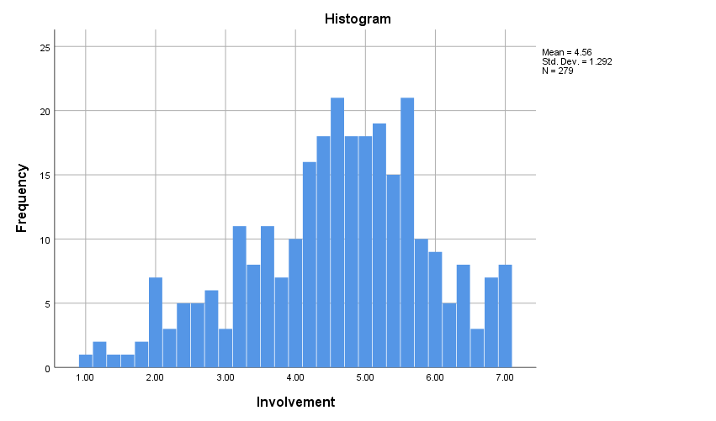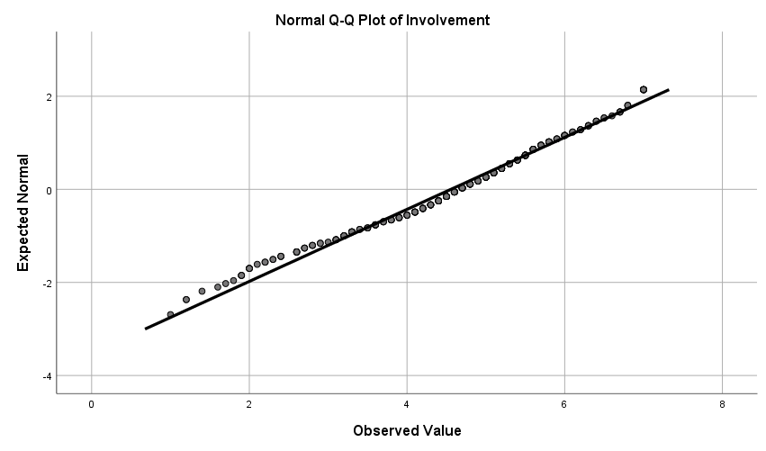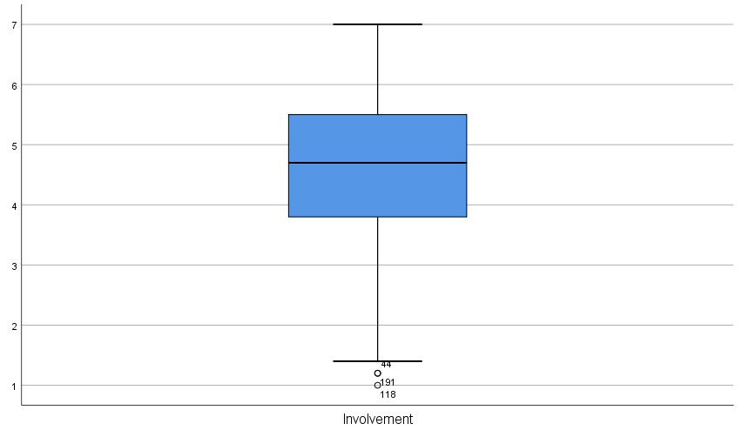

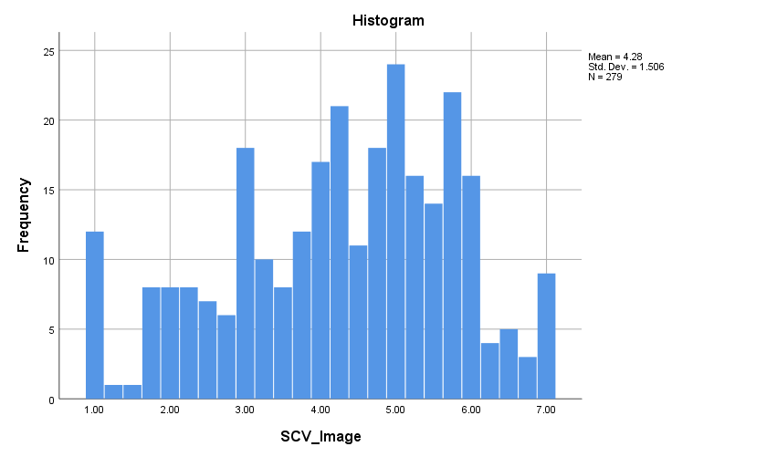

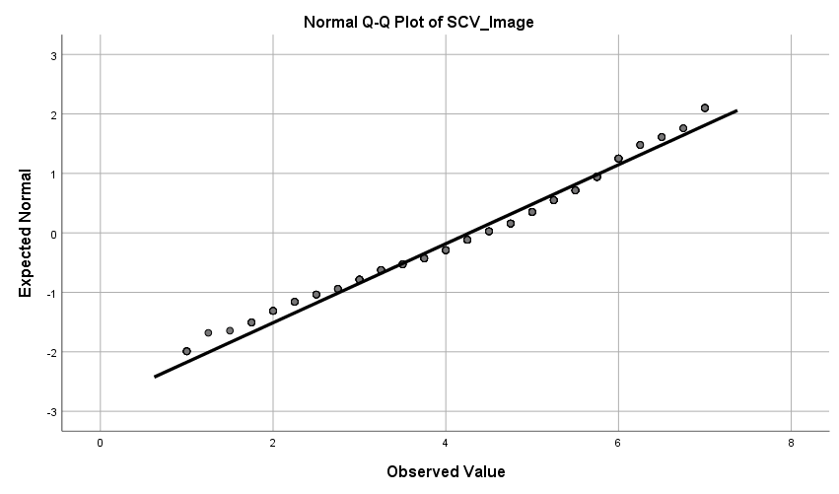
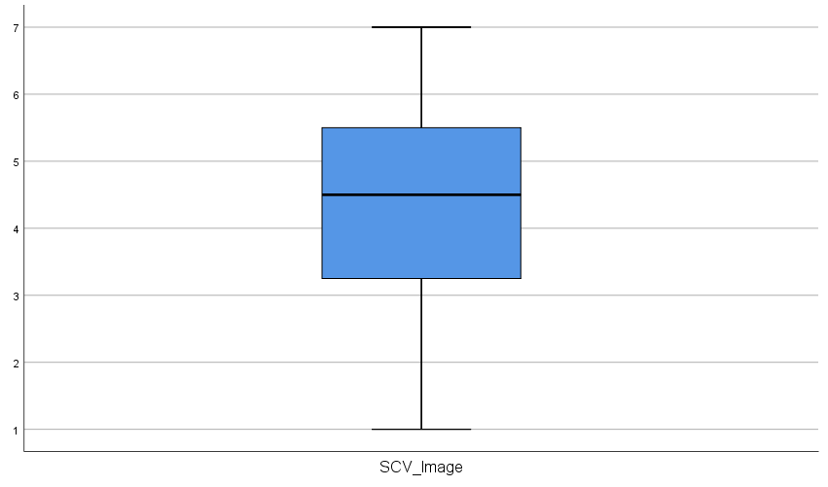

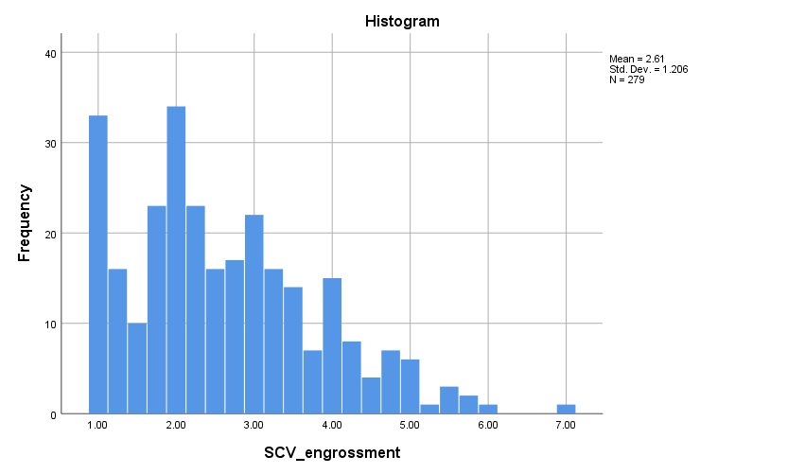

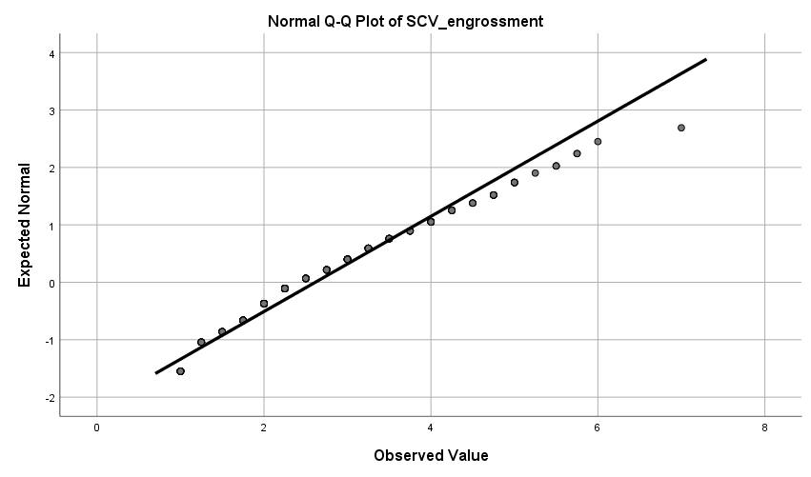

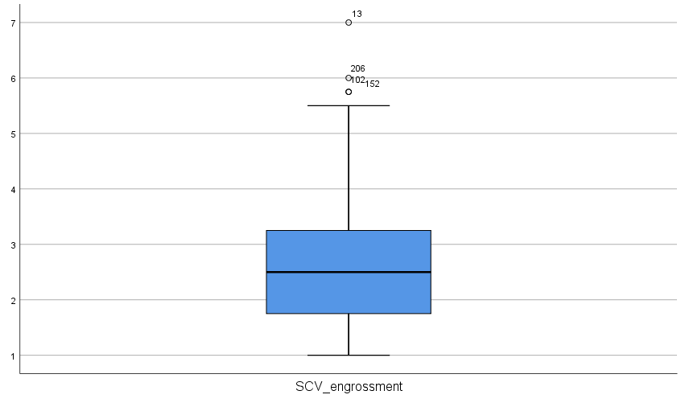

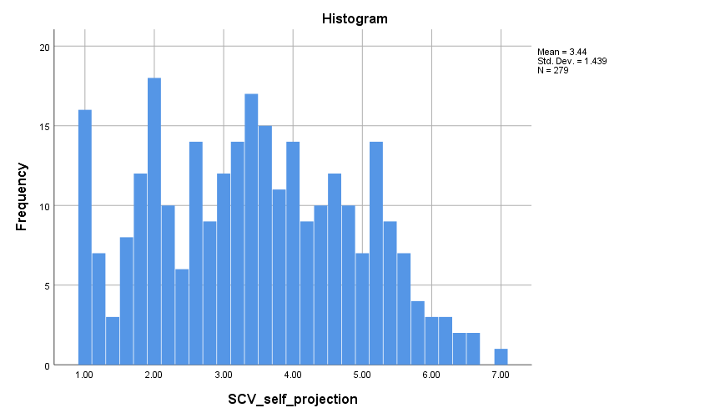

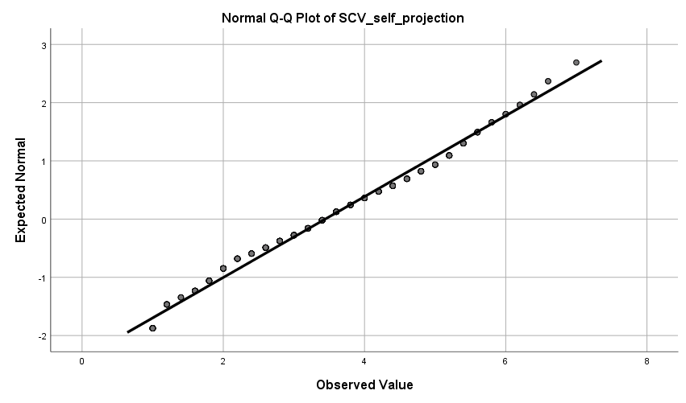
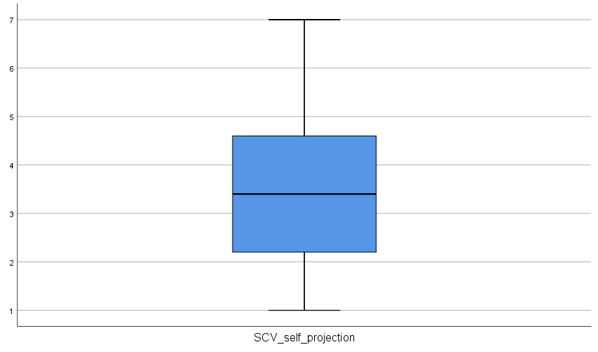

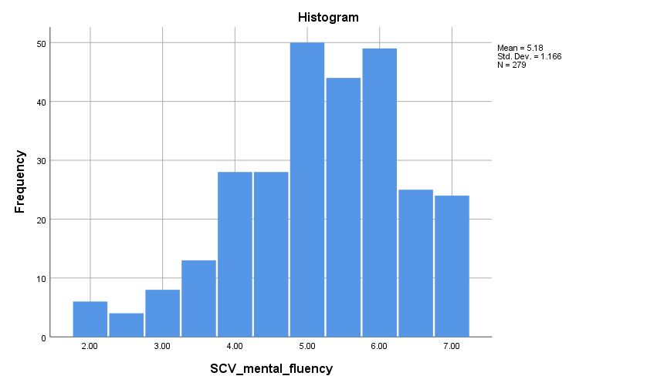

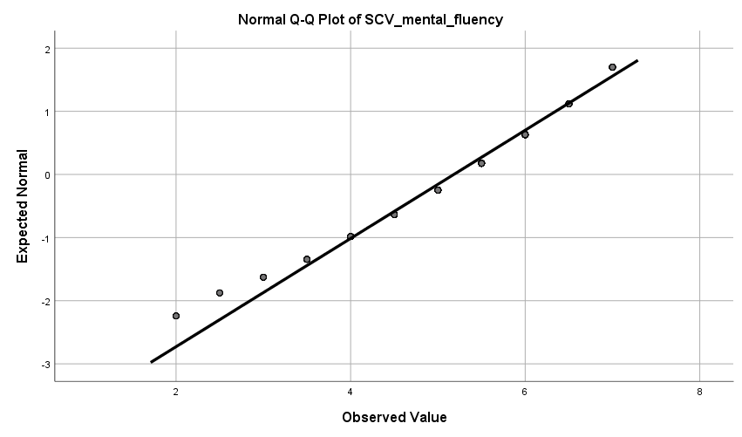
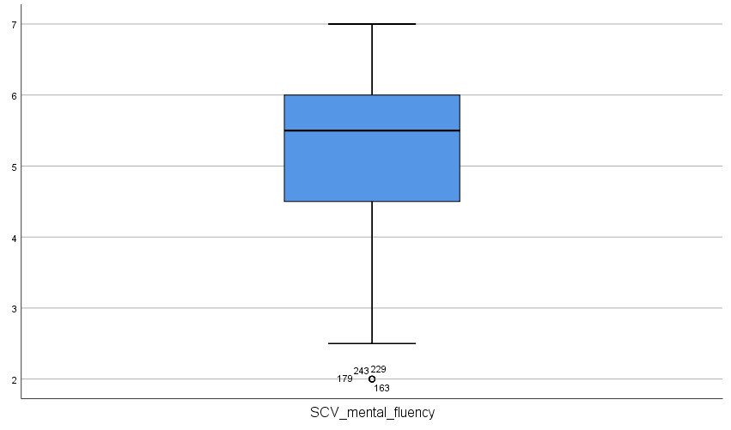

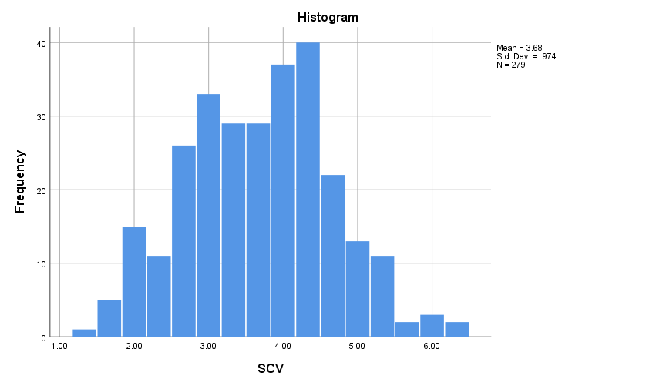
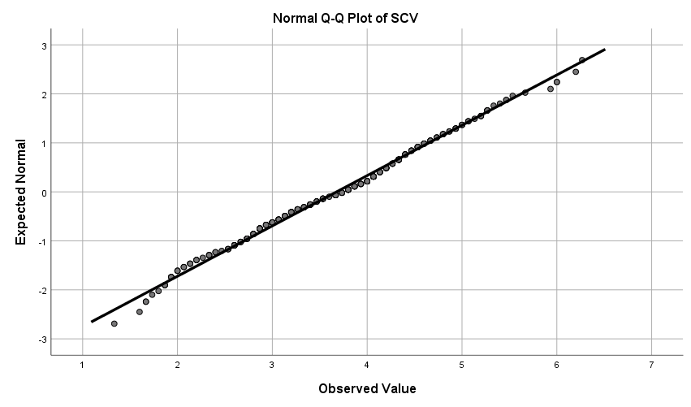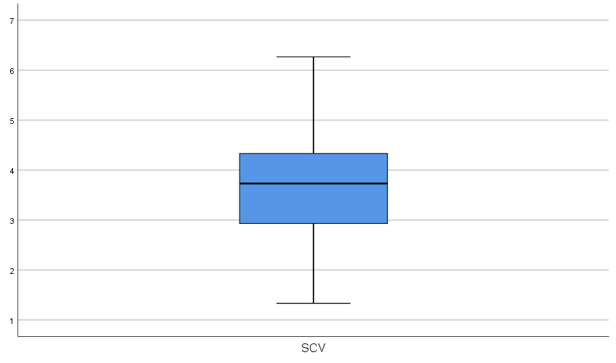

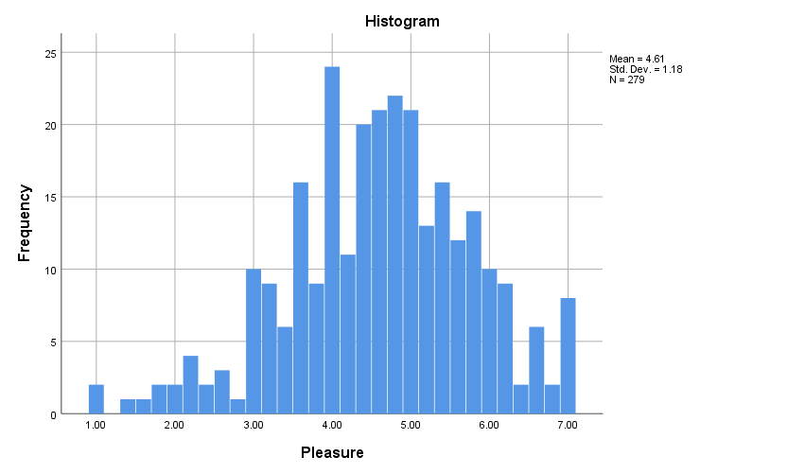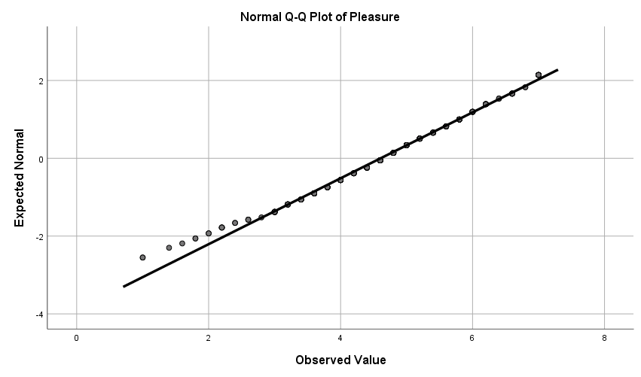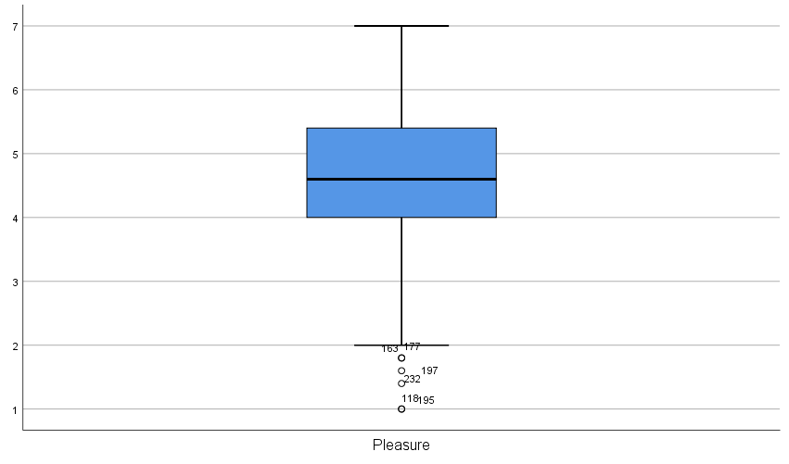

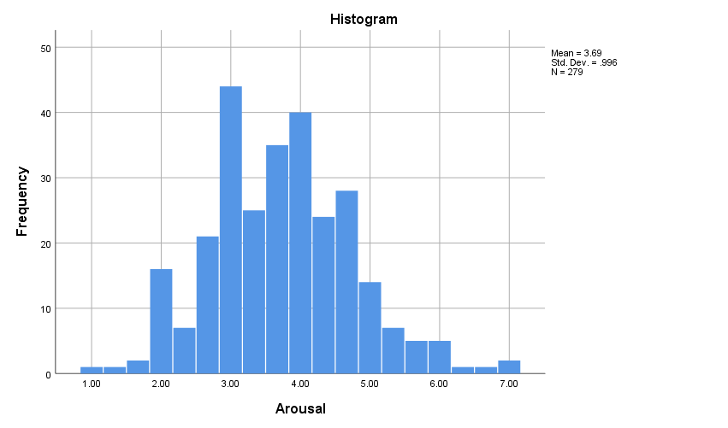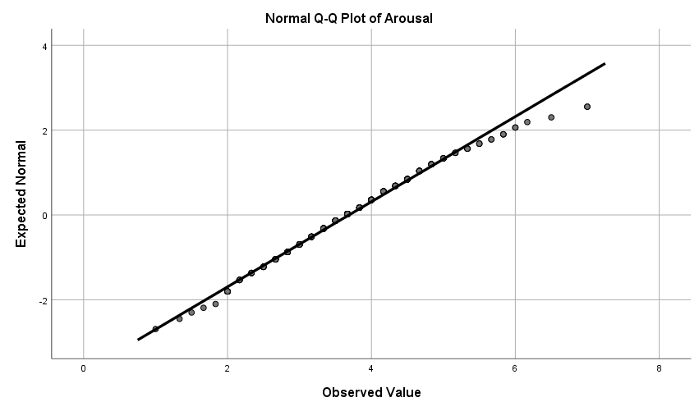
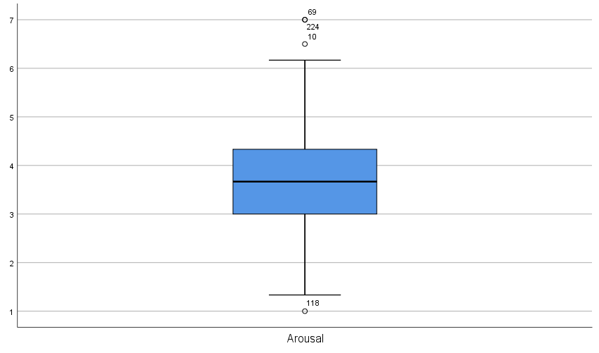

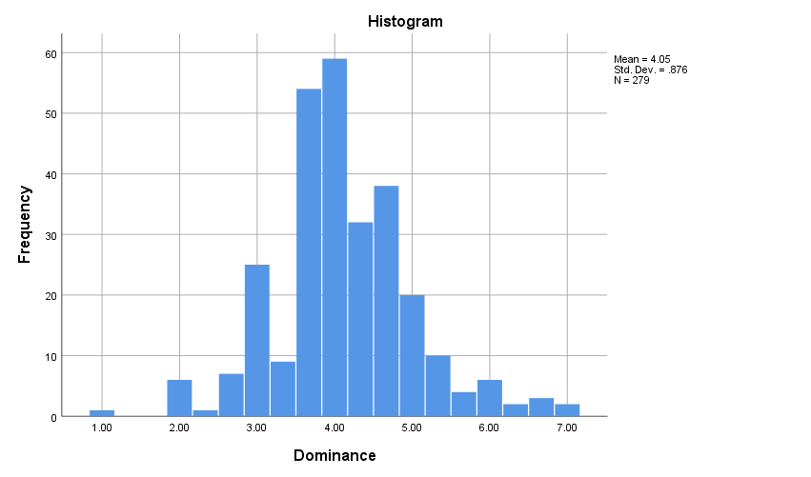
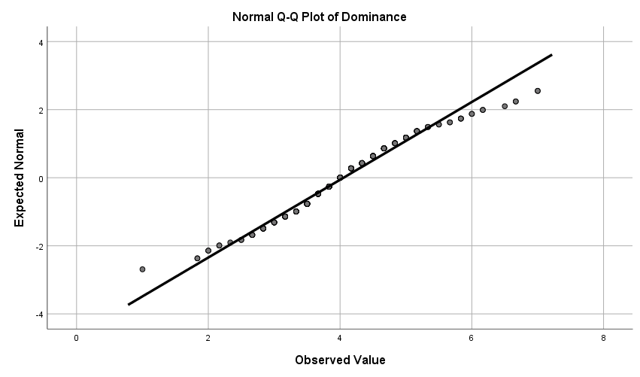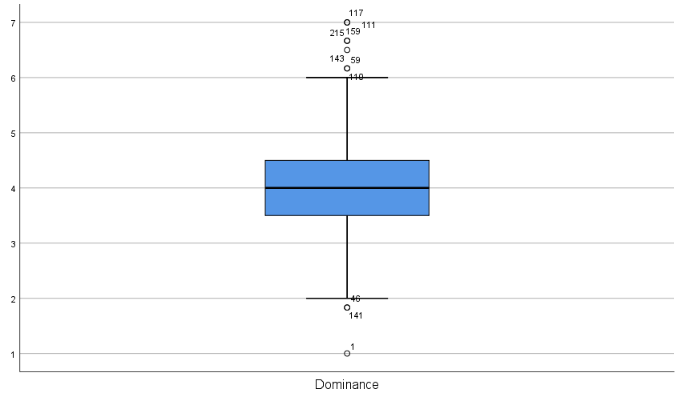
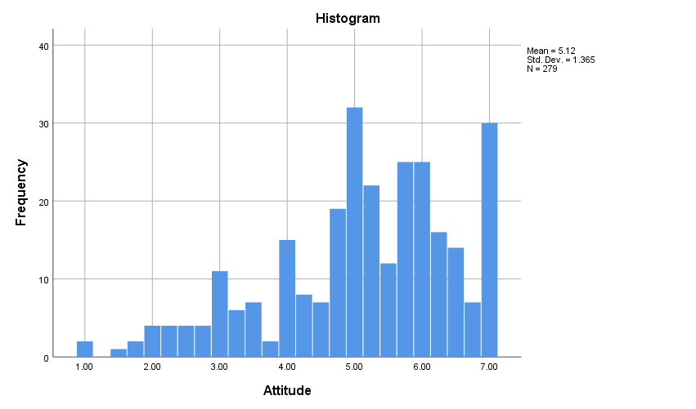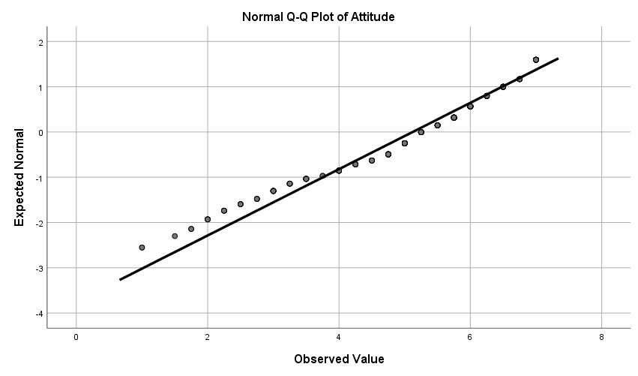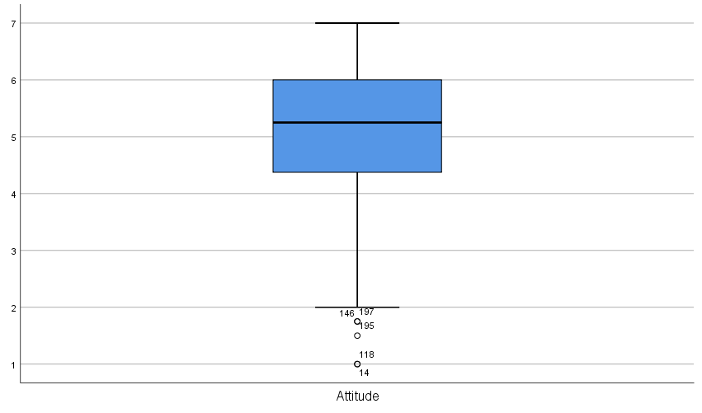

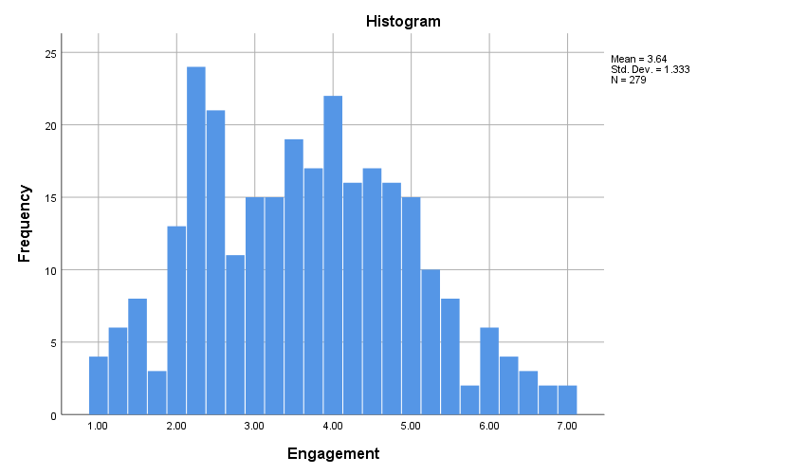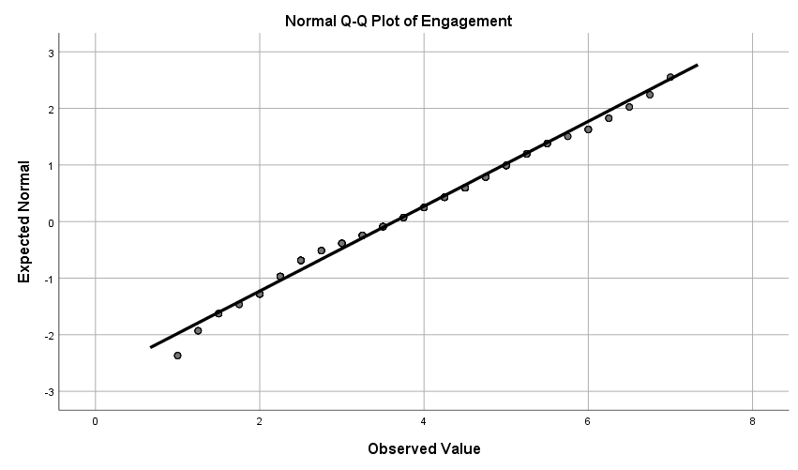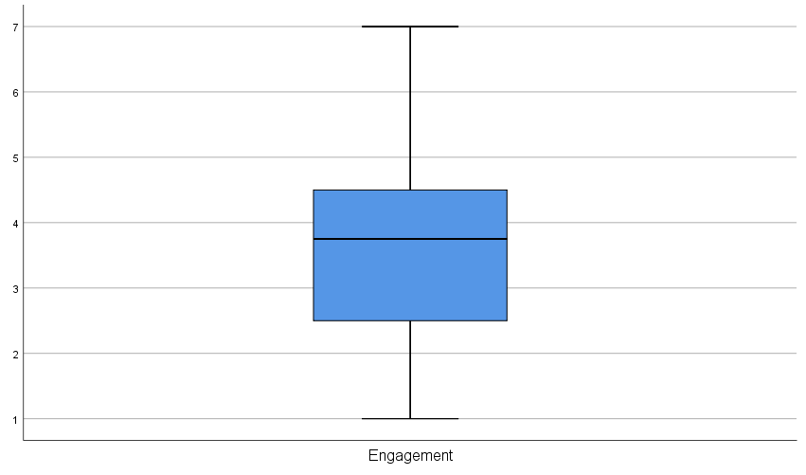

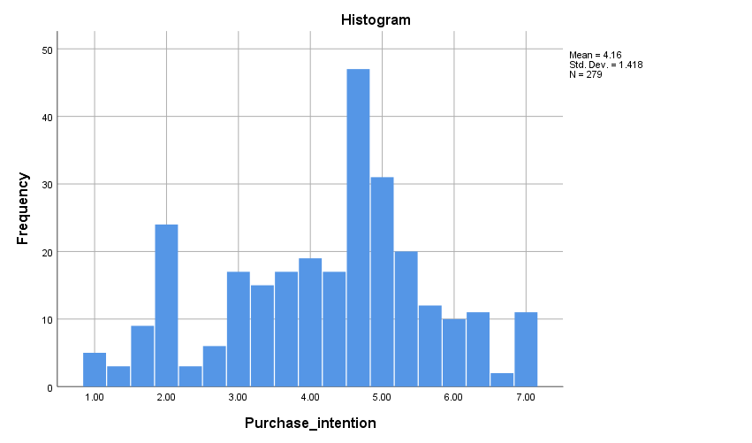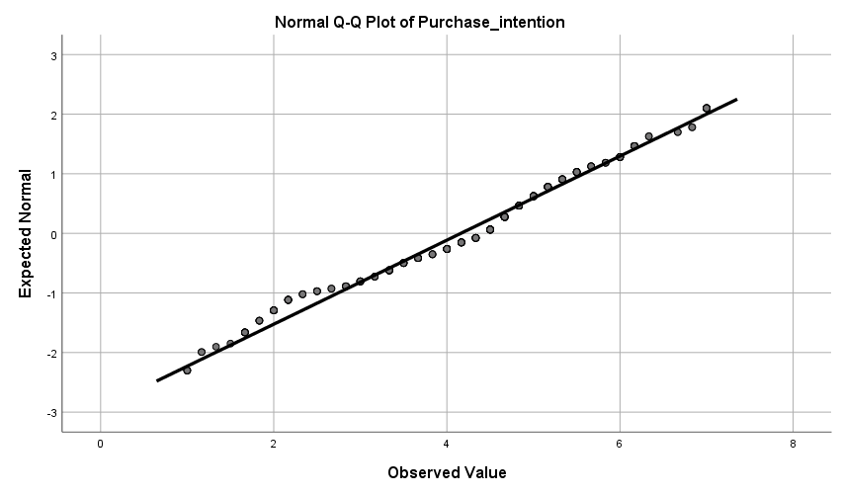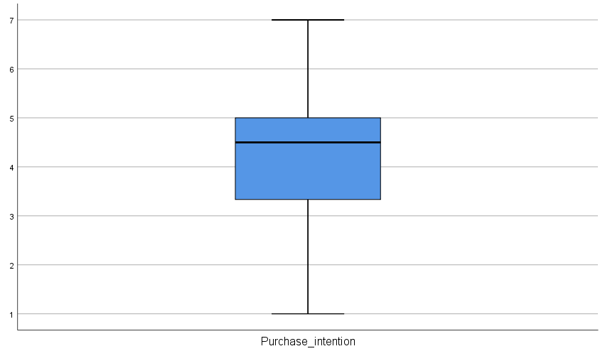

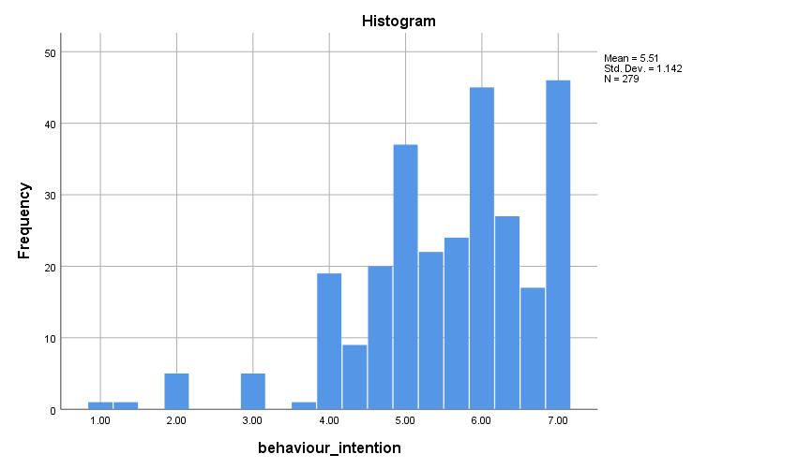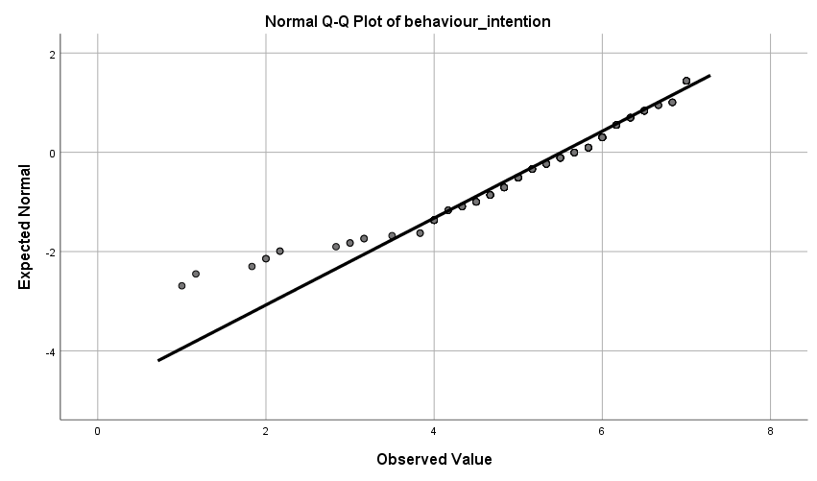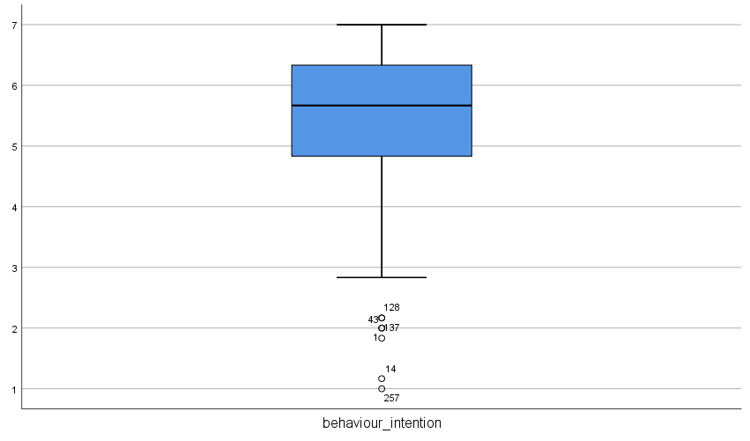

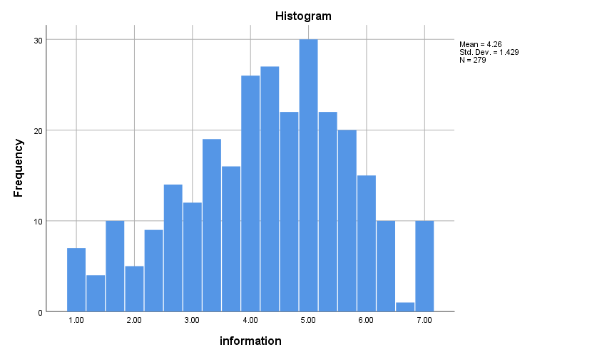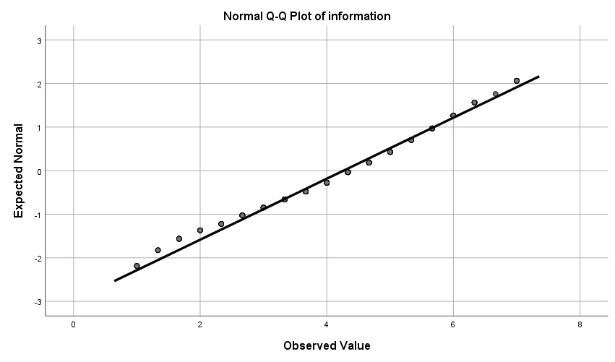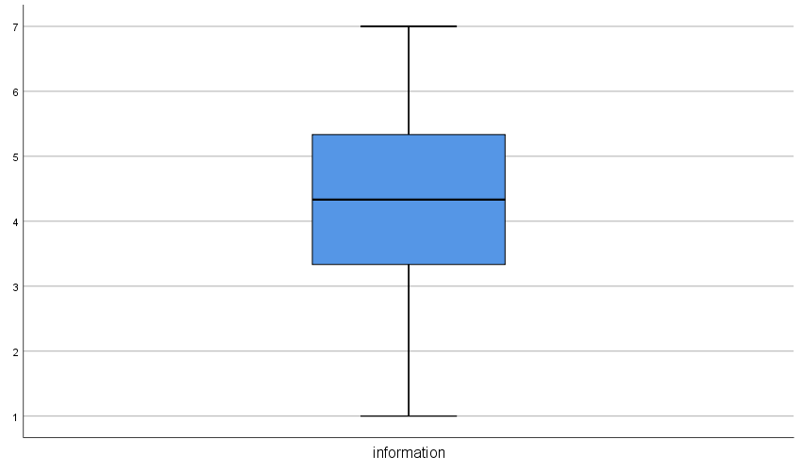
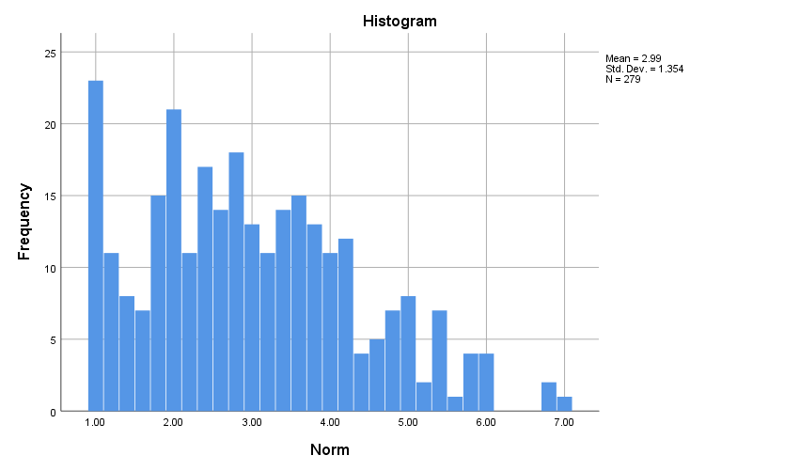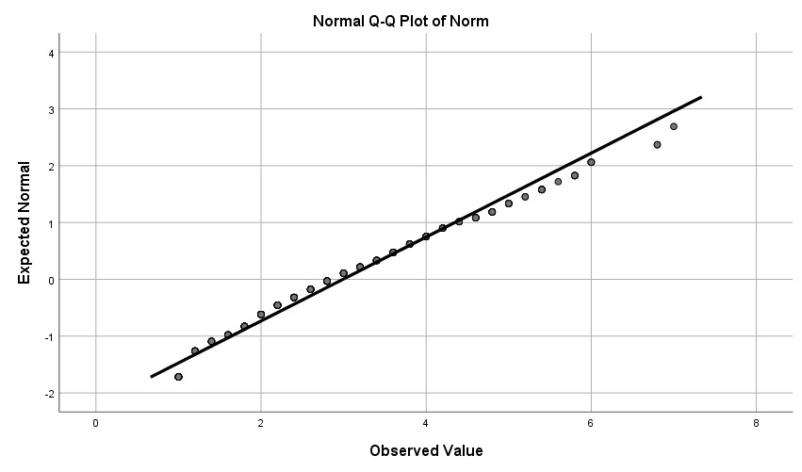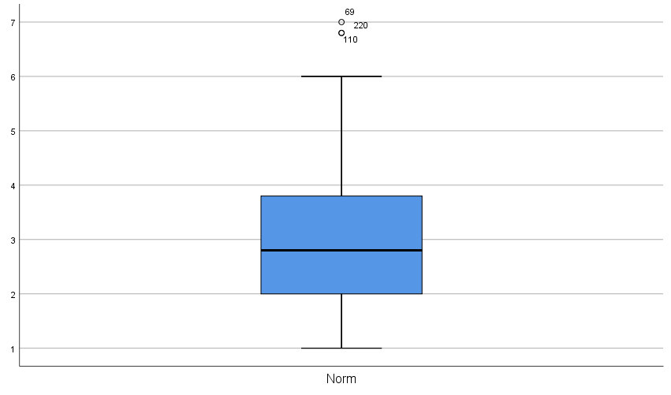
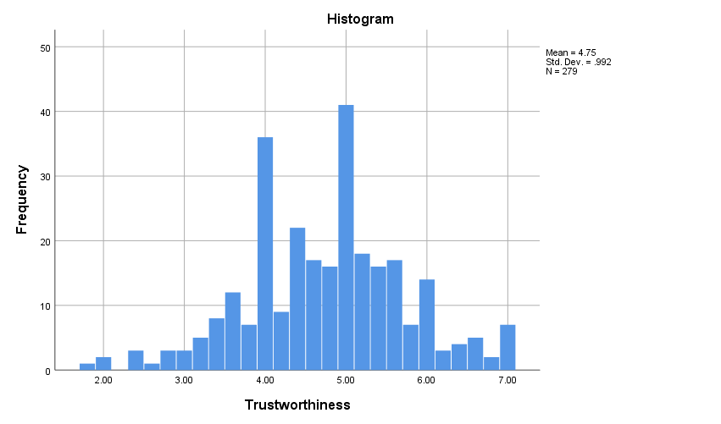
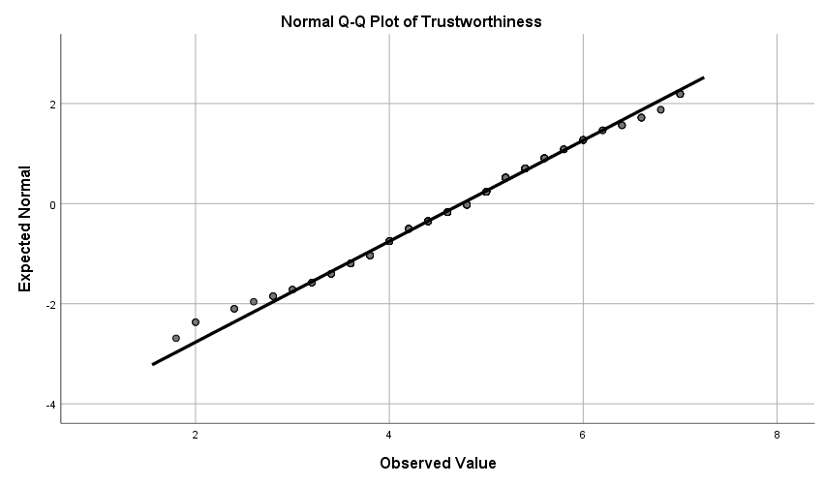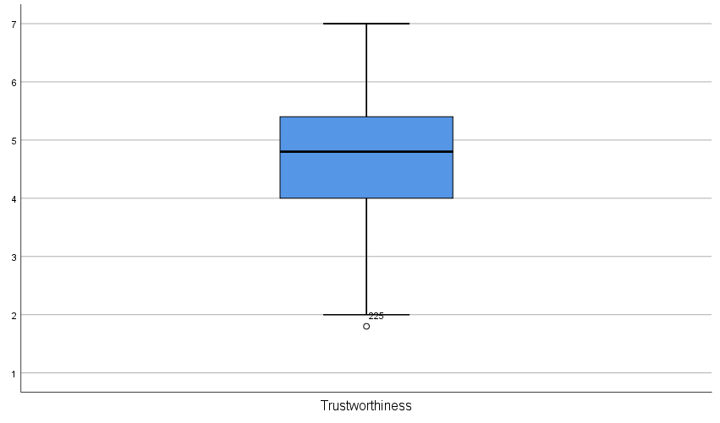
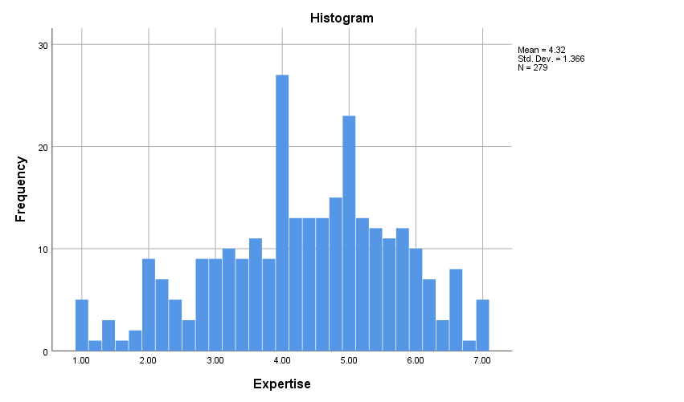
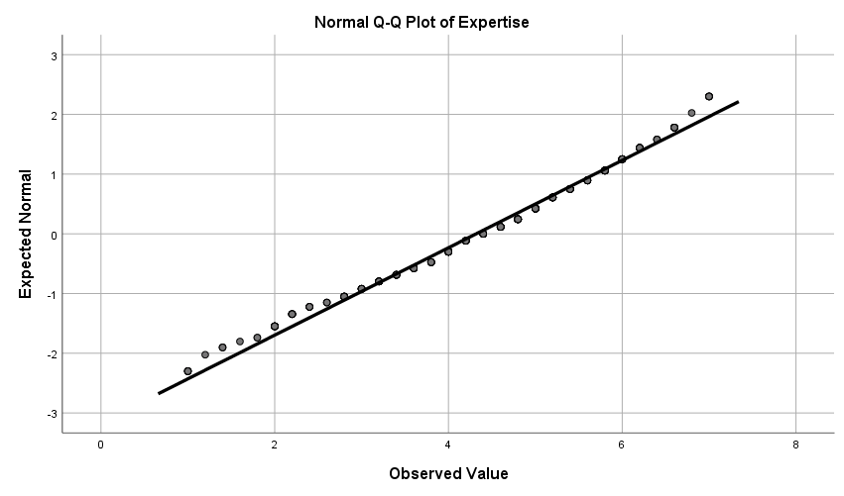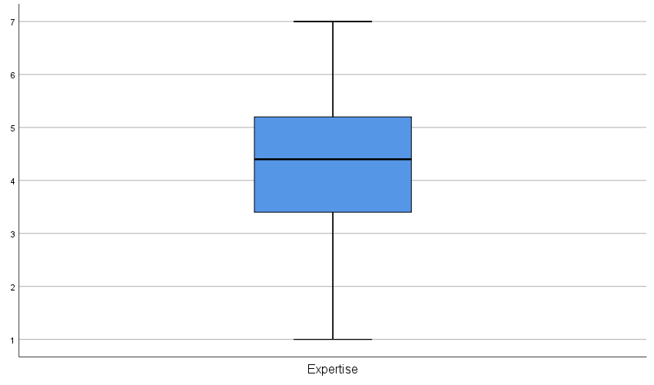

Appendix 3.4. Partial correlation table to determine CMB
Correlations
Control Variables |  | Involve  ment | SCV_  Image | SCV_eng  rossment | SCV_self_  projection | SCV_men  tal_fluency | Pleas  ure | Arousal | Domin  ance | Attitude | Engag  ement | Purcha  se | Behave  iour | Inform  ation | Norm | Exper  tise | CMB
 | Involvement
 | SCV_Image | 0.62***
 | SCV_engrossment | 0.214*** | 0.202**
 | SCV_self_projection | 0.538*** | 0.529*** | 0.369***
 | SCV_mental_fluency | 0.466*** | 0.449*** | 0.199** | 0.696***
 | Pleasure | 0.745*** | 0.57*** | 0.156** | 0.513*** | 0.553***
 | Arousal | 0.587*** | 0.393*** | 0.217*** | 0.462*** | 0.387*** | 0.529***
 | Dominance | 0.164** | 0.226*** | –0.013 | 0.199** | 0.162** | 0.18** | 0.226***
 | Attitude | 0.7*** | 0.498*** | 0.081 | 0.455*** | 0.491*** | 0.757*** | 0.42*** | 0.164**
 | Engagement | 0.589*** | 0.438*** | 0.226*** | 0.543*** | 0.456*** | 0.652*** | 0.476*** | 0.172** | 0.538***
 | Purchase | 0.641*** | 0.539*** | 0.116 | 0.535*** | 0.475*** | 0.613*** | 0.488*** | 0.192** | 0.555*** | 0.571***
 | behaviour | 0.333*** | 0.232*** | –0.004 | 0.244*** | 0.251*** | 0.381*** | 0.214*** | 0.163** | 0.338*** | 0.282*** | 0.337***
 | information | 0.38*** | 0.252*** | 0.125 | 0.361*** | 0.309*** | 0.348*** | 0.27*** | 0.15* | 0.31*** | 0.449*** | 0.391*** | 0.258***
 | Norm | 0.323*** | 0.238*** | 0.304*** | 0.439*** | 0.362*** | 0.237*** | 0.396*** | 0.089 | 0.167** | 0.364*** | 0.323*** | 0.067 | 0.541***
 | Expertise | 0.418*** | 0.391*** | 0.15* | 0.389*** | 0.327*** | 0.424*** | 0.33*** | 0.07 | 0.41*** | 0.45*** | 0.409*** | 0.156** | 0.254*** | 0.268***
 | Marker variable | 0.101 | 0.021 | 0.104 | 0.22*** | 0.149* | 0.159** | 0.082 | 0.028 | 0.026 | 0.076 | 0.069 | 0.031 | 0.053 | 0.15* | 0.005
a  controlled  Marker  Variable | Involvement
 | SCV_Image | 0.621***
 | SCV_engrossment | 0.206** | 0.201**
 | SCV_self_projection | 0.532*** | 0.538*** | 0.357***
 | SCV_mental_fluency | 0.458*** | 0.451*** | 0.186** | 0.688***
 | Pleasure | 0.743*** | 0.574*** | 0.142* | 0.496*** | 0.542***
 | Arousal | 0.583*** | 0.393*** | 0.21*** | 0.456*** | 0.38*** | 0.524***
 | Dominance | 0.162** | 0.226*** | –0.016 | 0.197** | 0.159** | 0.178** | 0.224***
 | Attitude | 0.702*** | 0.497*** | 0.079 | 0.461*** | 0.493*** | 0.763*** | 0.42*** | 0.163**
 | Engagement | 0.586*** | 0.438*** | 0.22*** | 0.541*** | 0.451*** | 0.65*** | 0.473*** | 0.17** | 0.538***
 | Purchase | 0.639*** | 0.539*** | 0.11 | 0.534*** | 0.471*** | 0.611*** | 0.485*** | 0.19** | 0.554*** | 0.569***
 | behaviour | 0.332*** | 0.232*** | –0.007 | 0.244*** | 0.249*** | 0.381*** | 0.212*** | 0.162** | 0.337*** | 0.281*** | 0.335***
 | information | 0.378*** | 0.251*** | 0.12* | 0.358*** | 0.305*** | 0.345*** | 0.267*** | 0.149* | 0.309*** | 0.447*** | 0.389*** | 0.256***
 | Norm | 0.313*** | 0.237*** | 0.293*** | 0.421*** | 0.347*** | 0.219*** | 0.39*** | 0.086 | 0.165** | 0.358*** | 0.317*** | 0.063 | 0.54***
 | Expertise | 0.42*** | 0.391*** | 0.15* | 0.398*** | 0.33*** | 0.429*** | 0.331*** | 0.07 | 0.41*** | 0.451*** | 0.41*** | 0.156** | 0.254*** | 0.271***
.a Cells contain zero–order (Pearson) correlations.
* represents significance at .05 level, ** represents significance at .01 level and *** represents significance at .001 level

Appendix 3.5 – Exploratory factor analysis result

EFA rotated loading | N 279 | February N 158 | April N 121
invlv_1 | 0.825 | 0.827 | 0.823
invlv_2 | 0.86 | 0.846 | 0.875
invlv_3 | 0.784 | 0.794 | 0.771
invlv_4 | 0.851 | 0.862 | 0.844
invlv_5 | 0.846 | 0.859 | 0.831
invlv_6 | 0.787 | 0.779 | 0.801
invlv_7 | 0.786 | 0.74 | 0.839
invlv_8 | 0.817 | 0.829 | 0.807
invlv_9 | 0.781 | 0.794 | 0.765
invlv_10 | 0.818 | 0.818 | 0.817
SCV_image_1 | 0.868 | 0.864 | 0.878
SCV_image_2 | 0.911 | 0.904 | 0.92
SCV_image_3 | 0.911 | 0.898 | 0.926
SCV_image_4 | 0.911 | 0.902 | 0.922
SCVengrossment_1 | 0.751 | 0.808 | 0.638
SCVengrossment_2 | 0.796 | 0.785 | 0.816
SCVengrossment_3 | 0.876 | 0.873 | 0.883
SCVengrossment_4 | 0.84 | 0.848 | 0.83
SCV_self_projection_1 | 0.773 | 0.792 | 0.759
SCV_self_projection_2 | 0.775 | 0.781 | 0.773
SCV_self_projection_3 | 0.877 | 0.878 | 0.874
SCV_self_projection_4 | 0.85 | 0.847 | 0.855
SCV_self_projection_5 | 0.88 | 0.884 | 0.874
SCV mental fluency | N/A | n/A | N/a
pleasure_1 | 0.882 | 0.875 | 0.893
pleasure_2 | 0.893 | 0.885 | 0.907
pleasure_3 | 0.872 | 0.861 | 0.885
pleasure_4 | 0.81 | 0.827 | 0.786
pleasure_5 | 0.825 | 0.785 | 0.879
Arousal_1 | 0.75 | 0.648 | 0.843
Arousal_2 | 0.719 | 0.66 | 0.781
Arousal_3 | 0.705 | 0.7 | 0.721
Arousal_4 | 0.775 | 0.787 | 0.768
Arousal_5 | 0.767 | 0.754 | 0.783
Arousal_6 | 0.784 | 0.783 | 0.789
dominance_1 | 0.625 | 0.644 | 0.596
dominance_2 | 0.735 | 0.702 | 0.782
dominance_3 | 0.726 | 0.729 | 0.732
dominance_4 | 0.746 | 0.731 | 0.772
dominance_5 | 0.508 | 0.451 | 0.579
dominance_6 | 0.57 | 0.529 | 0.641
attitude_1 | 0.922 | 0.926 | 0.915
attitude_2 | 0.955 | 0.959 | 0.952
attitude_3 | 0.931 | 0.936 | 0.923
attitude_4 | 0.915 | 0.915 | 0.918
engagement_1 | 0.496 | 0.479 | 0.517
engagement_2 | 0.779 | 0.724 | 0.846
engagement_3 | 0.894 | 0.886 | 0.906
engagement_4 | 0.849 | 0.861 | 0.831
coff_purce_intent_1 | 0.928 | 0.931 | 0.928
coff_purce_intent_2 | 0.937 | 0.944 | 0.93
coff_purce_intent_3 | 0.87 | 0.899 | 0.829
coff_purce_intent_4 | 0.753 | 0.851 | 0.611
coff_purce_intent_5 | 0.711 | 0.703 | 0.727
coff_purce_intent_6 | 0.897 | 0.9 | 0.894
behaviour_intent_1 | 0.935 | 0.951 | 0.918
behaviour_intent_2 | 0.932 | 0.945 | 0.915
behaviour_intent_3 | 0.905 | 0.916 | 0.889
behaviour_intent_4 | 0.891 | 0.924 | 0.844
behaviour_intent_5 | 0.74 | 0.796 | 0.633
behaviour_intent_6 | 0.917 | 0.951 | 0.861
info_1 | 0.814 | 0.802 | 0.83
info_2 | 0.806 | 0.84 | 0.757
info_3 | 0.83 | 0.811 | 0.849
norm_1 | 0.798 | 0.786 | 0.813
norm_2 | 0.771 | 0.808 | 0.72
norm_3 | 0.836 | 0.843 | 0.826
norm_4 | 0.814 | 0.8 | 0.835
norm_5 | 0.79 | 0.808 | 0.773
expertise_1 | 0.889 | 0.903 | 0.873
expertise_2 | 0.935 | 0.94 | 0.931
expertise_3 | 0.908 | 0.895 | 0.924
expertise_4 | 0.917 | 0.936 | 0.892
expertise_5 | 0.916 | 0.911 | 0.924

Appendix 3.6-Comparison of convergent validity and Cronbach's Alpha (α) among overall sample, February sample and April sample
Variables | Overall sample  N = 279 |  | February sample  N = 158 |  | April sample  N = 121
 | CR | α | CR | α | CR | α
Involvement | .95 | .944 | .95 | .943 | .95 | .944
SCV_Image | .94 | .832 | .94 | .913 | .95 | .931
SCV_engrossment | .89 | .922 | .90 | .846 | .87 | .801
SCV_self_projection | .92 | .888 | .92 | .892 | .92 | .885
SCV_mental_fluency | n/a |  | n/a |  | n/a
Pleasure | .93 | .909 | .93 | .899 | .94 | .914
Arousal | .89 | .845 | .87 | .813 | .90 | .867
Dominance | .82 | .726 | .80 | .694 | .84 | .770
Ad Attitude | .96 | .949 | .96 | .951 | .96 | .945
Engagement | .85 | .756 | .84 | .742 | .86 | .787
Purchase intention | .94 | .923 | .95 | .938 | .92 | .904
Behavioural intention | .96 | .946 | .97 | .959 | .94 | .918
Informational influence | .86 | .750 | .86 | .753 | .85 | .743
Normative influence | .90 | .861 | .90 | .867 | .90 | .849
Source Expertise | .96 | .950 | .96 | .952 | .96 | .946

Appendix 3.7 – Comparison of the February and April sample by variables

Independent Samples Test
 |  |  | Levene's Test for Equality of Variances |  |  |  | t-test for Equality of Means
 |  |  | F |  | Sig. |  | t |  | df |  | Sig. (2-tailed) |  | Mean Difference |  | Std. Error Difference |  | 95% Confidence Interval of the Difference
 |  |  |  |  |  |  |  |  |  |  |  |  |  |  |  |  | Lower |  | Upper
Involvement | Equal variances assumed | .069 |  | .793 |  | .780 |  | 277 |  | .436 |  | .12189 |  | .15623 |  | -.18566 |  | .42944
 | Equal variances not assumed |  |  |  |  | .776 |  | 252.604 |  | .439 |  | .12189 |  | .15712 |  | -.18755 |  | .43133
SCV_Image | Equal variances assumed | .879 |  | .349 |  | .103 |  | 277 |  | .918 |  | .01877 |  | .18225 |  | -.34000 |  | .37753
 | Equal variances not assumed |  |  |  |  | .102 |  | 249.483 |  | .919 |  | .01877 |  | .18382 |  | -.34327 |  | .38080
SCV_engrossment | Equal variances assumed | 3.187 |  | .075 |  | 1.065 |  | 277 |  | .288 |  | .15510 |  | .14565 |  | -.13163 |  | .44183
 | Equal variances not assumed |  |  |  |  | 1.085 |  | 272.834 |  | .279 |  | .15510 |  | .14290 |  | -.12622 |  | .43643
SCV_self_projection | Equal variances assumed | .807 |  | .370 |  | -.160 |  | 277 |  | .873 |  | -.02786 |  | .17419 |  | -.37077 |  | .31505
 | Equal variances not assumed |  |  |  |  | -.161 |  | 262.080 |  | .873 |  | -.02786 |  | .17349 |  | -.36948 |  | .31376
SCV_mental_fluency | Equal variances assumed | .113 |  | .737 |  | -.366 |  | 277 |  | .715 |  | -.07093 |  | .19402 |  | -.45286 |  | .31101
 | Equal variances not assumed |  |  |  |  | -.367 |  | 262.489 |  | .714 |  | -.07093 |  | .19315 |  | -.45125 |  | .30939
Pleasure | Equal variances assumed | .127 |  | .722 |  | -.996 |  | 277 |  | .320 |  | -.14203 |  | .14260 |  | -.42275 |  | .13868
 | Equal variances not assumed |  |  |  |  | -.993 |  | 255.715 |  | .321 |  | -.14203 |  | .14298 |  | -.42360 |  | .13954
Arousal | Equal variances assumed | 2.554 |  | .111 |  | .465 |  | 277 |  | .642 |  | .05606 |  | .12054 |  | -.18123 |  | .29334
 | Equal variances not assumed |  |  |  |  | .457 |  | 240.112 |  | .648 |  | .05606 |  | .12259 |  | -.18543 |  | .29754
Dominance | Equal variances assumed | .042 |  | .837 |  | .315 |  | 277 |  | .753 |  | .03340 |  | .10594 |  | -.17515 |  | .24195
 | Equal variances not assumed |  |  |  |  | .315 |  | 256.040 |  | .753 |  | .03340 |  | .10619 |  | -.17572 |  | .24252
Attitude | Equal variances assumed | .097 |  | .756 |  | .366 |  | 277 |  | .715 |  | .06038 |  | .16514 |  | -.26470 |  | .38545
 | Equal variances not assumed |  |  |  |  | .370 |  | 267.757 |  | .712 |  | .06038 |  | .16333 |  | -.26120 |  | .38195
Engagement | Equal variances assumed | .401 |  | .527 |  | 1.999 |  | 277 |  | .047 |  | .32029 |  | .16023 |  | .00487 |  | .63570
 | Equal variances not assumed |  |  |  |  | 1.990 |  | 253.862 |  | .048 |  | .32029 |  | .16095 |  | .00333 |  | .63725
Purchase | Equal variances assumed | 1.676 |  | .196 |  | .461 |  | 277 |  | .645 |  | .07912 |  | .17152 |  | -.25852 |  | .41677
 | Equal variances not assumed |  |  |  |  | .466 |  | 267.804 |  | .641 |  | .07912 |  | .16963 |  | -.25486 |  | .41311
behaviour | Equal variances assumed | 1.630 |  | .203 |  | -.423 |  | 277 |  | .673 |  | -.05844 |  | .13820 |  | -.33049 |  | .21362
 | Equal variances not assumed |  |  |  |  | -.432 |  | 274.094 |  | .666 |  | -.05844 |  | .13522 |  | -.32465 |  | .20778
information | Equal variances assumed | .296 |  | .587 |  | 1.350 |  | 277 |  | .178 |  | .23275 |  | .17235 |  | -.10654 |  | .57203
 | Equal variances not assumed |  |  |  |  | 1.346 |  | 254.837 |  | .180 |  | .23275 |  | .17296 |  | -.10787 |  | .57337
Norm | Equal variances assumed | .093 |  | .761 |  | .307 |  | 277 |  | .759 |  | .05029 |  | .16382 |  | -.27220 |  | .37277
 | Equal variances not assumed |  |  |  |  | .308 |  | 262.778 |  | .758 |  | .05029 |  | .16303 |  | -.27073 |  | .37130
Trustworthiness | Equal variances assumed | 1.927 |  | .166 |  | .401 |  | 277 |  | .689 |  | .04808 |  | .12000 |  | -.18814 |  | .28430
 | Equal variances not assumed |  |  |  |  | .396 |  | 245.663 |  | .693 |  | .04808 |  | .12145 |  | -.19114 |  | .28730
Expertise | Equal variances assumed | .185 |  | .667 |  | .204 |  | 277 |  | .838 |  | .03374 |  | .16528 |  | -.29164 |  | .35911
 | Equal variances not assumed |  |  |  |  | .204 |  | 256.264 |  | .839 |  | .03374 |  | .16564 |  | -.29245 |  | .35992

Appendix 3.8- Confirmatory factor analysis

Outer loading:
 | Arousal | Behaviour | Purchase | SCV | attitude | dominance | engagement | engrossment | expertise | fluency | image | info | invlv | norm | pleasure | projection
Arousal_1 | 0.768
Arousal_2 | 0.756
Arousal_3 | 0.722
Arousal_4 | 0.723
Arousal_5 | 0.710
Arousal_6 | 0.804
SCV_image_1 |  |  |  |  |  |  |  |  |  |  | 0.874
SCV_image_1 |  |  |  | 0.746
SCV_image_2 |  |  |  |  |  |  |  |  |  |  | 0.909
SCV_image_2 |  |  |  | 0.710
SCV_image_3 |  |  |  | 0.735
SCV_image_3 |  |  |  |  |  |  |  |  |  |  | 0.910
SCV_image_4 |  |  |  |  |  |  |  |  |  |  | 0.908
SCV_image_4 |  |  |  | 0.700
SCV_mental_fluency_2 |  |  |  |  |  |  |  |  |  | 1.000
SCV_mental_fluency_2 |  |  |  | 0.719
SCV_self_projection_1 |  |  |  |  |  |  |  |  |  |  |  |  |  |  |  | 0.769
SCV_self_projection_1 |  |  |  | 0.673
SCV_self_projection_2 |  |  |  |  |  |  |  |  |  |  |  |  |  |  |  | 0.780
SCV_self_projection_2 |  |  |  | 0.734
SCV_self_projection_3 |  |  |  |  |  |  |  |  |  |  |  |  |  |  |  | 0.877
SCV_self_projection_3 |  |  |  | 0.794
SCV_self_projection_4 |  |  |  |  |  |  |  |  |  |  |  |  |  |  |  | 0.849
SCV_self_projection_4 |  |  |  | 0.768
SCV_self_projection_5 |  |  |  | 0.782
SCV_self_projection_5 |  |  |  |  |  |  |  |  |  |  |  |  |  |  |  | 0.878
SCVengrossment_1 |  |  |  | 0.227
SCVengrossment_1 |  |  |  |  |  |  |  | 0.688
SCVengrossment_2 |  |  |  | 0.458
SCVengrossment_2 |  |  |  |  |  |  |  | 0.810
SCVengrossment_3 |  |  |  | 0.431
SCVengrossment_3 |  |  |  |  |  |  |  | 0.881
SCVengrossment_4 |  |  |  |  |  |  |  | 0.863
SCVengrossment_4 |  |  |  | 0.478
attitude_1 |  |  |  |  | 0.922
attitude_2 |  |  |  |  | 0.954
attitude_3 |  |  |  |  | 0.933
attitude_4 |  |  |  |  | 0.913
behaviour_intent_1 |  | 0.937
behaviour_intent_2 |  | 0.935
behaviour_intent_3 |  | 0.906
behaviour_intent_4 |  | 0.890
behaviour_intent_5 |  | 0.733
behaviour_intent_6 |  | 0.918
coff_purce_intent_1 |  |  | 0.929
coff_purce_intent_2 |  |  | 0.936
coff_purce_intent_3 |  |  | 0.866
coff_purce_intent_4 |  |  | 0.753
coff_purce_intent_5 |  |  | 0.719
coff_purce_intent_6 |  |  | 0.894
dominance_1 |  |  |  |  |  | 0.732
dominance_2 |  |  |  |  |  | 0.600
dominance_3 |  |  |  |  |  | 0.587
dominance_4 |  |  |  |  |  | 0.380
dominance_5 |  |  |  |  |  | 0.108
dominance_6 |  |  |  |  |  | 0.808
engagement_1 |  |  |  |  |  |  | 0.500
engagement_2 |  |  |  |  |  |  | 0.743
engagement_3 |  |  |  |  |  |  | 0.892
engagement_4 |  |  |  |  |  |  | 0.877
expertise_1 |  |  |  |  |  |  |  |  | 0.885
expertise_2 |  |  |  |  |  |  |  |  | 0.936
expertise_3 |  |  |  |  |  |  |  |  | 0.913
expertise_4 |  |  |  |  |  |  |  |  | 0.914
expertise_5 |  |  |  |  |  |  |  |  | 0.917
info_1 |  |  |  |  |  |  |  |  |  |  |  | 0.792
info_2 |  |  |  |  |  |  |  |  |  |  |  | 0.745
info_3 |  |  |  |  |  |  |  |  |  |  |  | 0.891
invlv_1 |  |  |  |  |  |  |  |  |  |  |  |  | 0.825
invlv_10 |  |  |  |  |  |  |  |  |  |  |  |  | 0.816
invlv_2 |  |  |  |  |  |  |  |  |  |  |  |  | 0.863
invlv_3 |  |  |  |  |  |  |  |  |  |  |  |  | 0.779
invlv_4 |  |  |  |  |  |  |  |  |  |  |  |  | 0.854
invlv_5 |  |  |  |  |  |  |  |  |  |  |  |  | 0.843
invlv_6 |  |  |  |  |  |  |  |  |  |  |  |  | 0.794
invlv_7 |  |  |  |  |  |  |  |  |  |  |  |  | 0.785
invlv_8 |  |  |  |  |  |  |  |  |  |  |  |  | 0.809
invlv_9 |  |  |  |  |  |  |  |  |  |  |  |  | 0.785
norm_1 |  |  |  |  |  |  |  |  |  |  |  |  |  | 0.787
norm_2 |  |  |  |  |  |  |  |  |  |  |  |  |  | 0.761
norm_3 |  |  |  |  |  |  |  |  |  |  |  |  |  | 0.828
norm_4 |  |  |  |  |  |  |  |  |  |  |  |  |  | 0.792
norm_5 |  |  |  |  |  |  |  |  |  |  |  |  |  | 0.832
pleasure_1 |  |  |  |  |  |  |  |  |  |  |  |  |  |  | 0.879
pleasure_2 |  |  |  |  |  |  |  |  |  |  |  |  |  |  | 0.889
pleasure_3 |  |  |  |  |  |  |  |  |  |  |  |  |  |  | 0.866
pleasure_4 |  |  |  |  |  |  |  |  |  |  |  |  |  |  | 0.813
pleasure_5 |  |  |  |  |  |  |  |  |  |  |  |  |  |  | 0.835

Cross loading
 | Arousal | Behaviour | Purchase | SCV | attitude | dominance | engagement | engrossment | expertise | fluency | image | info | invlv | norm | pleasure | projection
Arousal_1 | 0.768 | 0.167 | 0.420 | 0.373 | 0.339 | 0.291 | 0.383 | 0.133 | 0.197 | 0.315 | 0.335 | 0.248 | 0.457 | 0.253 | 0.479 | 0.315
Arousal_2 | 0.756 | 0.125 | 0.384 | 0.467 | 0.382 | 0.184 | 0.345 | 0.211 | 0.271 | 0.393 | 0.363 | 0.238 | 0.477 | 0.357 | 0.447 | 0.428
Arousal_3 | 0.722 | 0.218 | 0.348 | 0.374 | 0.368 | 0.275 | 0.359 | 0.128 | 0.188 | 0.264 | 0.351 | 0.174 | 0.466 | 0.215 | 0.455 | 0.318
Arousal_4 | 0.723 | 0.134 | 0.356 | 0.320 | 0.241 | 0.194 | 0.332 | 0.187 | 0.298 | 0.223 | 0.209 | 0.163 | 0.397 | 0.290 | 0.297 | 0.322
Arousal_5 | 0.710 | 0.149 | 0.300 | 0.295 | 0.216 | 0.222 | 0.350 | 0.173 | 0.228 | 0.228 | 0.182 | 0.194 | 0.372 | 0.317 | 0.265 | 0.300
Arousal_6 | 0.804 | 0.193 | 0.410 | 0.445 | 0.372 | 0.233 | 0.418 | 0.225 | 0.286 | 0.332 | 0.364 | 0.299 | 0.507 | 0.348 | 0.484 | 0.395
SCV_image_1 | 0.398 | 0.226 | 0.522 | 0.746 | 0.451 | 0.305 | 0.440 | 0.241 | 0.337 | 0.439 | 0.874 | 0.273 | 0.593 | 0.220 | 0.561 | 0.516
SCV_image_1 | 0.398 | 0.226 | 0.522 | 0.746 | 0.451 | 0.305 | 0.440 | 0.241 | 0.337 | 0.439 | 0.874 | 0.273 | 0.593 | 0.220 | 0.561 | 0.516
SCV_image_2 | 0.401 | 0.243 | 0.493 | 0.710 | 0.435 | 0.272 | 0.420 | 0.185 | 0.402 | 0.392 | 0.909 | 0.273 | 0.564 | 0.213 | 0.499 | 0.447
SCV_image_2 | 0.401 | 0.243 | 0.493 | 0.710 | 0.435 | 0.272 | 0.420 | 0.185 | 0.402 | 0.392 | 0.909 | 0.273 | 0.564 | 0.213 | 0.499 | 0.447
SCV_image_3 | 0.356 | 0.153 | 0.478 | 0.735 | 0.479 | 0.350 | 0.357 | 0.182 | 0.349 | 0.420 | 0.910 | 0.243 | 0.552 | 0.240 | 0.511 | 0.493
SCV_image_3 | 0.356 | 0.153 | 0.478 | 0.735 | 0.479 | 0.350 | 0.357 | 0.182 | 0.349 | 0.420 | 0.910 | 0.243 | 0.552 | 0.240 | 0.511 | 0.493
SCV_image_4 | 0.345 | 0.208 | 0.441 | 0.700 | 0.425 | 0.362 | 0.349 | 0.189 | 0.324 | 0.360 | 0.908 | 0.257 | 0.527 | 0.192 | 0.472 | 0.438
SCV_image_4 | 0.345 | 0.208 | 0.441 | 0.700 | 0.425 | 0.362 | 0.349 | 0.189 | 0.324 | 0.360 | 0.908 | 0.257 | 0.527 | 0.192 | 0.472 | 0.438
SCV_mental_fluency_2 | 0.402 | 0.252 | 0.474 | 0.719 | 0.491 | 0.314 | 0.455 | 0.205 | 0.328 | 1.000 | 0.448 | 0.326 | 0.467 | 0.359 | 0.553 | 0.696
SCV_mental_fluency_2 | 0.402 | 0.252 | 0.474 | 0.719 | 0.491 | 0.314 | 0.455 | 0.205 | 0.328 | 1.000 | 0.448 | 0.326 | 0.467 | 0.359 | 0.553 | 0.696
SCV_self_projection_1 | 0.349 | 0.172 | 0.357 | 0.673 | 0.276 | 0.237 | 0.442 | 0.398 | 0.275 | 0.476 | 0.333 | 0.281 | 0.391 | 0.372 | 0.329 | 0.769
SCV_self_projection_1 | 0.349 | 0.172 | 0.357 | 0.673 | 0.276 | 0.237 | 0.442 | 0.398 | 0.275 | 0.476 | 0.333 | 0.281 | 0.391 | 0.372 | 0.329 | 0.769
SCV_self_projection_2 | 0.361 | 0.232 | 0.566 | 0.734 | 0.445 | 0.312 | 0.444 | 0.173 | 0.391 | 0.542 | 0.534 | 0.290 | 0.467 | 0.265 | 0.453 | 0.780
SCV_self_projection_2 | 0.361 | 0.232 | 0.566 | 0.734 | 0.445 | 0.312 | 0.444 | 0.173 | 0.391 | 0.542 | 0.534 | 0.290 | 0.467 | 0.265 | 0.453 | 0.780
SCV_self_projection_3 | 0.388 | 0.151 | 0.414 | 0.794 | 0.423 | 0.294 | 0.474 | 0.398 | 0.357 | 0.585 | 0.451 | 0.287 | 0.460 | 0.363 | 0.453 | 0.877
SCV_self_projection_3 | 0.388 | 0.151 | 0.414 | 0.794 | 0.423 | 0.294 | 0.474 | 0.398 | 0.357 | 0.585 | 0.451 | 0.287 | 0.460 | 0.363 | 0.453 | 0.877
SCV_self_projection_4 | 0.404 | 0.236 | 0.429 | 0.768 | 0.347 | 0.241 | 0.428 | 0.333 | 0.275 | 0.618 | 0.444 | 0.346 | 0.472 | 0.413 | 0.411 | 0.849
SCV_self_projection_4 | 0.404 | 0.236 | 0.429 | 0.768 | 0.347 | 0.241 | 0.428 | 0.333 | 0.275 | 0.618 | 0.444 | 0.346 | 0.472 | 0.413 | 0.411 | 0.849
SCV_self_projection_5 | 0.447 | 0.219 | 0.445 | 0.782 | 0.390 | 0.327 | 0.475 | 0.331 | 0.325 | 0.663 | 0.426 | 0.387 | 0.448 | 0.415 | 0.472 | 0.878
SCV_self_projection_5 | 0.447 | 0.219 | 0.445 | 0.782 | 0.390 | 0.327 | 0.475 | 0.331 | 0.325 | 0.663 | 0.426 | 0.387 | 0.448 | 0.415 | 0.472 | 0.878
SCVengrossment_1 | 0.060 | -0.082 | -0.067 | 0.227 | -0.020 | -0.090 | 0.055 | 0.688 | 0.025 | 0.091 | 0.028 | 0.097 | 0.013 | 0.204 | -0.015 | 0.151
SCVengrossment_1 | 0.060 | -0.082 | -0.067 | 0.227 | -0.020 | -0.090 | 0.055 | 0.688 | 0.025 | 0.091 | 0.028 | 0.097 | 0.013 | 0.204 | -0.015 | 0.151
SCVengrossment_2 | 0.177 | 0.091 | 0.165 | 0.458 | 0.121 | 0.049 | 0.228 | 0.810 | 0.174 | 0.235 | 0.208 | 0.116 | 0.224 | 0.259 | 0.183 | 0.360
SCVengrossment_2 | 0.177 | 0.091 | 0.165 | 0.458 | 0.121 | 0.049 | 0.228 | 0.810 | 0.174 | 0.235 | 0.208 | 0.116 | 0.224 | 0.259 | 0.183 | 0.360
SCVengrossment_3 | 0.223 | -0.042 | 0.096 | 0.431 | 0.072 | 0.045 | 0.190 | 0.881 | 0.134 | 0.152 | 0.193 | 0.069 | 0.221 | 0.254 | 0.173 | 0.313
SCVengrossment_3 | 0.223 | -0.042 | 0.096 | 0.431 | 0.072 | 0.045 | 0.190 | 0.881 | 0.134 | 0.152 | 0.193 | 0.069 | 0.221 | 0.254 | 0.173 | 0.313
SCVengrossment_4 | 0.254 | -0.005 | 0.179 | 0.478 | 0.086 | 0.061 | 0.268 | 0.863 | 0.156 | 0.160 | 0.226 | 0.130 | 0.241 | 0.295 | 0.144 | 0.383
SCVengrossment_4 | 0.254 | -0.005 | 0.179 | 0.478 | 0.086 | 0.061 | 0.268 | 0.863 | 0.156 | 0.160 | 0.226 | 0.130 | 0.241 | 0.295 | 0.144 | 0.383
attitude_1 | 0.402 | 0.339 | 0.553 | 0.487 | 0.922 | 0.435 | 0.493 | 0.063 | 0.401 | 0.443 | 0.485 | 0.318 | 0.640 | 0.148 | 0.677 | 0.405
attitude_2 | 0.395 | 0.308 | 0.519 | 0.485 | 0.954 | 0.378 | 0.470 | 0.087 | 0.375 | 0.470 | 0.437 | 0.299 | 0.646 | 0.143 | 0.701 | 0.425
attitude_3 | 0.467 | 0.329 | 0.530 | 0.531 | 0.933 | 0.371 | 0.522 | 0.108 | 0.394 | 0.509 | 0.475 | 0.330 | 0.677 | 0.209 | 0.758 | 0.467
attitude_4 | 0.370 | 0.280 | 0.463 | 0.466 | 0.913 | 0.387 | 0.488 | 0.087 | 0.361 | 0.399 | 0.454 | 0.280 | 0.646 | 0.138 | 0.688 | 0.391
behaviour_intent_1 | 0.196 | 0.937 | 0.319 | 0.230 | 0.303 | 0.154 | 0.264 | -0.023 | 0.161 | 0.242 | 0.192 | 0.249 | 0.309 | 0.075 | 0.371 | 0.233
behaviour_intent_2 | 0.214 | 0.935 | 0.330 | 0.242 | 0.316 | 0.135 | 0.256 | 0.012 | 0.141 | 0.229 | 0.198 | 0.174 | 0.315 | 0.056 | 0.338 | 0.243
behaviour_intent_3 | 0.129 | 0.906 | 0.302 | 0.205 | 0.298 | 0.165 | 0.205 | -0.030 | 0.133 | 0.225 | 0.191 | 0.200 | 0.271 | 0.001 | 0.325 | 0.191
behaviour_intent_4 | 0.253 | 0.890 | 0.290 | 0.231 | 0.282 | 0.148 | 0.308 | 0.009 | 0.166 | 0.225 | 0.205 | 0.233 | 0.326 | 0.073 | 0.388 | 0.216
behaviour_intent_5 | 0.115 | 0.733 | 0.229 | 0.217 | 0.269 | 0.069 | 0.156 | 0.054 | 0.063 | 0.174 | 0.203 | 0.250 | 0.236 | 0.041 | 0.243 | 0.188
behaviour_intent_6 | 0.256 | 0.918 | 0.318 | 0.252 | 0.334 | 0.149 | 0.306 | 0.002 | 0.169 | 0.238 | 0.246 | 0.261 | 0.323 | 0.118 | 0.381 | 0.221
coff_purce_intent_1 | 0.507 | 0.311 | 0.929 | 0.586 | 0.505 | 0.323 | 0.580 | 0.152 | 0.400 | 0.462 | 0.545 | 0.416 | 0.629 | 0.322 | 0.607 | 0.509
coff_purce_intent_2 | 0.473 | 0.296 | 0.936 | 0.561 | 0.540 | 0.330 | 0.586 | 0.138 | 0.375 | 0.463 | 0.508 | 0.396 | 0.629 | 0.306 | 0.593 | 0.495
coff_purce_intent_3 | 0.356 | 0.289 | 0.866 | 0.518 | 0.511 | 0.299 | 0.465 | 0.082 | 0.321 | 0.446 | 0.478 | 0.330 | 0.533 | 0.204 | 0.514 | 0.463
coff_purce_intent_4 | 0.435 | 0.291 | 0.753 | 0.478 | 0.393 | 0.247 | 0.460 | 0.090 | 0.349 | 0.371 | 0.450 | 0.316 | 0.474 | 0.282 | 0.504 | 0.426
coff_purce_intent_5 | 0.320 | 0.276 | 0.719 | 0.374 | 0.395 | 0.234 | 0.387 | 0.134 | 0.241 | 0.268 | 0.298 | 0.327 | 0.429 | 0.299 | 0.383 | 0.360
coff_purce_intent_6 | 0.447 | 0.267 | 0.894 | 0.508 | 0.484 | 0.295 | 0.453 | 0.127 | 0.386 | 0.399 | 0.455 | 0.368 | 0.560 | 0.280 | 0.512 | 0.458
dominance_1 | 0.279 | 0.143 | 0.282 | 0.252 | 0.318 | 0.732 | 0.311 | 0.030 | 0.198 | 0.240 | 0.192 | 0.229 | 0.241 | 0.229 | 0.277 | 0.257
dominance_2 | 0.176 | 0.071 | 0.138 | 0.150 | 0.097 | 0.600 | 0.181 | 0.001 | 0.155 | 0.044 | 0.175 | 0.097 | 0.100 | -0.006 | 0.121 | 0.133
dominance_3 | 0.139 | 0.129 | 0.158 | 0.199 | 0.123 | 0.587 | 0.061 | -0.017 | 0.008 | 0.201 | 0.199 | 0.069 | 0.128 | 0.059 | 0.173 | 0.174
dominance_4 | 0.103 | 0.093 | 0.021 | -0.008 | -0.035 | 0.380 | -0.011 | -0.068 | -0.049 | 0.005 | 0.023 | 0.095 | -0.031 | 0.062 | 0.011 | -0.011
dominance_5 | 0.006 | 0.117 | -0.045 | -0.005 | -0.148 | 0.108 | -0.111 | 0.008 | -0.137 | -0.045 | -0.001 | -0.127 | -0.040 | -0.065 | -0.106 | 0.000
dominance_6 | 0.227 | 0.119 | 0.264 | 0.340 | 0.386 | 0.808 | 0.288 | 0.050 | 0.161 | 0.262 | 0.347 | 0.304 | 0.309 | 0.141 | 0.328 | 0.287
engagement_1 | 0.201 | 0.198 | 0.258 | 0.334 | 0.420 | 0.321 | 0.500 | 0.089 | 0.191 | 0.259 | 0.313 | 0.154 | 0.321 | -0.021 | 0.394 | 0.288
engagement_2 | 0.378 | 0.135 | 0.316 | 0.329 | 0.194 | 0.136 | 0.743 | 0.239 | 0.297 | 0.283 | 0.161 | 0.339 | 0.324 | 0.418 | 0.373 | 0.347
engagement_3 | 0.449 | 0.239 | 0.519 | 0.489 | 0.376 | 0.335 | 0.892 | 0.234 | 0.446 | 0.358 | 0.375 | 0.467 | 0.510 | 0.395 | 0.542 | 0.461
engagement_4 | 0.427 | 0.282 | 0.589 | 0.561 | 0.608 | 0.318 | 0.877 | 0.187 | 0.417 | 0.463 | 0.453 | 0.441 | 0.602 | 0.320 | 0.645 | 0.526
expertise_1 | 0.310 | 0.131 | 0.400 | 0.375 | 0.341 | 0.185 | 0.366 | 0.135 | 0.885 | 0.293 | 0.350 | 0.233 | 0.346 | 0.277 | 0.359 | 0.312
expertise_2 | 0.337 | 0.175 | 0.419 | 0.416 | 0.407 | 0.210 | 0.444 | 0.112 | 0.936 | 0.313 | 0.393 | 0.256 | 0.438 | 0.221 | 0.441 | 0.358
expertise_3 | 0.271 | 0.123 | 0.382 | 0.452 | 0.386 | 0.268 | 0.444 | 0.175 | 0.913 | 0.323 | 0.402 | 0.261 | 0.424 | 0.248 | 0.407 | 0.396
expertise_4 | 0.295 | 0.140 | 0.334 | 0.381 | 0.346 | 0.190 | 0.400 | 0.148 | 0.914 | 0.273 | 0.319 | 0.223 | 0.337 | 0.232 | 0.345 | 0.350
expertise_5 | 0.281 | 0.156 | 0.322 | 0.395 | 0.394 | 0.172 | 0.435 | 0.181 | 0.917 | 0.290 | 0.319 | 0.284 | 0.364 | 0.270 | 0.388 | 0.361
info_1 | 0.205 | 0.247 | 0.247 | 0.241 | 0.255 | 0.157 | 0.376 | 0.095 | 0.172 | 0.176 | 0.158 | 0.792 | 0.298 | 0.420 | 0.315 | 0.258
info_2 | 0.157 | 0.167 | 0.227 | 0.184 | 0.159 | 0.191 | 0.272 | 0.092 | 0.142 | 0.218 | 0.073 | 0.745 | 0.223 | 0.430 | 0.162 | 0.209
info_3 | 0.322 | 0.206 | 0.480 | 0.444 | 0.344 | 0.369 | 0.477 | 0.117 | 0.311 | 0.358 | 0.381 | 0.891 | 0.411 | 0.475 | 0.380 | 0.412
invlv_1 | 0.450 | 0.278 | 0.530 | 0.557 | 0.589 | 0.325 | 0.497 | 0.177 | 0.429 | 0.385 | 0.548 | 0.342 | 0.825 | 0.266 | 0.607 | 0.461
invlv_10 | 0.414 | 0.286 | 0.547 | 0.536 | 0.631 | 0.308 | 0.498 | 0.174 | 0.339 | 0.394 | 0.503 | 0.324 | 0.816 | 0.200 | 0.589 | 0.457
invlv_2 | 0.557 | 0.303 | 0.567 | 0.583 | 0.604 | 0.298 | 0.545 | 0.226 | 0.379 | 0.399 | 0.561 | 0.371 | 0.863 | 0.294 | 0.634 | 0.478
invlv_3 | 0.344 | 0.244 | 0.522 | 0.471 | 0.540 | 0.225 | 0.408 | 0.159 | 0.309 | 0.336 | 0.446 | 0.289 | 0.779 | 0.272 | 0.533 | 0.397
invlv_4 | 0.564 | 0.315 | 0.560 | 0.555 | 0.558 | 0.243 | 0.521 | 0.209 | 0.342 | 0.371 | 0.541 | 0.386 | 0.854 | 0.323 | 0.647 | 0.454
invlv_5 | 0.467 | 0.259 | 0.534 | 0.528 | 0.612 | 0.261 | 0.480 | 0.187 | 0.359 | 0.385 | 0.490 | 0.294 | 0.843 | 0.237 | 0.618 | 0.451
invlv_6 | 0.506 | 0.312 | 0.500 | 0.567 | 0.587 | 0.238 | 0.512 | 0.193 | 0.317 | 0.447 | 0.564 | 0.306 | 0.794 | 0.277 | 0.677 | 0.444
invlv_7 | 0.564 | 0.271 | 0.458 | 0.492 | 0.502 | 0.250 | 0.447 | 0.216 | 0.294 | 0.348 | 0.460 | 0.310 | 0.785 | 0.289 | 0.606 | 0.403
invlv_8 | 0.481 | 0.231 | 0.490 | 0.464 | 0.591 | 0.309 | 0.451 | 0.135 | 0.308 | 0.321 | 0.457 | 0.312 | 0.809 | 0.205 | 0.587 | 0.387
invlv_9 | 0.566 | 0.221 | 0.508 | 0.539 | 0.498 | 0.267 | 0.465 | 0.269 | 0.341 | 0.406 | 0.477 | 0.331 | 0.785 | 0.316 | 0.585 | 0.448
norm_1 | 0.291 | 0.051 | 0.238 | 0.309 | 0.106 | 0.109 | 0.306 | 0.182 | 0.164 | 0.283 | 0.142 | 0.524 | 0.213 | 0.787 | 0.177 | 0.346
norm_2 | 0.322 | 0.093 | 0.247 | 0.380 | 0.136 | 0.152 | 0.238 | 0.247 | 0.209 | 0.330 | 0.215 | 0.399 | 0.273 | 0.761 | 0.163 | 0.386
norm_3 | 0.326 | 0.057 | 0.233 | 0.378 | 0.152 | 0.117 | 0.301 | 0.263 | 0.192 | 0.316 | 0.215 | 0.438 | 0.255 | 0.828 | 0.196 | 0.381
norm_4 | 0.305 | -0.038 | 0.201 | 0.257 | 0.052 | 0.118 | 0.264 | 0.223 | 0.238 | 0.238 | 0.128 | 0.338 | 0.195 | 0.792 | 0.164 | 0.252
norm_5 | 0.342 | 0.091 | 0.360 | 0.394 | 0.206 | 0.255 | 0.403 | 0.319 | 0.272 | 0.277 | 0.240 | 0.452 | 0.346 | 0.832 | 0.239 | 0.381
pleasure_1 | 0.492 | 0.343 | 0.554 | 0.513 | 0.668 | 0.347 | 0.609 | 0.154 | 0.400 | 0.478 | 0.481 | 0.356 | 0.625 | 0.215 | 0.879 | 0.416
pleasure_2 | 0.483 | 0.338 | 0.558 | 0.548 | 0.631 | 0.370 | 0.551 | 0.129 | 0.373 | 0.453 | 0.531 | 0.315 | 0.656 | 0.211 | 0.889 | 0.458
pleasure_3 | 0.488 | 0.362 | 0.515 | 0.470 | 0.625 | 0.306 | 0.549 | 0.108 | 0.333 | 0.499 | 0.411 | 0.335 | 0.600 | 0.192 | 0.866 | 0.403
pleasure_4 | 0.484 | 0.265 | 0.484 | 0.550 | 0.605 | 0.193 | 0.512 | 0.244 | 0.318 | 0.461 | 0.481 | 0.278 | 0.641 | 0.221 | 0.813 | 0.460
pleasure_5 | 0.440 | 0.344 | 0.510 | 0.537 | 0.714 | 0.407 | 0.566 | 0.094 | 0.396 | 0.478 | 0.524 | 0.312 | 0.672 | 0.191 | 0.835 | 0.450

Appendix 4: Result

Appendix 4.1

One way MANOVA
Descriptive Statistics
 | caption_cat | Mean | Std. Deviation | N
Image quality | Negative | 4.0164 | 1.57712 | 137
 | positive | 4.5246 | 1.39443 | 142
 | Total | 4.2751 | 1.50592 | 279
Engrossment | Negative | 2.6314 | 1.28412 | 137
 | positive | 2.5986 | 1.12985 | 142
 | Total | 2.6147 | 1.20599 | 279
Self–projection | Negative | 3.4044 | 1.52672 | 137
 | positive | 3.4817 | 1.35420 | 142
 | Total | 3.4437 | 1.43941 | 279
Mental fluency | Negative | 4.3212 | 1.61762 | 137
 | positive | 4.4718 | 1.59206 | 142
 | Total | 4.3978 | 1.60355 | 279

Multivariate Testsª
Effect |  | Value | F | Hypothesis df | Error df | Sig. | Partial Eta Squared
Intercept | Pillai's Trace | .929 | 901.018^{b} | 4.000 | 274.000 | .000 | .929
 | Wilks' Lambda | .071 | 901.018^{b} | 4.000 | 274.000 | .000 | .929
 | Hotelling's Trace | 13.154 | 901.018^{b} | 4.000 | 274.000 | .000 | .929
 | Roy's Largest Root | 13.154 | 901.018^{b} | 4.000 | 274.000 | .000 | .929
caption_cat | Pillai's Trace | .035 | 2.476^{b} | 4.000 | 274.000 | .045 | .035
 | Wilks' Lambda | .965 | 2.476^{b} | 4.000 | 274.000 | .045 | .035
 | Hotelling's Trace | .036 | 2.476^{b} | 4.000 | 274.000 | .045 | .035
 | Roy's Largest Root | .036 | 2.476^{b} | 4.000 | 274.000 | .045 | .035
a. Design: Intercept + caption_cat
b. Exact statistic

Tests of Between–Subjects Effects
Source | Dependent Variable | Type III Sum of Squares | df | Mean Square | F | Sig. | Partial Eta Squared
Corrected Model | Image quality | 18.010ª | 1 | 18.010 | 8.146 | .005 | .029
 | Engrossment | .075^{b} | 1 | .075 | .051 | .821 | .000
 | Self–projection | .417^{c} | 1 | .417 | .201 | .655 | .001
 | Mental fluency | 1.583^{d} | 1 | 1.583 | .615 | .434 | .002
Intercept | Image quality | 5086.621 | 1 | 5086.621 | 2300.627 | .000 | .893
 | Engrossment | 1907.236 | 1 | 1907.236 | 1306.860 | .000 | .825
 | Self–projection | 3306.340 | 1 | 3306.340 | 1591.217 | .000 | .852
 | Mental fluency | 5391.117 | 1 | 5391.117 | 2093.694 | .000 | .883
caption_cat | Image quality | 18.010 | 1 | 18.010 | 8.146 | .005 | .029
 | Engrossment | .075 | 1 | .075 | .051 | .821 | .000
 | Self–projection | .417 | 1 | .417 | .201 | .655 | .001
 | Mental fluency | 1.583 | 1 | 1.583 | .615 | .434 | .002
Error | Image quality | 612.439 | 277 | 2.211
 | Engrossment | 404.255 | 277 | 1.459
 | Self–projection | 575.570 | 277 | 2.078
 | Mental fluency | 713.256 | 277 | 2.575
Total | Image quality | 5729.563 | 279
 | Engrossment | 2311.750 | 279
 | Self–projection | 3884.720 | 279
 | Mental fluency | 6111.000 | 279
Corrected Total | Image quality | 630.449 | 278
 | Engrossment | 404.330 | 278
 | Self–projection | 575.987 | 278
 | Mental fluency | 714.839 | 278
a. R Squared = .029 (Adjusted R Squared = .025)
b. R Squared = .000 (Adjusted R Squared = –.003)
c. R Squared = .001 (Adjusted R Squared = –.003)
d. R Squared = .002 (Adjusted R Squared = –.001)

Discriminant analysis

Eigenvalues
Function | Eigenvalue |  | % of Variance |  | Cumulative % |  | Canonical Correlation
1 | .036ª |  | 100.0 |  | 100.0 |  | .187
a. First 1 canonical discriminant functions were used in the analysis.
Wilks' Lambda
Test of Function(s) |  | Wilks' Lambda |  | Chi–square |  | df |  | Sig.
1 |  | .965 |  | 9.763 |  | 4 |  | .045

Structure Matrix
 | Function
 | 1
Image quality | .902
Mental fluency | .248
Self–projection | .142
Engrossment | –.072
Pooled within–groups correlations between discriminating variables and standardized canonical discriminant functions
Variables ordered by absolute size of correlation within function.

Two way MANOVA

Multivariate Testsª
Effect |  | Value | F | Hypothesis df | Error df | Sig. | Partial Eta Squared
Intercept | Pillai's Trace | .930 | 906.862^{b} | 4.000 | 271.000 | .000 | .930
 | Wilks' Lambda | .070 | 906.862^{b} | 4.000 | 271.000 | .000 | .930
 | Hotelling's Trace | 13.385 | 906.862^{b} | 4.000 | 271.000 | .000 | .930
 | Roy's Largest Root | 13.385 | 906.862^{b} | 4.000 | 271.000 | .000 | .930
caption_cat | Pillai's Trace | .039 | 2.755^{b} | 4.000 | 271.000 | .028 | .039
 | Wilks' Lambda | .961 | 2.755^{b} | 4.000 | 271.000 | .028 | .039
 | Hotelling's Trace | .041 | 2.755^{b} | 4.000 | 271.000 | .028 | .039
 | Roy's Largest Root | .041 | 2.755^{b} | 4.000 | 271.000 | .028 | .039
Expert_cat | Pillai's Trace | .013 | .925^{b} | 4.000 | 271.000 | .450 | .013
 | Wilks' Lambda | .987 | .925^{b} | 4.000 | 271.000 | .450 | .013
 | Hotelling's Trace | .014 | .925^{b} | 4.000 | 271.000 | .450 | .013
 | Roy's Largest Root | .014 | .925^{b} | 4.000 | 271.000 | .450 | .013
caption_cat * Expert_cat | Pillai's Trace | .019 | 1.343^{b} | 4.000 | 271.000 | .254 | .019
 | Wilks' Lambda | .981 | 1.343^{b} | 4.000 | 271.000 | .254 | .019
 | Hotelling's Trace | .020 | 1.343^{b} | 4.000 | 271.000 | .254 | .019
 | Roy's Largest Root | .020 | 1.343^{b} | 4.000 | 271.000 | .254 | .019
a. Design: Intercept + caption_cat + Expert_cat + caption_cat * Expert_cat
b. Exact statistic

Tests of Between–Subjects Effects
Source | Dependent Variable | Type III Sum of Squares | df | Mean Square | F | Sig. | Partial Eta Squared
Corrected Model | Image quality | 26.406ª | 3 | 8.802 | 4.026 | .008 | .042
 | Engrossment | 2.560^{b} | 3 | .853 | .594 | .619 | .006
 | Self–projection | 5.408^{c} | 3 | 1.803 | .873 | .456 | .009
 | Mental fluency | 2.271^{d} | 3 | .757 | .294 | .830 | .003
Intercept | Image quality | 5039.767 | 1 | 5039.767 | 2305.044 | .000 | .894
 | Engrossment | 1872.421 | 1 | 1872.421 | 1304.078 | .000 | .826
 | Self–projection | 3260.055 | 1 | 3260.055 | 1578.435 | .000 | .852
 | Mental fluency | 5334.615 | 1 | 5334.615 | 2071.044 | .000 | .883
caption_cat | Image quality | 20.399 | 1 | 20.399 | 9.330 | .002 | .033
 | Engrossment | .018 | 1 | .018 | .012 | .912 | .000
 | Self–projection | .616 | 1 | .616 | .298 | .586 | .001
 | Mental fluency | 2.088 | 1 | 2.088 | .810 | .369 | .003
Expert_cat | Image quality | 7.136 | 1 | 7.136 | 3.264 | .072 | .012
 | Engrossment | .003 | 1 | .003 | .002 | .963 | .000
 | Self–projection | .913 | 1 | .913 | .442 | .507 | .002
 | Mental fluency | .200 | 1 | .200 | .077 | .781 | .000
caption_cat * Expert_cat | Image quality | .005 | 1 | .005 | .002 | .964 | .000
 | Engrossment | 2.543 | 1 | 2.543 | 1.771 | .184 | .006
 | Self–projection | 3.961 | 1 | 3.961 | 1.918 | .167 | .007
 | Mental fluency | .052 | 1 | .052 | .020 | .888 | .000
Error | Image quality | 599.076 | 274 | 2.186
 | Engrossment | 393.415 | 274 | 1.436
 | Self–projection | 565.912 | 274 | 2.065
 | Mental fluency | 705.772 | 274 | 2.576
Total | Image quality | 5687.313 | 278
 | Engrossment | 2281.500 | 278
 | Self–projection | 3853.360 | 278
 | Mental fluency | 6062.000 | 278
Corrected Total | Image quality | 625.481 | 277
 | Engrossment | 395.975 | 277
 | Self–projection | 571.320 | 277
 | Mental fluency | 708.043 | 277
a. R Squared = .042 (Adjusted R Squared = .032)
b. R Squared = .006 (Adjusted R Squared = –.004)
c. R Squared = .009 (Adjusted R Squared = –.001)
d. R Squared = .003 (Adjusted R Squared = –.008)

Appendix 4.2. Regression analysis

Regression analysis between ‘involvement’ and ‘image quality’

Model Summary^{b}
Model |  | R | R Square |  |  |  |  |  |  | Adjusted R Square |  | Std. Error of the Estimate
1 |  | .620ª | .384 |  |  |  |  |  |  | .382 |  | 1.18404
a. Predictors: (Constant), Involvement
b. Dependent Variable: Image quality
ANOVAª
Model |  |  |  | Sum of Squares |  |  |  | df |  |  |  |  | Mean Square |  |  |  | F |  |  | Sig.
1 | Regression |  |  |  | 242.107 |  |  |  | 1 |  |  |  |  | 242.107 |  |  |  | 172.693 |  | .000^{b}
 | Residual |  |  |  | 388.342 |  |  |  | 277 |  |  |  |  | 1.402
 | Total |  |  |  | 630.449 |  |  |  | 278
a. Dependent Variable: Image quality
b. Predictors: (Constant), Involvement
Coefficientsª
Model |  |  |  |  |  | Unstandardized Coefficients |  |  |  |  | Standardized Coefficients |  |  |  | t |  |  |  | Sig. |  | 95.0% Confidence Interval for B |  |  |  | Correlations |  |  | Collinearity Statistics
 |  |  |  |  |  | B | Std. Error |  |  |  | Beta |  |  |  |  |  |  |  |  |  | Lower Bound |  |  | Upper Bound | Zero–order | Partial | Part | Tolerance | VIF
1 | (Constant) |  |  |  |  | .985 | .260 |  |  |  |  |  |  |  | 3.784 |  |  |  | .000 |  | .472 |  |  | 1.497
 | Involvement |  |  |  |  | .722 | .055 |  |  |  | .620 |  |  |  | 13.141 |  |  |  | .000 |  | .614 |  |  | .830 | .620 | .620 | .620 | 1.000 | 1.000
a. Dependent Variable: Image quality

Regression analysis between ‘involvement’ and ‘engrossment’
Model Summary^{b}
Model |  |  | R |  |  | R Square |  |  | Adjusted R Square |  |  |  |  | Std. Error of the Estimate
1 |  |  | .214ª |  |  | .046 |  |  | .042 |  |  |  |  | 1.18009
a. Predictors: (Constant), Involvement
b. Dependent Variable: Engrossment
ANOVAª
Model |  |  |  |  |  |  | Sum of Squares |  |  |  | df |  |  |  | Mean Square |  |  |  | F | Sig.
1 |  | Regression |  |  |  |  | 18.573 |  |  |  | 1 |  |  |  | 18.573 |  |  |  | 13.337 | .000^{b}
 |  | Residual |  |  |  |  | 385.757 |  |  |  | 277 |  |  |  | 1.393
 |  | Total |  |  |  |  | 404.330 |  |  |  | 278
a. Dependent Variable: Engrossment
b. Predictors: (Constant), Involvement
Coefficientsª
Model |  |  |  | Unstandardized Coefficients |  |  |  | Standardized Coefficients |  | t |  | Sig. | 95.0% Confidence Interval for B |  |  |  | Correlations |  |  |  |  |  |  | Collinearity Statistics
 |  |  |  | B | Std. Error |  |  | Beta |  |  |  |  | Lower Bound |  |  | Upper Bound | Zero–order |  |  |  | Partial | Part |  | Tolerance | VIF
1 | (Constant) |  |  | 1.703 | .259 |  |  |  |  | 6.568 |  | .000 | 1.193 |  |  | 2.214
 | Involvement |  |  | .200 | .055 |  |  | .214 |  | 3.652 |  | .000 | .092 |  |  | .308 | .214 |  |  |  | .214 | .214 |  | 1.000 | 1.000
a. Dependent Variable: Engrossment

Regression analysis between ‘involvement’ and ‘self projection’

Model Summary^{b}
Model |  |  | R |  |  | R Square |  |  | Adjusted R Square |  |  |  | Std. Error of the Estimate
1 |  |  | .538ª |  |  | .290 |  |  | .287 |  |  |  | 1.21544
a. Predictors: (Constant), Involvement
b. Dependent Variable: Self–projection
ANOVAª
Model |  |  |  |  |  |  | Sum of Squares |  |  | df |  |  |  | Mean Square |  |  |  | F | Sig.
1 |  | Regression |  |  |  |  | 166.773 |  |  | 1 |  |  |  | 166.773 |  |  |  | 112.890 | .000^{b}
 |  | Residual |  |  |  |  | 409.213 |  |  | 277 |  |  |  | 1.477
 |  | Total |  |  |  |  | 575.987 |  |  | 278
a. Dependent Variable: Self–projection
b. Predictors: (Constant), Involvement
Coefficientsª
Model |  |  |  | Unstandardized Coefficients |  |  |  | Standardized Coefficients |  |  | t | Sig. |  |  | 95.0% Confidence Interval for B |  |  |  |  | Correlations |  |  |  | Collinearity Statistics
 |  |  |  | B | Std. Error |  |  | Beta |  |  |  |  |  |  | Lower Bound | Upper Bound |  |  |  | Zero–order |  | Partial | Part | Tolerance | VIF
1 | (Constant) |  |  | .713 | .267 |  |  |  |  |  | 2.669 | .008 |  |  | .187 | 1.239
 | Involvement |  |  | .599 | .056 |  |  | .538 |  |  | 10.625 | .000 |  |  | .488 | .710 |  |  |  | .538 |  | .538 | .538 | 1.000 | 1.000
a. Dependent Variable: Self–projection

Regression analysis between ‘involvement’ and ‘mental fluency’

Model Summary^{b}
Model | R | R Square | Adjusted R Square | Std. Error of the Estimate
1 | .466ª | .217 | .214 | 1.42143
a. Predictors: (Constant), Involvement
b. Dependent Variable: Mental fluency

ANOVAª
Model |  |  |  |  | Sum of Squares | df |  | Mean Square |  |  |  | F |  | Sig.
1 |  | Regression |  |  | 155.170 | 1 |  | 155.170 |  |  |  | 76.799 |  | .000^{b}
 |  | Residual |  |  | 559.669 | 277 |  | 2.020
 |  | Total |  |  | 714.839 | 278
a. Dependent Variable: Mental fluency
b. Predictors: (Constant), Involvement
Coefficientsª
Model |  |  | Unstandardized Coefficients |  |  |  | Standardized Coefficients |  | t | Sig. | 95.0% Confidence Interval for B |  |  |  | Correlations |  |  |  | Collinearity Statistics
 |  |  | B | Std. Error |  |  | Beta |  |  |  | Lower Bound |  | Upper Bound |  | Zero–order | Partial |  | Part | Tolerance | VIF
1 | (Constant) |  | 1.764 | .312 |  |  |  |  | 5.646 | .000 | 1.149 |  | 2.379
 | Involvement |  | .578 | .066 |  |  | .466 |  | 8.763 | .000 | .448 |  | .708 |  | .466 | .466 |  | .466 | 1.000 | 1.000
a. Dependent Variable: Mental fluency

Multiple Regression analysis between ‘SCV’ and ‘Pleasure’

Model Summary^{b}
Model |  |  | R |  | R Square |  |  |  | Adjusted R Square |  |  |  | Std. Error of the Estimate
1 |  |  | .663ª |  | .439 |  |  |  | .431 |  |  |  | .89042
a. Predictors: (Constant), Mental fluency, Engrossment, Image quality, Self–projection
b. Dependent Variable: Pleasure
ANOVAª
Model |  |  |  |  |  |  | Sum of Squares |  |  | df |  |  |  |  | Mean Square |  |  | F |  | Sig.
1 |  | Regression |  |  |  |  | 170.104 |  |  | 4 |  |  |  |  | 42.526 |  |  | 53.637 |  | .000^{b}
 |  | Residual |  |  |  |  | 217.242 |  |  | 274 |  |  |  |  | .793
 |  | Total |  |  |  |  | 387.346 |  |  | 278
a. Dependent Variable: Pleasure
b. Predictors: (Constant), Mental fluency, Engrossment, Image quality, Self–projection
Coefficientsª
Model |  |  |  | Unstandardized Coefficients |  |  |  | Standardized Coefficients |  |  | t | Sig. |  | 95.0% Confidence Interval for B |  |  |  |  | Correlations |  |  |  | Collinearity Statistics
 |  |  |  | B |  | Std. Error |  | Beta |  |  |  |  |  | Lower Bound |  | Upper Bound |  |  | Zero–order |  | Partial | Part | Tolerance | VIF
1 | (Constant) |  |  | 2.080 |  | .200 |  |  |  |  | 10.422 | .000 |  | 1.687 |  | 2.473
 | Image quality |  |  | .297 |  | .042 |  | .379 |  |  | 7.047 | .000 |  | .214 |  | .380 |  |  | .570 |  | .392 | .319 | .707 | 1.414
 | Engrossment |  |  | –.019 |  | .048 |  | –.020 |  |  | –.401 | .689 |  | –.113 |  | .075 |  |  | .156 |  | –.024 | –.018 | .857 | 1.167
 | Self–projection |  |  | .081 |  | .058 |  | .099 |  |  | 1.405 | .161 |  | –.032 |  | .194 |  |  | .513 |  | .085 | .064 | .414 | 2.414
 | Mental fluency |  |  | .234 |  | .047 |  | .318 |  |  | 4.974 | .000 |  | .141 |  | .326 |  |  | .553 |  | .288 | .225 | .502 | 1.991
a. Dependent Variable: Pleasure

Regression analysis between ‘Pleasure’ and ‘ad attitude’

Model Summary^{b}
Model |  |  | R |  |  | R Square |  |  | Adjusted R Square |  |  |  |  | Std. Error of the Estimate
1 |  |  | .757ª |  |  | .573 |  |  | .572 |  |  |  |  | .89299
a. Predictors: (Constant), Pleasure
b. Dependent Variable: Attitude
ANOVAª
Model |  |  |  |  |  |  | Sum of Squares |  |  |  | df |  |  |  | Mean Square |  |  | F |  |  | Sig.
1 |  | Regression |  |  |  |  | 296.965 |  |  |  | 1 |  |  |  | 296.965 |  |  | 372.400 |  |  | .000^{b}
 |  | Residual |  |  |  |  | 220.890 |  |  |  | 277 |  |  |  | .797
 |  | Total |  |  |  |  | 517.855 |  |  |  | 278
a. Dependent Variable: Attitude
b. Predictors: (Constant), Pleasure
Coefficientsª
Model |  |  |  | Unstandardized Coefficients |  |  |  | Standardized Coefficients |  | t |  | Sig. | 95.0% Confidence Interval for B |  |  |  |  |  | Correlations |  |  |  | Collinearity Statistics
 |  |  |  | B | Std. Error |  |  | Beta |  |  |  |  | Lower Bound |  |  | Upper Bound |  |  | Zero–order | Partial |  | Part | Tolerance |  | VIF
1 | (Constant) |  |  | 1.087 | .216 |  |  |  |  | 5.038 |  | .000 | .662 |  |  | 1.512
 | Pleasure |  |  | .876 | .045 |  |  | .757 |  | 19.298 |  | .000 | .786 |  |  | .965 |  |  | .757 | .757 |  | .757 | 1.000 |  | 1.000
a. Dependent Variable: Attitude

Multiple Regression analysis between ‘SCV’ and ‘Arousal’

Model Summary^{b}
Model |  |  | R |  | R Square |  |  |  | Adjusted R Square |  |  |  | Std. Error of the Estimate
1 |  |  | .502ª |  | .252 |  |  |  | .241 |  |  |  | .86815
a. Predictors: (Constant), Mental fluency, Engrossment, Image quality, Self–projection
b. Dependent Variable: Arousal
ANOVAª
Model |  |  |  |  |  | Sum of Squares |  |  |  | df |  |  |  |  | Mean Square |  |  | F |  | Sig.
1 |  | Regression |  |  |  | 69.493 |  |  |  | 4 |  |  |  |  | 17.373 |  |  | 23.051 |  | .000^{b}
 |  | Residual |  |  |  | 206.510 |  |  |  | 274 |  |  |  |  | .754
 |  | Total |  |  |  | 276.003 |  |  |  | 278
a. Dependent Variable: Arousal
b. Predictors: (Constant), Mental fluency, Engrossment, Image quality, Self–projection
Coefficientsª
Model |  |  |  | Unstandardized Coefficients |  |  |  | Standardized Coefficients |  |  | t | Sig. |  | 95.0% Confidence Interval for B |  |  |  |  | Correlations |  |  |  | Collinearity Statistics
 |  |  |  | B |  |  | Std. Error | Beta |  |  |  |  |  | Lower Bound |  | Upper Bound |  |  | Zero–order |  | Partial | Part | Tolerance |  | VIF
1 | (Constant) |  |  | 2.097 |  |  | .195 |  |  |  | 10.773 | .000 |  | 1.713 |  | 2.480
 | Image quality |  |  | .129 |  |  | .041 | .195 |  |  | 3.141 | .002 |  | .048 |  | .210 |  |  | .393 |  | .186 | .164 | .707 |  | 1.414
 | Engrossment |  |  | .049 |  |  | .047 | .059 |  |  | 1.045 | .297 |  | –.043 |  | .141 |  |  | .217 |  | .063 | .055 | .857 |  | 1.167
 | Self–projection |  |  | .184 |  |  | .056 | .266 |  |  | 3.271 | .001 |  | .073 |  | .294 |  |  | .462 |  | .194 | .171 | .414 |  | 2.414
 | Mental fluency |  |  | .064 |  |  | .046 | .102 |  |  | 1.387 | .166 |  | –.027 |  | .154 |  |  | .387 |  | .084 | .072 | .502 |  | 1.991
a. Dependent Variable: Arousal

Regression analysis between ‘Arousal’ and ‘ad attitude’

Model Summary^{b}
Model |  |  | R |  |  | R Square |  |  | Adjusted R Square |  |  |  |  | Std. Error of the Estimate
1 |  |  | .420ª |  |  | .177 |  |  | .174 |  |  |  |  | 1.24063
a. Predictors: (Constant), Arousal
b. Dependent Variable: Attitude
ANOVAª
Model |  |  |  |  |  |  | Sum of Squares |  |  |  | df |  |  |  | Mean Square |  |  |  | F |  | Sig.
1 |  | Regression |  |  |  |  | 91.506 |  |  |  | 1 |  |  |  | 91.506 |  |  |  | 59.451 |  | .000^{b}
 |  | Residual |  |  |  |  | 426.349 |  |  |  | 277 |  |  |  | 1.539
 |  | Total |  |  |  |  | 517.855 |  |  |  | 278
a. Dependent Variable: Attitude
b. Predictors: (Constant), Arousal
Coefficientsª
Model |  |  |  | Unstandardized Coefficients |  |  |  | Standardized Coefficients |  | t |  | Sig. | 95.0% Confidence Interval for B |  |  |  | Correlations |  |  |  |  |  | Collinearity Statistics
 |  |  |  | B | Std. Error |  |  | Beta |  |  |  |  | Lower Bound |  |  | Upper Bound | Zero–order |  |  | Partial |  | Part | Tolerance |  | VIF
1 | (Constant) |  |  | 2.997 | .285 |  |  |  |  | 10.505 |  | .000 | 2.435 |  |  | 3.559
 | Arousal |  |  | .576 | .075 |  |  | .420 |  | 7.710 |  | .000 | .429 |  |  | .723 | .420 |  |  | .420 |  | .420 | 1.000 |  | 1.000
a. Dependent Variable: Attitude

Multiple Regression analysis between ‘SCV’ and ‘Dominance’

Model Summary^{b}
Model |  |  | R |  | R Square |  |  |  | Adjusted R Square |  |  |  |  | Std. Error of the Estimate
1 |  |  | .262ª |  | .069 |  |  |  | .055 |  |  |  |  | .85100
a. Predictors: (Constant), Mental fluency, Engrossment, Image quality, Self–projection
b. Dependent Variable: Dominance
ANOVAª
Model |  |  |  |  |  |  | Sum of Squares |  |  |  | df |  |  |  | Mean Square |  |  | F |  |  | Sig.
1 |  | Regression |  |  |  |  | 14.676 |  |  |  | 4 |  |  |  | 3.669 |  |  | 5.066 |  |  | .001^{b}
 |  | Residual |  |  |  |  | 198.432 |  |  |  | 274 |  |  |  | .724
 |  | Total |  |  |  |  | 213.108 |  |  |  | 278
a. Dependent Variable: Dominance
b. Predictors: (Constant), Mental fluency, Engrossment, Image quality, Self–projection
Coefficientsª
Model |  |  |  | Unstandardized Coefficients |  |  |  | Standardized Coefficients |  | t |  | Sig. | 95.0% Confidence Interval for B |  |  |  |  |  | Correlations |  |  |  | Collinearity Statistics
 |  |  |  | B |  | Std. Error |  | Beta |  |  |  |  | Lower Bound |  |  | Upper Bound |  |  | Zero–order | Partial |  | Part | Tolerance |  | VIF
1 | (Constant) |  |  | 3.511 |  | .191 |  |  |  | 18.403 |  | .000 | 3.135 |  |  | 3.886
 | Image quality |  |  | .098 |  | .040 |  | .169 |  | 2.434 |  | .016 | .019 |  |  | .177 |  |  | .226 | .145 |  | .142 | .707 |  | 1.414
 | Engrossment |  |  | –.073 |  | .046 |  | –.101 |  | –1.607 |  | .109 | –.163 |  |  | .017 |  |  | –.013 | –.097 |  | –.094 | .857 |  | 1.167
 | Self–projection |  |  | .086 |  | .055 |  | .142 |  | 1.563 |  | .119 | –.022 |  |  | .195 |  |  | .199 | .094 |  | .091 | .414 |  | 2.414
 | Mental fluency |  |  | .004 |  | .045 |  | .007 |  | .090 |  | .929 | –.084 |  |  | .092 |  |  | .162 | .005 |  | .005 | .502 |  | 1.991
a. Dependent Variable: Dominance

Regression analysis between ‘dominance’ and ‘ad attitude’

Model Summary^{b}
Model |  |  | R |  |  | R Square |  |  | Adjusted R Square |  |  |  |  | Std. Error of the Estimate
1 |  |  | .164ª |  |  | .027 |  |  | .023 |  |  |  |  | 1.34886
a. Predictors: (Constant), Dominance
b. Dependent Variable: Attitude
ANOVAª
Model |  |  |  |  |  |  | Sum of Squares |  |  |  | df |  |  |  | Mean Square |  |  | F | Sig.
1 |  | Regression |  |  |  |  | 13.872 |  |  |  | 1 |  |  |  | 13.872 |  |  | 7.624 | .006^{b}
 |  | Residual |  |  |  |  | 503.983 |  |  |  | 277 |  |  |  | 1.819
 |  | Total |  |  |  |  | 517.855 |  |  |  | 278
a. Dependent Variable: Attitude
b. Predictors: (Constant), Dominance
Coefficientsª
Model |  |  |  | Unstandardized Coefficients |  |  |  | Standardized Coefficients |  | t |  | Sig. | 95.0% Confidence Interval for B |  |  |  | Correlations |  |  |  |  |  | Collinearity Statistics
 |  |  |  | B | Std. Error |  |  | Beta |  |  |  |  | Lower Bound |  |  | Upper Bound | Zero–order |  |  | Partial |  | Part | Tolerance | VIF
1 | (Constant) |  |  | 4.087 | .383 |  |  |  |  | 10.671 |  | .000 | 3.333 |  |  | 4.841
 | Dominance |  |  | .255 | .092 |  |  | .164 |  | 2.761 |  | .006 | .073 |  |  | .437 | .164 |  |  | .164 |  | .164 | 1.000 | 1.000
a. Dependent Variable: Attitude

Regression analysis between ‘ad attitude’ and ‘engagement’

Model Summary^{b}
Model |  |  | R |  |  | R Square |  |  |  | Adjusted R Square |  |  |  | Std. Error of the Estimate
1 |  |  | .538ª |  |  | .290 |  |  |  | .287 |  |  |  | 1.12592
a. Predictors: (Constant), Attitude
b. Dependent Variable: Engagement
ANOVAª
Model |  |  |  |  |  |  |  | Sum of Squares |  |  |  | df |  |  | Mean Square |  |  |  | F | Sig.
1 |  | Regression |  |  |  |  |  | 143.161 |  |  |  | 1 |  |  | 143.161 |  |  |  | 112.930 | .000^{b}
 |  | Residual |  |  |  |  |  | 351.151 |  |  |  | 277 |  |  | 1.268
 |  | Total |  |  |  |  |  | 494.312 |  |  |  | 278
a. Dependent Variable: Engagement
b. Predictors: (Constant), Attitude
Coefficientsª
Model |  |  |  | Unstandardized Coefficients |  |  | Standardized Coefficients |  | t |  | Sig. |  | 95.0% Confidence Interval for B |  |  |  | Correlations |  |  |  |  |  |  | Collinearity Statistics
 |  |  |  | B | Std. Error |  | Beta |  |  |  |  |  | Lower Bound |  |  | Upper Bound | Zero–order |  |  |  | Partial | Part |  | Tolerance | VIF
1 | (Constant) |  |  | .945 | .262 |  |  |  | 3.606 |  | .000 |  | .429 |  |  | 1.462
 | Attitude |  |  | .526 | .049 |  | .538 |  | 10.627 |  | .000 |  | .428 |  |  | .623 | .538 |  |  |  | .538 | .538 |  | 1.000 | 1.000
a. Dependent Variable: Engagement

Multiple Regression analysis between ‘SCV’ and ‘engagement’

Model Summary^{b}
Model |  | R |  | R Square |  |  |  | Adjusted R Square |  |  |  | Std. Error of the Estimate
1 |  | .579ª |  | .335 |  |  |  | .325 |  |  |  | 1.09552
a. Predictors: (Constant), Mental fluency, Engrossment, Image quality, Self–projection
b. Dependent Variable: Engagement
ANOVAª
Model |  |  |  |  | Sum of Squares |  |  |  | df |  |  |  |  | Mean Square |  | F |  | Sig.
1 | Regression |  |  |  | 165.470 |  |  |  | 4 |  |  |  |  | 41.368 |  | 34.469 |  | .000^{b}
 | Residual |  |  |  | 328.842 |  |  |  | 274 |  |  |  |  | 1.200
 | Total |  |  |  | 494.312 |  |  |  | 278
a. Dependent Variable: Engagement
b. Predictors: (Constant), Mental fluency, Engrossment, Image quality, Self–projection
Coefficientsª
Model |  |  | Unstandardized Coefficients |  |  |  | Standardized Coefficients |  |  | t | Sig. |  | 95.0% Confidence Interval for B |  |  | Correlations |  |  |  |  | Collinearity Statistics
 |  |  | B |  |  | Std. Error | Beta |  |  |  |  |  | Lower Bound |  | Upper Bound | Zero–order | Partial |  |  | Part | Tolerance |  |  | VIF
1 | (Constant) |  | 1.255 |  |  | .246 |  |  |  | 5.109 | .000 |  | .771 |  | 1.738
 | Image quality |  | .173 |  |  | .052 | .195 |  |  | 3.326 | .001 |  | .070 |  | .275 | .438 | .197 |  |  | .164 | .707 |  |  | 1.414
 | Engrossment |  | .040 |  |  | .059 | .037 |  |  | .687 | .492 |  | –.075 |  | .156 | .226 | .041 |  |  | .034 | .857 |  |  | 1.167
 | Self–projection |  | .314 |  |  | .071 | .339 |  |  | 4.426 | .000 |  | .174 |  | .453 | .543 | .258 |  |  | .218 | .414 |  |  | 2.414
 | Mental fluency |  | .104 |  |  | .058 | .126 |  |  | 1.805 | .072 |  | –.009 |  | .218 | .456 | .108 |  |  | .089 | .502 |  |  | 1.991
a. Dependent Variable: Engagement

Regression analysis between ‘ad attitude’ and ‘purchase’

Model Summary^{b}
Model |  |  | R |  |  | R Square |  |  |  | Adjusted R Square |  |  |  | Std. Error of the Estimate
1 |  |  | .555ª |  |  | .308 |  |  |  | .305 |  |  |  | 1.18187
a. Predictors: (Constant), Attitude
b. Dependent Variable: Purchase
ANOVAª
Model |  |  |  |  |  |  |  | Sum of Squares |  |  |  | df |  |  | Mean Square |  |  |  | F |  | Sig.
1 |  | Regression |  |  |  |  |  | 171.910 |  |  |  | 1 |  |  | 171.910 |  |  |  | 123.073 |  | .000^{b}
 |  | Residual |  |  |  |  |  | 386.917 |  |  |  | 277 |  |  | 1.397
 |  | Total |  |  |  |  |  | 558.827 |  |  |  | 278
a. Dependent Variable: Purchase
b. Predictors: (Constant), Attitude
Coefficientsª
Model |  |  |  | Unstandardized Coefficients |  |  | Standardized Coefficients |  | t |  | Sig. |  | 95.0% Confidence Interval for B |  |  |  | Correlations |  |  |  |  |  |  | Collinearity Statistics
 |  |  |  | B | Std. Error |  | Beta |  |  |  |  |  | Lower Bound |  |  | Upper Bound | Zero–order |  |  | Partial |  | Part |  | Tolerance | VIF
1 | (Constant) |  |  | 1.211 | .275 |  |  |  | 4.402 |  | .000 |  | .670 |  |  | 1.753
 | Attitude |  |  | .576 | .052 |  | .555 |  | 11.094 |  | .000 |  | .474 |  |  | .678 | .555 |  |  | .555 |  | .555 |  | 1.000 | 1.000
a. Dependent Variable: Purchase

Regression analysis between ‘engagement’ and ‘norm’

Model Summary^{b}
Model |  |  | R |  |  | R Square |  |  | Adjusted R Square |  |  |  |  | Std. Error of the Estimate
1 |  |  | .364ª |  |  | .133 |  |  | .130 |  |  |  |  | 1.26306
a. Predictors: (Constant), Engagement
b. Dependent Variable: Norm
ANOVAª
Model |  |  |  |  |  |  | Sum of Squares |  |  |  | df |  |  |  | Mean Square |  |  |  | F | Sig.
1 |  | Regression |  |  |  |  | 67.640 |  |  |  | 1 |  |  |  | 67.640 |  |  |  | 42.399 | .000^{b}
 |  | Residual |  |  |  |  | 441.902 |  |  |  | 277 |  |  |  | 1.595
 |  | Total |  |  |  |  | 509.543 |  |  |  | 278
a. Dependent Variable: Norm
b. Predictors: (Constant), Engagement
Coefficientsª
Model |  |  |  | Unstandardized Coefficients |  |  |  | Standardized Coefficients |  | t |  | Sig. | 95.0% Confidence Interval for B |  |  |  | Correlations |  |  |  |  |  |  | Collinearity Statistics
 |  |  |  | B | Std. Error |  |  | Beta |  |  |  |  | Lower Bound |  |  | Upper Bound | Zero–order |  |  |  | Partial | Part |  | Tolerance | VIF
1 | (Constant) |  |  | 1.646 | .220 |  |  |  |  | 7.481 |  | .000 | 1.213 |  |  | 2.080
 | Engagement |  |  | .370 | .057 |  |  | .364 |  | 6.511 |  | .000 | .258 |  |  | .482 | .364 |  |  |  | .364 | .364 |  | 1.000 | 1.000
a. Dependent Variable: Norm

Regression analysis between ‘engagement’ and ‘information’

Model Summary^{b}
Model |  |  | R |  |  | R Square |  |  | Adjusted R Square |  |  |  |  | Std. Error of the Estimate
1 |  |  | .449ª |  |  | .202 |  |  | .199 |  |  |  |  | 1.27887
a. Predictors: (Constant), Engagement
b. Dependent Variable: information
ANOVAª
Model |  |  |  |  |  |  | Sum of Squares |  |  |  | df |  |  |  | Mean Square |  |  |  | F | Sig.
1 |  | Regression |  |  |  |  | 114.512 |  |  |  | 1 |  |  |  | 114.512 |  |  |  | 70.016 | .000^{b}
 |  | Residual |  |  |  |  | 453.037 |  |  |  | 277 |  |  |  | 1.636
 |  | Total |  |  |  |  | 567.549 |  |  |  | 278
a. Dependent Variable: information
b. Predictors: (Constant), Engagement
Coefficientsª
Model |  |  |  | Unstandardized Coefficients |  |  |  | Standardized Coefficients |  | t |  | Sig. | 95.0% Confidence Interval for B |  |  |  | Correlations |  |  |  |  |  |  | Collinearity Statistics
 |  |  |  | B | Std. Error |  |  | Beta |  |  |  |  | Lower Bound |  |  | Upper Bound | Zero–order |  |  |  | Partial | Part |  | Tolerance | VIF
1 | (Constant) |  |  | 2.513 | .223 |  |  |  |  | 11.278 |  | .000 | 2.074 |  |  | 2.952
 | Engagement |  |  | .481 | .058 |  |  | .449 |  | 8.368 |  | .000 | .368 |  |  | .595 | .449 |  |  |  | .449 | .449 |  | 1.000 | 1.000
a. Dependent Variable: information

Regression analysis between ‘information’ and ‘purchase’

Model Summary^{b}
Model |  |  | R |  |  | R Square |  |  | Adjusted R Square |  |  |  |  | Std. Error of the Estimate
1 |  |  | .391ª |  |  | .153 |  |  | .150 |  |  |  |  | 1.30706
a. Predictors: (Constant), information
b. Dependent Variable: Purchase
ANOVAª
Model |  |  |  |  |  |  | Sum of Squares |  |  |  | df |  |  |  | Mean Square |  |  |  | F | Sig.
1 |  | Regression |  |  |  |  | 85.595 |  |  |  | 1 |  |  |  | 85.595 |  |  |  | 50.102 | .000^{b}
 |  | Residual |  |  |  |  | 473.232 |  |  |  | 277 |  |  |  | 1.708
 |  | Total |  |  |  |  | 558.827 |  |  |  | 278
a. Dependent Variable: Purchase
b. Predictors: (Constant), information
Coefficientsª
Model |  |  |  | Unstandardized Coefficients |  |  |  | Standardized Coefficients |  | t |  | Sig. | 95.0% Confidence Interval for B |  |  |  | Correlations |  |  |  |  |  |  | Collinearity Statistics
 |  |  |  | B | Std. Error |  |  | Beta |  |  |  |  | Lower Bound |  |  | Upper Bound | Zero–order |  |  |  | Partial |  | Part | Tolerance | VIF
1 | (Constant) |  |  | 2.506 | .247 |  |  |  |  | 10.158 |  | .000 | 2.020 |  |  | 2.992
 | information |  |  | .388 | .055 |  |  | .391 |  | 7.078 |  | .000 | .280 |  |  | .496 | .391 |  |  |  | .391 |  | .391 | 1.000 | 1.000
a. Dependent Variable: Purchase

Regression analysis between ‘norm’ and ‘purchase’

Model Summary^{b}
Model |  |  | R |  |  | R Square |  |  |  | Adjusted R Square |  |  |  | Std. Error of the Estimate
1 |  |  | .323ª |  |  | .104 |  |  |  | .101 |  |  |  | 1.34438
a. Predictors: (Constant), Norm
b. Dependent Variable: Purchase
ANOVAª
Model |  |  |  |  |  |  |  | Sum of Squares |  |  |  | df |  |  | Mean Square |  |  |  | F |  | Sig.
1 |  | Regression |  |  |  |  |  | 58.188 |  |  |  | 1 |  |  | 58.188 |  |  |  | 32.195 |  | .000^{b}
 |  | Residual |  |  |  |  |  | 500.639 |  |  |  | 277 |  |  | 1.807
 |  | Total |  |  |  |  |  | 558.827 |  |  |  | 278
a. Dependent Variable: Purchase
b. Predictors: (Constant), Norm
Coefficientsª
Model |  |  |  | Unstandardized Coefficients |  |  | Standardized Coefficients |  | t |  | Sig. |  | 95.0% Confidence Interval for B |  |  |  | Correlations |  |  |  |  |  |  | Collinearity Statistics
 |  |  |  | B | Std. Error |  | Beta |  |  |  |  |  | Lower Bound |  |  | Upper Bound | Zero–order |  |  | Partial |  | Part |  | Tolerance | VIF
1 | (Constant) |  |  | 3.151 | .196 |  |  |  | 16.114 |  | .000 |  | 2.766 |  |  | 3.536
 | Norm |  |  | .338 | .060 |  | .323 |  | 5.674 |  | .000 |  | .221 |  |  | .455 | .323 |  |  | .323 |  | .323 |  | 1.000 | 1.000
a. Dependent Variable: Purchase

Regression analysis between ‘Purchase’ and ‘behaviour’

Model Summary^{b}
Model |  |  | R |  |  | R Square |  |  | Adjusted R Square |  |  |  | Std. Error of the Estimate
1 |  |  | .337ª |  |  | .113 |  |  | .110 |  |  |  | 1.07760
a. Predictors: (Constant), Purchase
b. Dependent Variable: behaviour
ANOVAª
Model |  |  |  |  |  |  | Sum of Squares |  |  |  | df |  |  | Mean Square |  |  |  | F | Sig.
1 |  | Regression |  |  |  |  | 41.097 |  |  |  | 1 |  |  | 41.097 |  |  |  | 35.392 | .000^{b}
 |  | Residual |  |  |  |  | 321.656 |  |  |  | 277 |  |  | 1.161
 |  | Total |  |  |  |  | 362.753 |  |  |  | 278
a. Dependent Variable: behaviour
b. Predictors: (Constant), Purchase
Coefficientsª
Model |  |  |  | Unstandardized Coefficients |  |  |  | Standardized Coefficients |  | t | Sig. | 95.0% Confidence Interval for B |  |  |  | Correlations |  |  |  |  |  |  | Collinearity Statistics
 |  |  |  | B | Std. Error |  |  | Beta |  |  |  | Lower Bound |  |  | Upper Bound | Zero–order |  |  |  | Partial |  | Part | Tolerance | VIF
1 | (Constant) |  |  | 4.385 | .200 |  |  |  |  | 21.883 | .000 | 3.991 |  |  | 4.780
 | Purchase |  |  | .271 | .046 |  |  | .337 |  | 5.949 | .000 | .181 |  |  | .361 | .337 |  |  |  | .337 |  | .337 | 1.000 | 1.000
a. Dependent Variable: behaviour

Appendix 4.3 ANOVA

One way ANOVA
Descriptives
 |  | N |  | Mean | Std. Deviation | Std. Error |  | 95% Confidence Interval for Mean |  |  |  | Minimum | Maximum
 |  |  |  |  |  |  |  | Lower Bound |  | Upper Bound
Engagement | Negative | 137 |  | 3.5620 | 1.36183 | .11635 |  | 3.3320 |  | 3.7921 |  | 1.00 | 6.75
 | positive | 142 |  | 3.7113 | 1.30611 | .10961 |  | 3.4946 |  | 3.9280 |  | 1.00 | 7.00
 | Total | 279 |  | 3.6380 | 1.33345 | .07983 |  | 3.4808 |  | 3.7951 |  | 1.00 | 7.00
ANOVA
 |  |  |  |  |  |  | Sum of Squares |  | df |  | Mean Square |  |  | F |  | Sig.
Engagement |  |  | Between Groups |  |  |  | 1.553 |  | 1 |  | 1.553 |  |  | .873 |  | .351
 |  |  | Within Groups |  |  |  | 492.760 |  | 277 |  | 1.779
 |  |  | Total |  |  |  | 494.312 |  | 278

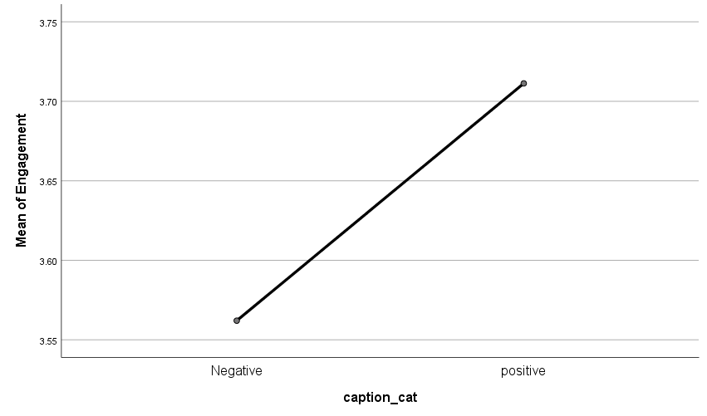

Two way ANOVA

Descriptive Statistics
Dependent Variable: Engagement
Expert_cat | caption_cat | Mean | Std. Deviation | N
low | Negative | 3.2273 | 1.20952 | 66
 | Positive | 3.8289 | 1.17559 | 76
 | Total | 3.5493 | 1.22483 | 142
high | Negative | 3.8393 | 1.40975 | 70
 | Positive | 3.5758 | 1.43913 | 66
 | Total | 3.7114 | 1.42494 | 136
Total | Negative | 3.5423 | 1.34700 | 136
 | Positive | 3.7113 | 1.30611 | 142
 | Total | 3.6286 | 1.32658 | 278

Tests of Between–Subjects Effects
Dependent Variable: Engagement
Source | Type III Sum of Squares | df | Mean Square | F | Sig. | Partial Eta Squared
Corrected Model | 16.972ª | 3 | 5.657 | 3.295 | .021 | .035
Intercept | 3626.487 | 1 | 3626.487 | 2111.950 | .000 | .885
Expert_cat | 2.230 | 1 | 2.230 | 1.298 | .255 | .005
caption_cat | 1.980 | 1 | 1.980 | 1.153 | .284 | .004
Expert_cat * caption_cat | 12.963 | 1 | 12.963 | 7.549 | .006 | .027
Error | 470.493 | 274 | 1.717
Total | 4147.813 | 278
Corrected Total | 487.465 | 277
a. R Squared = .035 (Adjusted R Squared = .024)

Appendix 4.4 Controlling variable- age, gender, and education

February sample of 158
results of regression analysis by controlling variables - age gender and education
Dependent variable | Independent variable | β | R² | ΔR²
 | Control variables |  | 0.012
SCV_image | Involvement | .751*** | 0.428 | 0.416***
 | Control variables |  | 0.014
SCV_engrossment | Involvement | .211* | 0.057 | .043*
 | Control variables |  | 0.025
SCV_self projection | Involvement | .638*** | 0.327 | .302***
 | Control variables |  | 0.014
SCV_mental fluency | Involvement | 0.598*** | 0.227 | .213***
 | Control variables |  | 0.021
social media engagement | SCV_image | 0.237** | 0.378 | .357***
 | SCV_engrossment | 0.065
 | SCV_self projection | 0.177
 | SCV_mental fluency | 0.18*
 | Control variables |  | 0.009
Pleasure | SCV_image | 0.322*** | 0.434 | .425***
 | SCV_engrossment | 0.014
 | SCV_self projection | 0.032
 | SCV_mental fluency | 0.234***
 | Control variables |  | 0.016
Arousal | SCV_image | 0.139* | 0.313 | .297***
 | SCV_engrossment | 0.063
 | SCV_self projection | 0.179*
 | SCV_mental fluency | 0.061
 | Control variables |  | 0.014
Dominance | SCV_image | 0.022 | 0.09 | .076*
 | SCV_engrossment | -0.092
 | SCV_self projection | 0.172*
 | SCV_mental fluency | -0.013
 | Control variables |  | 0.034
Ad attitude | Pleasure | 0.946*** | 0.641 | .606***
 | Control variables |  | 0.034
Ad attitude | Arousal | .684*** | 0.238 | .203***
 | Control variables |  | 0.034
Ad attitude | Dominance | 0.247 | 0.057 | 0.023
 | Control variables |  | 0.021
social media engagement | Ad attitude | .578*** | 0.4 | .379***
 | Control variables |  | 0.008
Purchase intention | Ad attitude | .601*** | 0.331 | .323***
 | Control variables |  | 0.02
Normative influence | Social media engagement | .338*** | 0.12 | .101***
 | Control variables |  | 0.023
Informative infulence | Social media engagement | .463*** | 0.203 | .180***
 | Control variables |  | 0.008
Purchase intention | Normative influence | .340*** | 0.108 | 0.1***
 | Control variables |  | 0.008
Purchase intention | Informative infulence | .408*** | 0.158 | .15***
 | Control variables |  | 0.092
Behavioural intention | Purchase intention | 0.284*** | 0.208 | .116***
***p < .001 | The first of row every cell represents model 1with the control variables and the second row represents the model 2 with the independent variables from the model
**p < .005
*p < .05
April sample of 121
results of regression analysis by controlling variables - age gender and education
Dependent variable | Independent variable | β | R² | ΔR²
 | Control variables |  | 0.029
SCV_image | Involvement | .688*** | 0.367 | .338***
 | Control variables |  | 0.013
SCV_engrossment | Involvement | .183* | 0.061 | .048*
 | Control variables |  | 0.008
SCV_self projection | Involvement | .542*** | 0.263 | .255***
 | Control variables |  | 0.009
SCV_mental fluency | Involvement | .552*** | 0.223 | .214***
 | Control variables |  | 0.001
social media engagement | SCV_image | 0.117 | 0.324 | .323***
 | SCV_engrossment | -0.022
 | SCV_self projection | 0.46***
 | SCV_mental fluency | 0.023
 | Control variables |  | 0.02
Pleasure | SCV_image | 0.288*** | 0.488 | .467***
 | SCV_engrossment | -0.067
 | SCV_self projection | 0.13
 | SCV_mental fluency | 0.243**
 | Control variables |  | 0.011
Arousal | SCV_image | 0.138* | 0.216 | .205***
 | SCV_engrossment | 0.023
 | SCV_self projection | 0.172
 | SCV_mental fluency | 0.071
 | Control variables |  | 0.005
Dominance | SCV_image | 0.18** | 0.098 | .093*
 | SCV_engrossment | -0.041
 | SCV_self projection | -0.013
 | SCV_mental fluency | 0.009
 | Control variables |  | 0.028
Ad attitude | Pleasure | .799*** | 0.554 | .526***
 | Control variables |  | 0.028
Ad attitude | Arousal | .476*** | 0.179 | .151***
 | Control variables |  | 0.028
Ad attitude | Dominance | 0.236 | 0.054 | 0.026
 | Control variables |  | 0.001
social media engagement | Ad attitude | .459*** | 0.191 | .190***
 | Control variables |  | 0.017
Purchase intention | Ad attitude | .589*** | 0.33 | .313***
 | Control variables |  | 0.019
Normative influence | Social media engagement | .435*** | 0.215 | .196***
 | Control variables |  | 0.023
Informative infulence | Social media engagement | .485*** | 0.228 | .205***
 | Control variables |  | 0.0117
Purchase intention | Normative influence | .368*** | 0.146 | .128***
 | Control variables |  | 0.017
Purchase intention | Informative infulence | 0.388*** | 0.186 | .168***
 | Control variables |  | 0.022
Behavioural intention | Purchase intention | .238** | 0.117 | .095**
***p < .001
**p < .005 | The first of row every cell represents model 1with the control variables and the second row represents the model 2 with the independent variables from the model
*p < .05

Reference list

Aagerup, U., & Nilsson, J. (2016). Green consumer behavior: being good or seeming good? Journal of Product and Brand Management, 25(3), 274–284. doi:10.1108/jpbm–06–2015–0903
Aaker, D. A., Stayman, D. M. and Vezina, R. (1988) ' Identifying feelings elicited by advertising', Psychology & Marketing, 5(1), pp. 1–16.
Accenture (2018) To affinity and beyond: from me to we, the rise of the purpose – led brand. Available at: https://www.accenture.com/t20190201T104905Z__w__/us–en/_acnmedia/Thought–Leadership–Assets/PDF/Accenture–CompetitiveAgility–GCPR–POV.pdf (accessed 1st May 2020)
Ahmed, W. (2018). Using social media data for research: An overview of tools. Journal of Communication Technology, 1(1), 78-93.
Algesheimer, R., Dholakia, U. M. and Herrmann, A. (2005) ‘The social influence of brand community: Evidence from European car clubs’, Journal of Marketing, 69(3), pp. 19–34. Available from: http://web.b.ebscohost.com/ehost/pdfviewer/pdfviewer?vid=6&sid=0ac6a5f6–a0be–4d5c–a00c–ce48d68f7924%40sessionmgr104 . (Accessed: 20th November 2017).
Akman, I. and Mishra, A. (2017) 'Factors influencing consumer intention in social commerce adoption', Information Technology & People, 30(2), pp. 356–370. Doi: 10.1108/ITP–01–2016–0006
Amit, E. and Joshua D. Greene (2012), “You See, the Ends Don't Justify the Means: Visual Imagery and Moral Judgment,” Psychological Science, 23(8,) 861–868. Doi: 10.1177/0956797611434965
Andersen. P. H. (2005) ‘Relationship marketing and brand involvement of professionals through web–enhanced brand communities: the case of Coloplast’, Industrial Marketing Management, 34 (3), pp. 285– 297. doi:10.1016/j.indmarman.2004.07.007
Andreoli, V. and Worchel, S. (1978) 'Effects of Media, Communicator, and Message Position on Attitude Change', Public opinion quarterly, 42(1), pp. 59-70.
Andrews, J. C., Akhter, S. H., Durvasula, S. and Muehling, D.D. (1992) ' The effects of advertising distinctiveness and message content involvement on cognitive and affective responses to advertising', Journal of Current Issues & Research in Advertising, 14(1), pp. 45–58. Doi: 10.1080/10641734.1992.10504979
Angus, A. (2018) Top 10 Global Consumer Trends for 2018 Emerging Forces Shaping Consumer Behaviour, Euromonitor International. Available from: http://go.euromonitor.com/white–paper–economies–consumers–2018–global–consumer–trends–EN.html (Accessed: 10th January 2018).
Antonetti, P., & Maklan, S. (2014). Feelings that Make a Difference: How Guilt and Pride Convince Consumers of the Effectiveness of Sustainable Consumption Choices. Journal of Business Ethics, 124(1), 117–134. doi:10.1007/s10551–013–1841–9
Antonetti, P., Manika, D., and Katsikeas, C. (2019). Why consumer animosity reduces product quality perceptions: The role of extreme emotions in international crises. International Business Review, 28(4), 739–753. Doi: 10.1016/j.ibusrev.2019.02.003
Arli, D., & Tjiptono, F. (2017). God and green: Investigating the impact of religiousness on green marketing. International Journal of Nonprofit and Voluntary Sector Marketing, 22(3). doi:10.1002/nvsm.1578
Aronson, E., Wilson, T. D., and Akert, A. M. (2005). Social psychology. Upper Saddle River, NJ: Prentice Hall.
Ashforth, B. E. and Meal, M. (1989) Social Identity theory and the organization. Academy of management review. 14 (1), pp. 20–39. Doi: 10.5465/AMR.1989.4278999.
Austgulen, M. H. (2014). Environmentally sustainable meat consumption: An analysis of the Norwegian public debate. Journal of Consumer Policy, 37(1), 45–66. DOI 10.1007/s10603–013–9246–9
Axsen, J., Orlebar, C. and Skippon, S. (2013) 'Social influence and consumer preference formation for pro–environmental technology: The case of a UK workplace electric–vehicle study', Ecological Economics, 95, pp. 96–107. Doi: 10.1016/j.ecolecon.2013.08.009
Back, M. D., Stopfer, J. M., Vazire, S., Gaddis, S., Schmukle, S. C., Egloff, B. and Gosling, S. D. (2010) Facebook Profiles Reflect Actual Personality, Not Self–Idealization, Psychological Science, 21(3) 372–374. Doi: 10.1177/0956797609360756.
Baek, T.H., Kim, S., Yoon, S., Choi, Y.K., Choi, D. and Bang, H. (2021) 'Emojis and assertive environmental messages in social media campaigns', Internet Research, pp. 1066-2243.
Bakker, I., van der Voordt, T., Vink, P. and de Boon, J., (2014). Pleasure, arousal, dominance: Mehrabian and Russell revisited. Current Psychology, 33(3), pp.405–421. doi: 10.1007/s12144–014–9219–4
Balderjahn, I., Buerke, A., Kirchgeorg, M., Peyer, M., Seegebarth, B. and Wiedmann, K.P. (2013) 'Consciousness for sustainable consumption: scale development and new insights in the economic dimension of consumers’ sustainability', AMS review, 3(4), pp. 181-192.
Banbury, C., Stinerock, R. and Subrahmanyan, S. (2012) Sustainable consumption: Introspecting across multiple lived cultures. Journal of Business Research. 65(4) pp. 497–503. doi:10.1016/j.jbusres.2011.02.028.
Bansal, P. and Roth, K. (2000) ' Why companies go green: A model of ecological responsiveness', Academy of management journal, 43(4), pp. 717–736.
Bapna, S., Benner, M.J. and Liangfei, Q. (2019) 'NURTURING ONLINE COMMUNITIES: AN EMPIRICAL INVESTIGATION', MIS Quarterly, 43(2), pp. 425–452. Doi: 10.25300/MISQ/2019/14530
Barreto, A. and Ramalho, D. (2019), "The impact of involvement on engagement with brand posts", Journal of Research in Interactive Marketing, 13(3) pp. 277–301. Doi: 10.1108/JRIM–01–2018–0013
Barry, J. M., & Graça, S. S. (2018). HUMOR EFFECTIVENESS IN SOCIAL VIDEO ENGAGEMENT. Journal of Marketing Theory & Practice, 26(1/2), 158–180. doi:10.1080/10696679.2017.1389247
Barsalou, L. W. (2008). Grounded cognition. Annu. Rev. Psychol., 59, 617–645. Doi: 10.1146/annurev.psych.59.103006.093639
Basu, K., & Palazzo, G. (2008). Corporate social responsibility: A process model of sensemaking. Academy of management review, 33(1), 122–136. Doi: 10.5465/amr.2008.27745504
Batra, R. and Stephens, D. (1994) ' Attitudinal effects of ad‐evoked moods and emotions: The moderating role of motivation', Psychology & Marketing, 11(3), pp. 199–215. Doi: 10.1002/mar.4220110302
Batra, R., & Ray, M. L. (1986). Affective responses mediating acceptance of advertising. Journal of consumer research, 13(2), 234–249.doi:10.1086/209063
Bbc.co.uk (2021) Asda: George brand to sell second–hand clothing in shops. Available at https://www.bbc.co.uk/news/business–56916414?at_medium=custom7&at_custom3=BBC+Family+%26+Education+News&at_custom4=16A94762–A8C9–11EB–A030–E0BF923C408C&at_custom1=%5Bpost+type%5D&at_campaign=64&at_custom2=facebook_page&fbclid=IwAR15t–tWE0a27J–PB08UYiXxGA97cH9CI–wKi4gr4S59f3hnD1PBJN2CYAY (Accessed on: 9th May 2021)
BCG (2018) Total social impact. Available at: https://www.bcg.com/d/press/25october2017–total–societal–impact–174436 (Accessed on 10th December 2018)
Behl, A., & Dutta, P. (2019). Humanitarian supply chain management: a thematic literature review and future directions of research. Annals of Operations Research, 283(1), 1001–1044. Doi : 10.1007/s10479–018–2806–2
Belz, F. M. and Peattie, K. (2012) Sustainability marketing. 2nd edition. India: Wiley.
Benson, V., Jean–Noel, E. and Hand, C. (2019) 'An empirical study of purchase behaviour on social platforms', Information Technology & People, 32(4), pp. 876–896. Doi: 10.1108/ITP–08–2017–0267
Benson, V., Saridakis, G. and Tennakoon, H. (2015) 'Information disclosure of social media users', Information Technology & People, 28(3), pp. 426–441. Doi: 10.1108/ITP–10–2014–0232
Berger, J. and Milkman, K.L. (2012) 'What Makes Online Content Viral??', Journal of Marketing Research (JMR), 49(2), pp. 192-205.
Berkowitz, L. (1986) 'The elaboration likelihood model of persuasion', Advances in experimental social psychology, 19, pp. 123–205.
Bhattacharya, C. B. and Sen, S. (2003) Consumer–Company Identification: A Framework for Understanding Consumers' Relationships with Companies. Journal of Marketing. 67 (2). Pp 76–88. Available from: http://web.a.ebscohost.com/ehost/pdfviewer/pdfviewer?vid=3&sid=e35d2b98–eba6–4dae–b288–d9a8aa9aac1e%40sessionmgr4006 [Accessed February 25th 2018]
Bhattacharya, C. B., Rao, H. and Glynn, M. A. (1995) ‘Understanding the bond of identification: An investigation of its correlates among art museum members’, Journal of Marketing, 59 (4), pp. 46–57. Available fromhttp://web.a.ebscohost.com/ehost/pdfviewer/pdfviewer?vid=10&sid=0fe7fb3d–38f9–4172–b55a–7352b129af3a%40sessionmgr4009[Accessed February 25th 2018]
Bickart, B. A. & Ruth, J. A. (2012) Green Eco–Seals and Advertising Persuasion, Journal of Advertising, 41(4), 51–67, DOI: 10.1080/00913367.2012.10672457
Binder, M. and Blankenberg, A. K. (2017) “Green lifestyles and subjective well–being: More about self–image than actual behavior?”, Journal of Economic Behavior& Organization, 137, pp. 304–323. doi: 10.1016/j.jebo.2017.03.009.
Bishop, J. (2007). Increasing participation in online communities: A framework for human–computer interaction. Computers in human behavior, 23(4), 1881–1893. doi: 10.1016/j.chb.2005.11.004
Black, J. S.; Stern, P. C.; Elworth, J. T. (1985) “Personal and Contextual Influences on Household Energy Adaptations” Journal of Applied Psychology. , Vol. 70(1), p3–21. 19p. 4 Diagrams, 2 Charts. DOI: 10.1037/0021–9010.70.1.3.
Blazevic, V., Hammedi, W., Garnefeld, I., Rust, R. T., Keiningham, T., Andreassen, T. W., Donthu, N. and Carl, W. (2013) "Beyond traditional word‐of‐mouth: An expanded model of customer‐driven influence", Journal of Service Management, 24(3), pp. 294–313. Doi: 10.1108/09564231311327003.
Bloch, P. H., Sherrell, D. L., & Ridgway, N. M. (1986). Consumer search: An extended framework. Journal of consumer research, 13(1), 119–126. Doi: 10.1086/209052
Bocken, N. M., & Short, S. W. (2016). Towards a sufficiency–driven business model: Experiences and opportunities. Environmental Innovation and Societal Transitions, 18, 41–61. https://doi.org/10.1016/j.eist.2015.07.010
Bolton, R. N., Parasuraman, A., Hoefnagels, A., Migchels, N., Kabadayi, S., Gruber, T., Loreiro, Y. K. and Solnet, D. (2013) "Understanding Generation Y and their use of social media: a review and research agenda", Journal of Service Management, Vol. 24 Issue: 3, pp.245–267, https://doi.org/10.1108/09564231311326987
Bondy, T. and Talwar, V. (2011) ‘Through Thick and Thin: How Fair Trade Consumers Have Reacted to the Global Economic Recession’, Journal of Business Ethics. 101(3), pp. 365–383. Doi: 10.1007/s10551–010–0726–4.
Bone, P. F. and Ellen, P. S., (1992). The generation and consequences of communication–evoked imagery. Journal of Consumer Research, 19(1), pp.93–104. Doi: /10.1086/209289
Bowden, J. L. H. (2009) ‘The process of customer engagement: A conceptual framework’, Journal of Marketing Theory and Practice, 17(1), pp. 63–74. doi:10.2753/MTP1069–6679170105
Braun, V., & Clarke, V. (2006). Using thematic analysis in psychology. Qualitative Research in Psychology, 3(2), 77–101. doi:10.1191/1478088706qp063oa
Braun, V., & Clarke, V. (2012). Thematic analysis. In H. Cooper, P. M. Camic, D. L. Long, A. T. Panter, D. Rindskopf, & K. J. Sher (Eds.), APA handbooks in psychology®. APA handbook of research methods in psychology, Vol. 2. Research designs: Quantitative, qualitative, neuropsychological, and biological (p. 57–71). American Psychological Association. https://doi.org/10.1037/13620–004
Breves, P.L., Liebers, N., Abt, M. and Kunze, A. (2019) 'The perceived fit between instagram influencers and the endorsed brand: How influencer–brand fit affects source credibility and persuasive effectiveness.', Journal of Advertising Research, 59(4), pp. 440-454. Doi: 10.2501/JAR-2019-030
Briner, R. B., Denyer, D., & Rousseau, D. M. (2009). Evidence–Based Management: Concept Cleanup Time? Academy of Management Perspectives, 23(4), 19–32. doi:10.5465/amp.23.4.19
Brodie, R. J., Hollebeek, L. D., Juric´, B., and Ilic, A. (2011) ‘Customer engagement: conceptual domain, fundamental propositions, and implications for research’, Journal of Service Research, 14(3), pp. 252–271. doi: 10.1177/1094670511411703.
Brodie, R. J., Ilic, A., Juric, B. and Hollebeek, L. (2013) ‘Consumer engagement in a virtual brand community: An exploratory analysis’, Journal of Business Research, 66(1), pp. 105–114. doi:10.1016/j.jbusres.2011.07.029.
Brooks, J. S. and Wilson, C. (2015) 'The influence of contextual cues on the perceived status of consumption–reducing behavior', Ecological Economics, 117, pp. 108–117. Doi: 10.1016/j.ecolecon.2015.06.015
Brough, A. R., Wilkie, J. E. B., Jingjing, M. A., Isaac, M. S., & Gal, D. (2016). Is Eco–Friendly Unmanly? The Green–Feminine Stereotype and Its Effect on Sustainable Consumption. Journal of Consumer Research, 43(4), 567–582. doi:10.1093/jcr/ucw044
Buenstorf, G. and Cordes, C. (2008) 'Can Sustainable–consumption be learned? A model of cultural evolution', Ecological Economics, 67(4), pp. 646–657.
Burton, J.L., Mueller, K.M., Gollins, J. and Walls, D.M. (2019) 'The impact of airing super bowl television ads early on social media: Benefits and drivers of watching, liking, and sharing advertisements on social media.', Journal of Advertising Research, 59(4), pp. 391-401.
Calder, B. J., Malthouse, E. C. and Schaedel, U. (2009) ‘An Experimental Study of the Relationship between Online Engagement and Advertising Effectiveness’, Journal of Interactive Marketing, 23(4), pp. 321–331. doi:10.1016/j.intmar.2009.07.002.
Calder, B. J., Phillips, L. W. and Tybout, A. M. (1981), “Designing research for application”, Journal of Consumer Research, Vol. 8 No. 2, pp. 197–207.
Cao, D., Meadows, M., Wong, D. and Xia, S. (2021) ' Understanding consumers’ social media engagement behaviour: An examination of the moderation effect of social media context', Journal of Business Research, 122, pp. 835-846.
Caprar, D. V. and Neville, B. A. (2012) ‘"Norming" and "Conforming": Integrating Cultural and Institutional Explanations for Sustainability–adoption in Business’, Journal of Business Ethics, 110(2), pp. 231–245. doi: 10.1007/s10551–012–1424–1.
Carlson, J., Rahman, M., Voola, R. and De Vries, N., (2018) "Customer engagement behaviours in social media: capturing innovation opportunities", Journal of Services Marketing, Vol. 32 Issue: 1, pp.83–94, https://doi.org/10.1108/ JSM–02–2017–0059.
Carlson, J.R., Hanson, S., Pancras, J., Ross, W.T. and Rousseau‐Anderson, J. (2022) 'Social media advertising: How online motivations and congruency influence perceptions of trust', Journal of Consumer Behaviour, 21(2), pp. 197-213.

Carrington, M. J., Neville, B. A. and Whitwell, G. J. (2010) 'Why Ethical Consumers Don't Walk Their Talk: Towards a Framework for Understanding the Gap Between the Ethical Purchase Intentions and Actual Buying Behaviour of Ethically Minded Consumers', Journal of Business Ethics 97(1), pp. 139–158. Doi: 10.1007/s10551–010–0501–6
Carrington, M. J., Neville, B. A. and Whitwell, G. J. (2014) 'Lost in translation: Exploring the ethical consumer intention–behavior gap', Journal of Business Research, 67(1), pp. 2759–2767. Doi: 10.1016/j.jbusres.2012.09.022
Carroll, A. B. (1999) ‘Corporate Social Responsibility; Evolution of a Definitional Construct’. Business & Society, 38 (3), pp. 268–295.
Casalo´, L. V., Flavia´ N, C. and Guinali´u, M. (2008) ‘Promoting consumer’s participation in virtual brand communities: A new paradigm in branding strategy’, Journal of Marketing Communications, 14(1), pp. 19–36. doi: 10.1080/13527260701535236.
Cervellon, M.C. (2012) 'Victoria's dirty secrets: Effectiveness of green not-for-profit messages targeting brands', Journal of Advertising, 41(4), pp. 133-145. Doi: 10.2753/JOA0091-3367410409
Chamberlain, L. and Broderick, A. J. (2007), "The application of physiological observation methods to emotion research", Qualitative Market Research, 10 (2), pp. 199–216. doi:10.1108/13522750710740853
Chan, K. W. and Li, S. Y. (2010) ‘Understanding consumer–to–consumer interactions in virtual communities: The salience of reciprocity’, Journal of Business Research, 63(9–10), pp. 1033–1040. doi:10.1016/j.jbusres.2008.08.009.
Chan, R.Y., Wong, Y. H. and Leung, T. K. (2008) 'Applying ethical concepts to the study of “green” consumer behavior: An analysis of Chinese consumers’ intentions to bring their own shopping bags', Journal of Business Ethics, 79(4), pp. 469–481. Doi: 10.1007/s10551–007–9410–8
Chandran, S. and Morwitz, V. G. (2005) 'Effects of participative pricing on consumers' cognitions and actions: A goal theoretic perspective', Journal of Consumer Research, 32(2), pp. 249–259. Doi: 10.1086/432234
Chang (2012), “The Role of Ad–evoked Consumption Visions in Predicting Brand Attitudes: A Relevancy Principle Model,” Psychology and Marketing, 29, 12, 956–67.
Chang, A., Hsieh, S. H., & Lin, F. (2013). Personality Traits That Lead Members of Online Brand Communities to Participate in Information Sending and Receiving. International Journal of Electronic Commerce, 17(3), 37–61. doi:10.2753/jec1086–4415170302
Chen, S. C. and Hung, C. W. (2016) 'Elucidating the factors influencing the acceptance of green products: An extension of theory of planned behavior', Technological Forecasting and Social Change, 112, pp. 155–163.
Chen, X., Li, X., Yao, D. and Zhou, Z. (2019) 'Seeking the support of the silent majority: are lurking users valuable to UGC platforms?', Journal of the Academy of Marketing Science, 47(6), pp. 986–1004. Doi: 10.1007/s11747–018–00624–8
Chiu, C. M., Hsu, M. H. and Wang, E. T. G. (2006) 'Understanding knowledge sharing in virtual communities: An integration of social capital and social cognitive theories', Decision Support Systems, 42(3), pp. 1872–1888. doi:10.1016/j.dss.2006.04.001
Cho, Y. N., Thyroff, A., Rapert, M. I., Park, S. Y. and Lee, H. J. (2013) To be or not to be green: Exploring individualism and collectivism as antecedents of environmental behaviour, Journal of Business Research, 66 (8), pp. 1052–1059. doi:10.1016/j.jbusres.2012.08.020.
Choi, S. and Ng, A. (2011) ‘Environmental and economic dimensions of sustainability and price effects on consumer responses’, Journal of Business Ethics, 104(2), pp. 269–282. doi: 10.1 007/s 1 055 1–011 –0908–8.
Chorusanalytics.co.uk (2021) available at: The Chorus project: making sense from twitter. http://chorusanalytics.co.uk/#:~:text=Hence%2C%20the%20Chorus%20project%20is,for%20an%20audience%20unused%20to (Accessed on 24th May 2021)
Christensen, G. L., Olson, J. C. and Ross, W. T. ( 2004) 'Why Consumption Vision? Understating Consumer Value in Anticipatory Consumption Imaging', Advances in Consumer Research, North American Advances., 31, pp. 130–131.
Chung, S. and Cho, H. (2017) 'Fostering Parasocial Relationships with Celebrities on Social Media: Implications for Celebrity Endorsement', Psychology & Marketing, 34(4), pp. 481–495. Doi: 10.1002/mar.21001
Churchill, G. A Jr. (1979), ‘A Paradigm for Developing Better Measures for Marketing Constructs’. Journal of Marketing Research, 16 (1).
Citytosea.org.uk (2019) “COMPLAINT MADE OVER “MISLEADING” COCA–COLA ADVERT” available at: https://www.citytosea.org.uk/complaint–made–over–misleading–coca–cola–advert/ (accessed 15th Dec 2020)
Claffey, E. and Brady, M. (2017) 'Examining Consumers' Motivations to Engage in Firm–Hosted Virtual Communities', Psychology & Marketing, 34(4), pp. 356–375. Doi: 10.1002/mar.20994.
Cohen, J. (1988). Statistical power analysis for the behavioral sciences. 2nd edition. Academic press.
Colliander, J., & Dahlén, M. (2011). Following the fashionable friend: The power of social media: Weighing publicity effectiveness of blogs versus online magazines. Journal of advertising research, 51(1), 313–320. Doi: 10.2501/JAR–51–1–313–320
Collis, J. and Hussey, R. (2014) Business research: A practical guide for undergraduate and postgraduate students. 4 edn. UK: Macmillan International Higher Education.
Cova, B. & Dalli, D. (2009) ‘Working consumers: the next step in marketing theory?’, Marketing Theory, 9(3), pp. 315–339. doi: 10.1177/1470593109338144.
Cova, B. and Pace, S. (2006) ‘Brand community of convenience products: new forms of customer empowerment – the case “my Nutella the Community”’, European Journal of Marketing, 40(9/10), pp.1087–1105. doi:10.1108/03090560610681023.
Craig, G. (2019). Advertising Sustainability. In Media, Sustainability and Everyday Life (pp. 83–109). Palgrave Macmillan, London. Doi: 10.1057/978–1–137–53469–9_4
Crosby, L. A. and Taylor, J. R. (1983), “Psychological Commitment and Its Effects on Post–Decision Evaluation and Preference Stability Among Voters,” Journal of Consumer Research, 9 (4), 413–431. Doi: 10.1086/208935
Data.worldbank.org (2021) Fossil fuel energy consumption (% of total). Available at: https://data.worldbank.org/indicator/EG.USE.COMM.FO.ZS (Accessed on 27th May 2021)
Datatopics.worldbank.org (2021) 12- RESPONSIBLE CONSUMPTION AND PRODUCTION: Managing plastic and food waste for a sustainable future. Available at: https://datatopics.worldbank.org/sdgatlas/goal-12-responsible-consumption-and-production/ (Accessed on 27th May 2021).
Davari, A. and Strutton, D. (2014) ‘Marketing mix strategies for closing the gap between green consumers’ pro–environmental beliefs and behaviors’, Journal of Strategic Marketing, 22(7), pp. 563–586. doi: 10.1080/0965254X.2014.914059.
Davies, I. A., & Gutsche, S. (2016). Consumer motivations for mainstream "ethical" consumption. European Journal of Marketing, 50(7–8), 1326–1347. doi:10.1108/ejm–11–2015–0795
De Bakker, F. G., & Hellsten, I. (2013). Capturing online presence: Hyperlinks and semantic networks in activist group websites on corporate social responsibility. Journal of Business Ethics, 118(4), 807–823. Doi: 10.1007/s10551–013–1962–1
DeBono, K. G., & Harnish, R. J. (1988). Source expertise, source attractiveness, and the processing of persuasive information: A functional approach. Journal of Personality and social Psychology, 55(4), 541. Doi: 10.1037/0022–3514.55.4.541
de Gregorio, F., & Sung, T. (2010). Understanding attitudes toward and behaviors in response to product placement. Journal of Advertising, 39(1), 83–96. doi: 10.2753/JOA0091–3367390106.
de Oliveira Santini, F., Ladeira, W. J., Pinto, D. C., Herter, M. M., Sampaio, C.H. and Babin, B.J. (2020) 'Customer engagement in social media: a framework and meta–analysis', Journal of the Academy of Marketing Science, 48(6), pp. 1211–1228. Doi: 10.1007/s11747–020–00731–5
De Pelsmacker, P., Dens, N. and Kolomiiets, A. (2018) 'The impact of text valence, star rating and rated usefulness in online reviews', International Journal of Advertising, 37(3), pp. 340–359. Doi: 10.1080/02650487.2018.1424792
de Valck, K., van Bruggen, G. H. and Wierenga, B. (2009) ‘Virtual communities: A marketing perspective’, Decision Support Systems, 47(3), pp. 185–203. doi:10.1016/j.dss.2009.02.008.
Delbaere, M., Michael, B. and Phillips, B.J. (2021) 'Social media influencers: A route to brand engagement for their followers', Psychology & Marketing, 38(1), pp. 101-112.
Demmers, J., van Dolen, W.M. and Weltevreden, J. W. J. (2018) 'Handling Consumer Messages on Social Networking Sites: Customer Service or Privacy Infringement?', International Journal of Electronic Commerce, 22(1), pp. 8–35. Doi: 10.1080/10864415.2018.1396110
Demmers, J., Weltevreden, J. W. J. and van Dolen, W. M. (2020) 'Consumer Engagement with Brand Posts on Social Media in Consecutive Stages of the Customer Journey', International Journal of Electronic Commerce, 24(1), pp. 53–77. Doi: 10.1080/10864415.2019.1683701
Dermody, J., Hanmer–Lloyd, S., Koenig–Lewis, N., & Zhao, A. L. (2015). Advancing sustainable consumption in the UK and China: the mediating effect of pro–environmental self–identity. Journal of Marketing Management, 31(13–14), 1472–1502. doi:10.1080/0267257X.2015.1061039
Dermody, J., Koenig–Lewis, N., Zhao, A. L., & Hanmer–Lloyd, S. (2018). Appraising the influence of pro–environmental self–identity on sustainable consumption buying and curtailment in emerging markets: Evidence from China and Poland. Journal of Business Research, 86, 333–343. doi:10.1016/j.jbusres.2017.09.041
Desmet, P., (2010) ‘Are emotions consequences of affective expectations? A commentary essay’. Journal of Business Research, 63(8), pp.903–904. Doi: 10.1016/j.jbusres.2009.09.006
Dessart, L. (2017). Social media engagement: a model of antecedents and relational outcomes. Journal of Marketing Management, 33(5–6), 375–399. doi:10.1080/0267257x.2017.1302975
Dessart, L., Veloutsou, C. and Morgan–Thomas, A. (2015) "Consumer engagement in online brand communities: a social–media perspective", Journal of Product and Brand Management, 24(1), pp. 28–42. doi:10.1108/JPBM–06–2014–0635.
Deutsch, M. and Gerard, H. B. (1955) 'A study of normative and informational social influences upon individual judgment', The Journal of Abnormal and Social Psychology, 51(3), pp. 629–636. Doi: 10.1037/h0046408
Dholakia, U. M., Bagozzia, R. P. and Pearo, L. K. (2004) ‘A social influence model of consumer participation in network– and small–group–based virtual communities’, International Journal of Research in Marketing, 21(3), pp. 241–263. doi:10.1016/j.ijresmar.2003.12.004.
Dindar, M. and Yaman, N. D. (2018) '#IUseTwitterBecause: content analytic study of a trending topic in Twitter', Information Technology & People, 31(1), pp. 256–277. Doi: 10.1108/ITP–02–2017–0029
Dolan, R., Conduit, J., Fahy, J. and Goodman, S. (2016) 'Social–media–engagement behaviour: a uses and gratifications perspective', Journal of Strategic Marketing, 24(3), pp. 261–277.
Eckler, P. and Bolls, P. (2011) ' Spreading the Virus, Emotional Tone of Viral Advertising and Its Effect on Forwarding Intentions and Attitudes', Journal of Interactive Advertising, 11(2), pp. 1-11.
Edelman, (2018) earned brands, An annual global study of how brands earn, strengthen and protect their relationships with consumers. (https://www.edelman.com/sites/g/files/aatuss191/files/2018–10/2018_Edelman_Earned_Brand_Executive_Summary_Brochure.pdf).
Egea, J. M. O., & de Frutos, N. G. (2013). Toward consumption reduction: An environmentally motivated perspective. Psychology & Marketing, 30(8), 660–675. Doi: doi.10.1002/mar.20636
EPI (2020) 2018 Environmental Performance Index (EPI) https://epi.yale.edu/epi-results/2020/country/ltu (Accessed on 24th May 2021)
Erevelles, S. (1998). The role of affect in marketing. Journal of Business Research, 42(3), 199–215. 10.1016/S0148–2963(97)00118–5
Errmann, A., Seo, Y., Choi, Y. K., & Yoon, S. (2019). Divergent effects of friend recommendations on disclosed social media advertising in the United States and Korea. Journal of Advertising, 48(5), 495-511. Doi: 10.1080/00913367.2019.1663320
Ertz, M., Karakas, F. and Sarigöllü, E. (2016) 'Exploring pro–environmental behaviors of consumers: An analysis of contextual factors, attitude, and behaviors', Journal of Business Research, 69(10), pp. 3971–3980. Doi: 10.1016/j.jbusres.2016.06.010
Escalas, Jennifer (2004), “Imagine Yourself in the Product: Mental Simulation, Narrative Transportation, and Persuasion,” Journal of Advertising, 33(2) 37–48.
Escobar, M. L., Kommers, P. A. and Beldad, A. (2014) 'Using narratives as tools for channeling participation in online communities', Computers in human behavior, 37, pp. 64–72. Doi: 10.1016/j.chb.2014.04.013
ethicalhour.co.uk (2021) CONSUMER SUSTAINABILITY TRENDS 2021: WHAT TRENDS TO WATCH. Available at: https://ethicalhour.co.uk/consumer-sustainability-trends-2021/#proof (accessed on 30th May 2021)
Etikan, I., Musa, S. A. and Alkassim, R. S., 2016. Comparison of convenience sampling and purposive sampling. American journal of theoretical and applied statistics, 5(1), pp.1–4.
europeanbusinessreview.com (2017) Sustainability: A $12 Trillion a Year Market by 2030. Available at: https://www.europeanbusinessreview.com/sustainability-a-12-trillion-a-year-market-by-2030/ (accessed on 29th May 2021 )
Evers, U., Gruner, R. L., Sneddon, J., & Lee, J. A. (2018). Exploring materialism and frugality in determining product end‐use consumption behaviours. Psychology & Marketing, 35(12), 948–956. DOI: 10.1002/mar.21147
Fairweather, G. W. and Tornatzky, L. G. (1977) Experimental methods for social policy research. 1 edn. Oxford: Pergamon.
Fernando, A. G., Suganthi, L. and Sivakumaran, B. (2014) ‘If You Blog, Will They Follow? Using Online Media to Setthe Agenda for Consumer Concerns on “Greenwashed” Environmental Claims’, Journal of Advertising, 43(2), pp. 167–180. doi: 10.1080/00913367.2013.841088.
Field, A. (2018). Discovering Statistics Using IBM SPSS Statistics 5th ed. Los Angeles, Sage.
Fieseler, C., & Fleck, M. (2013). The pursuit of empowerment through social media: Structural social capital dynamics in CSR–blogging. Journal of business ethics, 118(4), 759–775. DOI 10.1007/s10551–013–1959–9
Fischer, D., Stanszus, L., Geiger, S., Grossman, P. and Schrader, U. (2017) 'Mindfulness and sustainable consumption: A systematic literature review of research approaches and findings', Journal of Cleaner Production, 162, pp. 544-558. Doi: 10.1016/j.jclepro.2017.06.007
Folse, J. A. G., Porter, M., Godbole, M. B. and Reynolds, K. E. (2016) ‘The Effects of Negatively Valenced Emotional Expressions in Online Reviews on the Reviewer, the Review, and the Product’, Psychology and Marketing, 33(9), pp: 747–760. doi: 10.1002/mar.20914.
Fournier, S., and Avery, J. (2011). The uninvited brand. Business Horizons, 54(3),193–207. Doi: 10.1016/j.bushor.2011.01.001.
Fox, N. J. (2012) The SAGE Encyclopedia of Qualitative Research Methods. Thousand Oaks: SAGE Publications, Inc.
Foxall, G. R. and Yani–de–Soriano, M. M., (2005). ‘Situational influences on consumers' attitudes and behavior’. Journal of Business Research, 58(4), pp.518–525. Doi: 10.1016/S0148–2963(03)00142–5.
Frank, P. and Brock, C. (2018) “Bridging the intention–behavior gap among organic grocery customers: The crucial role of point–of–sale information”, Psychology and Marketing, 35 (8), pp. 586–602. DOI: 10.1002/mar.21108
Freitas–da–Costa, M., & De Oliveira, K. K. (2015). Persuasive Communication on the Internet via You Tube: Is It Possible to Increase Environmental Awareness and Consumer Engagement with Sustainability? Teoria E Prática Em Administração., 5(1), 1–24. DOI: https://doi.org/10.21714/tpa.v5i1.20254
Fuller, C. M., Simmering, M. J., Atinc, G., Atinc, Y., and Babin, B. J. (2016). Common methods variance detection in business research. Journal of Business Research, 69(8), 3192–3198. Doi: 10.1016/j.jbusres.2015.12.008
Gavilanes, J. M., Flatten, T. C., and Brettel, M. (2018) ‘Content Strategies for Digital Consumer Engagement in Social Networks: Why Advertising Is an Antecedent of Engagement’, Journal of Advertising, 47(1), pp. 4–23, doi: 10.1080/00913367.2017.1405751
Gambetti, R. C., Graffigna, G. and Biraghi, S. (2012) ‘The grounded theory approach to consumer–brand engagement: The practitioner's standpoint’, International Journal of Market Research, 54(5), pp. 659–687. doi: 10.2501/IJMR–54–5–659–687.
Gibson, K. (2018) Burberry trashes tens of millions of dollars' worth of unsold products. Available at: https://www.cbsnews.com/news/burberry–trashes–tens–of–millions–of–dollars–worth–of–unsold–products/ (Accessed date 04.03.2020)
Giddens, L., Goutas, L., Leidner, D., & Sutanto, J. (2016). Engaging Consumers in Ethical Consumption: The Effect of Real–time Environmental Information on Eco–friendly Consumer Choice. 49th Hawaii International Conference on System Sciences (HICSS) (pp. 1020–1029). DOI: 10.1109/HICSS.2016.131
Gilly, M. C.; Graham, J. L.; Wolfinbarger, M. F.; and Yale, L. J. (1998) ‘A dyadic study of interpersonal information search’. Journal of Academic of marketing Science, 26(2), 83–100. Doi: 10.1177/0092070398262001
Gironda, J.T. and Korgaonkar, P.K. (2014) 'Understanding consumers’ social networking site usage', Journal of Marketing Management, 30(5-6), pp. 571-605. Doi: 10.1080/0267257X.2013.851106
Goh K. Y., Cheng–Suang H. and Lin, Z. (2013) 'Social Media Brand Community and Consumer Behavior: Quantifying the Relative Impact of User– and Marketer–Generated Content', Information Systems Research, 24(1), pp. 88–107. Doi: 10.1287/isre.1120.0469
Goldberg, M. E., & Hartwick, J. (1990). The effects of advertiser reputation and extremity of advertising claim on advertising effectiveness. Journal of consumer research, 17(2), 172-179.
Gonçalves, H. M., Lourenço, T. F. and Silva, G. M. (2016) ‘Green buying behavior and the theory of consumption values: A fuzzy–set approach’, Journal of Business Research. 69 (4), 1484–1491. Doi: 10.1016/j.jbusres.2015.10.129.
Green, M. C., & Brock, T. C. (2000). The role of transportation in the persuasiveness of public narratives. Journal of personality and social psychology, 79(5), 701. Doi: 10.1037/0022–3514.79.5.701
Greenpeace International (2018) “Global survey reveals FMCG companies’ contribution to plastic pollution crisis”. Available from: https://www.greenpeace.org/international/press–release/19031/global–survey–reveals–fmcg–companies–contribution–to–plastic–pollution–crisis/ (Accessed 16th Oct 2020)
Greenwald, A. G., & Leavitt, C. (1984). Audience involvement in advertising: Four levels. Journal of Consumer research, 11(1), 581–592. Doi: 10.1086/208994
Grimmer, M. and Bingham, T. (2013) Company environmental performance and consumer purchase intentions, Journal of Business Research, 66 (10) 1945–1953. doi: 10.1016/j.jbusres.2013.02.017
Grimmer, M., Kilburn, A. P., & Miles, M. P. (2016). ‘The effect of purchase situation on realized pro–environmental consumer behavior’. Journal of Business Research, 69(5), 1582–1586. Doi: 10.1016/j.jbusres.2015.10.021
Gunarathne, P., Rui, H. and Seidmann, A. (2017) 'Whose and What Social Media Complaints Have Happier Resolutions? Evidence from Twitter', Journal of Management Information Systems, 34(2), pp. 314–340. Doi: 10.1080/07421222.2017.1334465
Gupta, S., Pansari, A. and Kumar, V. (2018) 'Global Customer Engagement', Journal of International Marketing, 26(1), pp. 4–29. doi:10.1509/jim.17.0091
theguardian.com (2021) Co–op to ditch plastic bags for life over pollution concerns. Available at https://www.theguardian.com/business/2021/apr/30/co–op–to–ditch–plastic–bags–for–life–over–pollution–concerns (Accessed on 9th May 2021)
Habibi, M. R., Larochea, M., and Richard, M. O. (2014) ‘Brand communities based in social media: How unique are they? Evidence from two exemplary brand communities’, International Journal of Information Management, 34(2), pp. 123–132. doi: 10.1016/j.ijinfomgt.2013.11.010.
Hamilton, R. W., Schlosser, A. N. N. and Yu–Jen, C. (2017) 'Who's Driving This Conversation? Systematic Biases in the Content of Online Consumer Discussions', Journal of Marketing Research (JMR), 54(4), pp. 540–555. Doi: 10.1509/jmr.14.0012
Han, J., Seo, Y. and Ko, E. (2017) ‘Staging luxury experiences for understanding sustainable fashion consumption: A balance theory application’, Journal of Business Research. 74. Pp:162–167. Doi: 10.1016/j.jbusres.2016.10.029.
Han, N. R., Baek, T. H., Yoon, S., & Kim, Y. (2019). Is that coffee mug smiling at me? How anthropomorphism impacts the effectiveness of desirability vs. feasibility appeals in Sustainability–advertising. Journal of Retailing and Consumer Services, 51, 352–361.
Hair, J. F., Black, W. C., Babin, B. J., and Anderson, R. E. (2009). Multivariate Data Analysis 7th Edition Pearson Prentice Hall.
Hair Jr, J. F., Hult, G. T. M., Ringle, C. M., & Sarstedt, M. (2021). A primer on partial least squares structural equation modeling (PLS-SEM). 2nd edition Sage publications.
Harmeling, C. M., Palmatier, R. W., Fang, E. and Wang, D. (2017) 'Group Marketing: Theory, Mechanisms, and Dynamics', Journal of Marketing, 81(4), pp. 1–24. Doi: 10.1509/jm.15.0495
Harvey, C. G., Stewart, D. B., & Ewing, M. T. (2011). Forward or delete: What drives peer–to–peer message propagation across social networks? Journal of Consumer Behaviour, 10(6), 365–372. doi:10.1002/cb.383
Hassan, S.M., Rahman, Z. and Paul, J. (2021) 'Consumer ethics: A review and research agenda', Psychology & Marketing. Doi: 10.1002/mar.21580
Havlena, W. J., Holbrook, M. B. and Lehmann, D. R., (1989). Assessing the validity of emotional typologies. Psychology & Marketing, 6(2), pp.97–112. Doi: 10.1002/mar.4220060203
Heath, Y., & Gifford, R. (2002). Extending the theory of planned behavior: Predicting the use of public transportation. Journal of Applied Social Psychology, 32(10), 2154–2189. Doi: 10.1111/j.1559–1816.2002.tb02068.x
Hennig–Thurau, T., Gwinner, K. P., Walsh, G. and Gremler, D. D. (2004) ‘Electronic word–of–mouth via consumer opinion platforms: what motivated consumers to articulate themselves on the internet?’, Journal of Interactive Marketing, 18(1), pp. 38–52. doi:IO.IOO2/dir.lOO73.
Herédia–Colaço, V., & do Vale, R. C. (2018). Seize the day or save the world? The importance of ethical claims and product nature congruity. Journal of Business Ethics, 152(3), 783–801. Doi:10.1007/s10551–016–3342–0
Hindess, B. (1977) Philosophy and methodology in social sciences. Great Britain: The harvester press.
Hirschman, E. C. (1983) ‘Predictors of self–projection, fantasy fulfillment, and escapism’. The Journal of Social Psychology, 120(1), pp.63–76, doi: 10.1080/00224545.1983.9712011
Hirsh, J. B. and Dolderman, D. (2007) ‘Personality predictors of Consumerism and Environmentalism: A preliminary study’, Personality and Individual Differences. 43 (2007) 1583–1593. doi:10.1016/j.paid.2007.04.015
Hoffman, D. L. and Novak, T. P. (1996) ‘Marketing in hypermedia computer–mediated environments: Conceptual foundations’, Journal of Marketing, 60 (3), pp. 50–68. Available from: http://web.b.ebscohost.com/ehost/pdfviewer/pdfviewer?vid=4&sid=b2b31452–0c7e–4ea9–8655–49a0fd63ba28%40pdc–v–sessmgr01 (Accessed 27th November 2017)
Holbrook, M. B. and Batra, R., (1987). Assessing the role of emotions as mediators of consumer responses to advertising. Journal of consumer research, 14(3), pp.404–420. Doi: 10.1086/209123.
Hollebeek, L. D. (2011) ‘Demystifying customer brand engagement: Exploring the loyalty nexus’, Journal of Marketing Management, 27(7–8), pp. 785–807. doi: 10.1080/0267257X.2010.500132.
Hollebeek, L. D. (2018) "Individual–level cultural consumer engagement styles: Conceptualization, propositions and implications", International Marketing Review, 35(1), pp. 42–71, doi:10.1108/IMR–07–2016–0140
Hollebeek, L. D. and Chen, T. (2014) "Exploring positively– versus negatively–valenced brand engagement: a conceptual model", Journal of Product and Brand Management, 23(1), pp. 62–74, doi: 10.1108/JPBM–06–2013–0332
Hollebeek, L. D., Glynn, M. S. and Brodie, R. J. (2014) ‘Consumer brand engagement in social media: conceptualization, scale development and validation’, Journal of Interactive Marketing, 28(2), pp. 149–165. doi: 10.1016/j.intmar.2013.12.002.
Hollebeek, L. D., Srivastava, R. K. and Chen, T. (2016) ‘S–D logic–informed customer engagement: integrative framework, revised fundamental propositions, and application to CRM’, Journal Academy of Marketing Science, pp. 1–25. doi: 10.1007/s11747–016–0494–5.
Hollenbeck, C. R., & Zinkhan, G. M. (2006). Consumer activism on the internet: The role of anti-brand communities. ACR North American Advances. : 479-485.
Hovland, C. I., Janis, I.L. and Kelley, H.H., (1953). Communication and persuasion. New Haven, CT, US: Yale University Press.
Hsieh, S. H. and Chang, A. (2016) 'The Psychological Mechanism of Brand Co–creation Engagement', Journal of Interactive Marketing, 33, pp. 13–26. Doi: 10.1016/j.intmar.2015.10.001
Huang, H. C., Lin, T. H., Lai, M. C. and Lin, T. L. (2014) ‘Environmental consciousness and green customer behavior: An examination of motivation crowding effect’, International Journal of Hospitality Management, 40 (2014) 139–149. Doi: 10.1016/j.ijhm.2014.04.006.
Huang, J., Boh, W. F. and Goh, K.H. (2017)¹ 'A Temporal Study of the Effects of Online Opinions: Information Sources Matter', Journal of Management Information Systems, 34(4), pp. 1169–1202. Doi: 10.1080/07421222.2017.1394079
Huang, J. H. and Chen, Y. F. (2006) ' Herding in online product choice', Psychology & Marketing, 23(5), pp. 413–428. Doi: 10.1002/mar.20119
Huang, L. (2015) 'Quality or responsibility? The impact of two categories of corporate social responsibility on the consumerbrand relationship.', Marketing Management Journal, 25(1), pp. 27–41.
Huang, M., Ali, R., & Liao, J. (2017). The effect of user experience in online games on word of mouth: A pleasure–arousal–dominance (PAD) model perspective. Computers in Human Behavior, 75, 329–338. Doi: 10.1016/j.chb.2017.05.015
Huang, M. H. (2001). The theory of emotions in marketing. Journal of Business and Psychology, 16(2), 239–247. DOI: 10.1023/A:1011109200392.
Huang, M. H. and Rust, R. (2011) ‘Sustainability and consumption’, Journal of the academy of marketing science, 39(1):pp. 40–54, doi:10.1007/s11747–010–0193–6
Huang, Y., Wang, L. and Shi, J. (2012) 'How Attachment Affects the Strength of Peer Influence on Adolescent Consumer Behavior', Psychology & Marketing, 29(8), pp. 558–567. Doi: 10.1002/mar.20543
Hughes, C., Swaminathan, V. and Brooks, G. (2019) 'Driving Brand Engagement Through Online Social Influencers: An Empirical Investigation of Sponsored Blogging Campaigns', Journal of Marketing, 83(5), pp. 78–96. Doi: 10.1177/0022242919854374
Huh, Y. E., Vosgerau, J. and Morewedge, C. K. (2014) 'Social Defaults: Observed Choices Become Choice Defaults', Journal of Consumer Research, 41(3), pp. 746–760. Doi: 10.1086/677315
Hussain, S., Wang, G. J., Jafar, R. M. S., Ilyas, Z., Mustafa, G. and Yang, J. Z. (2018) 'Consumers' online information adoption behavior: Motives and antecedents of electronic word of mouth communications', Computers in Human Behavior, 80, pp. 22–32. Doi: 10.1016/j.chb.2017.09.019
Hutter, K., Hautz, J., Dennhardt, S. and Fu¨ ller, J. (2013) ‘The impact of user interactions in social–media on brand awareness and purchase intention: the case of MINI on Facebook’, Journal of Product and Brand Management, 22/(5/6), pp. 342–35. Doi: 10.1108/JPBM–05–2013–0299.
Ibrahim, H., and Al–Ajlouni, M. M. Q. (2018) "Sustainable consumption: Insights from the protection motivation (PMT), deontic justice (DJT) and construal level (CLT) theories", Management Decision, Vol. 56 Issue: 3, pp.610–633. Doi: 10.1108/MD–05–2016–0323
Ibrahim, N. F., Wang, X. and Bourne, H. (2017) 'Exploring the effect of user engagement in online brand communities: Evidence from Twitter', Computers in Human Behavior, 72, pp. 321–338. Doi: 10.1016/j.chb.2017.03.005
Ito, T. A., Larsen, J. T., Smith, N. K. and Cacioppo, J.T. (1998) ' Negative information weighs more heavily on the brain: the negativity bias in evaluative categorizations', Journal of personality and social psychology, 75(4), pp. 887–900. Doi: 10.1037/0022–3514.75.4.887
Jackson, T. and Papathanasopoulou, E. (2008) ' Luxury or ‘lock–in’? An exploration of unSustainable–consumption in the UK: 1968 to 2000', Ecological Economics, 68(1–2), pp. 80–95. Doi: 10.1016/j.ecolecon.2008.01.026
Jansson, J., Nordlund, A., & Westin, K. (2017). Examining drivers of sustainable consumption: The influence of norms and opinion leadership on electric vehicle adoption in Sweden. Journal of Cleaner Production, 154, 176–187. doi:10.1016/j.jclepro.2017.03.186
Johnstone, M. L. and Tan, L. P. (2014) ‘Exploring the Gap Between Consumers' green rhetoric and Purchasing behaviour’, Journal of business ethics. 132(2), pp . 311–328. Doi: 10.1007/s10551–014–2316–3.
Johnstone, M.–L. and Hooper, S. (2016) 'Social influence and green consumption behaviour: a need for greater government involvement', Journal of Marketing Management, 32(9–10), pp. 827–855. Doi: : 10.1080/0267257X.2016.1189955
Joshi, Y., & Rahman, Z. (2016). Predictors of young consumer's green purchase behaviour. Management of Environmental Quality, 27(4), 452–472. doi:10.1108/meq–05–2015–0091
Juhl, H. J., Fenger, M. H., & Thøgersen, J. (2017). Will the consistent organic food consumer step forward? An empirical analysis. Journal of Consumer Research, 44(3), 519–535. DOI: 10.1093/jcr/ucx052
Jung, H. J., Kim, H., & Oh, K. W. (2016). Green Leather for Ethical Consumers in China and Korea: Facilitating Ethical Consumption with Value–Belief–Attitude Logic. Journal of Business Ethics, 135(3), 483–502. doi:10.1007/s10551–014–2475–2
Kalamas, M., Cleveland, M., & Laroche, M. (2014). Pro–environmental behaviours for thee but not for me: Green giants, green gods, and external environmental locus of control. Journal of Business Research, 67(2), 12–22. Doi: 10.1016/j.jbusres.2013.03.007
Kangun, N., Carlson, L. and Grove, S.J. (1991), “Environmental advertising claims: a preliminary investigation”, Journal of Public Policy and Marketing, Vol. 10 No. 2, pp. 47–58.
Kaplan, A. M. and Haenlein, M. (2010) Users of the world, unite! The challenges and opportunities of Social Media, Business Horizons, 53(1), pp. 59–68. doi: 10.1016/j.bushor.2009.09.003
Kaplan, M. F., & Miller, C. E. (1987). Group decision making and normative versus informational influence. Effects of type of issue and assigned decision rule. Journal of Personality and Social Psychology, 53, 306–313.
Karahanna, E., Sean Xin, X., Yan, X. and Zhang, N. (2018) 'THE NEEDS–AFFORDANCES–FEATURES PERSPECTIVE FOR THE USE OF SOCIAL MEDIA', MIS Quarterly, 42(3), pp. 737–756. Doi: 10.25300/MISQ/2018/11492
Keller, K. L. (2013) Strategic brand management, 4th edition (Boston, Pearson)
Kemper, J. A. and Ballantine, P. W. (2019) 'What do we mean by sustainability marketing?', Journal of Marketing Management, 35(3–4), pp. 277–309. Doi: 10.1080/0267257X.2019.1573845
Khan, M. L. (2017). Social–media engagement: What motivates user participation and consumption on YouTube? Computers in Human Behavior, 66, 236–247. doi:10.1016/j.chb.2016.09.024
Kidwell, B., Farmer, A. and Hardesty, D.M., (2013). Getting liberals and conservatives to go green: Political ideology and congruent appeals. Journal of Consumer Research, 40(2), pp.350–367. Doi: 10.1086/670610
Ki, C. W. C. and Kim, Y. K. (2019) 'The mechanism by which social media influencers persuade consumers: The role of consumers' desire to mimic', Psychology & Marketing, 36(10), pp. 905–922. Doi: 10.1002/mar.21244
Kiani, I. and Laroche, M. (2019) 'From desire to help to taking action: Effects of personal traits and social media on market mavens' diffusion of information', Psychology & Marketing, 36(12), pp. 1147–1161. Doi: 10.1002/mar.21263
Kilbourne, W. E. (2004) ‘Sustainable communication and the dominant social paradigm: can they be integrated?’ Marketing theory. 4(3). 187–208. DOI: 10.1177/1470593104045536
Kilbourne, W. E. (2010) 'Facing the Challenge of Sustainability in a Changing World: An Introduction to the Special Issue', Journal of Macromarketing, 30(2), pp. 109–111. Doi : 10.1177/0276146710363726
Kilbourne, W. E., & Mittelstaedt, J. D. (2012). From profligacy to sustainability: Can we get there from here? In D. Mick, S. Pettigrew, C. Pechmann, & J. Ozanne (Eds.), Transformative consumer research for personal and collective well–being (pp. 283–300). New York: Routledge.
Kilbourne, W. and Pickett, G. (2008) 'How materialism affects environmental beliefs, concern, and environmentally responsible behavior', Journal of Business Research, 61(9), pp. 885–893. doi:10.1016/j.jbusres.2007.09.016.
Kilbourne, W. E., Beckmann, S. C. and Thelenc, E. (2002) 'The role of the dominant social paradigm in environmental attitudes A multinational examination', Journal of Business Research, 55(3), pp. 193–204.
Kim, A. and Dennis, A. R. (2019) 'SAYS WHO? THE EFFECTS OF PRESENTATION FORMAT AND SOURCE RATING ON FAKE NEWS IN SOCIAL MEDIA', MIS Quarterly, 43(3), pp. 1025–1039. Doi: 10.25300/MISQ/2019/15188
Kim, A. J., & Johnson, K. K. (2016). Power of consumers using social media: Examining the influences of brand–related user–generated content on Facebook. Computers in Human Behavior, 58, 98–108. Doi: 10.1016/j.chb.2015.12.047
Kim, A., Moravec, P. L. and Dennis, A. R. (2019) 'Combating Fake News on Social Media with Source Ratings: The Effects of User and Expert Reputation Ratings', Journal of Management Information Systems, 36(3), pp. 931–968. Doi: 10.1080/07421222.2019.1628921
Kim, E., & Drumwright, M. (2016). Engaging consumers and building relationships in social media: How social relatedness influences intrinsic vs. extrinsic consumer motivation. Computers in Human Behavior, 63, 970–979. doi:10.1016/j.chb.2016.06.025
Kim, S. (2013) ‘Does corporate advertising work in a crisis? An examination of inoculation theory’, Journal of Marketing Communications, 19(4), pp. 293–305. doi: 10.1080/13527266.2011.634430
Kim, T., Kim, H. and Kim, Y. (2019) 'How Do Brands' Facebook Posts Induce Consumers'e-Word-of-Mouth Behavior?: Informational versus Emotional Message Strategy: A Computational Analysis', Journal of Advertising Research, 59(4), pp. 402-413. Doi: 10.2501/JAR-2019-027
Kinnear, T. C., and Taylor, J. R. (1973). The effect of ecological concern on brand perceptions. Journal of marketing research, 10(2), 191–197.doi: 10.1177/002224377301000210
Kisielius, J., & Sternthal, B. (1986). Examining the vividness controversy: An availability-valence interpretation. Journal of Consumer Research, 12(4), 418-431.
Koller, M. Floh, A. and Alexander Zauner, A. (2011) ‘Further Insights into Perceived Value and Consumer Loyalty: A “Green” Perspective’ Psychology & Marketing, 28(12): 1154–1176. DOI: 10.1002/mar.20432.
Kristensson, P., Wästlund, E. and Söderlund, M. (2017) ‘Influencing consumers to choose environment friendly offerings: Evidence from field experiments’, Journal of Business Research 76 (2017) 89–97. Doi:10.1016/j.jbusres.2017.03.003.
Kulkarni, K.K., Kalro, A.D. and Sharma, D. (2020) 'The interaction effect of ad appeal and need for cognition on consumers' intentions to share viral advertisements', Journal of Consumer Behaviour, 19(4), pp. 327-338.
Kumar, A., Bezawada, R., Rishika, R., Janakiraman, R. and Kannan, P. K. (2016) 'From Social to Sale: The Effects of Firm–Generated Content in Social Media on Customer Behavior', Journal of Marketing, 80(1), pp. 7–25. Doi: 10.1509/jm.14.0249
Kumar, V., Chattaraman, V., Neghina, C., Skiera, B., Aksoy, L., Buoye, A. and Henseler, J. (2013) 'Data‐driven services marketing in a connected world', Journal of Service Management, 24(3), pp. 330–352. Doi: 10.1108/09564231311327021.
Kumar, V., Rajan, B., Gupta, S. and Pozza, I. D. (2017) 'Customer engagement in service', Journal of the Academy of Marketing Science, 47(1), pp. 138–160. Doi: 10.1007/s11747–017–0565–2
Kuo, Y. F., and Feng, L. H. (2013) ‘Relationships among community interaction characteristics, perceived benefits, community commitment, and oppositional brand loyalty in online brand communities’, International Journal of Information Management 33 (6), pp. 948– 962. doi:10.1016/j.ijinfomgt.2013.08.005
Lacher, K. T. and Mizerski, R. (1994), ‘An exploratory study of the responses and relationships involved in the evaluation of, and in the intention to purchase new rock music’, Journal of Consumer Research, 21(2), pp.366–380. Doi: 10.1086/209404
Larceneux, F., Benoit–Moreau, F., &Renaudin, V. (2012). Why might organic labels fail to promote sustainable consumption? Marginal labelling and brand equity effects. Journal of Consumer Policy. 35, 85–104. doi:10.1007/s10603–011–9186–1
Larson, L. R., Stedman, R. C., Cooper, C. B., Decker, D. J. (2015), Understanding the multi–dimensional structure of pro–environmental behavior. Journal of Environmental Psychology, 43 pp. 112–124
Lareu, J. (2017) How VW fared with its no–apology ads. Available at:https://www.autonews.com/article/20170408/RETAIL03/304109995/how–vw–fared–with–its–no–apology–ads (Accessed date 04.03.2020
Leary, R. B., Vann, R. J., Mittelstaedt, J. D., Murphy, P. E. and Sherry, J. F. (2014) 'Changing the marketplace one behavior at a time: Perceived marketplace influence and sustainable consumption', Journal of Business Research, 67(9), pp. 1953–1958. Doi: 10.1016/j.jbusres.2013.11.004
Lee, J. S., Hsu, L. T., Han, H. and Kim, Y. (2010) ‘Understanding how consumers view green hotels: how a hotel's green image can influence behavioural intentions’, Journal of Sustainable Tourism, 18(7), 901–914. DOI:10.1080/09669581003777747
Lee, K., Oh, W. Y., & Kim, N. (2013). Social media for socially responsible firms: Analysis of Fortune 500’s Twitter profiles and their CSR/CSIR ratings. Journal of business ethics, 118(4), 791–806. DOI 10.1007/s10551–013–1961–2
Lee, M. K., Shi, N., Cheung, C. M., Lim, K. H., & Sia, C. L. (2011). Consumer's decision to shop online: The moderating role of positive informational social influence. Information & management, 48(6), 185–191. Doi:10.1016/j.im.2010.08.005
Leila, E., Elisa, M. and Fanny, R. (2016) ‘“Do as I Do”: Effect of Descriptive Social Norm and Endorsement on Ad Credibility and Intention to Purchase Non–Overpackaged Products’, AMA Marketing & Public Policy Academic Conference Proceedings, 26, pp. 109–110. Available at: http://search.ebscohost.com/login.aspx?direct=true&db=bth&AN=119960883&site=bsi–live (Accessed: 22 November 2020).
Lemke, F., Clark, M. and Wilson, H. (2011) 'Customer experience quality: an exploration in business and consumer contexts using repertory grid technique', Journal of the Academy of Marketing Science, 39(6), pp. p846–869. Doi: 10.1007/s11747–010–0219–0.
Li, C. Y. (2013). Persuasive messages on information system acceptance: A theoretical extension of elaboration likelihood model and social influence theory. Computers in Human Behavior, 29(1), 264–275. doi: 10.1016/j.chb.2012.09.003
Li, L. P., Juric, B., & Brodie, R. J. (2018). Actor engagement valence: Conceptual foundations, propositions and research directions. Journal of Service Management, 29(3), 491–516. Doi: 10.1108/JOSM–08–2016–0235
Li, T., Berens, G. and de Maertelaere, M. (2013) 'Corporate Twitter Channels: The Impact of Engagement and Informedness on Corporate Reputation', International Journal of Electronic Commerce, 18(2), pp. 97–126. Doi: 10.2753/JEC1086–4415180204
Li, X., & Kaplanidou, K. (2013). The impact of the 2008 Beijing Olympic Games on China’s destination brand: A US-based examination. Journal of Hospitality & Tourism Research, 37(2), 237-261. Doi: 10.1177/1096348011425499
Lim, W. M. (2016) ‘A blueprint for sustainability marketing: Defining its conceptual boundaries for progress’, Marketing Theory, 16(2), pp. 232–249. doi: 10.1177/1470593115609796.
Lim, W. M. (2017) ‘Inside the substantial consumption theoretical toolbox: Critical concept for sustainability, consumption and marketing’, Journal of Business Research, Vol 78, pp. 69–80. doi: 10.1016/j.jbusres.2017.05.001.
Lin, X., Sarker, S. and Featherman, M. (2019) 'Users' Psychological Perceptions of Information Sharing in the Context of Social Media: A Comprehensive Model', International Journal of Electronic Commerce, 23(4), pp. 453–491. Doi: 10.1080/10864415.2019.1655210
Lin, H. Y. and Hsu, M. H. (2015) “Using Social Cognitive Theory to Investigate Green Consumer Behavior”, Business Strategy and the Environment, 24 (5), pp. 326–343, DOI: 10.1002/bse.1820.
Line, N. D., Hanks, L. and Zhang, L. (2016) ‘Sustainability communication: The effect of message construals on consumers’ attitudes towards green restaurants’, International Journal of Hospitality Management. 57, pp. 143–151. Doi:10.1016/j.ijhm.2016.07.001.
Liobikiene, G., Mandravickaite, J., & Bernatoniene, J. (2016). Theory of planned behavior approach to understand the green purchasing behavior in the EU: A cross–cultural study. Ecological Economics, 125, 38–46. doi:10.1016/j.ecolecon.2016.02.008
Lorde, T., Greenidge, D., & Devonish, D. (2011). Local residents’ perceptions of the impacts of the ICC Cricket World Cup 2007 on Barbados: Comparisons of pre-and post-games. Tourism management, 32(2), 349-356. Doi: 10.1016/j.tourman.2010.03.004
Loureiro, S. M. C., Gorgus, T., & Kaufmann, H. R. (2017). Antecedents and outcomes of online brand engagement The role of brand love on enhancing electronic–word–of–mouth. Online Information Review, 41(7), 985–1005. doi:10.1108/oir–08–2016–0236
Lovett, M. J., Peres, R. and Shachar, R. (2013), ‘On Brands and Word of Mouth,’ Journal of Marketing Research, 50 (4), 427–444. doi: 10.1509/jmr.11.0458.
Lowe, B. and Johnson, D. (2017) "Diagnostic and prescriptive benefits of consumer participation in virtual communities of personal challenge", European Journal of Marketing, Vol. 51 Issue: 11/12, pp.1817–1835. Doi: 10.1108/EJM–05–2016–0271
Luchs, M. G. and Kumar, M. (2017) ' “Yes, but this other one looks better/works better”: how do consumers respond to trade–offs between sustainability and other valued attributes?', Journal of Business Ethics, 140(3), pp. 567–584. Doi: 10.1007/s10551–015–2695–0
Luchs, M. G., Brower, J., & Chitturi, R. (2012). Product choice and the importance of aesthetic design given the emotion–laden trade–off between sustainability and functional performance. Journal of Product Innovation Management, 29(6), 903–916. Doi: 10.1111/j.1540–5885.2012.00970.x
Luchs, M. G., Naylor, R.W., Irwin, J.R. and Raghunathan, R. (2010) 'The sustainability liability: Potential negative effects of ethicality on product preference', Journal of Marketing, 74(5), pp. 18–31. Doi:10.1509/jmkg.74.5.018
Lyon, T. P. and Montgomery, A. W. (2014) ‘Tweetjacked: The impact of social–media on corporate Greenwash’, Journal of Business Ethics, 118(4), pp. 747–757. doi: 10.1007/s10551–013–1958–x.
MacKenzie, S. B., Lutz, R. J., & Belch, G. E. (1986). The role of attitude toward the ad as a mediator of advertising effectiveness: A test of competing explanations. Journal of marketing research, 23(2), 130–143. Doi: 10.1177/002224378602300205
MacKenzie, S. B., & Podsakoff, P. M. (2012). Common method bias in marketing: Causes, mechanisms, and procedural remedies. Journal of retailing, 88(4), 542–555. Doi: 10.1016/j.jretai.2012.08.001
Majid, S., Lopez, C., Megicks, P. and Lim, W. M. (2019) 'Developing effective social media messages: Insights from an exploratory study of industry experts', Psychology & Marketing, 36(6), pp. 551–564. Doi: 10.1002/mar.21196
Malhotra, N. K. and Das, S. (2013) Marketing research: An applied orientation. 6th edition. India: Pearson.
Manika, D., Gregory‐Smith, D., & Antonetti, P. (2017). Pride in Technology‐Based Health Interventions: A Double‐Edged Sword. Psychology & Marketing, 34(4), 410–427. Doi: 10.1002/mar.20997
Malthouse, E. and Hofacker, C. (2010) ‘Looking back and looking forward with interactive marketing’, Journal of Interactive Marketing, 24(3), pp. 181–184. doi: 10.1016/j.intmar.2010.04.005.
Marbach, J., Lages, C. R. and Nunan, D. (2016) ‘Who are you and what do you value? Investigating the role of personality traits and customer–perceived value in online customer engagement’, Journal of Marketing Management, 32(5–6), pp. 502–525. Doi: 10.1080/0267257X.2015.1128472
Marder, B., Shankar, A., Houghton, D. and Joinson, A. (2017) '“What if my mum sees it?”', Information Technology & People, 30(1), pp. 210–226. Doi: 10.1108/ITP–10–2015–0263
Marketingweek (2016) Consumer trust in brands on social–media falls as line between marketing and non–commercial blurs. Available at : https://www.marketingweek.com/consumer–trust–in–brands–on–social–media–falls–as–line–between–marketing–and–non–commercial–blurs/ (Accessed on 5th May 2020)
Massara, F., Liu, S. S., &Melara, R. D. (2010). Adapting to a retail environment: Modeling consumer–environment interactions. Journal of Business Research, 63(7), 673–681. Doi; 10.1016/j.jbusres.2009.05.004
Martin, D. and Schouten, J. (2012) Sustainable marketing. Boston, Prentice hall
Mazaheri, E., Richard, M. O. and Laroche, M., (2011). Online consumer behavior: Comparing Canadian and Chinese website visitors. Journal of Business Research, 64(9), pp.958–965. doi:10.1016/j.jbusres.2010.11.018
McAlexander, J. H., Schouten, J. W. and Koenig, H. F. (2002) ‘Building brand community’, Journal of Marketing, 66(1), pp. 38–54. Available at: http://web.b.ebscohost.com/ehost/pdfviewer/pdfviewer?vid=14&sid=0ac6a5f6–a0be–4d5c–a00c–ce48d68f7924%40sessionmgr104. (Accessed: 22nd November 2017)
McDonagh, P. (1998) 'Towards a theory of Sustainable Communication in Risk Society: Relating issues of sustainability to marketing communications', Journal of Marketing Management, 14(6 ), pp. 591–622. Doi: 10.1362/026725798784867699
McDonagh, P. and Prothero, A. (2014) ‘Sustainability marketing research: past, present and future’, Journal of Marketing Management, 30(11–12), pp. 1186–1219,
Meire, M., Hewett, K., Ballings, M., Kumar, V. and Van den Poel, D. (2019) 'The Role of Marketer–Generated Content in Customer Engagement Marketing', Journal of Marketing, 83(6), pp. 21–42. Doi: 10.1177/0022242919873903
Mehrbian, A. (1996) ‘Pleasure–Arousal.Dominance: A General Framework for Describing and Measuring Individual Differences in Temperament’, Current Psychology, 14(4), pp. 261–292. Doi: 10.1007/BF02686918.
Mehrabian, A., & Russell J. A. (1974). An approach to environmental psychology. Cambridge, MA: MIT Press.
Melville, N. P. (2010) 'Information systems innovation for environmental sustainability', MIS Quarterly Executive, 34(1), pp. 1–21.
Menguca, B. and Ozanne, L. K. (2005) 'Challenges of the ‘‘green imperative’’: a natural resource–based approach to the environmental orientation–business performance relationship', Journal of Business Research, 58( 4), pp. 430– 438. doi: 10.1016/j.jbusres.2003.09.002
Mick, D. G. (2006) “PRESIDENTIAL ADDRESS: Meaning and mattering through transformative consumer research”, Advances in consumer research, 33, pp. 1–4.
Middlemiss, L. (2018) Sustainable–consumption Key Issues (London, Routledge)
Miniero, G., Rurale, A. and Addis, M., (2014) ‘Effects of arousal, dominance, and their interaction on pleasure in a cultural environment’, Psychology & Marketing, 31(8), pp.628–634. doi: 10.1002/mar.20723
Minton, E. Lee, C., Orth, U., Kim, C. H. and Kahle, L. (2012) ‘Sustainable marketing and social media’, Journal of Advertising, 41(4), pp. 69–84. doi: 10.2753/JOA0091–3367410405.
Minton, E. A., Kahle, L. R. and Kim, C. H. (2015) 'Religion and motives for sustainable behaviors: A cross–cultural comparison and contrast', Journal of Business Research, 68(9), pp. 1937–1944.
Minton, E. A., Spielmann, N., Kahle, L. R., & Kim, C. H. (2018). The subjective norms of sustainable consumption: A cross–cultural exploration. Journal of Business Research, 82, 400–408. doi:10.1016/j.jbusres.2016.12.031
Mitchell, A. A. (1986), "The Effect of Verbal and Visual Components of Advertisements on Brand Attitudes and Attitude Toward the Advertisement," journal of consumption Research, 13 (), 12–24. Doi : 10.1086/209044
Montororios, F. J., Luque–Martinez, T. and Rodriguez–Molina, M. A. (2008) ‘How green should you be: Can environmental associations enhance brand performance?’, Journal of Advertising Research, 48(4), pp. 547–563. doi: 10.2501/S0021849908080525.
Morrongiello, C., N'Goala, G. and Kreziak, D. (2017) 'Customer Psychological Empowerment as a Critical Source of Customer Engagement', International Studies of Management & Organization, 47(1), pp. 61-87.
msci.com (2021) MSCI ANNOUNCES THE RESULTS OF ITS ANNUAL MARKET CLASSIFICATION REVIEW. https://www.msci.com/market–classification (accessed on 4th May 2021)
Muñiz, A. M. & Schau, H. J. (2007) ‘Vigilante marketing and consumer–created communications’, Journal of Advertising, 36(3), pp. 35–50. doi: 10.2753/JOA0091–3367360303
Munzel, A., Galan, J. P. and Meyer–Waarden, L. (2018) 'Getting By or Getting Ahead on Social Networking Sites? The Role of Social Capital in Happiness and Well–Being', International Journal of Electronic Commerce, 22(2), pp. 232–257. Doi: 10.1080/10864415.2018.1441723
Muntinga, D. G., Moorman, M. and Smit, E. G. (2011) ‘Introducing COBRAs Exploring motivations for brand–related social–media use’, International Journal of Advertising, 30(1), pp. 13–46. doi: 10.2501/IJA–30–1–013–046.
Nambisan, S. and Baron, R. (2009), “Virtual customer environments: testing a model of voluntary participation in value co–creation activities”, Journal of Product Innovation Management, Vol. 26No. 4, pp. 388–406. Doi: 10.1111/j.1540–5885.2009.00667.x
Nan, X. and Heo, K. (2007) ‘Consumer responses to Corporate Social Responsibility (CSR) initiatives: Examining the role of brand–cause fit in cause–related marketing’, Journal of Advertising, 36(2), pp. 63–74. doi: 10.2753/JOA0091–336736020.
Näsi, M., Räsänen, P., Hawdon, J., Holkeri, E. and Oksanen, A. (2015) 'Exposure to online hate material and social trust among Finnish youth', Information Technology & People, 28(3), pp. 607–622. Doi: 10.1108/ITP–09–2014–0198
Nelson, B. (2019) https://www.treehugger.com/the–worst–forms–of–pollution–4869160 (accessed 14th Nov 2020)
netlytic.org (2021) netlytic. Available at https://netlytic.org/index.php (Accessed on 24th May 2021)
Nielsen, J. H., Escalas, J. E., &Hoeffler, S. (2018). Mental simulation and category knowledge affect really new product evaluation through transportation. Journal of Experimental Psychology: Applied, 24(2), 145–158. Doi: 10.1037/xap0000169
Nikolinakou, A. and King, K. W. (2018) 'Viral video ads: Emotional triggers and social media virality', Psychology & Marketing, 35(10), pp. 715–726. Doi: 10.1002/mar.21129
Ngobo, P. V. (2011). What drives household choice of organic products in grocery stores? Journal of Retailing, 87(1), 90–100.
nodexl.codeplex.com (2018) NodeXL. Available at http://nodexl.codeplex.com/ (Accessed on 26th May 2021)
O'Brien, I. M., Jarvis, W. Soutar, G. N. (2015) "Integrating social issues and customer engagement to drive loyalty in a service organisation", Journal of Services Marketing, Vol. 29 Issue: 6/7, pp.547–559, https://doi.org/10.1108/ JSM–02–2015–0085
Ohanian, R., (1990) ‘Construction and validation of a scale to measure celebrity endorsers' perceived expertise, trustworthiness, and attractiveness’. Journal of advertising, 19(3), pp.39–52.
Olsen, M. C., Slotegraaf, R. J. and Chandukala, S. R. (2014) 'Green claims and message frames: how green new products change brand attitude', Journal of Marketing, 78(5), pp. 119–137. Doi: 10.1509/jm.13.0387
Oppenheimer, D. M., Meyvis, T., & Davidenko, N. (2009). Instructional manipulation checks: Detecting satisficing to increase statistical power. Journal of experimental social psychology, 45(4), 867–872. Doi: 10.1016/j.jesp.2009.03.009
Ottman, J.A. (1993), Green Marketing: Challenges & Opportunities, NTC Business Books, Chicago, IL.
Paço, A. M. F. D and Reis, R (2012) Factors Affecting Skepticism toward Green Advertising, Journal of Advertising, 41(4), 147-155, DOI:10.1080/00913367.2012.10672463
Pallant, J. (2010) SPSS Survival Manual : A Step by Step Guide to Data Analysis Using SPSS, McGraw–Hill Education, 2003. ProQuest Ebook Central, http://ebookcentral.proquest.com/lib/ncl/detail.action?docID=744152. Created from ncl on 2020–06–14 12:52:31.
Pagani, M. and Mirabello, A. (2011) 'The Influence of Personal and Social–Interactive Engagement in Social TV Web Sites', International Journal of Electronic Commerce, 16(2), pp. 41–68. Doi: 10.2753/JEC1086–4415160203
Pagiaslis, A., & Krontalis, A. K. (2014). Green consumption behavior antecedents: Environmental concern, knowledge, and beliefs. Psychology & Marketing, 31(5), 335–348. Doi: 10.1002/mar.20698
Panzone, L., Hilton, D., Sale, L., & Cohen, D. (2016). Socio–demographics, implicit attitudes, explicit attitudes, and sustainable consumption in supermarket shopping. Journal of Economic Psychology, 55, 77–95. doi:10.1016/j.joep.2016.02.004
Papista, E., & Krystallis, A. (2013). Investigating the types of value and cost of green brands: Proposition of a conceptual framework. Journal of business ethics, 115(1), 75–92. Doi: 10.1007/s10551–012–1367–6
Parasuraman, A., Zeithaml, V. A. and Malhotra, A. (2005) 'ES–QUAL: A multiple–item scale for assessing electronic service quality', Journal of service research, 7(3), pp. 213–233.
Park, D. H., & Kim, S. (2008). The effects of consumer knowledge on message processing of electronic word–of–mouth via online consumer reviews. Electronic commerce research and applications, 7(4), 399–410. Doi:10.1016/j.elerap.2007.12.001
Patel, N. (2021) 38 Content Marketing Stats That Every Marketer Needs to Know. Available at: trk.blmte.com (accessed on 28th May 2021).
Peattie, K. and Crane, A. (2005) ‘Green marketing: legend, myth, farce or prophesy?’, Qualitative Market Research, 8(4), pp. 357–370. doi: 10.1108/13522750510619733.
Peattie, K., & Peattie, S. (2009). Social marketing: A pathway to consumption reduction?. Journal of Business Research, 62(2), 260–268. Doi: doi.org/10.1016/j.jbusres.2008.01.033
Peloza, J., & Shang, J. (2011). How can corporate social responsibility activities create value for stakeholders? A systematic review. Journal of the Academy of Marketing Science, 39(1), 117–135. doi:10.1007/s11747–010–0213–6
Pepper, M., Jackson, T., & Uzzell, D. (2009). An examination of the values that motivate socially conscious and frugal consumer behaviours. International Journal of Consumer Studies, 33(2), 126–136. doi:10.1111/j.1470–6431.2009.00753.x
Pera, R. and Viglia, G. (2016) 'Exploring How Video Digital Storytelling Builds Relationship Experiences', Psychology & Marketing, 33(12), pp. 1142–1150. Doi: 10.1002/mar.20951
Perera, C., Auger, P., & Klein, J. (2018). Green consumption practices among young environmentalists: a practice theory perspective. Journal of Business Ethics, 152(3), 843–864. Doi: 10.1007/s10551–016–3376–3.
Petrova, P. K., & Cialdini, R. B. (2005). Fluency of consumption imagery and the backfire effects of imagery appeals. Journal of Consumer Research, 32(3), 442-452.
Petty, R. E. and Cacioppo, J. T. (2018) Attitude and persuation: Classic and contemporary approaches. New York: Routledge.
Pickett–Baker, J. And Ozaki, R. (2008) ‘Pro–environmental products: marketing influence on consumer purchase decision.” Journal of consumer marketing, 25 (5): 281 –293
Pinto, C. D., Herter, M. M., Rossi, P., & Borges, A. (2014). Going green for self or for others? Gender and identity salience effects on sustainable consumption. International Journal of Consumer Studies, 38(5), 540–549. doi:10.1111/ijcs.12114
’Phillips, B. J. and McQuarrie, E. F. (2010) ‘Narrative and persuasion in fashion advertising’, Journal of Consume Research, 37(3), pp. 368 – 392. doi: 10.1086/653087.
Phillips, D. M. (1996). Anticipating the Future: The Role of Consumption Visions in Consumer Behavior. Advances in consumer research, 23(1).
Phillips, D. M., Olson, J. C., & Baumgartner, H. (1995). Consumption visions in consumer decision making. ACR North American Advances.22, 280–284
Phipps, M. and Brace–Govan, J. (2011) ‘From Right to Responsibility: Sustainable Change in Water Consumption’, Journal of Public Policy and Marketing, 30 (2) pp. 203–219. Doi: 10.1509/jppm.30.2.203.
Phipps, M., Ozanne, L.K., Luchs, M. G., Subrahmanyan, S., Kapitan, S., Catlin, J.R., Gau, R., Naylor, R.W., Rose, R .L., Simpson, B. and Weaver, T. (2013) 'Understanding the inherent complexity of sustainable consumption:A social cognitive framework', Journal of Business Research 66(8), pp. 1227–1234.
Podsakoff, P. M., MacKenzie, S. B., Lee, J. Y., & Podsakoff, N. P. (2003). Common method biases in behavioral research: a critical review of the literature and recommended remedies. Journal of applied psychology, 88(5), 879. Doi: 10.1037/0021–9010.88.5.879
Porter, C. E. and Donthu, N. (2008) ‘Cultivating trust and harvesting value in virtual communities’, Management Science, 54(1), pp. 113–128. doi: 10.1287/mnsc. 1070.0765.
Prahalad, C. K. and Ramaswamy, V. (2004) "Co‐creating unique value with customers", Strategy & Leadership, 32 (3), pp: 4–9, doi: 10.1108/10878570410699249.
Perdue, B. C. and Summers, J. O., (1986) 'Checking the success of manipulations in marketing experiments', Journal of marketing research, 23(4), pp. 317–326. Doi: 10.1177/002224378602300401
Prendergast, G., Ko, D. and Siu Yin, V. Y. (2010) 'Online word of mouth and consumer purchase intentions', International journal of advertising, 29(5), pp. 687–708. Doi: 10.2501/S0265048710201427
Priester, J. R. and Petty, R. E. (2008) 'The Influence of Spokesperson Trustworthiness on Message Elaboration, Attitude Strength, and Advertising Effectiveness', Journal of Consumer Psychology, 13(4). Doi: 10.1207/S15327663JCP1304_08
Prothero, A. (1990), “Green consumerism and the societal marketing concept: marketing strategies for the 1990s”, Journal of Marketing Management, Vol. 6 No. 2, pp. 87–103. Doi: 10.1080/0267257X.1990.9964119
Prothero, A. and McDonagh, P. (1992), “Producing environmentally acceptable cosmetics? The impact of environmentalism on the United Kingdom cosmetics and toiletries industry”, Journal of Marketing Management, 8(2), pp. 147–66. Doi: 10.1080/0267257X.1992.9964186
Prothero, A., McDonagh, P., and Dobscha, S. (2010). Is green the new black? Reflections on a green commodity discourse. Journal of Macromarketing, 30(2), 147–159. Doi: 10.1177/0276146710361922.
Raghunathan, R. and Corfman, K. I. M. (2006) 'Is Happiness Shared Doubled and Sadness Shared Halved? Social Influence on Enjoyment of Hedonic Experiences', Journal of Marketing Research (JMR), 43(3), pp. 386–394. Doi: 10.1509/jmkr.43.3.386
Ratchford, B. T. (1987). New insights about the FCB grid. Journal of advertising research. 27(4), 24–38.
Rettie, R., Burchell, K. and Riley, D. (2012) ‘Normalising green behaviours: A new approach to sustainability marketing’, Journal of Marketing Management, 28 (3–4), pp. 420–444. doi: 10.1080/0267257X.2012.658840.
Richard, M. O. and Chebat, J. C., (2016). ‘Modeling online consumer behavior: Preeminence of emotions and moderating influences of need for cognition and optimal stimulation level’. Journal of Business Research, 69(2), pp.541–553. Doi:10.1016/j.jbusres.2015.05.010.
Rishika, R., Kumar, A., Janakiraman, R. and Bezawada, R. (2013) 'The Effect of Customers' Social Media Participation on Customer Visit Frequency and Profitability: An Empirical Investigation', Information Systems Research, 24(1), pp. 108–127. Doi: 10.1287/isre.1120.0460
Ritchie, H. and Roser, M. (2018) Plastic pollution. Available at: https://ourworldindata.org/plastic–pollution (Accessed on 5th September 2018)
Rivera‐Arrubla, Y. A., & Zorio‐Grima, A. (2016). Integrated reporting, connectivity, and social media. Psychology & Marketing, 33(12), 1159–1165. doi: 10.1002/mar.20953
Roberts, J. A. (1996) ‘Green consumers in the 1990s: Profile and implications for advertising’, Journal of Business Research, 36(3) pp. 217–231. doi: 10.1016/0148–2963(95)00150–6.
Rodgers, S. and Thorson, E. (2018) ‘Special Issue Introduction: Digital Engagement with Advertising’, Journal of Advertising, 47(1) pp. 1–3. doi:10.1080/00913367.2017.1414003.
Rosario, A. B., Sotgiu, F., de Valck, K. and Bijmolt T. H. A. (2016) ‘The effect of electronic word of mouth on sales: A meta–analytic review of platform, product, and metric Factors’, Journal of Marketing Research, 53(3), pp. 297–318. doi: 10.1509/jmr.14.0380.
Rosenberg, A. (1995) Philosophy of social science. 2nd edition. United States of America: Westview Press.
Rowe, Z. O., Wilson, H. N., Dimitriu, R., Charnley, F. J., & Lastrucci, G. (2019). Pride in my past: Influencing sustainable choices through behavioral recall. Psychology & Marketing, 36(4), 276–286. DOI: 10.1002/mar.21178
Ryoo, Y., Hyun, N. K. and Sung, Y. (2017) The Effect of Descriptive Norms and Construal Level on Consumers' Sustainable Behaviors, Journal of Advertising, 46(4), pp. 536–549, DOI: 10.1080/00913367.2017.1396514
Salkind, N. J. (2007) ENCYCLOPEDIA OF MEASUREMENT AND STATISTICS. Thousand oaks: Sage, publication.
Salkind, N. J. (2010) Encyclopaedia of research design. Sage.
Sander, F., Föhl, U., Walter, N., & Demmer, V. (2021). Green or social? An analysis of environmental and social sustainability advertising and its impact on brand personality, credibility and attitude. Journal of Brand Management, 28 (429–445). Doi: 10.1057/s41262-021-00236-8
Sass, E. (2010) BP Fumbles Social–media Response to Spill, What Should It Do? Available at:https://www.mediapost.com/publications/article/127368/bp–fumbles–social–media–response–to–spill–what–sh.html (Accessed date 04.03.2020)
Salazar, H. A., Oerlemans, L., & van Stroe–Biezen, S. (2013). Social influence on sustainable consumption: evidence from a behavioural experiment. International Journal of Consumer Studies, 37(2), 172–180. doi:10.1111/j.1470–6431.2012.01110.x
Saunders, M., Lewis, P. and Thornhill, A. (2016) Research Methods for Business Students 7edn. Harlow: Pearson.
Sayer, A. (2004) Realism and social science. London: Sage publications ltd.
Saxton, G. D., Gómez, L., Ngoh, Z., Lin, Y. P., & Dietrich, S. (2019). Do CSR messages resonate? Examining public reactions to firms’ CSR efforts on social media. Journal of business ethics, 155(2), 359–377. DOI: 10.1007/s10551–017–3464–z
Schaltegger, S. and Wagner, M. (2011) “Sustainable Entrepreneurship and Sustainability Innovation: Categories and Interactions”, Business Strategy and the Environment, 20 (4), pp. 222–237. DOI: 10.1002/bse.682
Schau, H. J., Muñiz Jr., A. M. and Arnould, E. J. (2009) ‘How brand community practices create value’, Journal of Marketing, 73(5), pp. 30–51. doi: 10.1509/jmkg.73.5.30.
Schrader, U., & Thøgersen, J. (2011). Putting Sustainable–consumption into practice. Journal of consumer policy, 34(1), 3–8. Doi: 10.1007/s10603–011–9154–9
Scheinbaum, A. C. (2016) ‘Digital Engagement: Opportunities and Risks for Sponsors Consumer–Viewpoint and Practical Considerations For Marketing via Mobile and Digital Platforms’, Journal of Advertising Research, 56(4), pp. 341–345. doi: 10.2501/JAR–2016–040.
Schivinski, B., Christodoulides, G. and Dabrowski, D. (2016) ‘Measuring consumers’ engagement with brand–related social–media content development and validation of a scale that identifies levels of social–media engagement with brands’, Journal of Advertising Research, 56(1), pp. 64 – 80. doi: 10.2501/JAR–2016–004.
Schlegelmilch, B. B., Bohlen, G. M., & Diamantopoulos, A. (1996). The link between green purchasing decisions and measures of environmental consciousness. European Journal of Marketing, 30 (5), 35–55. Doi: 10.1108/03090569610118740
Schlosser, A. E., (2003). Experiencing products in the virtual world: the role of goal and imagery in influencing attitudes versus purchase intentions. Journal of consumer research, 30(2), pp.184–198. Doi: 10.1086/376807
Schouten, A.P., Janssen, L. and Verspaget, M. (2020) 'Celebrity vs. Influencer endorsements in advertising: the role of identification, credibility, and Product-Endorser fit', International journal of advertising, 39(2), pp. 258-281.
Schuhwerk, M. E., & Lefkoff–Hagius, R. (1995). Green or non–green? Does type of appeal matter when advertising a green product? Journal of advertising, 24(2), 45–54. Doi: 10.1080/00913367.1995.10673475
Sedlacko, M., Martinuzzi, A., Røpke, I., Videira, N., & Antunes, P. (2014). Participatory systems mapping for sustainable consumption: Discussion of a method promoting systemic insights. Ecological Economics, 106, 33–43. Doi: 10.1016/j.ecolecon.2014.07.002
Segev, S., Fernandes, J. & Hong, C. (2016) Is Your Product Really Green? A Content Analysis to Reassess Green Advertising, Journal of Advertising, 45:1, 85–93, DOI: 10.1080/00913367.2015.1083918
Sen, S. and Bhattacharya, C. B. (2001) ‘Does Doing Good Always Lead to Doing Better? Consumer Reactions to Corporate Social Responsibility’, Journal of Marketing Research, 38 (2), pp. 225–243. Available at : http://www.jstor.org/stable/1558626 [Accessed on 28th Feb 2018].
Seo, Y., Li, X., Choi, Y. K. and Yoon, S. (2018) ‘Narrative Transportation and Paratextual Features of Social–media in Viral Advertising’, Journal of Advertising, 47(1), pp. 83–95, doi: 10.1080/00913367.2017.1405752.
Shan, Y. and King, K. W. (2015) ‘The Effects of Interpersonal Tie Strength and Subjective Norms on Consumers' Brand–Related eWOM Referral Intentions.’, Journal of Interactive Advertising, 15(1), pp. 16–27, doi: 10.1080/15252019.2015.1016636.
Shang, J. and Peloza, J. (2016) 'Can 'Real' Men Consume Ethically? How Ethical Consumption Leads to Unintended Observer Inference', Journal of Business Ethics, 139(1), pp. 129–145. Doi: 10.1007/s10551–015–2627–z
Shao, G. (2009) "Understanding the appeal of user‐generated media: a uses and gratification perspective", Internet Research, 19(1), pp.7–25. doi: 10.1108/10662240910927795
Sharma, A. and Foropon, C. (2019) "Green product attributes and green purchase behavior: A theory of planned behavior perspective with implications for circular economy", Management Decision, 57 (4), pp.1018–1042. Doi: 10.1108/MD–10–2018–1092
Shen, Y. C., Huang, C. Y., Chu, C. H. and Liao, H. C. (2010), “Virtual community loyalty: an interpersonal–interaction perspective”, International Journal of Electronic Commerce, Vol. 15 No. 1, pp. 49–73.
Shiv, B. and Huber, J (2000), “The Impact of Anticipating Satisfaction on Consumer Choice,” Journal of Consumer Research, 27, 2, 202–16.
Siliquini–Cinelli, L. E. (2019) Legal Positivism in a Global and Transnational Age. Springer.
Simmons, J. P. and Nelson, Leif D. and Simonsohn, Uri, Life after P–Hacking (2013). Meeting of the Society for Personality and Social Psychology, New Orleans, LA, 17–19 January 2013. Available at SSRN: https://ssrn.com/abstract=2205186 or http://dx.doi.org/10.2139/ssrn.2205186
Smith, T. (1998), The Green Marketing Myth: Tending our Goats at the Edge of Apocalypse, University of Toronto Press, Toronto.
Song, S. Y., & Kim, Y. K. (2018). Theory of virtue ethics: do consumers’ good traits predict their socially responsible consumption?. Journal of Business Ethics, 152(4), 1159–1175. Doi: 10.1007/s10551–016–3331–3
Song, Z.; Daryanto, A; Soopramanien, D. (2019) Place attachment, trust and mobility: Three–way interaction effect on urban residents' environmental citizenship behaviour. Journal of Business Research, Vol. 105, p168–177. 10p. DOI: 10.1016/j.jbusres.2019.08.001.
Soyez, K. (2012) "How national cultural values affect pro‐environmental consumer behavior", International Marketing Review, Vol. 29 (6), pp. 623–646, doi: 10.1108/02651331211277973.
Spotts, H. E., Purvis, S. C. and Patnaik, S. (2014) 'How Digital Conversations Reinforce Super Bowl Advertising', Journal of Advertising Research, 54(4), pp. 454–468. Doi: 10.2501/JAR–54–4–454–468
Staats, A. W. and Lohr, J. M. (1979), “Images, Language, Emotions and Personality: Social Behaviorism's Theory,” Journal of Mental Imagery (3), 85–106.
Stathopoulou, A., Borel, L., Christodoulides, G. and West, D. (2017) 'Consumer Branded #Hashtag Engagement: Can Creativity in TV Advertising Influence Hashtag Engagement?', Psychology & Marketing, 34(4), pp. 448–462. Doi: 10.1002/mar.20999
Statista (2016) Global environmentally conscious consumers' demand for products 2016, by region (https://www.statista.com/statistics/590912/care–for–environment–increases–consumer–demand–for–sustainable–products–by–region/ ) (Accessed 8th May 2021)
Statista (2017) Social–media & user–generated content: Statistics and market data on social–media & user–generated content. Available from: https://www.statista.com/markets/424/topic/540/social–media–user–generated–content/(Accessed 23rd November 2017)
Statista (2020) Distribution of worldwide social media users in 2020, by region https://www.statista.com/statistics/295619/regional–distribution–of–social–media–users–worldwide/ (Accessed 8th May 2021)
Statista (2021)¹ Daily time spent on social networking by internet users worldwide from 2012 to 2017 (in minutes). Available from: https: https://www.statista.com/statistics/433871/daily–social–media–usage–worldwide/ (Accessed 30th April 2021)
Statista (2021)² Daily time spent watching TV worldwide from 2011 to 2021(in minutes). Available from: https://www.statista.com/statistics/730428/tv–time–spent–worldwide/#:~:text=According%20to%20ZenithOptimedia%2C%20TV%20viewers,from%20170%20minutes%20in%202017. (Accessed 30th April 2021).
Statista (2021)³Most popular social networks worldwide as of April 2020, ranked by number of active users (in millions) Available from: https://www.statista.com/statistics/272014/global–social–networks–ranked–by–number–of–users/ (Accessed 8th May 2021)
Statista (2021)⁴ Distribution of Facebook users worldwide as of April 2020, by age and gender . Available from: https://www.statista.com/statistics/376128/facebook–global–user–age–distribution/ (Accessed 28rd May 2021)
Statista (2021)⁵ Worldwide sales of organic food from 1999 to 2019. Available from: https://www.statista.com/statistics/273090/worldwide-sales-of-organic-foods-since-1999/ (Accessed 29th May 2021)
Statista (2021)⁶ Environmentally friendly brand attributes that are important to consumers worldwide in 2020. Available from: https://www.statista.com/statistics/1234119/consumer-interest-in-sustainable-environmental-brands/ (Accessed 4th June 2021)
Steenhaut, S., & Van Kenhove, P. (2006). The mediating role of anticipated guilt in consumers’ ethical decision–making. Journal of business ethics, 69(3), 269–288. Doi: 10.1007/s10551–006–9090–9
Stern, P. C. (2000) “Toward a Coherent Theory of Environmentally Significant Behavior”, Journal of Social Issues, 56 (3), pp. 407–424. doi:10.1111/0022–4537.00175
Sternthal, B., Dholakia, R., & Leavitt, C. (1978). The persuasive effect of source credibility: Tests of cognitive response. Journal of Consumer research, 4(4), 252–260. Doi: doi.org/10.1086/208704
Susarla, A., Oh, J. H. and Tan, Y. (2016) 'Influentials, Imitables, or Susceptibles? Virality and Word–of–Mouth Conversations in Online Social Networks', Journal of Management Information Systems, 33(1), pp. 139–170. Doi: 10.1080/07421222.2016.1172454.
Sussman, S. W., and Siegal, W. S. (2003). Informational influence in organizations: an integrated approach to knowledge adoption. Information Systems Research, 14(1), 47–65. doi: 10.1287/isre.14.1.47.14767.
Sustaincoffee.org (2019) Sustainable coffee challenge. Available from: https://www.sustaincoffee.org/about/
Tabachnick, B. G.,and Fidell, L. S. (2014). Using multivariate statistics . 6th edition. Boston, MA: Pearson.
Tags.hawksey.info (2021) TAGS – Twitter Archiving Google Sheet. Available at https://tags.hawksey.info/ (accessed 24th May 2021)
Tang, Z., Chen, L. and Gillenson, M.L. (2018) 'How to keep brand fan page followers? The lens of person–environment fit theory', Information Technology & People, 31(4), pp. 927–947. Doi: 10.1108/ITP–04–2016–0076
Tehseen, S., Ramayah, T., and Sajilan, S. (2017). Testing and controlling for common method variance: A review of available methods. Journal of Management Sciences, 4(2), 142–168. Doi: 10.20547/jms.2014.1704202
Tanner, C. and Kast, S. W. (2003) ‘Promoting Sustainable Consumption: Determinants of Green Purchases by Swiss Consumers’, Psychology and Marketing, 20(10), pp. 883–902. doi: 10.1002/mar. 10101.
Teng, S., Khong, K. W. and Goh, W.W. (2014) 'Conceptualizing Persuasive Messages Using ELM in Social Media', Journal of Internet Commerce, 13(1), pp. 65–87. Doi: 10.1080/15332861.2014.910729.
Terry, G., Hayfield, N., Clarke, V., & Braun, V. (2017). Thematic analysis. The Sage handbook of qualitative research in psychology, 17–37.
Thøgersen, J. and Schrader, U. (2012) “From Knowledge to Action—New Paths Towards Sustainable Consumption”, Journal of Consumer Policy, 35 (1), pp. 1–5. Doi: 10.1007/s10603–012–9188–7.
Thøgersen, J., Jørgensen, A. K., & Sandager, S. (2012). Consumer decision making regarding a “green” everyday product. Psychology & Marketing, 29(4), 187–197. Doi:10.1002/mar.20514
Tranfield, D., Denyer, D., & Smart, P. (2003). Towards a Methodology for Developing Evidence–Informed Management Knowledge by Means of Systematic Review. British Journal of Management, 14(3), 207–222. doi:10.1111/1467–8551.00375
Triantafillidou, A., & Siomkos, G. (2018). The impact of Facebook experience on consumers' behavioral Brand engagement. Journal of Research in Interactive Marketing, 12(2), 164–192. doi:10.1108/jrim–03–2017–0016
Tsai, H. T., Huang, H. C., & Chiu, Y. L. (2012). Brand community participation in Taiwan: Examining the roles of individual–, group–, and relationship–level antecedents. Journal of Business Research, 65(5), 676–684. doi:10.1016/j.jbusres.2011.03.011
TrackMaven (2016), “The content marketing paradox revisited: time for a reboot?”, available at: http://pages.trackmaven.com/rs/251-LXF-778/images/Content-Paradox-Revisited.pdf (accessed 28th May 2021).
Trusov, M., Bucklin, R.E. and Pauwels, K. (2009) 'Effects of word–of–mouth versus traditional marketing: findings from an internet social networking site. ', Journal of marketing, , 73(5), pp. 90–102. Doi: 10.1509/jmkg.73.5.90
Tucker, E. M., Rifon, N. J., Lee, E. M. and Reece, B. B. (2012) ‘Consumer Receptivity to Green Ads’, Journal of Advertising, 41(4), pp. 9–23, DOI: 10.1080/00913367.2012.10672454.
UNEP (United Nations Environment Programme) (2002). Industry as a partner for sustainabledevelopment: Advertising, United Nations Environment Programme.https://wedocs.unep.org/handle/20.500.11822/8277
Unilad.co.uk (2018) Iceland selling 5 cuddly rang tans to help orphans after banned ad. https://www.unilad.co.uk/animals/iceland–selling–5–cuddly–rang–tans–to–help–orphans–after–banned–ad/ (Accessed 10th March 2020)
Urien, B. and Kilbourne, W. (2011) ‘Generativity and Self– Enhancement Values in Eco–Friendly Behavioral Intentions and Environmentally Responsible Consumption Behavior’ Psychology & Marketing, Vol. 28(1), pp. 69–90. DOI: 10.1002/mar.20381
Valor, C. and Carrero, I. (2014) 'Viewing responsible consumption as a personal project', Psychology & Marketing, 31(12), pp. 1110–1121. Doi: 10.1002/mar.20758
Van Doorn, J., Lemon, K. N., Mittal, V., Nass, S., Pick, D., Pirner, P., and Verhoef, P. C. (2010) ‘Customer engagement behavior: theoretical foundations and research directions’, Journal of Service Research, 13(3), pp. 253–266. doi: 10.1177/1094670510375599.
Van Doorn, J., and Verhoef, P. C. (2015). Drivers of and barriers to organic purchase behavior. Journal of Retailing, 91(3), 436–450.
Varul, M. Z. (2009) ‘Ethical selving in cultural contexts: fairtrade consumption as an everyday ethical practice in the UK and Germany’, International Journal of Consumer Studies, 33 (2), pp. 183–189. doi: 10.1111/j.1470–6431.2009.00762.x.
Valley, L. (2019) Unpacked: a closer look at Waitrose’s plastic–free trial. Available at:https://www.thegrocer.co.uk/store–design/unpacked–a–closer–look–at–waitroses–plastic–free–trial/594188.article (Accessed date 04.03.2020)
Vaughn, R. (1980) 'How advertising works: A planning model', Journal of advertising research., 20(5).27–33.
Veloutsou, C. and Moutinho, L. (2009) 'Brand relationships through brand reputation and brand tribalism ', Journal of Business Research 62(3), pp. 314–322. Doi: 10.1016/j.jbusres.2008.05.010
Venkatesh, V., & Brown, S. A. (2001). A longitudinal investigation of personal computers in homes: Adoption determinants and emerging challenges. MIS Quarterly, 25, 71–102. Doi: 10.2307/3250959
Venkatesh, V. and Davis, F. D. (2000) ' A theoretical extension of the technology acceptance model: Four longitudinal field studies', Management science, 46(2), pp. 186–204. Doi: 10.1287/mnsc.46.2.186.11926
Verhoef, P. C., Reinartz, W. J. and Krafft, M. (2010) ‘Customer engagement as a new perspective in customer management’, Journal of Service Research, 13(3), pp. 247–252. doi: 10.1177/1094670510375461.
Vermeir, I., & Verbeke, W. (2008). Sustainable food consumption among young adults in Belgium: Theory of planned behaviour and the role of confidence and values. Ecological economics, 64(3), 542–553. doi:10.1016/j.ecolecon.2007.03.007
Vivek, S. D., Beatty, S. E., and Morgan, R. M. (2012) ‘customer engagement: exploring customer relationships beyond purchase’, Journal of Marketing Theory and Practice, 20(2), pp. 127–145. doi: 10.2753/MTP1069–6679200201.
Voorveld, H. A. M., van Noort, G., Muntinga, D. G. and Fred Bronner, F. (2018) ‘Engagement with Social–media and Social–media Advertising: The Differentiating Role of Platform Type’, Journal of Advertising, 47(1), pp. 38–54, DOI: 10.1080/00913367.2017.1405754.
Walker, B. A. and Olson J. C. (1994), The Activated Self in Consumer Behaviour: A Cognitive Structure Perspective. Pennsylvania, PA: Pennsylvania State University.
Walker, B. A. and Olson J. C. (1997), “The Activated Self in Consumer Behavior: A Cognitive Structure Perspective,” Research in Consumer Behavior,8,135–71.
Walters, G., Sparks, B. and Herington, C. (2007), “The Effectiveness of Print Advertising Stimuli in Evoking Elaborate Consumption Visions for Potential Travelers,” Journal of Travel Research, 46(1) 24–34.
Wang, J., Bowen, Z., Liu, H. and Yu, L. (2020) 'A two–factor theoretical model of social media discontinuance: role of regret, inertia, and their antecedents', Information Technology & People, 34(1), pp. 1–24. Doi: 10.1108/ITP–10–2018–0483
Weforum.org (2018) Companies need to be born socially responsible. Here are 10 reasons why Available from: (https://www.weforum.org/agenda/2018/03/companies-need-to-be-born-socially-responsible-here-s-why/)(accessed on 30th May 2021)
Weforum.org (2019) From Greenpeace to Greta, this is how environmentalism became mainstream https://www.weforum.org/agenda/2019/10/this–is–how–climate–science–went–mainstream?fbclid=IwAR3sDdJqY21jRGlSLmoGr2vl6yTOCzZK4csk2UsoXyVcYmQxdx4H3bkyXPI (Accessed 15th January 2021)
WBCSD (2018). Sustainable–consumption Facts and Trends From a business perspective, The Business Role Focus Area. Retrieved from http://www.saiplatform.org/uploads/Modules/Library/WBCSD_Sustainable_Consumption_web.pdf
Wei, C. F., Chiang, C. T., Kou, T. C. and Lee, B. C. Y. (2017) 'Toward Sustainable Livelihoods: Investigating the Drivers of Purchase Behavior for Green Products', Business Strategy & the Environment (John Wiley & Sons, Inc), 26(5), pp. 626–639.
Wei, L., Yang, G., Shoenberger, H. and Shen, F. (2021) 'Interacting with Social Media Ads: Effects of Carousel Advertising and Message Type on Health Outcomes', Journal of Interactive Advertising, 21(3), pp. 269-282.
Whetten, D. A. (1989) ‘What Constitutes a Theoretical Contribution?’, The Academy of Management Review, 14(4), pp. 490–495. doi: 10.2307/258554.
White, K., MacDonnell, R. and Dahl, D. W. (2011) 'It's the mind–set that matters: The role of construal level and message framing in influencing consumer efficacy and conservation behaviors', Journal of Marketing Research, 48(3), pp. 472–485. Doi: 10.1509/jmkr.48.3.472
White, K. and Simpson, B. (2013) 'When Do (and Don’t) Normative Appeals Influence Sustainable Consumer Behaviors?', Journal of Marketing, 77, pp. 78–95. Doi: 10.1509/jm.11.0278
Wilcox, K. and Stephen, A. T. (2013) ‘Are Close Friends the Enemy? Online Social Networks, Self–Esteem, and Self–Control’, Journal of Consumer Research, 40(1), pp. 90–103. Doi: 10.1086/668794.
Wirtz, J., den Ambtman, A., Bloemer, J. Horváth, C., Ramaseshan, B., van deKlundert, J., Canli, Z. G., and Kandampully, J. (2013) ‘Managing brands and customer engagement in online brand communities’, Journal of Service Management, 24(3), pp. 223–244. doi:10.1108/09564231311326978.
Wu, P. F. (2013). In search of negativity bias: An empirical study of perceived helpfulness of online reviews. Psychology & Marketing, 30(11), 971–984. Doi: 10.1002/mar.20660
Wu, C. S., Zhou, X. X. and Song, M. (2016) 'Sustainable consumer behavior in China: an empirical analysis from the Midwest regions', Journal of Cleaner Production, 134, pp. 147–165. Doi: 10.1016/j.jclepro.2015.06.057
Xie, K. and Lee, Y.–J. (2015) 'Social Media and Brand Purchase: Quantifying the Effects of Exposures to Earned and Owned Social Media Activities in a Two–Stage Decision Making Model', Journal of Management Information Systems, 32(2), pp. 204–238. Doi: 10.1080/07421222.2015.1063297
Yadav, R. and Pathak, G.S. (2017) 'Determinants of Consumers' Green Purchase Behavior in a Developing Nation: Applying and Extending the Theory of Planned Behavior', Ecological Economics, 134, pp. 114–122.
Yannopoulou, N., Liu, M.J., Bian, X. and Heath, T. (2019) 'Exploring social change through social media: The case of the Facebook group Indignant Citizens', International Journal of Consumer Studies, 43(4), pp. 348–357. Doi: 10.1111/ijcs.12514
Yang, D., Lu, Y. Zhu, W. and Su, C. (2015) ‘Going green: How different advertising appeals impact green consumption behavior’, Journal of Business Research. 68 (12) pp. 2663–2675. Doi:10.1016/j.jbusres.2015.04.004.
Yani‐de‐Soriano, M., Foxall, G. R. and Newman, A. J., (2013), ‘The impact of the interaction of utilitarian and informational reinforcement and behavior setting scope on consumer response’, Psychology & Marketing, 30(2), pp.148–159. DOI: 10.1002/mar.20594.
Yi, M. Y., Yoon, J. J., Davis, J. M., & Lee, T. (2013). Untangling the antecedents of initial trust in Web–based health information: The roles of argument quality, source expertise, and user perceptions of information quality and risk. Decision support systems, 55(1), 284–295. Doi: 10.1016/j.dss.2013.01.029
Yim, M. Y. C., Baek, T. H. and Sauer, P. L. (2018) 'I See Myself in Service and Product Consumptions: Measuring Self–transformative Consumption Vision (SCV) Evoked by Static and Rich Media', Journal of Interactive Marketing, 44(1), pp. 122–139. Doi: 10.1016/j.intmar.2018.07.001.
Yim, M. Y. C. and Yoo, C. Y. (2020) 'Are Digital Menus Really Better than Traditional Menus? The Mediating Role of Consumption Visions and Menu Enjoyment ', Journal of Interactive Marketing, 50, pp. 65–80. Doi: 10.1016/j.intmar.2020.01.001
Yoo, E., Rand, W., Eftekhar, M., and Rabinovich, E. (2016). Evaluating information diffusion speed and its determinants in social media networks during humanitarian crises. Journal of Operations Management, 45, 123-133. Doi: 10.1016/j.jom.2016.05.007
Yoon, G., Li, C., Ji, Y., North, M., Hong, C. and Liu, J. (2018) ‘Attracting Comments: Digital Engagement Metrics on Facebook and Financial Performance’, Journal of Advertising, 47(1) pp. 24–37, doi: 10.1080/00913367.2017.1405753.
Young, S. (2018) H&M launches Conscious exclusive 2018 collection. Available at:https://www.independent.co.uk/life–style/fashion/hm–conscious–exclusive–2018–collection–sustainable–organic–a8322011.html (Accessed date 04.03.2020)
Zaglia, M. E. (2013) ‘Brand communities embedded in social networks’, Journal of Business Research, 66(2), pp. 216–223. doi: 10.1016/j.jbusres.2012.07.015.
Zaichkowsky, J. L., (1985). Measuring the involvement construct. Journal of consumer research, 12(3), pp.341–352. Doi: 10.1086/208520
Zaichkowsky, J. L., (1987). The emotional affect of product involvement. ACR North American Advances.
Zaichkowsky, J. L., (1994). The personal involvement inventory: Reduction, revision, and application to advertising. Journal of advertising, 23(4), pp.59–70. Doi: 10.1080/00913367.1943.10673459
Zheng, X., Cheung, C.M.K., Matthew, K.O.L. and Liang, L. (2015) 'Building brand loyalty through user engagement in online brand communities in social networking sites', Information Technology & People, 28(1), pp. 90–106. Doi: 10.1108/ITP–08–2013–0144
Zhu, F. and Zhang, X. (2010), “Impact of online consumer reviews on sales: the moderating role of product and consumer characteristics”, Journal of Marketing, 74 (2), pp. 133–148. doi: 10.1509/jmkg.74.2.133.
Zikmund, W. G., Babin, B. J., Carr, J. C., and Griffin, M. (2010) Business Research Methods. 8th edition. South–Western Cengage Learning

