- Representative Mass Chromatograms of Steranes and Triterpanes in Assam oils (sample AS-1).

- M/z 217 mass chromatogram showing the distributions of steranes and diasteranes in representative oil (sample AS-1) from the Assam Delta. I.S is the 5-β cholane internal standard

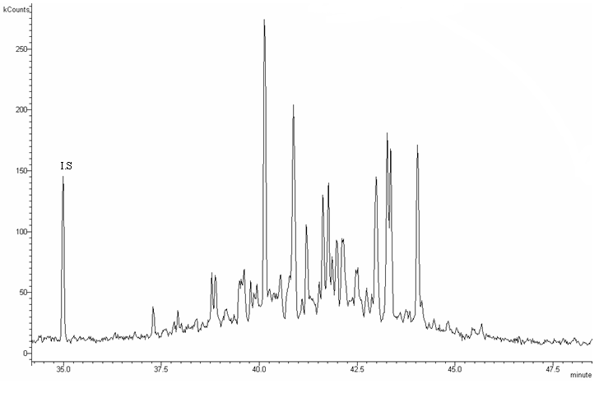

B. M/z 218 mass chromatogram showing the distributions of steranes and diasteranes in representative oil (sample AS-1) from the Assam Delta. This ion best monitors the αββ steranes eluting as doublets. I.S is the 5-β cholane internal standard

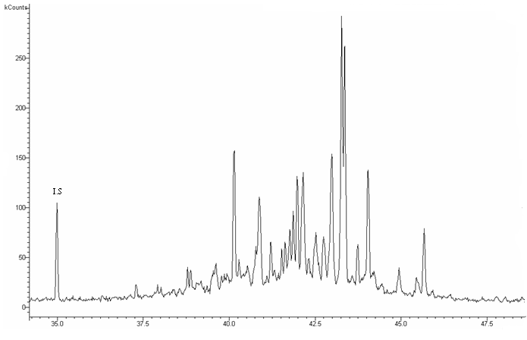

C. M/z 259 mass chromatogram showing the distributions of diasteranes in sample in representative oil (sample AS-1) from the Assam Delta.

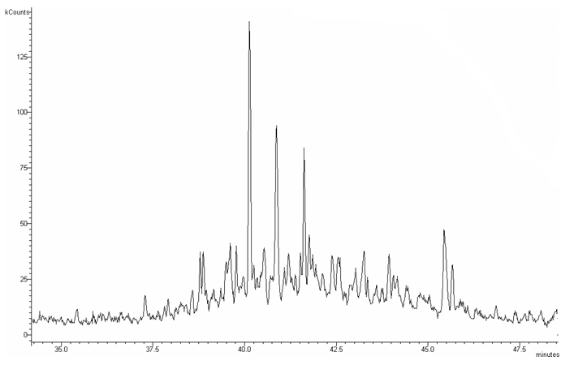

D. M/z 191 mass chromatogram showing the distributions of triterpanes in representative oil (sample AS-1) from the Assam Delta .

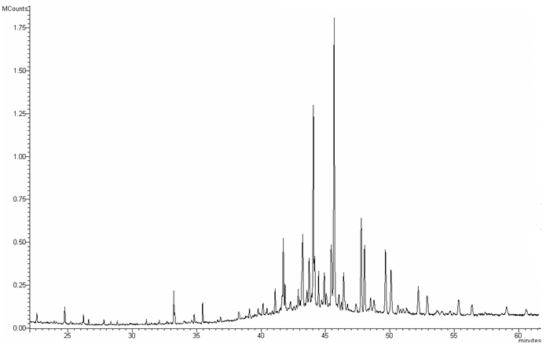

- Representative Mass Chromatograms of Steranes and Triterpanes in Beaufort-Mackenzie oils (sample BM-2).

  - M/z 217 mass chromatogram showing the distributions of steranes and diasteranes in representative oil (sample BM-2) from Beaufort-Mackenzie Delta. I.S is the 5-β cholane internal standard peak.

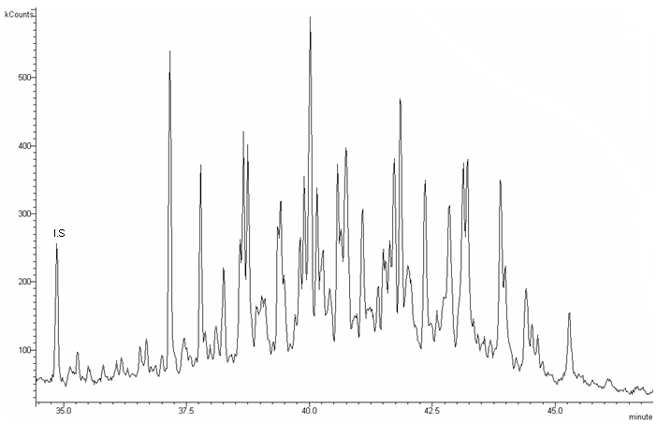

  - M/z 218 mass chromatogram showing the distributions of steranes and diasteranes in representative oil (sample BM-2) from Beaufort-Mackenzie Delta. I.S is the 5-β cholane internal standard peak. The ion 218 best monitors the αββ steranes eluting as doublets.

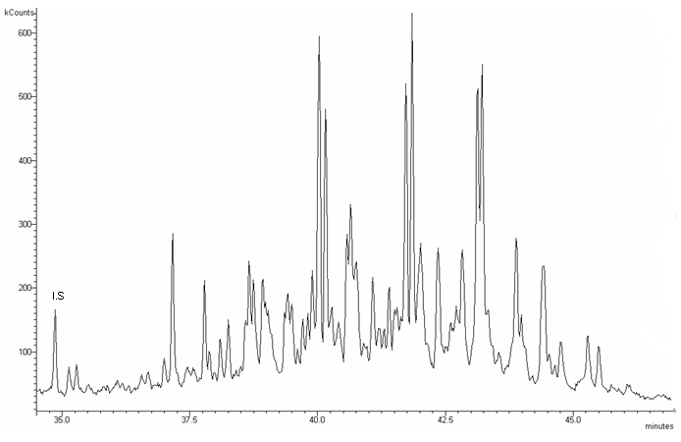

  - M/z 259 mass chromatogram showing the distribution of diasteranes in sample in representative oil (sample BM-2) from Beaufort-Mackenzie Delta.

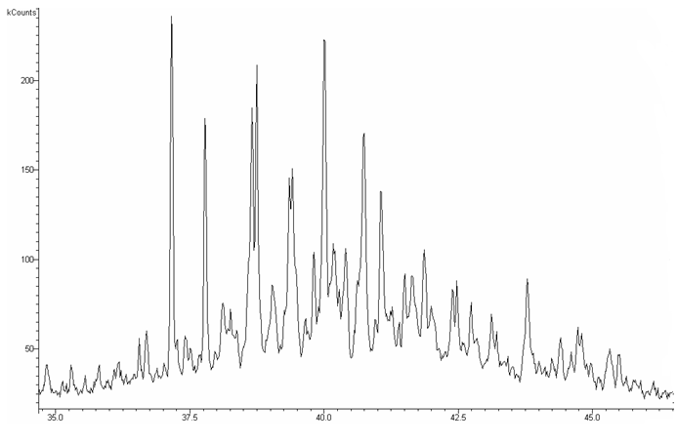

  - M/z 191 mass chromatogram showing the distributions of triterpanes in representative oil (sample BM-2) from Beaufort-Mackenzie Delta.

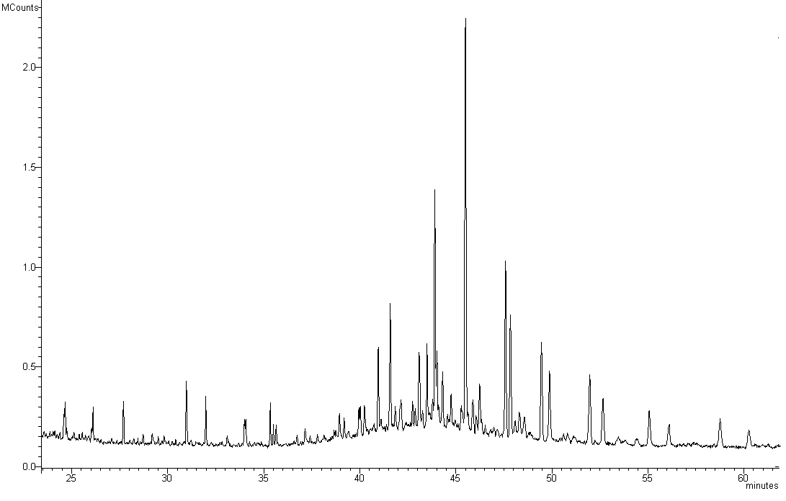

- Representative Mass Chromatograms of Steranes and Triterpanes in Gulf of Mexico oils (sample GOM-1).

  - M/z 217 mass chromatogram showing the distributions of steranes and diasteranes in representative oil( sample GOM-1) from the Gulf of Mexico. I.S is the 5-β cholane internal standard peak.

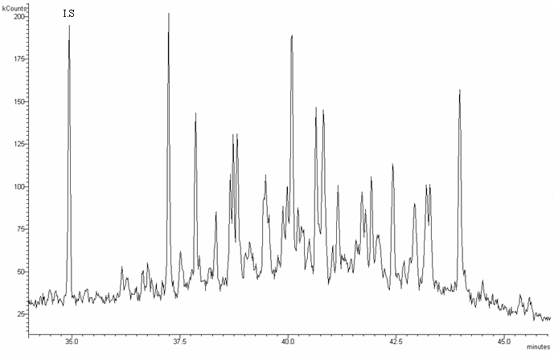

  - M/z 218 mass chromatogram showing the distributions of steranes and diasteranes in representative oil( sample GOM-1) from the Gulf of Mexico. I.S is the 5-β cholane internal standard. The ion 218 best monitors the αββ steranes. I

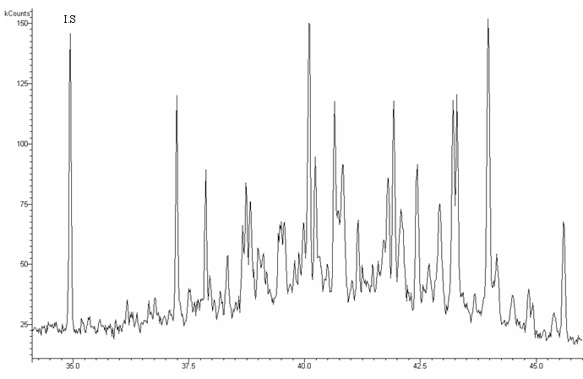

  - M/z 259 mass chromatogram showing the distribution of diasteranes in representative oil (sample GOM-1) from the Gulf of Mexico.

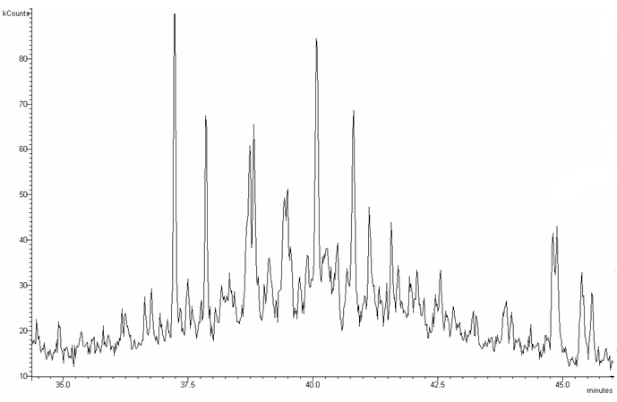

  - M/z 191 mass chromatogram showing the distribution of triterpanes in representative oil (sample GOM-1) from the Gulf of Mexico.

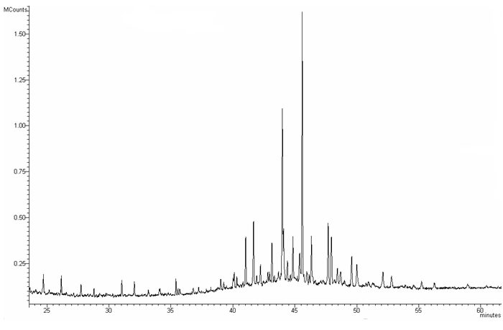

- Representative Mass Chromatograms of Steranes and Triterpanes in oils from the Niger Delta.

  - M/z 217 mass chromatogram showing the distributions of steranes and diasteranes in representative shallow water oil, top chromatogram (sample NDO10) and deepwater oil, lower chromatogram (Sample NDO14) from the Niger Delta. I.S is the 5-β cholane internal standard peak.
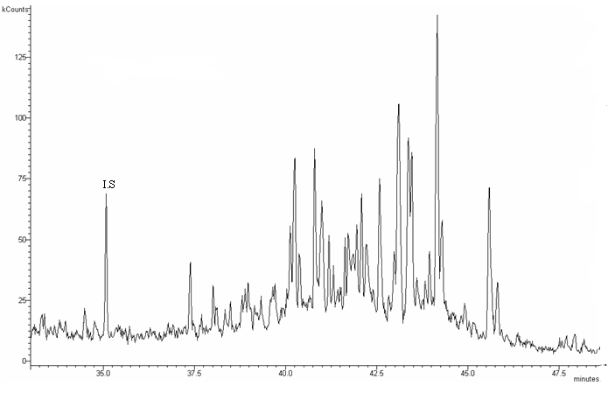

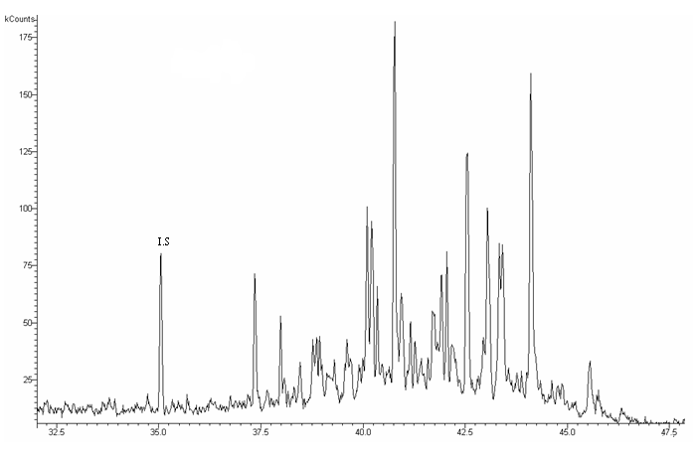

B. M/z 218 mass chromatogram showing the distributions of steranes and diasteranes in representative shallow water oil from the Niger Delta (top, sample NDO10) and deepwater oil (bottom, sample NDO14). I.S is the 5-β cholane internal standard. The ion 218 best monitors the αββ steranes.

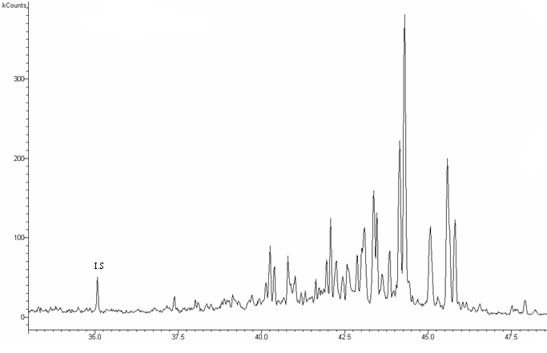

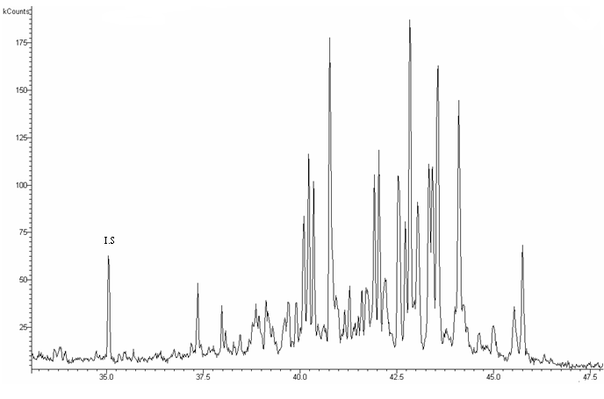
C. M/z 259 mass chromatogram showing the distribution of diasteranes in representative shallow water oil from the Niger Delta (top, sample NDO10) and deepwater oil (bottom, sample NDO14).

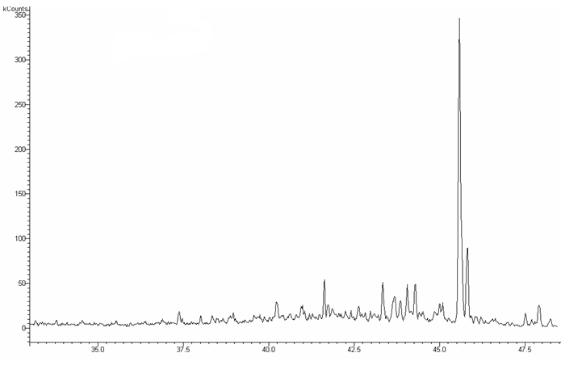

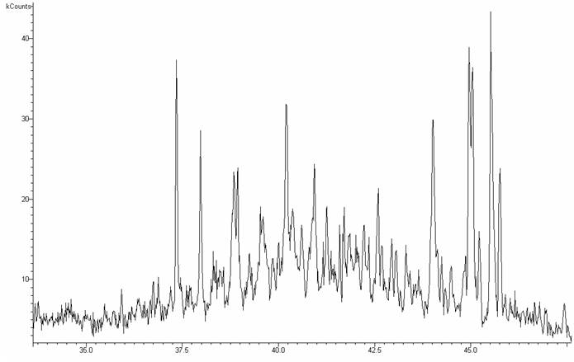
D. M/z 191 mass chromatogram showing the distribution of triterpanes in representative shallow water oil from the Niger Delta (top, sample NDO10) and deepwater oil (bottom, sample NDO14).

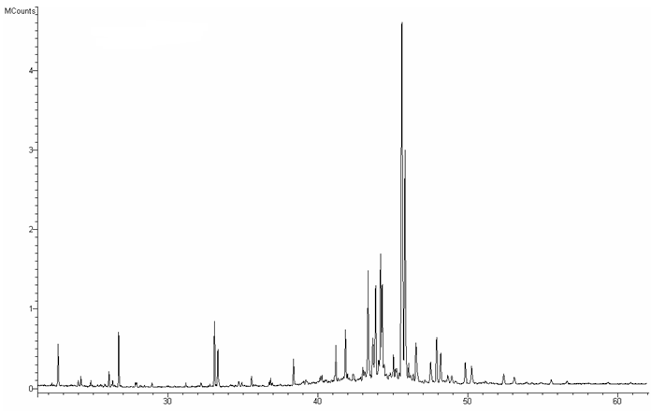

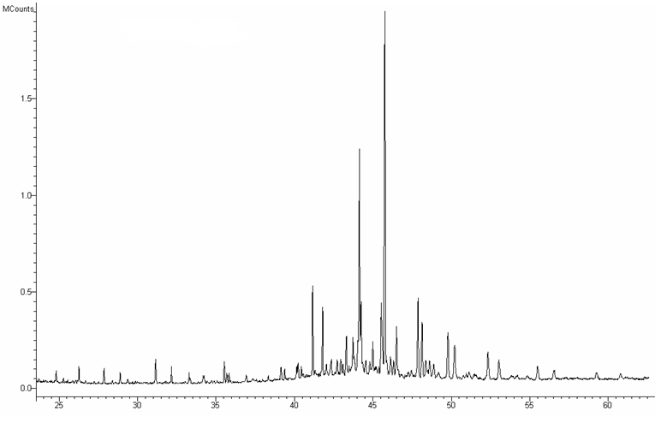

- Representative Mass Chromatograms of Steranes and Triterpanes in oils from the Kutei Basin.

  - M/z 217 mass chromatogram showing the distributions of steranes and diasteranes in representative oil from the Kutei Basin (sample KT-5). I.S is the 5-β cholane internal standard peak.

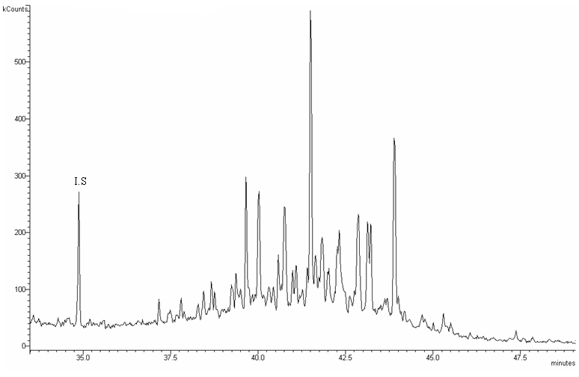

  - M/z 218 mass chromatogram showing the distributions of steranes and diasteranes in representative oil from the Kutei Basin (sample KT-5) I.S is the 5-β cholane internal standard. The ion 218 best monitors the αββ steranes.

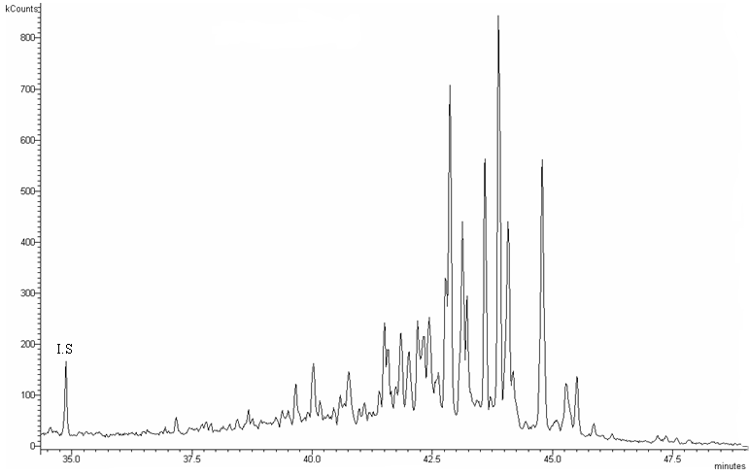

C. M/z 259 mass chromatogram showing the distribution of diasteranes in representative oil from the Kutei Basin (sample KT-5).

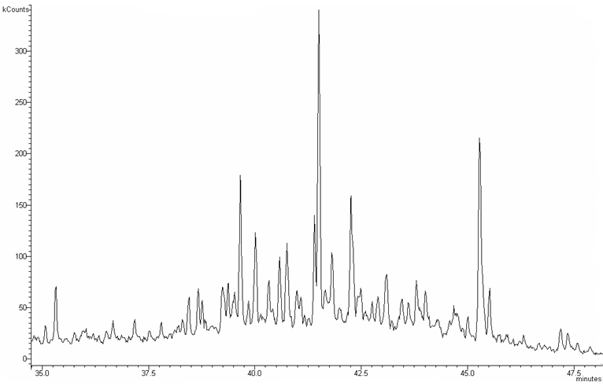

D. M/z 191 mass chromatogram showing the distribution of triterpanes in representative oil from the Kutei Basin (sample KT-5).



